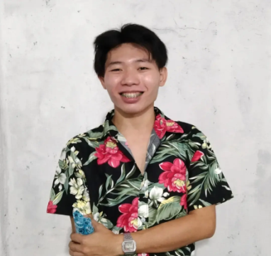C:\Users\uzgg\Downloads\PinClipart.com_email-clipart_5304769.pngC:\Users\uzgg\Downloads\PinClipart.com_phone-calling-clipart_5712843.pngC:\Users\uzgg\Downloads\202-2020524_cliparto.png

**SKILLS**

* Can code in HTML/CSS and Javascript and still studying.
* Knowledge in using MS Word,Excel and Powerpoint.
* Willing to learn new technology that used.

**EDUCATION**

**TERTIARY:**

Not yet **SECONDARY:**

Trinity Polytechnic College(Grade 12) 2020-2022

Novaliches High School(Grade 9-10) 2018-2020  
Deparo High School(Grade 7-8) 2016-2018  
**PRIMARY:**

San Agustin Elementary School(Grade 1-6) 2010-2016

* Graphic Design Para Sa Mga Baguhan 2022
* 4th Place in Programming Philippines Coding Game Titled “The Matrix” 2020

**Certifications and Accreditations**

* Basic Computer 2016
* Creating an Adventure Game with Python Code 2022

**Work Experience**

2020-2022 **DheeluxeSkin** **Stuff**

* Can print materials needed
* Repacking order
* Cleaning
* Troubleshooting



**Career Objectives**

To further develop a career path within distinguished international IT companies that can greatly enchance my skill and establish stronger connection.

**Age:** 19 **Sex:** Male

**Birthdate:** August 4, 2002

**Language:** Filipino

**Jonrie M. Badiang**

224 Diamante Sapphire Street Caloocan City

09702552127

jonriemain@gmail.com