Handledare: Martin Gerdin Wärnberg

Bihandledare: Kapil Dev Soni

**Predicting intensive care unit admission in trauma patients in India using the quick sequential organ failure assessment score (qSOFA)**

**Seminarieversion**

**Författare:** **Björn Lindberg**

Institutionen för global folkhälsa  
Björn Lindberg  
Läkarprogrammet KI  
Examensarbete 30 p  
Höstterminen 2020





**Förutsägande av intensivvårdsinläggning hos traumapatienter i Indien användandes the quick sequential organ failure assessment score (qSOFA)**

*Bakgrund:* Trauma är ett globalt problem som påverkar ett stort antal människor varje år. Det är känt att majoriteten av dödsfall från trauma sker kort tid efter skadetillfället och det är därför viktigt att snabbt kunna gradera och prioritera patienter med trauma. Quick sequential organ failure assessment score (qSOFA score) har visats kunna användas för att förutsäga dödligheten hos patienter med trauma men det är ännu inte visat att qSOFA score kan användas för att predicera intensivvårdsinläggning och därmed vara till hjälp i kliniskt beslutfattande.

*Syfte:* Syftet med detta projekt är att bedöma validiteten av qSOFA för att förutsäga intensivvårdsinläggning hos traumapatienter vid sjukhus med begränsade resurser.

*Material och Metoder:* Towards Improved Trauma Care Outcomes in India (TITCO) kohorten och complete case analysis används för att beräkna ny optimala gränsvärden för parametrarna ingåendes i qSOFA score med hjälp av logistisk regression. Nya oddskvoter räknas ut efter de uppdaterade gränsvärdena och prestandan jämförs mellan originalmodellen och den uppdaterade modellen. Bootstrap metoden används för att estimera de korresponderande konfidensintervallen till resultatet.

*Resultat:* Den uppdaterade modellen presterar signifikant bättre än originalmodellen både med avseende på diskriminering och kalibrering.

*Slutsats:* En uppdaterad qSOFA score kan användas för att uppskatta den övergripande risken för intensivvårdsinläggning hos traumapatienter vid urbana indiska sjukhus men mer forskning behövs innan en uppdaterad qSOFA ska kunna användas i kliniskt beslutfattande.

**Predicting intensive care unit admission in trauma patients in India using the quick sequential organ failure assessment score (qSOFA)**

*Introduction:* Trauma is a global problem affecting a large number of people each year. It is known that the majority of deaths from trauma happens shortly after the injury and it is therefore important to quickly be able to assess and prioritize patients with severe injury. Quick sequential organ failure assessment score (qSOFA score) has been shown to be able to predict mortality in trauma patients but it has not been shown whether qSOFA can be used to predict intensive care unit (ICU) admission and therefore be used as a help in direct clinical practice.

*Aims:* The aim of this project is to assess the validity of qSOFA in predicting ICU admission in trauma patients admitted to hospitals in a low resource setting.

*Material and Methods:* The Towards Improved Trauma Care Outcomes in India (TITCO) cohort and complete case analysis was used to calculate new optimal cutoffs for the parameters in the qSOFA score using logistic regression. New odds ratios were calculated using the uppdated cutoffs and the performence was compared between the original and updated model. The bootstrap method was used to estimate the corresponding confidence intervals for the results.

*Results:* The updated model performs significantly better than the original model both in terms of discrimination and calibration.

*Conclusions:* An updated qSOFA score can be used to estimate the overall risk for ICU admission in trauma patients in urban India hospitals but more research is needed before qSOFA can be implemented and used in clinical decision making.

*Keywords:*

Trauma, qSOFA, Intensive care

# Abbreviations

AUC –Area Under the receiver operating characteristics Curve

CI – Confidence Interval

DALY - Disability Adjusted Life Years

GCS – Glasgow Coma Scale

ICI - Integrated Calibration Index

ICU – Intensive Care Unit

OR – Odds Ratio

qSOFA – quick Sequential Organ Failure Assessment

RR – Respiratory Rate

RTS – Revised Trauma Score

SBP – Systolic Blood Pressure

SD – Standard Deviation

SOFA - Sequential Organ Failure Assessment

TITCO – Towards Improved Trauma Care Outcomes in India

T-RTS – Triage Revised Trauma Score

# Introduction

Trauma is defined as the clinical entity composed of both physical injury and the body’s associated response. Trauma patients are a heterogenous group with wide range of different causes where some of the most prominent ones are traffic related injuries, falls, self-harm, interpersonal violence and burns. Trauma is a global health problem and the total number of injuries is estimated to be at least 520 million cases per year (1).

The effects of trauma on patients and their families can be divided into non-fatal and fatal trauma. The effects of non-fatal trauma can be further subdivided into Disability Adjusted Life Years (DALY) lost and economic effects. DALY is a measurement using both the mortality, in years lost between death and local life expectancy, and morbidity, as in years lived with reduced function due to the disease both physical and psychological. In 2017 trauma accounted for 10.1% of total DALY lost. This is about the same as all neoplasms, 9.4 %, and can be compared to that of cardiovascular diseases accounting for 14.6 % (2).

Whereas the physical disabilities depend on the type of injury in a fairly straight forward way, the psychological effects include depression, anxiety and post traumatic distress and are often long lasting after an injury. In a 12 month follow up study from the United Kingdom the result showed that patients who had experienced an unintentional injury had elevated levels of depression, anxiety and post traumatic distress scores up to at least a year after the injury. The same study also showed that patients with lower socioeconomic status, lower pre-injury quality of life, and higher pre-injury depression and anxiety scores where associated with a higher rate of psychological effects after the injury (3).A multinational study of the association between depression and injuries could also show that although differing slightly depending on the country income there was an increased risk of depression in patients whom had suffered traffic or other injuries (4).

The economic effects in turn regards both the out of pocket expenses for treatments as well as reduced productivity due to reduced ability after the injury. A study in northern India from 2019 calculated that 22% of patients who presented with traumatic injuries afterward had catastrophic health expenditure defined as 30% or more of their total expenditure on healthcare related costs and 12 % were pushed below the international poverty line as a consequence of their injury (5).

Regarding fatal trauma and the mortality associated with traumatic injuries in 2017 trauma accounted for 8% of total global deaths (2). According to calculations done by Mock et al. (6) 90% of all deaths due to trauma were in low- and middle-income countries which also had a mortality rate 60-80% higher than that of high-income countries. Mock et al. also calculated that an improvement in trauma care globally to the level of that in high income countries could save about 1.7 million lives annually, or about one third of the global deaths due to trauma, not including possible injury prevention.

It is known that most fatalities in response to traumatic injuries occur shortly after the injury. In order to reduce the mortality in patients with severe trauma it is vital with early intervention, often surgical, as by “the golden hour” concept. The higher mortality is often because of patients suffering from internal and external bleeding where surgery is an important part of the hemorrhage control (7). It is evident that in parts of the world with fewer hospitals, reduced access to healthcare and a less developed ambulance networks the time parameter is one of the contributing factors to the increased mortality in trauma patients in low- and middle-income countries.

For patients with severe infections the Sequential Organ Failure Assessment (SOFA) score was developed in 1994 to grade the level of organ dysfunction in critically ill patients. The SOFA score is based on the reduced function scored 0-4 for each of the respiratory, cardiovascular, neurological, hepatic, coagulation and renal systems. Initially the focus was mainly patients suffering from severe infections and sepsis, but it was early recognized to be applicable in a wide range of critical illnesses such as severe trauma (8).

Alongside the last revision of the sepsis definition in 2016 the quick Sequential Organ Failure Assessment score (qSOFA score) was developed. The qSOFA score includes three parameters: Systolic blood pressure (SBP) below 100 mmHg, a respiratory rate (RR) above 22 min and an altered consciousness, measured with a Glasgow Coma Scale (GCS) score below 15. One point is awarded for each parameter yielding a total score of 0-3. The qSOFA score was introduced as a screening tool, to be performed bedside to identify patients with high-risk of organ dysfunction due to infections (9), (10). The qSOFA score has also been shown to be able to predict mortality in patients with traumatic injuries when used both in prehospital care (11) as well as repeated evaluation during hospitalization (12).

Another tool to assess the severity of a patient’s condition due to trauma is the Revised Trauma Score (RTS) and the Triage Revised Trauma Score (T-RTS) composed of the same parameters as qSOFA, that is SBP, RR and GCS, but with a score of 0-4 for each parameter instead of a single criteria. The scores can either be presented individually as used in RTS or added together to a total of 0-12 used in the T-RTS. The RTS is devised to be used in outcome evaluation and assessment of injury severity and the T-RTS for triage and finding patients a prehospital or initial setting in most need of specialized trauma care (13). However, there are some articles raising concerns about the sensitivity of the T-RTS depending on the type of injury. (14,15)

Because of the inherent urgency and complexity in trauma care it is vital to have an initial scoring system that is both simple to perform and that does not need laboratory nor other advanced measuring equipment. For this reason, the SOFA score can be said to use too advanced techniques and the T-RTS with its many subdividing cutoffs to be too complicated. The choice of using qSOFA is thus because of its promising signs in other studies and because of the possible clinical advantage in its simplicity.

It should also be noted that the majority of the research done on the topic of trauma and trauma care has been performed in high income countries. It is thus not clear if the results are also applicable in low resource settings, which arguably stand to benefit the most of a scoring system to be able to prioritize the limited resources at hand in hope of improving patient outcome. Furthermore, most studies report the predictive power of different scoring systems on mortality and it has not yet been sufficiently studied whether an initial qSOFA score can be used to predict admissions to an intensive care unit (ICU) and thus aid in the direct clinical treatment for trauma patients.

## Healthcare in India

The Indian healthcare is of now severely underfunded, the national healthcare expenditure is about 3.5% of national GDP, or about 70 USD per person in 2017, compared to a national healthcare expenditure of 5900 USD in Sweden for the same year. Out of these 70 USD per person 27 % is government expenditure and 72% is private expenditure, mostly out of pocket expenditures. The remaining expenditure is for external sources such as international aid. (16) This makes the unregulated private healthcare sector almost 3 times as large as the public providing 80% of outpatient care and 60% of inpatient care in India. India also lacks healthcare personal and in many cases complete medical training, especially regarding trauma care. (17, 18)

Besides the deficient monetary aspects of India’s healthcare system, it can also be said that there is a lack of sufficiently enforced safety policies and regulations, for example road traffic and workplace safety. Although it should be noted that in the new national health policy from 2017 one of the primary focuses are preventing rail and road traffic accidents. The national health policy also aims at expanding the number of hospital beds dedicated to trauma care across the country reducing the time between injury and care as guided by the golden hour concept discussed above. (17, 18)

## Aim

The aim of this project is to assess the validity of qSOFA in predicting ICU admission in trauma patients admitted to hospitals in a low resource setting.

# Ethical consideration

This study was performed on the open and anonymized Towards Improved Trauma Care Outcomes in India (TITCO) observational cohort dataset composed of data collected at several hospitals. (19) Ethics committees at all participating centers approved the collecting of data. (Lokmanya Tilak Municipal General Hospital, IEC/11/13; King Edward Memorial Hospital, IEC(I)/OUT/222/14; Seth Sukhlal Karnani Memorial Hospital, IEC/279; All‐India Institute of Medical Sciences, IEC/NP‐279/2013 RP‐01/2013).

No participant can be said to have been harmed by the study because of its purely observational nature. One could reason about the possible Hawthorne effect of observing healthcare workers or delay while collecting data could have a negative effect on the patients care. Although this could not be eliminated completely it was thought to be mitigated after the first few weeks of data collection.

Furthermore, because of the lack of harm due to it being an observational cohort and because of the physical and psychological distress already present for the patient and their relatives, the ethics committees reasoned that obtaining individual informed consent from the patients or their relatives would be an unnecessary burden and individual consent was therefore not gathered. The data was gathered in such a way to minimize the negative effects the study could have on the patients or their relatives.

The participants involved were often of low socioeconomic status, although this fact was never gathered about the individual patients, this is an effect of that the data was gathered at public university hospitals where patients of lower socioeconomic status were overrepresented. India has an underfunded public healthcare and those who can afford usually go to private alternatives. Because of the wide range of traumas, a patient’s socioeconomic status cannot be said to have an effect on the care received during hospitalization and is not thought of to be a contributing factor in the make-up of this study. It should be noted that because of the lack of enforced safety regulations and injury rehabilitation in India socioeconomic status do influence incidence and longtime outcome for the patients. But this angle is outside the scope of this study.

It can also be said that the resources needed to perform this study are small since no new data need to be gathered and thus the benefit of improved trauma care and health for trauma patients in low resource settings is sufficient to merit this project.

# Method

## Source of data

For this paper a retrospective analysis of the observational Towards Improved Trauma Care Outcomes in India (TITCO) cohort will be performed. (19) The data for TITCO was collected between July 2013 and December 2015 and includes patients admitted to four public university hospitals. The hospitals included were; Jai Prakash Narayan Apex Trauma Center, connected to the All India Institute of Medical Sciences in New Delhi, a large center solely dedicated to trauma care; King Edward Memorial hospital in Mumbai, a tertiary level hospital but without dedicated trauma wards; Lokmanya Tilak Municipal General Hospital in Mumbai, a tertiary level public university hospital with a smaller dedicated trauma ward; and Seth Sukhlal Karnani Memorial Hospital in Kolkata, connected to The Institute of Post-Graduate Medical Education and Research, a tertiary level public university hospital without a ward dedicated solely to trauma.

## Participants

The TITCO cohort include patients with a history of trauma who either got admitted to one of the participating hospitals or who died between arrival and admission. Patients were excluded from the database if they presented with isolated injuries to limbs without associated vascular damage as well as patients who were dead on arrival.

## Outcome

The primary outcome of interest was admission to the ICU during hospitalization as recorded in the TITCO database.

## Predictors

For each patient included in the study the qSOFA score was calculated using data recorded on arrival to the hospital by medical personal as found in the TITCO database. The values used in the calculations were respiratory rate, Glasgow coma scale and systolic blood pressure.

## Sample size

We included all patients in the TITCO cohort over the age of 18.

## Missing data

Complete case analysis was used.

## Statistical analysis methods

We used R for all statistical analysis. We described the sample characteristics using counts and percentages for qualitative variables and mean and standard deviations (SD) for quantitative variables. The study sample was randomly split into training, validation, and test samples with 60%, 20%, and 20% of the observations in each sample respectively. We used the training sample to update the qSOFA score by re-evaluation the optimal cutoffs for the predictors maximizing the Youden index. We used the validation sample to estimate the coefficients of the updated model as well as the odds ratios for each total score of the original (20) and updated model. We used the test sample to assess and compare the performance of the two models, both as a total score as well as individual parameters. Bootstrapping was used for the whole study to estimate 95% confidence intervals (CI) associated with point estimates.

# Results

The TITCO cohort included 16 000 patients (figure 1). We excluded 3373 patients because they were under the age of 18 and 98 patients because they died between arrival and admission. Patients with externally controlled breathing, such as intubation or surgical airway, were also excluded accounting for 493 patients. We further excluded 5435 patients due to missing data in either admission to the ICU (33), systolic blood pressure (2109), respiratory rate (4870), or GCS (1499). The final sample included 6601 patients.

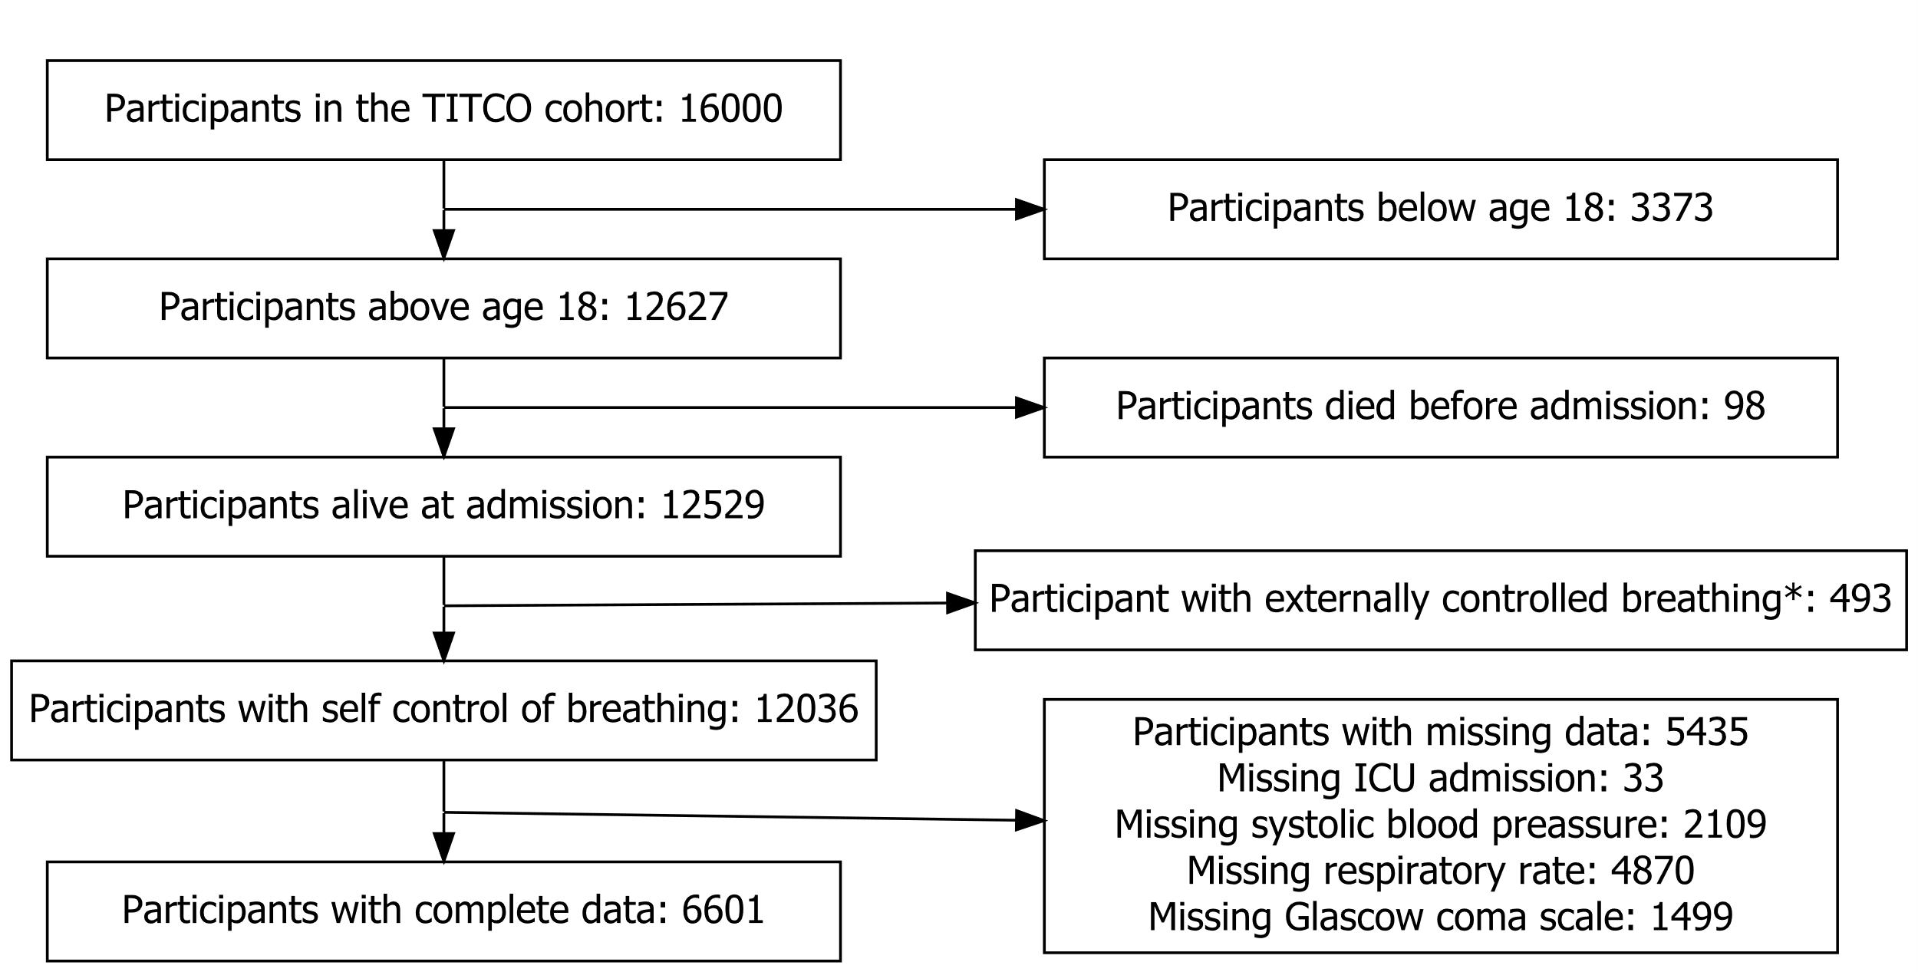

Figure 1 Study flowchart.   
* Externally controlled breathing includes intubation or surgical airways before arrival to a participating hospital.

The mean age was 37.55 with predominantly male participants (83%). The most common type of injury was road traffic injuries with 51 % followed by falls and assaults accounting for 26 % and 10 % respectively. Furthermore 61 % of patients were transported to a participating hospital from another health care facility. In the study population 41 % of patients had to be treated for some time in the ICU. The data is presented both overall and stratified by ICU admission in table 1 with corresponding standard deviations.

Table 1 Study characteristics stratified by ICU admission

|  |  |  |  |
| --- | --- | --- | --- |
|  | Overall | No ICU | ICU |
| Total participants | 6601 | 3877 | 2724 |
| Age (mean (SD)) | 37.55 (15.18) | 38.14 (15.45) | 36.71 (14.74) |
| Male (%) | 5480 (83.0) | 3082 (79.5) | 2398 (88.0) |
| Transported (%) | 4005 (60.7) | 2459 (63.4) | 1546 (56.8) |
| Mode of injury (%) |  |  |  |
| Assault | 627 (9.5) | 411 (10.6) | 216 (8.0) |
| Burn | 134 (2.0) | 133 (3.4) | 1 (0.0) |
| Fall | 1703 (25.9) | 1080 (27.9) | 623 (23.1) |
| Railway injury | 439 (6.7) | 99 (2.6) | 340 (12.6) |
| Road TRAFFIC  INJURY | 3364 (51.2) | 1944 (50.2) | 1420 (52.6) |
| Other | 307 (4.7) | 209 (5.4) | 98 (3.6) |
| ICU admission (%) | 2724 (41.3) | 0 (0.0) | 2724 (100.0) |
| Died after admission (%) | 1342 (20.3) | 551 (14.2) | 791 (29.0) |
| SBP (mean (SD)) | 116.34 (23.91) | 117.87 (19.10) | 114.16 (29.30) |
| RR (mean (SD)) | 18.85 (4.97) | 18.99 (4.94) | 18.64 (4.99) |
| GCS (mean (SD)) | 12.21 (4.00) | 12.97 (3.52) | 11.13 (4.38) |

We identified the following revised optimal cutoffs: 117 for SBP, 30 for RR and 14 for GCS. The corresponding confidence intervals and updated odds ratios can be seen in table 2 together with the original OR from Seymour et al.(20).

Table 2 Original and updated odds ratios (OR) for the logistic regression model.

|  |  |  |  |
| --- | --- | --- | --- |
|  | Original OR | Updated OR  (95%CI) | Optimal cutoffs (95%CI) |
| BASELINE | 0.01 | 0.452 (0.146 - 0.507) | - |
| SBP | 2.61(2.40-2.85) | 1.197 (1.158 - 3.483) | 117 (97 - 117) |
| RR | 3.18(2.89-3.50) | 2.054 (0.563 - 13.131) | 30 (8 - 34) |
| GCS | 4.31(9.96-4.69) | 2.342 (1.887 - 3.019) | 14 (11 - 14) |

The estimated probability of ICU admission and corresponding OR given the OR from table 2 and the distribution of the individual parameters in the study sample are presented in table 3 and 4.

Table 3 Estimated probabilities of ICU admission given an updated qSOFA score of 0-3 and corresponding OR.

|  |  |  |
| --- | --- | --- |
| Updated score | Estimated probability of ICU admission (95%CI) | Odds ratio (95% CI) |
| 0 | 0.311 (0.075 - 0.336) | 1 |
| 1 | 0.426 (0.294 - 0.538) | 1.642 (1.109 - 5.411) |
| 2 | 0.561 (0.44 - 0.766) | 2.829 (2.121 - 13.689) |
| 3 | 0.722 (0.492 - 0.97) | 5.765 (2.216 - 21960742.293) |

Table 4 Estimated probabilities of ICU admission given an original qSOFA score of 0-3 and corresponding OR.

|  |  |  |
| --- | --- | --- |
| Original score | Estimated probability of ICU admission (95%CI) | Odds ratio (95% CI) |
| 0 | 0.014 (0.01 - 0.029) | 1 |
| 1 | 0.046 (0.015 - 0.082) | 3.367 (1.273 - 5.37) |
| 2 | 0.11 (0.051 - 0.162) | 8.587 (3.267 - 12.612) |
| 3 | 0.264 | 25.057 (15.937 - 35.772) |

Figure 2 and figure 3 show a comparison between the predicted and observed probabilities for the new and updated model respectively and table 5 compares the performance in terms of Integrated calibration index (ICI) and Area under the curve (AUC) for the receiver operating characteristics for the original and updated model.

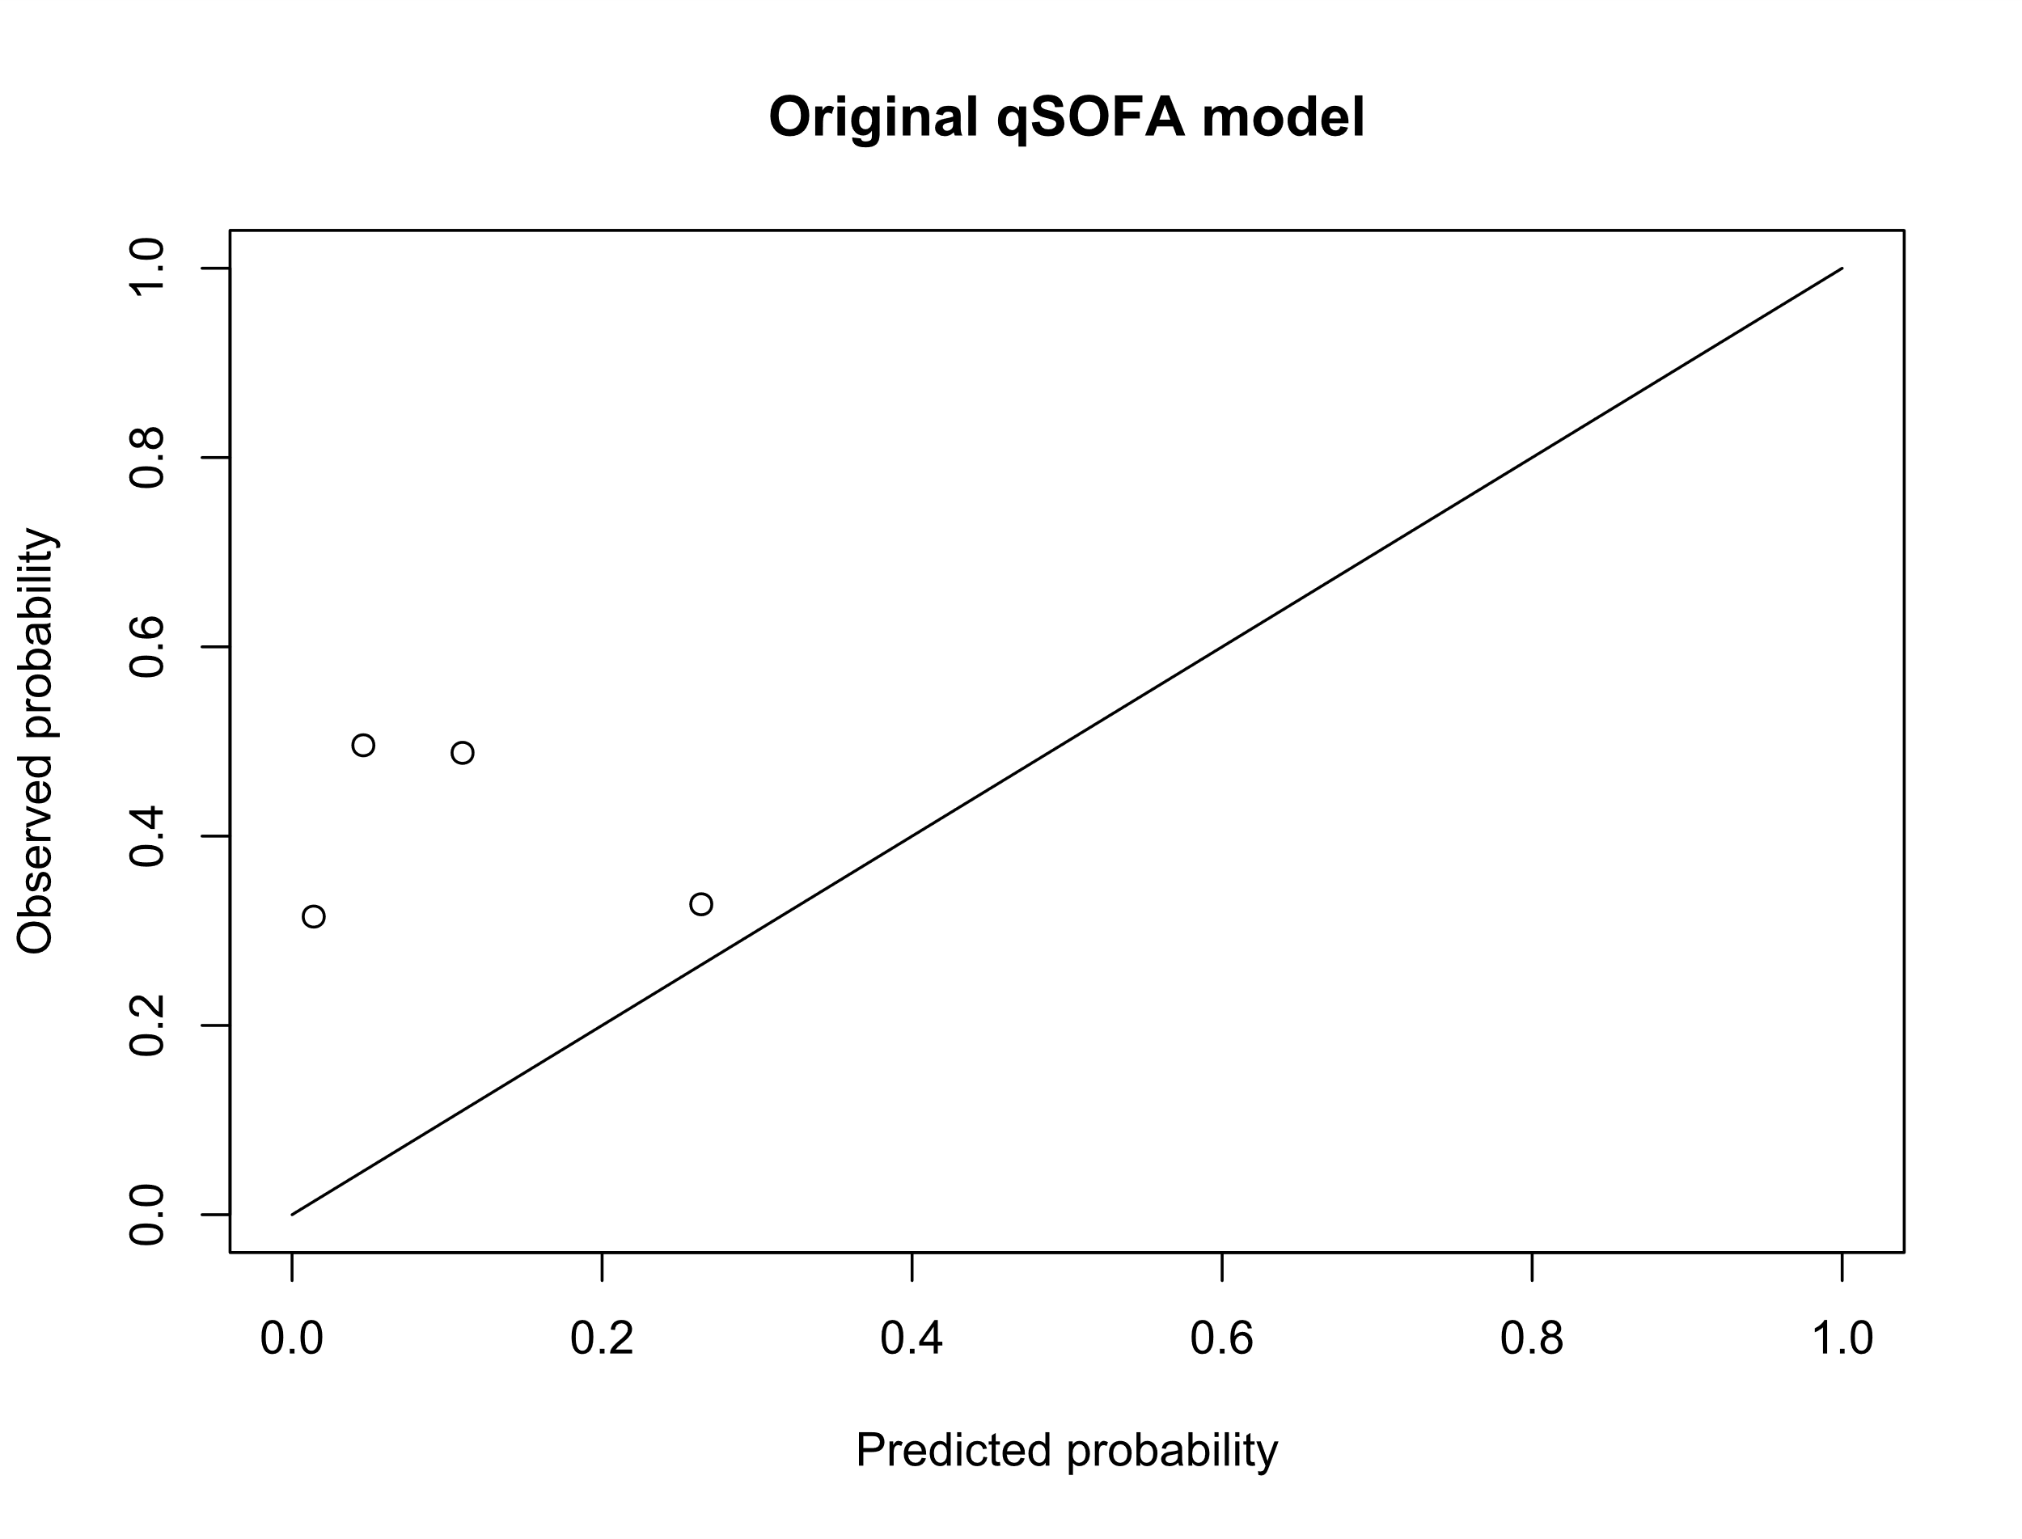

Figure 2 Integrated Calibration Index plot for the original qSOFA model.

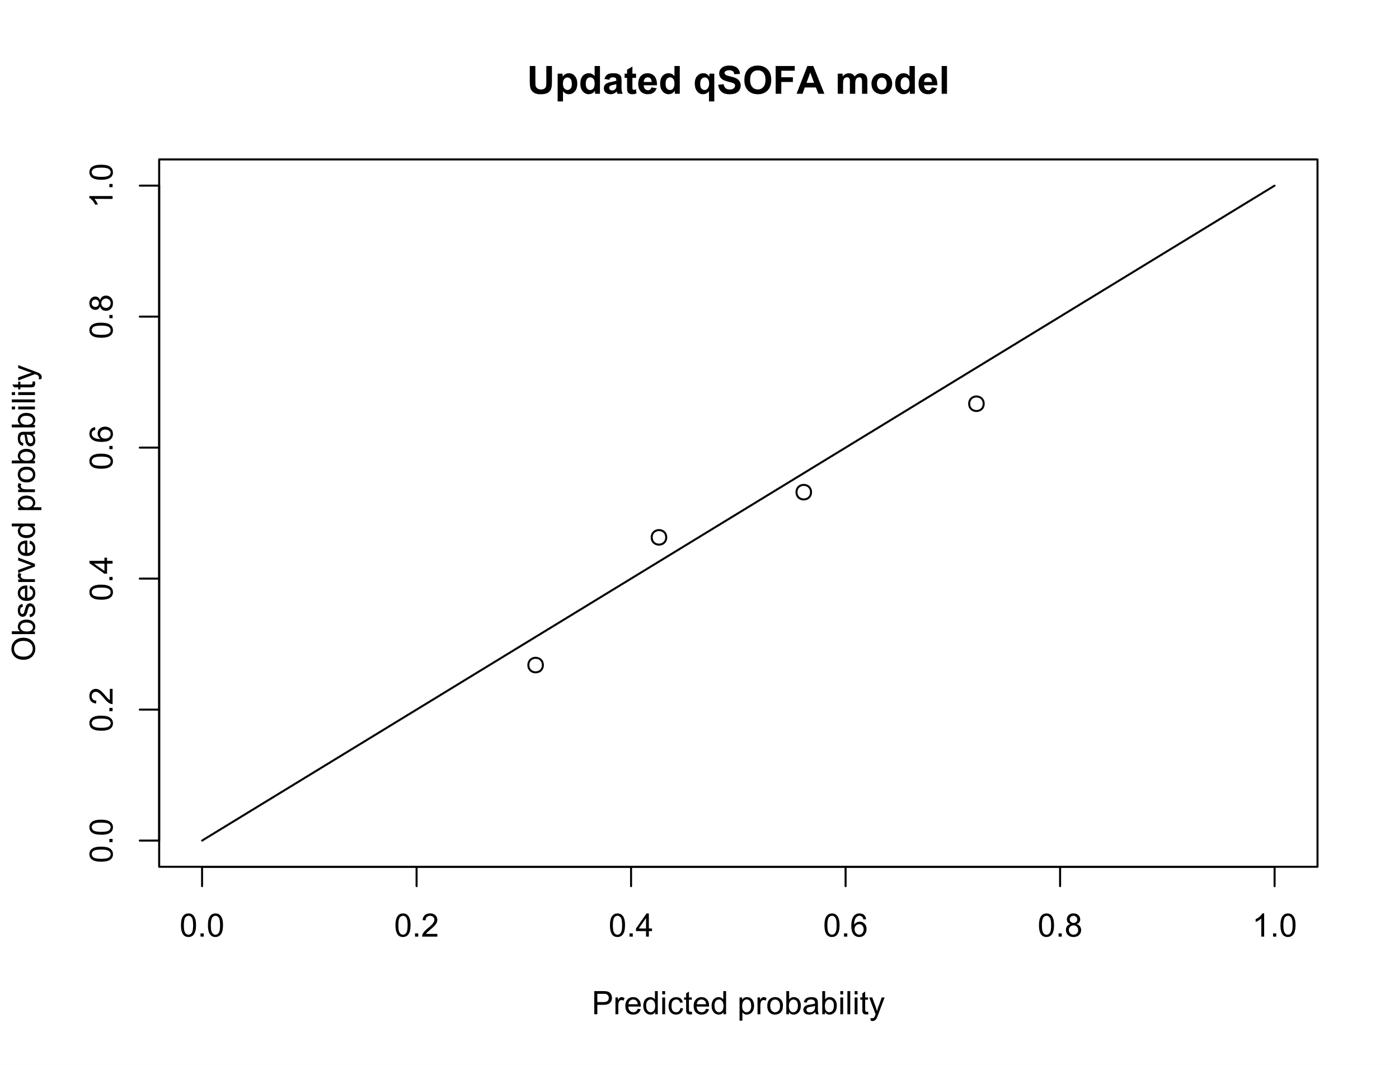

Figure 3 Integrated Calibration Index plot for the updated qSOFA model.

Table 5 Comparison of performance, ICI and AUC, between the original and updated qSOFA model as well as the ICI off the combined score for the original and updated model.  
Abbreviations: AUC Area under the curve, ICI Integrated calibration index

|  |  |  |  |  |
| --- | --- | --- | --- | --- |
|  | ICI  (95% CI) | Diff ICI  (95% CI) | AUC  (95%CI) | Diff AUC  (95%CI) |
| Original qSOFA separate | 0.385  (0.347 - 0.409) | - | 0.577  (0.563 - 0.623) | - |
| Updated qSOFA separate | 0.045  (0.014 - 0.083) | -0.339  (-0.375 - -0.281) | 0.624  (0.605 - 0.664) | 0.047  (0.025 - 0.063) |
| Original qSOFA score | 0.363  (0.329 - 0.388) | - | - | - |
| Updated qSOFA score | 0.038  (0.01 - 0.076) | -0.325  (-0.356 - -0.274) | - | - |

# Discussion

The aim of this study was to assess the validity of the qSOFA score in predicting ICU admissions in trauma patients. We found that in the context of urban Indian hospitals the original qSOFA score with its original cutoffs and coefficients did not accurately predict ICU admission. The original model underestimated the probability of ICU admission as can be seen in Figure 2. When updating the model adjusting the cutoffs and coefficients the new model performs significantly better both in terms of ICI and AUC.

While developing the original qSOFA score as a screening tool for patients with an increased risk of dying from severe infection it was shown that a low score of 0-1 corresponded to a mortality of approximately 1-2 percent and that a high score of 2-3 corresponded to a significantly higher mortality of 7-20 %. When using the predetermined cutoff value of 2 points this result made the original qSOFA a useful tool to be able to sort patients with a low score to also be of a low risk of dying. On the other hand, the results also allowed for that patients with a higher score could be more closely monitored and get access to treatment before more severe symptoms developed.

In contrast, with our updated qSOFA for predicting ICU admission in trauma patients a low score of 0-1 correspond to a probability for ICU admission of 0.311 - 0.426 percent and a high score of 2-3 correspond to a mortality of 0.561 - 0.722 percent. This shows that regardless of the score the patients still have a relatively high risk for ICU admission. Although a higher score is shown to correlate with a higher risk of ICU admission it is not clear what clinical relevance this score would have in the process of deciding the adequate level of care for patients with severe injuries.

The results also showed that out of the parameters included in the qSOFA, respiratory rate was not significantly associated with a higher risk of ICU admission and had an OR of 2.054 (0.563 - 13.131). This can be partially explained by that a new cutoff was calculated for each bootstrap resulting in different cutoffs being used while evaluating the model in turn leading to an increased uncertainty. Further research is needed before the original or an updated qSOFA score as presented in this study can be used in clinical decision making.

Although no other studies have been done correlating qSOFA to ICU admission studies have explored the connection between qSOFA and mortality, both regarding patients with risk for sepsis (10, 20) and trauma patients (12). Both these studies show that there is a clear association between the qSOFA score and mortality. Comparing this to our study on ICU admissions the ORs is higher when looking at mortality in both studies and the AUCs are slightly higher when looking at mortality. It can be argued that both ICU admission and mortality results from a more severe patient condition and thus should be correlated. However, it should be noted that there exist patients who died without being admitted to the ICU reducing this correlation. This could be partly because these patients were so severely injured that they either died before being able to be transferred to the ICU or it was decided that intensive care would not be of use for the patients. But it could also be due to a lack of ICU beds in the participating hospitals such that patients had to be prioritized for intensive care and not all patients who would benefit from it got admitted to the ICU. For context the number of ICU beds per 100 000 people is 2.3 in India compared with for example 7.3 in Japan. (21) To be able to explore this question more thoroughly further research is needed.

## Strengths and limitations

Strengths of this study were the large number of patients in the TITCO database and the that no previous studies have been done with a similar aim looking at ICU admission. Furthermore, the statistical analysis using bootstrap was rigorous and sound yielding trustworthy results for this context.

The study had several limitations. First the data collected for the TITCO database came from a homogeneous group of participating hospitals all in urban settings in India. Because of this it is not clear that the results presented here are generalizable to for example hospitals with a rural location or a different economic level.

Secondly it should be noted that 61 percent of the patients where for an unspecified time first treated at another hospital or health care facility and then later transferred to one of the participating hospitals. Because of this the parameters used in this study only show the first ones taken at arrival to the participating hospital and not always the first ones taken after the injury. Furthermore, the results in this study do not take into account any interventions performed before arrival or between arrival and admission to the ICU.

## Clinical applications

The results from this study is not significant enough to merit direct clinical use of the original nor updated model. However, one can see that for trauma patients SBP and GCS are of more importance than RR for predicting intensive care and thus this could be used when evaluating future patients. But further research is needed when optimal cutoffs are decided to better evaluate the updated model for clinical use.

## Future studies

A way for future research to investigate the usage of qSOFA in ICU admission would be to look at ICU admission, qSOFA score and mortality combined. This in order to investigate whether patients, depending on their qSOFA score, who were admitted to the ICU had a lower morality compared to patients with the same qSOFA score not admitted to the ICU. The aim of this would be to decide which patients would be the most helped by intensive care to better allocate the resources on hand.

Conclusion

An updated qSOFA score can be used to estimate the overall risk for ICU admission in trauma patients in urban India hospitals but more research is needed before it can be implemented and used in clinical decision making.

# Contributions

Aside from the collecting of data done before the start of this project most of this project has been made by me with supervision and help from my supervisor Martin Gerdin. My work has apart from this paper also included writing and performing all the statistical analyses for this project.

# Acknowledgements

I want to thank the TITCO contributors for collecting the data for this project and I want to thank Martin Gerdin for supervising me and all the help along the way.

# References

1. James SL, Castle CD, Dingels ZV, Fox JT, Hamilton EB, Liu Z, et al. Global injury morbidity and mortality from 1990 to 2017: results from the Global Burden of Disease Study 2017. Inj Prev. 2020;26(Supp 1):i96-i114.

2. Global, regional, and national disability-adjusted life-years (DALYs) for 359 diseases and injuries and healthy life expectancy (HALE) for 195 countries and territories, 1990-2017: a systematic analysis for the Global Burden of Disease Study 2017. Lancet. 2018;392(10159):1859-922.

3. Kendrick D, Baker R, Hill T, Beckett K, Coupland C, Kellezi B, et al. Early risk factors for depression, anxiety and post-traumatic distress after hospital admission for unintentional injury: Multicentre cohort study. J Psychosom Res. 2018;112:15-24.

4. Stickley A, Oh H, Sumiyoshi T, McKee M, Koyanagi A. Injury and depression among 212 039 individuals in 40 low- and middle-income countries. Epidemiol Psychiatr Sci. 2019;29:e32.

5. Prinja S, Jagnoor J, Sharma D, Aggarwal S, Katoch S, Lakshmi PVM, et al. Out-of-pocket expenditure and catastrophic health expenditure for hospitalization due to injuries in public sector hospitals in North India. PLoS One. 2019;14(11):e0224721.

6. Mock C, Joshipura M, Arreola-Risa C, Quansah R. An estimate of the number of lives that could be saved through improvements in trauma care globally. World J Surg. 2012;36(5):959-63.

7. King DR. Initial Care of the Severely Injured Patient. N Engl J Med. 2019;380(8):763-70.

8. Lambden S, Laterre PF, Levy MM, Francois B. The SOFA score-development, utility and challenges of accurate assessment in clinical trials. Crit Care. 2019;23(1):374.

9. Shankar-Hari M, Phillips GS, Levy ML, Seymour CW, Liu VX, Deutschman CS, et al. Developing a New Definition and Assessing New Clinical Criteria for Septic Shock: For the Third International Consensus Definitions for Sepsis and Septic Shock (Sepsis-3). Jama. 2016;315(8):775-87.

10. Singer M, Deutschman CS, Seymour CW, Shankar-Hari M, Annane D, Bauer M, et al. The Third International Consensus Definitions for Sepsis and Septic Shock (Sepsis-3). Jama. 2016;315(8):801-10.

11. Miyamoto K, Shibata N, Ogawa A, Nakashima T, Kato S. Prehospital quick sequential organ failure assessment score to predict in-hospital mortality among patients with trauma. Am J Emerg Med. 2019;37(12):2165-70.

12. Miyamoto K, Shibata N, Ogawa A, Nakashima T, Kato S. Prehospital and in-hospital quick Sequential Organ Failure Assessment (qSOFA) scores to predict in-hospital mortality among trauma patients: an analysis of nationwide registry data. Acute Med Surg. 2020;7(1):e532.

13. Champion HR, Sacco WJ, Copes WS, Gann DS, Gennarelli TA, Flanagan ME. A revision of the Trauma Score. J Trauma. 1989;29(5):623-9.

14. Giannakopoulos GF, Saltzherr TP, Lubbers WD, Christiaans HM, van Exter P, de Lange-de Klerk ES, et al. Is a maximum Revised Trauma Score a safe triage tool for Helicopter Emergency Medical Services cancellations? Eur J Emerg Med. 2011;18(4):197-201.

15. Alvarez BD, Razente DM, Lacerda DA, Lother NS, LC VO-B, Stahlschmidt CM. Analysis of the Revised Trauma Score (RTS) in 200 victims of different trauma mechanisms. Rev Col Bras Cir. 2016;43(5):334-40.

16. The World Bank. World Bank Open Data  [Internet].  Washington, USA :  World Bank group ; 2019[cited date 2020 Dec 19]. Available from: https://data.worldbank.org/.

17. Roy N. Towards improved trauma care outcomes in India : studies of rates, trends and causes of mortality in urban Indian university hospitals. Solna: Karolinska Institutet; 2017.

18. Gerdin M. The risk of dying : predicting trauma mortality in urban Indian hospitals. Solna: Karolinska Institutet; 2015.

19. TITCO collaborators (2017). TITCO dataset version 1. Available from  https://github.com/titco/titco-I .

20. Seymour CW, Liu VX, Iwashyna TJ, Brunkhorst FM, Rea TD, Scherag A, et al. Assessment of Clinical Criteria for Sepsis: For the Third International Consensus Definitions for Sepsis and Septic Shock (Sepsis-3). Jama. 2016;315(8):762-74.

21. Phua J, Faruq MO, Kulkarni AP, Redjeki IS, Detleuxay K, Mendsaikhan N, et al. Critical Care Bed Capacity in Asian Countries and Regions. Crit Care Med. 2020;48(5):654-62.