Associations between trauma resuscitation procedures and opportunities for improvement in adult patients with severe trauma

## List of Abbreviations

* ISS - Injury Severity Score
* KUH - Karolinska University Hospital
* M&M - Morbidity and mortality
* OFI - Opportunities for improvement

# Introduction

## Background

Traumatic injury, a condition resulting from physical injury and the body’s associated response, is a major cause of death and permanent disability worldwide, particularly in young people (1,2). In 2020, it was responsible for an estimated 4.4 million deaths, accounting for approximately 8% of all deaths globally, with 90% of injury-related deaths occurring in low- and middle-income countries (3). Traumatic injuries can be complex and require multidisciplinary treatment and rehabilitation, resulting in personal and societal costs and a significant public health burden globally (2). Common causes include road traffic accidents, falls, and violence-related injuries, with road traffic injuries estimated to cost $500 billion per year (4). The specific causes of traumatic injury can vary over time and may be influenced by a variety of factors such as population age, behavior, and resources for prevention and treatment (5).

Studies have shown that the quality of trauma care plays a significant role in patient outcomes, with higher-quality care leading to better outcomes, showing the importance of optimizing treatment quality (6,7). During trauma emergencies, a broad array of interventions are required depending on the type and severity of the trauma and the patient’s specific needs (8). Resuscitation procedures, such as airway management, fluid resuscitation, and blood transfusion, play a crucial role in stabilizing the patient and preserving vital organ function. The quick and effective implementation of these procedures can greatly improve the patient’s chances of survival and recovery (8), showing the importance to have a well-functioning trauma system in place (9,10).

A trauma system is a coordinated network of healthcare facilities and services designed to provide effective care to trauma patients. The key components of this system include specialized trauma centers, prehospital care, quality improvement programs, inter-facility transfer, education and training, and adequate resources (10).

Trauma centers are specialized hospitals that are equipped and staffed with experienced medical professionals to provide advanced care (1). The level of care provided by a trauma center varies, ranging from Level I, which is the highest level of care, to Level IV, which is the lowest level of care. This allows patients to receive the most appropriate level of care based on the severity of their injury (6).

A well-functioning trauma system is committed to quality improvement programs to ensure the delivery of safe and high-quality healthcare. The aim of these programs is to find opportunities for improvement (OFI), which are areas where there is room for improvement or where errors may occur. Factors such as inadequate staffing levels, outdated equipment and technology, lack of collaboration among healthcare providers, and inadequate pre-hospital care can all contribute to OFIs in trauma care. Most of these OFIs are due to procedural errors (11).

When a potential OFI is suspected in a patient’s care, the case is reviewed during a Mortality and Morbidity (M&M) conference. These conferences play a key role in improving healthcare quality by providing a platform for a multidisciplinary team that uses a systematic and comprehensive approach to identify and prioritize areas for improvement (12). If an OFI is identified, new guidelines are established to prevent similar future outcomes, and tracking various metrics, such as adverse events and other measures of quality, is used to identify areas for improvement and patterns and trends (12,13).

One common area where OFIs are found is during the initial resuscitation phase, also known as the “golden hour” of trauma care. During this time, prompt and appropriate intervention can have a significant impact on the patient’s outcome (13,14). The main objective of care during this phase is to stabilize the patient and address any life-threatening injuries. OFIs related to resuscitation often involve airway management, fluid resuscitation, hemorrhage control, and chest injury management (15–17). These errors are said to often lead to death later on (11).

Preventable deaths continue to occur in even the most well-equipped and staffed trauma centers. The complex variables involved in trauma resuscitation make it challenging to pinpoint the exact cause of an adverse event (7) and research on the effectiveness of various interventions is limited (18). Despite progress in this field more research is needed to understand the impact of specific resuscitation procedures and OFIs (11,18,19).

# Aim

The aim of this study is to determine the relationship between resuscitation procedures and opportunities for improvement in adult patients with severe trauma.

# Methods

### Study design

We conducted a registry-based study using data on trauma patients included in two registries at Karolinska University Hospital (KUH): the trauma registry and the trauma care quality database. The trauma registry reports to the Swedish Trauma Registry and includes information on pre-hospital, hospital, and post-hospital care in accordance with the Utstein template (20). The trauma care quality database consists of cases selected for the M&M conference with info on OFI.

The two databases were linked and analyzed to estimate the association between the resuscitation procedures and opportunities for improvement using multivariable logistic regression. To ensure objectivity all statistical analyses were first done on synthetic data and when using real data, names and ID numbers are anonymized.

### Setting

The Karolinska University Hospital is situated in Solna, Sweden, and is the primary trauma center for the Stockholm region as well as several other regions. This means that KUH is the main center for treating traumatic injuries for an approximate population of 3 million people. The trauma center at KUH meets the standards of a level 1 trauma center as set by the American College of Surgeons (21). All high-priority patients in Stockholm are transported to KUH for treatment by a trauma team. Cases with suspicion of OFI are included in the M&M conference and reviewed by a board, which then assigns an OFI if appropriate. Regardless of whether an OFI is assigned, all cases are recorded in a database.

### Participants

The inclusion criteria for this study are patients included in both databases and are at least 15 years. Patients with incomplete data for all relevant variables were excluded from the analysis. Data was collected for patients registered between 2017 and 2021.

The trauma registry includes patients who triggered a trauma alert at the hospital, admitted patients with NISS>15, and transferred patients within 7 days of the event with NISS>15. It excludes patients with only a chronic subdural hematoma injury and those where the trauma alert was false.

The trauma care quality database includes all patients reviewed by the Morbidity and Mortality board, which are selected by a specialized nurse.

### Variables

**Study outcome** The primary outcome of the study will be the binary variable “opportunities for improvement.” The outcome will be coded as either “Yes” if there is at least one opportunity for improvement identified, or “No” if there are no opportunities for improvement identified. The data for this outcome will be extracted from the trauma care quality database.

**Predictors** The study aims to examine the association between recusation procedures and opportunities for improvement, using a database with select variables chosen through discussion among the research team.

### Data sources and measurements

All data is obtained from the Karolinska University Hospital (KUH) trauma registry and the trauma care quality database. The patient’s age and gender are recorded in the registry using their personal number, which is a unique identifier used in Sweden.

### Bias

To minimize this risk of bias we used synthetic data to develop the analysis model before implementing it on the real data collected from the databases.

### Study size

We will include all patients in both the KUH trauma care quality registry and the corresponding information from the KUH trauma registry. The registration period for these patients was between 2014 and 2021, with a total of approximately 22,000 patients.

### Quantitative variables

These variables include thoracotomy, laparotomy, pelvic packing, revascularization, radiological intervention, craniotomy, intracranial pressure measurement, thoracic drain, external fracture fixation, major fracture surgery and operating room wound revision

### Statistical methods

The data was compiled and analyzed using R, a statistical computing language. The conversion and handling of variables were done according to the SweTrau manual (22). A multivariable logistic regression was conducted to find the significant association between resuscitation procedures and opportunities for improvement. The results were presented with a 95% confidence level and a p-value less than 0.05 was considered significant.

### Ethical considerations

The study uses anonymized patient information stored in a secure database. No patient consent was required due to public interest in improving trauma care. Stockholm Research Ethics Review Board approval number 2021-02541 and 2021-03531

# Results

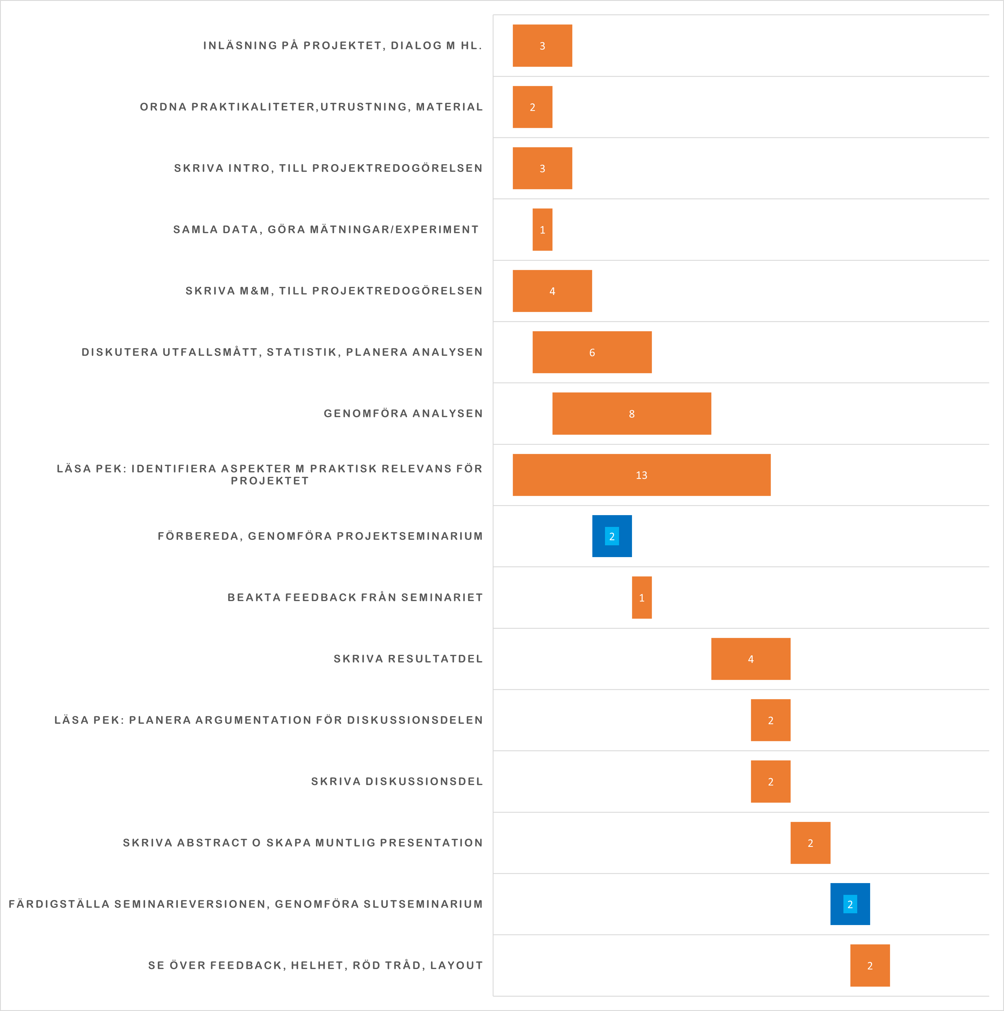

# References

========

1. Candefjord S, Asker L, Caragounis EC. Mortality of trauma patients treated at trauma centers compared to non-trauma centers in sweden: A retrospective study. European Journal of Trauma and Emergency Surgery [Internet]. 2020 Jul;48(1):525–36. Available from: <https://doi.org/10.1007/s00068-020-01446-6>

2. Evans C, Howes D, Pickett W, Dagnone L. Audit filters for improving processes of care and clinical outcomes in trauma systems. Cochrane Database of Systematic Reviews [Internet]. 2009 Oct; Available from: <https://doi.org/10.1002/14651858.cd007590.pub2>

3. WHO. Injuries and violence [Internet]. 2021 [cited 2023 Jan 31]. Available from: <https://www.who.int/news-room/fact-sheets/detail/injuries-and-violence>

4. Bulto LN, Dessie Y, Geda B. Magnitude, causes and characteristics of trauma victims visiting emergency and surgical units of dilchora hospital, eastern ethiopia. Pan African Medical Journal [Internet]. 2018;30. Available from: <https://doi.org/10.11604/pamj.2018.30.177.10969>

5. Organization WH. Injuries and violence: The facts 2014 [Internet]. 2014 [cited 2023 Jan 31]. Available from: <https://www.who.int/news-room/fact-sheets/detail/injuries-and-violence>

6. Demetriades D, Martin M, Salim A, Rhee P, Brown C, Chan L. The effect of trauma center designation and trauma volume on outcome in specific severe injuries. Annals of Surgery [Internet]. 2005 Oct;242(4):512–9. Available from: <https://doi.org/10.1097/01.sla.0000184169.73614.09>

7. Teixeira PGR, Inaba K, Hadjizacharia P, Brown C, Salim A, Rhee P, et al. Preventable or potentially preventable mortality at a mature trauma center. Journal of Trauma: Injury, Infection &amp$\mathsemicolon$ Critical Care [Internet]. 2007 Dec;63(6):1338–47. Available from: <https://doi.org/10.1097/ta.0b013e31815078ae>

8. Martin MJ, Johnson A, Rott M, Kuchler A, Cole F, Ramzy A, et al. Choosing wisely: A prospective study of direct to operating room trauma resuscitation including real-time trauma surgeon after-action review. Journal of Trauma and Acute Care Surgery [Internet]. 2021 Aug;91(2S):S146–53. Available from: <https://doi.org/10.1097/ta.0000000000003176>

9. Cole E, Weaver A, Gall L, West A, Nevin D, Tallach R, et al. A decade of damage control resuscitation. Annals of Surgery [Internet]. 2019 Nov;273(6):1215–20. Available from: <https://doi.org/10.1097/sla.0000000000003657>

10. Moran CG, Lecky F, Bouamra O, Lawrence T, Edwards A, Woodford M, et al. Changing the system - major trauma patients and their outcomes in the NHS (england) 200817. EClinicalMedicine [Internet]. 2018 Aug;2-3:13–21. Available from: <https://doi.org/10.1016/j.eclinm.2018.07.001>

11. Ghorbani P, Strömmer L. Analysis of preventable deaths and errors in trauma care in a scandinavian trauma level-i centre. Acta Anaesthesiologica Scandinavica [Internet]. 2018 May;62(8):1146–53. Available from: <https://doi.org/10.1111/aas.13151>

12. Blackmore AR, Leonard J, Madayag R, Bourg PW. Using the trauma quality improvement program metrics data to enhance clinical practice. Journal of Trauma Nursing [Internet]. 2019 May;26(3):121–7. Available from: <https://doi.org/10.1097/jtn.0000000000000436>

13. Organization WH. Guidelines for trauma quality improvement programmes [Internet]. 2009 [cited 2023 Jan 31]. Available from: <https://apps.who.int/iris/handle/10665/44061>

14. Vioque SM, Kim PK, McMaster J, Gallagher J, Allen SR, Holena DN, et al. Classifying errors in preventable and potentially preventable trauma deaths: A 9-year review using the joint commissions standardized methodology. The American Journal of Surgery [Internet]. 2014 Aug;208(2):187–94. Available from: <https://doi.org/10.1016/j.amjsurg.2014.02.006>

15. Sanddal TL, Esposito TJ, Whitney JR, Hartford D, Taillac PP, Mann NC, et al. Analysis of preventable trauma deaths and opportunities for trauma care improvement in utah. Journal of Trauma: Injury, Infection &amp$\mathsemicolon$ Critical Care [Internet]. 2011 Apr;70(4):970–7. Available from: <https://doi.org/10.1097/ta.0b013e3181fec9ba>

16. Roy N, Veetil DK, Khajanchi MU, Kumar V, Solomon H, Kamble J, et al. Learning from 2523 trauma deaths in india- opportunities to prevent in-hospital deaths. BMC Health Services Research [Internet]. 2017 Feb;17(1). Available from: <https://doi.org/10.1186/s12913-017-2085-7>

17. O’Reilly D, Mahendran K, West A, Shirley P, Walsh M, Tai N. British Journal of Surgery [Internet]. 2013 Mar;100(6):749–55. Available from: <http://dx.doi.org/10.1002/bjs.9096>

18. Santana MJ, Straus S, Gruen R, Stelfox HT. A qualitative study to identify opportunities for improving trauma quality improvement. Journal of Critical Care [Internet]. 2012 Dec;27(6):738.e1–7. Available from: <https://doi.org/10.1016/j.jcrc.2012.07.010>

19. Berbiglia L, Lopez PP, Bair L, Ammon A, Navas G, Keller M, et al. Patterns of early mortality after trauma in a neighborhood urban trauma center: Can we improve outcomes? Am Surg. 2013 Aug;79(8):764–7.

20. Dick WF, Baskett PJF. Recommendations for uniform reporting of data following major trauma the utstein style. Resuscitation [Internet]. 1999 Oct;42(2):81–100. Available from: <https://doi.org/10.1016/s0300-9572(99)00102-1>

21. Karolinska University Hospital. Karolinska university hospital becomes sweden’s first trauma centre [Internet]. 2020 [cited 2022 Sep 9]. Available from: <https://www.karolinska.se/en/karolinska-university-hospital/news/2020/12/karolinska-university-hospital-becomes-swedens-first-trauma-centre>

22. Swetrau, manual SweTrau 2021 [internet]. Stockholm: Svenska traumaregister [Internet]. [cited 2022]. Available from: <https://rcsyd.se/swetrau/wp-content/uploads/sites/10/2022/06/SweTrau-Manual-2021.pdf>