ESCUELA SUPERIOR POLITECNICA DEL LITORAL
Faculty of Electrical and Computer Engineering
Software Engineering II

ACCEPTANCE TEST WORKSHOP
I Term 2026
Inventory Manager
Repository: https://github.com/Jonthz/T6-AcepptanceTesting

Member | Name | Project Role
Member 1 | Jorge Bravo Vidal | Technical Lead / Developer
Member 2 | Jonathan Paul Zambrano Arriaga | BDD Developer
Member 3 | Giovanni Sambonino | BDD Developer
Member 4 | Darwin Pacheco | QA Specialist
Member 5 | Ricardo Asanza | BDD Developer
Member 6 | Luis Abrahan Cedeno Arteaga | Release Manager

Submission Report
July 7, 2026

Introduction
This report documents the development and validation of an Inventory Manager project through acceptance testing. Acceptance testing verifies whether a system satisfies user needs, business requirements, and acceptance criteria before delivery.
The workshop follows the Behavior Driven Development (BDD) approach. BDD expresses system behavior through scenarios that can be understood by both technical and non-technical stakeholders. These scenarios are written with Gherkin syntax, using steps such as Given, When, and Then.
The assignment introduces Cucumber as the framework for writing Gherkin-based acceptance tests. In this Python project, the team used Behave, a Python BDD framework that supports Gherkin feature files and step definitions. The tested system is a command-line Inventory Manager that allows users to add, list, update, remove, and search products.

Objectives
- Validate the correct behavior of the Inventory Manager through acceptance tests.
- Define system behavior using Gherkin scenarios.
- Automate the scenarios with Behave step definitions in Python.
- Execute the acceptance test suite and document the results.
- Review errors, apply corrections, and run the tests again.
- Provide evidence of team participation and rubric compliance.

Project Scope
The Inventory Manager is a Python command-line application. Each product is represented with at least four attributes:
Attribute | Description
name | Product name or identifier
quantity | Units available in stock
price | Unit price
category | Product category

The project implements the four suggested functionalities from the assignment and one additional feature defined by the team:
Feature | Functionality | Type | Status
Feature 1 | Add a product to the inventory | Suggested | Implemented and validated
Feature 2 | List all products in the inventory | Suggested | Implemented and validated
Feature 3 | Update the quantity of a product | Suggested | Implemented and validated
Feature 4 | Remove a product from the inventory | Suggested | Implemented and validated
Feature 5 | Search a product by name | Additional | Implemented and validated

Repository Structure
T6-AcepptanceTesting/
|-- README.md
|-- inventory.py
|-- requirements.txt
|-- features/
| |-- inventory.feature
| `-- steps/
| `-- inventory_steps.py
`-- docs/
|-- evidencia_behave.txt
|-- reporte_practica.md
`-- reporte_practica.docx

Team Work Distribution
Member | Name | Role | Responsibility | Evidence in the Project
Member 1 | Jorge Bravo Vidal | Technical Lead / Developer | Base setup, initial structure, and add product feature | inventory.py, add product scenario
Member 2 | Jonathan Paul Zambrano Arriaga | BDD Developer | List products feature | Listing scenario and listing steps
Member 3 | Giovanni Sambonino | BDD Developer | Update quantity feature | Update quantity scenario and assertions
Member 4 | Darwin Pacheco | QA Specialist | Remove product feature and failed interaction | Successful and failed remove scenarios
Member 5 | Ricardo Asanza | BDD Developer | Additional search feature | Search scenarios and filtering logic
Member 6 | Luis Abrahan Cedeno Arteaga | Release Manager | Integration, test execution, corrections, and report | docs/evidencia_behave.txt, final report, PR branch lacedeno

Part 1: Project Setup
The assignment requires preparing the repository, virtual environment, dependencies, and initial application execution. The following activities were completed:
- The GitHub repository was created and updated.
- A local virtual environment was prepared.
- Project dependencies were installed from requirements.txt.
- Behave was installed and verified.
- The main application file, inventory.py, was reviewed.
- The project structure was aligned with Behave conventions.
Environment setup commands:
python3 -m venv .venv
source .venv/bin/activate
pip install -r requirements.txt

Application execution command:
python inventory.py

Project Setup Evidence
Assignment Requirement | Evidence
Repository created | Repository link included in the cover and README
Virtual environment prepared | Local .venv used to install and run Behave
Behave installed | requirements.txt includes behave==1.3.3
Main file created | inventory.py
Behave structure created | features/inventory.feature and features/steps/inventory_steps.py

Part 1: Code Creation and Requirements Compliance
The inventory.py file implements the main logic of the Inventory Manager. The domain functions are:
Function | Purpose
add_product | Adds products with name, quantity, price, and category
find_product | Searches products by name, case-insensitively
list_products | Displays existing products
update_quantity | Updates the quantity of an existing product
remove_product | Removes a product or returns an error message
search_products | Searches products by keyword

The additional feature selected by the team was search product by name. This feature validates both successful searches and searches with no matches.

Part 2: Feature File Creation
The file features/inventory.feature documents the acceptance scenarios in Gherkin. The assignment requires 5 features and at least 5 scenarios. The project contains 5 functionalities and 7 scenarios, which exceeds the minimum requirement.
Scenario | Covered Feature | Type
Add a product to the inventory | Add product | Successful flow
List all products in the inventory | List products | Successful flow with data table
Update the quantity of a product | Update quantity | Successful flow
Remove a product from the inventory | Remove product | Successful flow
Remove a product that does not exist | Remove product | Failed interaction
Filter products containing a specific word | Search product | Successful flow
Search for a product that does not exist | Search product | Failed interaction

Example scenario with a data table:
Scenario: Update the quantity of a product
Given the inventory contains products:
| Product | Quantity |
| Coffee | 10 |
When the user updates product "Coffee" to quantity "25"
Then the inventory should show product "Coffee" with quantity "25"

Part 2: Acceptance Test Creation
The Behave steps are implemented in features/steps/inventory_steps.py. These steps connect the Gherkin scenarios with the Python logic in inventory.py.
The project uses context to share data within each scenario. This avoids global variables and keeps each test isolated. The project also uses context.table to read data tables from Gherkin scenarios, especially for listing, updating, and searching products.
Example of data table handling:
@given('the inventory contains products:')
def step_impl(context):
context.inventory = []
for row in context.table:
quantity = row.get("Quantity", 0)
price = row.get("Price", 0.0)
category = row.get("Category", "General")
ok, message = add_product(
context.inventory,
row["Product"],
quantity,
price,
category,
)
assert ok, message

Example of a failed interaction scenario:
Scenario: Remove a product that does not exist
Given the inventory is empty
When the user removes the product "Coffee"
Then the output should be "Product Coffee was not found"

Part 2: Test Run Evidence
Command executed:
behave

Result:
1 feature passed, 0 failed, 0 skipped
7 scenarios passed, 0 failed, 0 skipped
23 steps passed, 0 failed, 0 skipped

The complete test run evidence is stored in:
docs/evidencia_behave.txt

Additional Windows Test Evidence
The team also executed the acceptance tests in a Windows environment after installing Behave in a virtual environment. The requested command sequence was pip install behave followed by behave.
Captured result: 1 feature passed, 5 scenarios passed, and 15 steps passed with 0 failures. This is included as complementary team evidence; the final current branch execution remains documented in docs/evidencia_behave.txt with 7 scenarios and 23 steps passing.
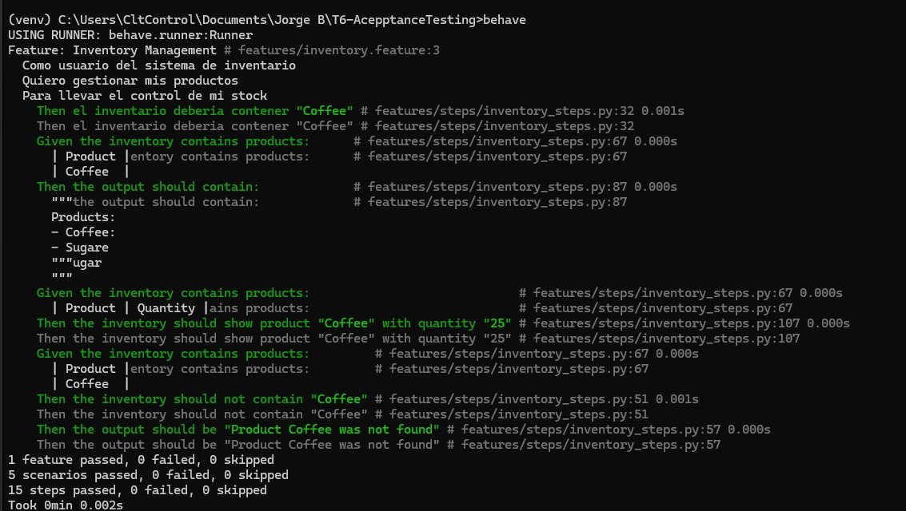
Figure: Windows Behave execution evidence.

Part 3: Iterative Process and Corrections
The assignment requires reviewing previous results, correcting any errors found, and running the tests again. During integration, the project files were reviewed and the following issues were addressed:
Finding | Correction Applied | Evidence
The Feature 4 step block appeared out of order and later became duplicated after main was updated | A single Feature 4 block was kept and the steps were ordered as Feature 1, 2, 3, 4, and 5 | features/steps/inventory_steps.py
The step that loads products from data tables only used Product | Optional support for Quantity, Price, and Category was added | features/steps/inventory_steps.py
The console remove option did not print the message returned by the function | The remove_product message is now printed in the menu | inventory.py
Updated evidence was required after corrections | behave was run again and docs/evidencia_behave.txt was updated | docs/evidencia_behave.txt

After these corrections, the complete test suite was executed again and passed without errors.

Rubric Compliance Matrix
Rubric Criterion | Weight | How It Is Covered | Evidence
Part 1 - Tool configuration, evidence | 10 | Virtual environment, dependencies, and Behave configured | requirements.txt, README instructions, test evidence
Part 1 - Code creation, evidence, quality, requirements | 20 | Inventory Manager implemented with 5 functionalities and products with 4 attributes | inventory.py, README, project scope section
Part 2 - Feature file creation | 10 | Gherkin feature file created with acceptance scenarios | features/inventory.feature
Part 2 - Acceptance tests creation | 30 | Automated steps with context, context.table, and assertions | features/steps/inventory_steps.py
Part 2 - Test run evidence | 10 | Behave execution documented | docs/evidencia_behave.txt
Part 3 - Tests/code correction evidence | 20 | Corrections documented and tests executed again | Iterative Process and Corrections section
Required report sections | Requirement | Cover, introduction, development, conclusions, recommendations, and references included | This document
Repository link | Critical requirement | Link included in the cover and README | https://github.com/Jonthz/T6-AcepptanceTesting

Individual Participation Evidence
The rubric includes an individual penalty if evidence of participation is missing. To address this requirement, each member is linked to a verifiable project artifact:
Member | Name | Evidence for Review
Member 1 | Jorge Bravo Vidal | Add product feature and steps; base structure in inventory.py
Member 2 | Jonathan Paul Zambrano Arriaga | List products scenario and steps; Gherkin data table usage
Member 3 | Giovanni Sambonino | Update quantity scenario and steps; assertions for quantity validation
Member 4 | Darwin Pacheco | Successful and failed remove scenarios; error message validation
Member 5 | Ricardo Asanza | Additional search feature; successful and failed search scenarios
Member 6 | Luis Abrahan Cedeno Arteaga | Test execution, integration corrections, evidence file, and final report

It is also recommended to preserve screenshots or commit history from each member as additional evidence for submission.

Final Deliverables
Required Deliverable | Status
Repository link for the Inventory Manager project | Included
Project with 5 features and at least 5 scenarios | Completed: 5 functionalities and 7 scenarios
Use of Cucumber/Gherkin and test documentation | Completed through Gherkin and Behave for Python
Practice report with cover, introduction, development, conclusions, recommendations, and references | Included
Test run evidence | Included in docs/evidencia_behave.txt
Evidence of iterative corrections | Included in this report

Conclusions
The project meets the workshop objectives because it implements a functional Inventory Manager and validates it through automated acceptance tests. The BDD scenarios document the expected behavior of the system, and the Behave steps connect those scenarios with the real program logic.
The current suite exceeds the minimum requirement because it contains 7 automated scenarios for 5 functionalities. The final Behave execution confirms that every scenario passes successfully.
The iterative process helped identify and correct step organization issues, incomplete data table support, and console output details. After the corrections, the complete suite was executed again with successful results.

Recommendations
- Keep one feature file per functionality if the project grows.
- Standardize the language of the scenarios to avoid mixing English and Spanish.
- Add more negative tests for invalid quantities, empty names, and duplicated products.
- Preserve screenshots or commits per member to strengthen individual participation evidence.
- Run behave before each submission or pull request.
- Keep the report updated whenever code or tests are corrected.

References
- Software Testing Fundamentals, "Acceptance Testing": http://softwaretestingfundamentals.com/acceptance-testing/
- Gherkin Reference: https://cucumber.io/docs/gherkin/reference/
- Behave Documentation: https://behave.readthedocs.io/en/latest/tutorial/#feature-files
- Behave API Reference: https://behave.readthedocs.io/en/latest/api/
- ITDO, "What is BDD (Behavior Driven Development)": https://www.itdo.com/blog/que-es-bdd-behavior-driven-development/
- Project repository: https://github.com/Jonthz/T6-AcepptanceTesting

