**Project 2**

This algorithm works by finding the middle point a vector/array of Points sorted by their X values. Take P as the container and n as the size of P. P[n/2] as the middle point in the container. We divide the container in two halves with the left side being the points from P[0] to P[n/2] and the right side being P[n/2 + 1] to P[n-1]. We recursively find the smallest distances between the Points in the left and right sides and set dl and dr up as variables to hold the two distances. We then find d as the smallest value between dl and dr. Next we have to build another vector/array of the Points with a smaller distance to the midpoint that the current d value that we have. Calling this container strip, we merge sort it based on the y values of the Points. We find the smallest distance within the strip itself and then finally return the smallest value between d and the smallest distance within the strip. This will be the smallest distance between the points. Return the points with each step.

**Analysis of Strip function**

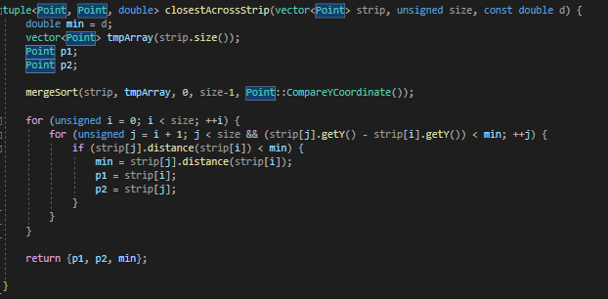 Avoid the worst case by merge sorting the strip based on the y values of each of the points. In order to check the minimum number of points possible we take the difference between the point i’s y value and point j’s y value and check to see if it’s within the box around the strip. If it is, we can continue, else we stop. This means that for any point Pi at most 7 points Pj are considered. Next we compare the distance between the Point Pi and Pj to see if the distance is smaller than the current smallest distance and if it is, we take that value and the points associated to it and assign them to local variables. At the end we return the 2 points and the smallest possible distance. The time to compute the minimum that’s better than the initial minimum distance is O(N) and because T(N) = 2T(N/2) + O(N) which is equal to T(N) = O(NlogN). Performing this recursively requires O(N log N) giving O(N log2N) which can then be reduced to O(N) ensuring O(N log N).