**(When I say average, mean is used)**

1. **Using default hash functions, what worked best for unsigned keys: Linear, Quadratic, or Chaining? Support answer.**
   1. For unsigned keys, chaining works best because the average experimental unsuccessful probes for chaining is so much lower than the experimental unsuccessful probes for linear and quadratic while the average experimental successful probing for chaining also is within .5 of linear and quadratic

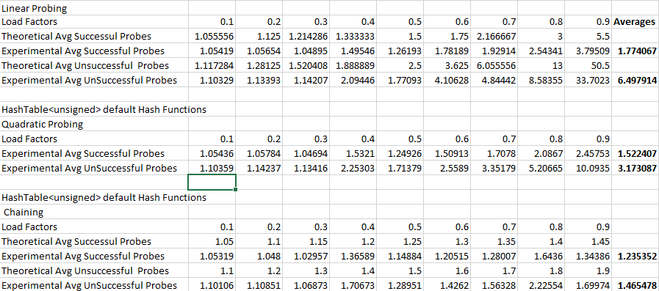

1. **Using default hash functions, what worked best for string keys: Linear, Quadratic, or Chaining? Support answer.**
   1. Similar to unsigned keys, the chaining also worked best for string keys. The average unsuccessful probing for chaining was again much lower than the averages for both linear and quadratic while the average successful probing was still within .8 of both linear and quadratic probing averages

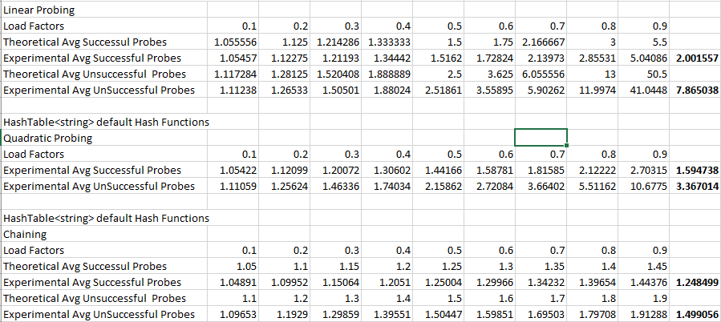

1. **Using my hash functions, what worked best for unsigned keys: Linear, Quadratic, or Chaining? Support answer.**
   1. Same as before, chaining has a much lower average unsuccessful probing than both linear and quadratic while also having a decently close successful probing to linear and quadratic. A case can be made to say that Linear has a much higher average successful probing but the problem is that it’s average unsuccessful probing is so much higher being 64 while chaining only has a 1.48 average unsuccessful.

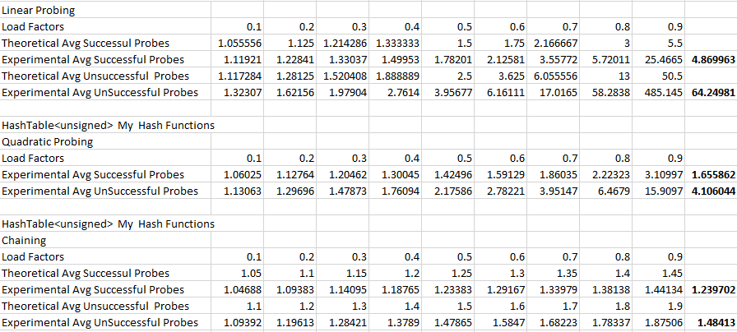

1. **Using my hash functions, what worked best for string keys: Linear, Quadratic, or Chaining? Support answer.**
   1. Again, the choice is with chaining because its average unsuccessful is so much lower than linear and quadratic while the average successful probing is relatively close to both linear and quadratic. Linears successful probing is more than .8 higher than chaining but it’s unsuccessful probing is also more than 8 higher than chaining’s unsuccessful

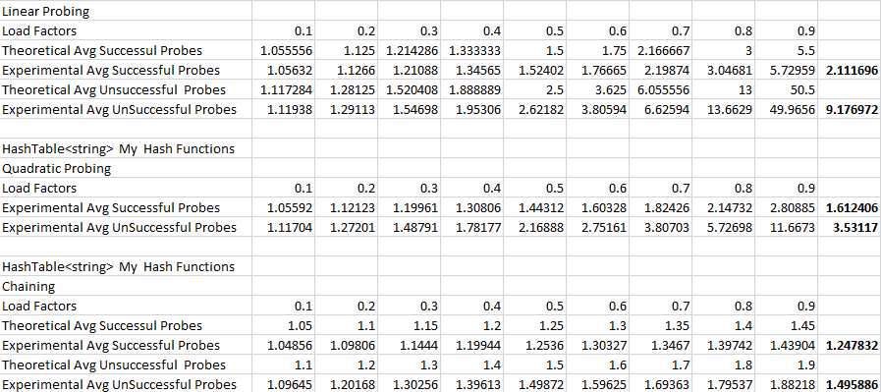

1. **Did you notice any tests taking longer than the other tests? Which ones? Why?**
   1. The analyses of all the chaining tests took longer than the other tests because we had to find a position within a list and then loop through the list of elements at that position while the others only have to go through one list of elements