* **Infoway Technology Institute pvt.limited, Pune**

# Project Name: Study-Point System (SPS)

# Project Members: Duration : 1 month

|  |  |
| --- | --- |
| **PRN No.** | **Name** |
| **220943120111** | **Vikram Rathod** |
| **220943120092** | **Saurabh Panbude** |
| **220943120108** | **Shriyog Vichare** |
| **220943120034** | **Govind Kulkarni** |

## Tables of Content:

**Introduction:**

* **Abstract:**
* **Objective and Scope:**
* **Modification and improvement:**
* **Project plan and models:**
* **Technology:**
* **Implementation of technologies:**
* **Hardware and software requirement:**
* **ER-Diagram**
* **DFD (data flow diagram)**
* **Table structures:**

**Introduction of Project:**

**Abstract:**

The main aim of the Study-Point System is to provide a one-stop-shop for Users to reserve seats online using a payment gateway. Currently, there is no such platform available that provides the live seat availability status of Study Points. In Study-Point System User can select any Study-Point and check Facilities, and reviews, and can connect with the study-point owner. Users can also explore other services like renting books, and laptops, and also can avail of Canteen facilities. The Study-Point System is User-friendly, secure, and scalable. This system will be hosted on the Cloud and will be accessible from anywhere at any time.

**Objective and Scope of Project:**

The main purpose of this study is design about Study-Point Management System is manage the details of Address, Student, Books, Electronic-gadgets and etc. It manage all the information about library address, student data and librarian data. The project is totally build at Admin end and thus only admin can manage all the data of library. The Study-Point System is a web-based application for assisting a librarian in managing a seat availability and books issue. The system would provide basic set of features to add/update members, add/update books, and manage the student information.

**Modification and improvement over the existing Implementation:**

After implementation of project:-

Student can reserved their seat as per availability via online tracking system to grab the seat as per requirement and also To manage the librarian members information and book information, borrowers and the history of transactions .To automatically record transactions in the data base.To easily make the inventory reports Inventory of Books Transactions Borrowed book and returned. There is a certain procedure that has to be followed by the students and librarian while returning the book. Within the due date, the student is required to return the book. Otherwise, the student has to pay certain amounts as a fine. The book borrowed by the student is being handed over to the librarian and now it is the duty of the librarian to issue the library card to the respective student by declaring that the student is no longer holding that book with him/her.

**Project Plan:**

There are two main architecture in this application:

1. **Users-** Student can search libraries on electronic gadgets as per availability. who can join library as per student destination.
2. **Admin :** To maintain and update the records and also to cater the needs of the users
3. **Modules -**Models for Study-Point System:

* Student data management.
* Seat management.
* Book management.
* Provides facilities and resources.
* Membership management.
* Online access.
* Payment gateway.

**Technology:**

**Frontend**- React.js and Bootstrap5, HTML5, JavaScript and CSS3

**Backend**- Java, J2EE, Springboot and JPA.

**Database**-MySQL

**Implementation Technologies:-**

**1. Spring Framework:**

Spring Framework is a Java platform that provides comprehensive infrastructure support for developing Java applications. Spring handles the infrastructure so you can focus on your application.

Spring enables you to build applications from “plain old Java objects” (POJOs) and to apply enterprise services non-invasively to POJOs. This capability applies to the Java SE programming model and to full and partial Java EE.

**1 Features of Spring Framework:**

**1. Lightweight:-** Spring is modular lightweight framework which allows you to selectively use any of its moduleson the top of Spring Core.

**2. Inversion of Control (IOC):**

This is another top feature of Spring-framework where application dependencies are satisfied by the framework itself. Framework creates the object in runtime and satisfies application dependencies.

3**. Aspect Oriented Programming (AOP)**

Aspect Oriented Programming (AOP) is very popular in programming world and in Spring it is well implemented. Developer can use Aspect Oriented Programming (AOP feature of spring to develop application in which business logic is separated from system services.

**4. Container:**

Spring provides their own container for managing the bean life cycle.

**5. MVC Framework**

Spring MVC Framework is used for developing MVC based web applications.

**6. Transaction Management:**

Spring framework provides generic Transaction Management layer which can be used with or without J2EE (JEE) environment.

**7. JDBC Exception Handling**

Spring provides their own abstraction of JDBC exception which further simplifies the exception handling in program.

**2.Advantages of Spring Framework:**

**1.Solving difficulties of Enterprise application development:**

Spring is solving the difficulties of development of complex applications, it provides Spring Core, Spring IOC and Spring AOP for integrating various components of business applications.

2. Support Enterprise application development through POJOs Spring supports development of Enterprise application development using the POJO classes which removes the need of importing heavy Enterprise container during development. This makes application testing much easier.

3. Easy integration other frameworks Spring designed to be used with all other frameworks of Java, you can use ORM, Struts, Hibernate and other frameworks of Java together. Springframework do not impose any restriction on the frameworks to be used together.

**4. Application Testing Spring:**

Container can be used to develop and run test cases outside enterprise container which makes testing much easier.

**5. Modularity**

Spring framework is modular framework and it comes with many modules such as Spring MVC, Spring ORM, Spring JDBC, Spring Transactions etc. which can used as per application requirement in modular fashion.

**6. Spring Transaction Management:**

Spring Transaction Management interface is very flexible it can configure to use local transactions in small application which can be scaled to JTA for global transactions.

**2. The JDBC Template:**

The central class of the Spring JDBC abstraction framework is the **JdbcTemplate** class that includes the most common logic in using the JDBC API to access data, such as handling the creation of connection, statement creation, statement execution, and release of resource. The **Jdbc-Template**class can be found in the **org.springframework.jdbc.core**package.

The **JdbcTemplate** class instances are thread-safe once configured. A single **JdbcTemplate** can be configured and injected into multiple DAOs.

We can use the **JdbcTemplate** to execute the different types of SQL statements. **Data Manipulation Language** (**DML**) is used for inserting, retrieving, updating, and deleting the data in the database such as **SELECT**, **INSERT**, or **UPDATE** statements.

**3.** **MySQL:**

MySQL, the most popular Open Source SQL database management system, is developed, distributed, and supported by Oracle Corporation.

**Features of MySQL:**

* **MySQL is a database management system.**

A database is a structured collection of data. It may be anything from a simple shopping list to a picture gallery or the vast amounts of information in a corporate network. To add, access, and process data stored in a computer database, you need a database management system such as MySQL Server. Since computers are very good at handling large amounts of data, database management systems play a central role in computing, as standalone utilities, or as parts of other applications.

* **MySQL databases are relational.**

A relational database stores data in separate tables rather than putting all the data in one big storeroom. The database structures are organized into physical files optimized for speed. The logical model, with objects such as databases, tables, views, rows, and columns, offers a flexible programming environment.

* **MySQL software is Open Source.**

Open Source means that it is possible for anyone to use and modify the software. Anybody can download the MySQL software from the Internet and use it without paying anything.

* **The MySQL Database Server is very fast, reliable, scalable, and easy to use.**

MySQL Server was originally developed to handle large databases much faster than existing solutions and has been successfully used in highly demanding production environments for several years. Although under constant development, MySQL Server today offers a rich and useful set of functions. Its connectivity, speed, and security make MySQL Server highly suited for accessing databases on the Internet.

* **MySQL Server works in client/server or embedded systems.**

The MySQL Database Software is a client/server system that consists of a multithreaded SQL server that supports different back ends, several different client programs and libraries, administrative tools, and a wide range of application programming interfaces (APIs).

**4. Hardware and Software requirement:**

**Hardware:**

1. Intel i3 processor 3rd generation or later / AMD Ryzen 200 2nd generation or later

2. 4 GB ddr3 ram.

3. Windows 7 Home edition or later.

4. 200 GB Sata HDD Space

5. Data Connection 200 kbps

**Software:**

1. Eclipse 4.7 Oxygen
2. MySQL 5.8 with Workbench 8.0
3. Google Chrome version 79.0
4. Apache Tomcat Server 8.5
5. Maven Dependencies

**Roles and Responsibilities:**

|  |  |  |
| --- | --- | --- |
| **Roles And Responsibilities** | | |
| 1 | Role | Backend |
| Member Name | **Vikram Rathod** |
| PRN No | 220943120111 |
| Description |  |
| 2 | Role | Frontend + Database |
| Member Name | **Saurabh Panbude** |
| PRN No | 220943120092 |
| Description |  |
| 3 | Role | Database |
| Member Name | **Shriyog Vichare** |
| PRN No | 220943120108 |
| Description |  |
| 4 | Role | Backend |
| Member Name | **Govind Kulkarni** |
| PRN No | 220943120034 |
| Description |  |

**Data Flow Diagram (DFD):**

Level 0:

Level1:

Level2:

**ERD / Database Tables:**

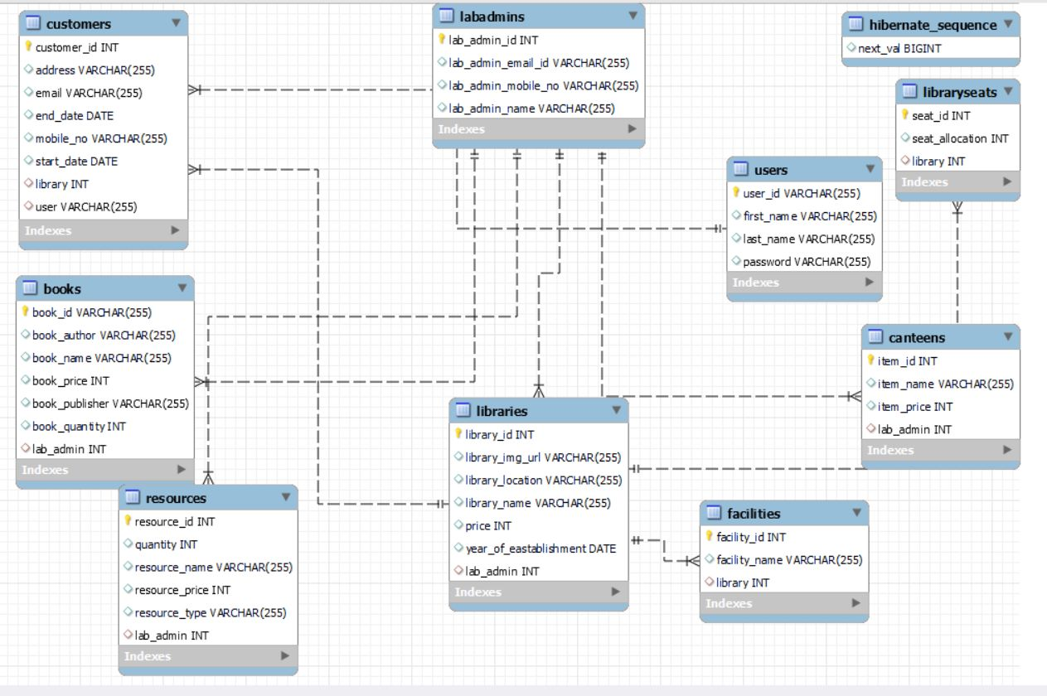

**Future Scope:**

* Our mission is to provide a user-friendly platform for Study-Point management that simplifies the process of organizing, searching for reserved seat, borrowing books, use Electronic Gadgets provided by librarian. We believe that everyone should have access to books and knowledge, regardless of their background or circumstances.
* In Future scope we can provide more facilites like giving to the premium members can get the discounts pack of study material example like social platform accounts.

Ex: Unacdamey, Byjus’s and so many platforms.