**Centry LLC Agenda**

Board Meeting 01

March 19, 2021

**HOST:** Mariana Perez

**ATTENDEES:** Thao My Nguyen, Jonathan Richards

**Time (PDT)** **Topic** **Presenter**

4:00 - 4:05 Welcome CEO

4:05 - 4:10 Opening statements CEO

4:10 - 4:11 Approval of Agenda CEO

4:11 - 4:21 Presentation         CEO/CTO/CFO

4:21 - 4:28 Round Table Discussion ALL

4:28 - 4:30 Adjournment CEO

**Pre-Read**

**BACKGROUND**

Platelet-rich plasma therapy is an effective and simple method of treatment for a wide variety of medical issues. The initial concept of PRP injections arose in the 1970s, for blood transfusions. After 2009, nearly a dozen clinical research trials took place within just a few years of each other and showed promising results for PRP therapy. As there is an advancement in our understanding of the human immune system, the use of PRP therapy has widely expanded.

PRP injections have now been shown valuable in not only medical treatments but also cosmetic procedures allowing them to gain popularity with the public. In 2017 there was a "Vampire Facial" trend that exploded on social media due to a celebrity that promoted the treatment. The injections are now used for a variety of procedures such as previously mentioned facials and to treat hair loss and now possibly to help individuals regain a sense of smell.

PRP is produced from the patients' blood, therefore, reducing the risk of infection. It is composed of a higher concentration of platelets which circulate through the blood and are critical for blood clotting. The platelets are separated from other blood cells and their concentration is increased during centrifugation. Platelets are on the front line of the immune response and play a significant role by delivering growth factors that can influence tissue repair in a variety of different cell types.

**PROBLEM AND SOLUTION**

The rise in demand is beneficial for providers who offer the therapy but there are barriers that various providers and patients experience due to insurances not willing to cover most PRP treatments. The high out-of-pocket cost for a PRP treatment has discouraged many potential patients from undergoing the treatment even when it is for a medical problem. Individuals with lower income may not even consider PRP treatment despite the benefits and low risk. That is what lead the team to create Centry LLC. Our goal is to provide PRP injection kits with increased effectiveness but at a lower cost to allow a diverse range of patients to gain access to the treatment.

PRP therapy requires follow-up appointments to reinject the treated area every three to six months depending on area size and quantity of injections. Centry will offer PRP injection kits with activator serum which will increase the effectiveness of growth factors found in the plasma. Centry will also offer the compatible centrifuge specialized to prepare PRP injections. The improved effectiveness of the PRP injection not only will reduce the quantity of blood that needs to be drawn but also will decrease the number of sessions the patient needs to show up for which will reduce the cost for the patient.

Platelet- Rich Plasma (PRP) Therapy treatment is an effective and safe treatment for a range of medical issues. The primary problem is the high cost per session of the treatment. The cost alone limits availability to a segment of the population that can afford to seek this effective treatment. The high out-of-pocket cost for a PRP treatment has discouraged many potential patients from undergoing the treatment even when it is for a medical issue.

Centry is proposing PRP injection kits with increased effectiveness but at a lower cost to allow a diverse range of patients to gain access to the treatment. Centry will offer an activator serum with the PRP injection kit which will increase the impact of the individuals own growth factors from the plasma.

**TEAM**

Centry is comprised of three individuals with a passion for helping people regain their confidence. The team believes that everyone should have fair access to treatments which is why the main focus is on reducing the cost of each treatment. The team's CEO is Mariana Perez ,she is prepared to contribute knowledge from her biological background and previous roles in operations management to the role of CEO for Centry LLC. The team's CFO is Thao, she is a current student in the Masters in Bioinformatics program. She hopes through her biological knowledge and learning experiences aspect can contribute to Centry, LLC. The team's CTO is Jonathan Richards, he is a graduate student as well, Masters in Bioinformatics. He has a background in statistics and data analysis and uses those skills to help analyze the effectiveness of Centry's PRP technology. He hopes his prior experience in customer service and as a QA will serve both the team and the public appropriately.

**CORPORATE STRUCTURE**

Centry is an LLC because it has a business structure that can combine the pass-through taxation of a partnership or sole proprietorship with the limited liability of a corporation.

**PRODUCT DETAIL**

Our product would include the materials necessary for the best PRP experience. We will offer a PRP injection kit which we are calling CKit and the compatible centrifuge models called Centryfuge. By providing the kit and centrifuge we have full control over tube design in order to maximize platelet retention. The kit is what we expect will set us apart from other PRP kit companies such as Anthrex Angel or Eclipse PRP. Centry will provide a unique activator serum which will promote faster growth factor activation and an anticoagulant which will allow recovery of 80% of a patient’s platelets.

For PRP therapy to be effective the higher the platelet concentration in the injection the greater the impact.

The centrifuge we will offer will also be intended for PRP production versus other centrifuges in the market which do not function specifically for PRP. This is due to the design which is focused to fit the vacutainers manufactured by Becton Dickinson (BD). Unfortunately, vacutainers are not FDA cleared as class II medical devices for creating PRP. In reality, vacutainers are class I medical devices intended for testing purposes only. Which are illegal to use for PRP preparation. The Centryfuge is designed to fit class II medical devices that are FDA cleared for PRP preparation.

**CUSTOMER DISCOVERY PLAN**

To develop Centry, feedback from potential customers is crucial in order to address concerns early on. By administering a series of diverse surveys, we can adjust to the ideal business model for Centry. Our customer discovery plan will take into account the provider as well as the patient. The surveys will be modified for the person that we interview but we intend to reduce the cost for the provider to overcome hesitancy and to find what the best price point is for the customer.

One issue we run into when narrowing the patient population for a survey sample is that the range of uses for PRP is vast. Centry plans to keep in mind the various uses of PRP but we also believe it is important to focus on a specific use to gain a deeper understanding of the expectations for those providers and patients. The use Centry will primarily focus on is for hair loss. Since the customer base for such treatments is promising and diverse. Centry plans to partner with dermatologists and individuals experiencing hair loss to provide the most reliable and effective PRP kit.

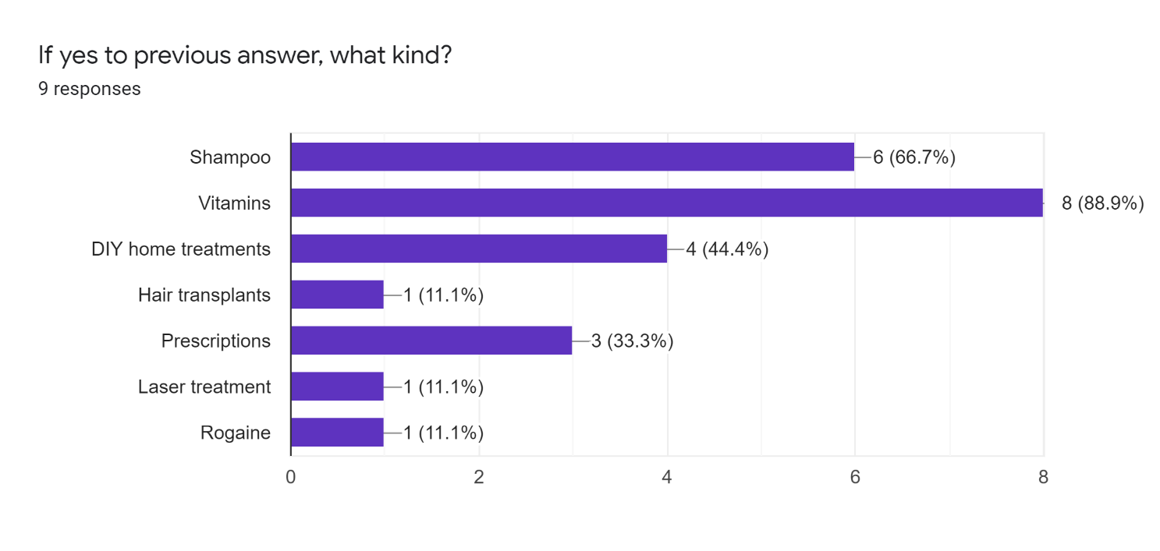

More customers seek treatment like shampoo, vitamins, home treatments, and prescriptions than hair transplants, laser treatment and Rogaine. This chart will give us an idea of our current and future competitors.

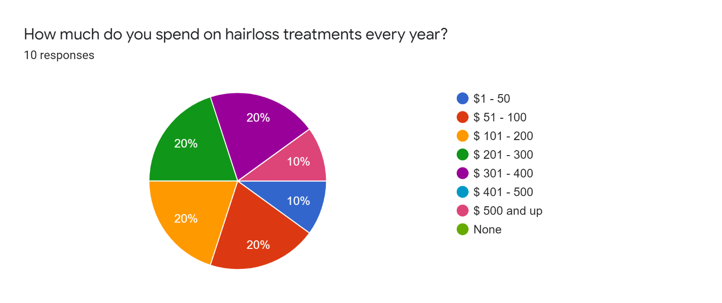

Generally, more customers willing to spend $51-$400 on hair loss treatment per year. We will use this price range into our cost factor for a reasonable price.

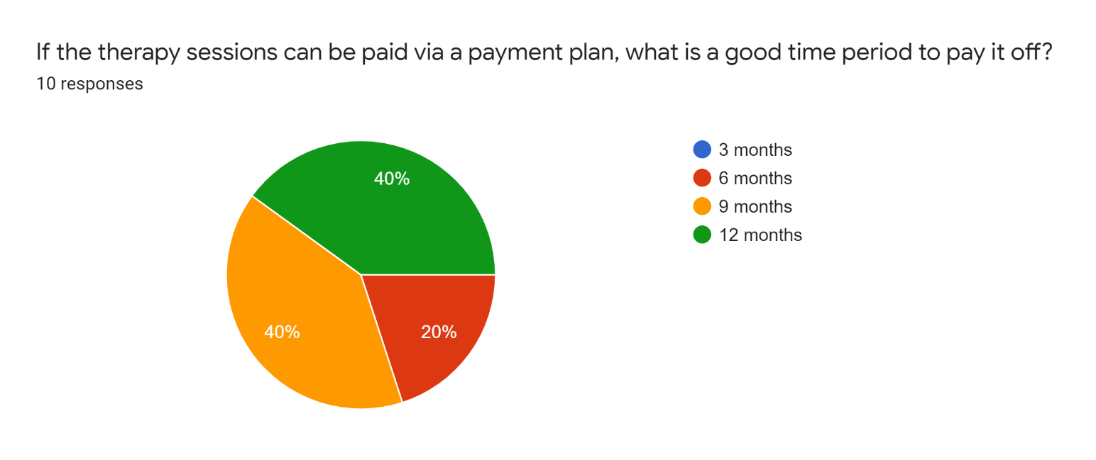

Based on the pie chart, there are more customers willing to have a payment plan for 9 months or 12 months instead of 3 or 6 months for the therapy session.

**(TAM/SAM/SOM)**

Total Available Market (TAM) refers to the combined revenues (or unit sales) of all the companies in a specific market on an annualized basis. In the case of Centry, the market the team must analyze and take into account is the healthcare and life sciences industry. The global platelet rich plasma market size was estimated at USD 414.8 million in 2019 and is expected to expand at a compound annual growth rate (CAGR) of 12.1% from 2020 to 2027. Pure platelet rich plasma dominated the market and accounted for the largest revenue share of 53.0% in 2019.

Served Available Market (SAM) refers to the share of Total Available Market that the companies providing a specific solution can fulfill. Centry’s CKit and Centryfuge can replace centrifuges not designed for PRP and the Ckit can be offered as a lower cost alternative when compared to other PRP kits. Currently PRP kits are sold to a variety of healthcare providers given that it is a treatment tool for a wide range of medical issues.

Share of Market (SOM) refers to what a particular company is planning to achieve over the next five years in terms of sales. Centry’s goal is to provide am updated cheaper alternative in order to drive out competition offering more expensive kits to healthcare providers. In five years Centry is striving for 25% of the market share of PRP kits.

**REVENUE MODEL/BUSINESS MODEL**

Our target customers are both men and women of all ages, especially customers who suffering hair loss due to alopecia areatea, stress, hormone imbalance and other diseases. Our plasma-rich platelet will help the patient regain their confidence back both personally and professionally with high quality of luxurious hair and astounding results after just 3 months by using the patient’s own plasma at the affordable price when compared to other PRP injection kits.

Centry will sell PRP kits and centrifuge machines to hospitals and clinics, our initial focus will be for cosmetic use therefore will require a partnership with dermatologists. Centry’s business plan will focus on perfecting the PRP kit since it will become the most profitable item. Patients who initiate PRP therapy have to return every year in order to continue to see the benefits of the therapy. Depending on the issue. The centrifuge we will offer will only be a one-time purchase until we decide to upgrade our technology therefore the stream of revenue, we are expecting to be mostly comprised of the CKit.

**OBSTACLES**

There are a wide range of side effects (infection, scar tissue, possible negative reactions to anesthetics, etc.) associated with PRP treatment, making it a moderate risk to the general public. Also, the high costs, as well as insurance plans usually not covering PRP treatment, make it too expensive for many individuals. We would need to have our technology to be cleared as class II medical devices for PRP preparation. Having an in-house process where we are the ones injecting serum could be another potential hurdle to overcome, as well as serious competition from other PRP companies.

Since our initial Board meeting, there were various adjustment to Centry’s business plan due to obstacles faced. One obstacle that we found that would affect the company structure was creating our very own Centryfuge. The logistics of producing a centrifuge to meet standards and work with a unique test tube design was not feasible for a company at our stage. The level of expertise needed along with testing was out of our scope, therefore our company has redirected to offering the CKit it centrifuges purchased from Eppendorf. The goal of Centry is to allow more clinics the ability to offer PRP treatments at a lower cost therefore by focusing funds on increased effectiveness of the kit instead of centrifuge it allows us to lower the cost.

**PRODUCT/TECH DEVELOPMENT**

Centry’s product of plasma-rich platelet (PRP) kit would require components of a blood collection kit with necessary tools for blood extraction. The blood collection kit would include: syringes, needles, tourniquet, and butterfly needle. The CKit produced would go on market at a retail price of $100 including the anticoagulant and activator serum.

For technology development, Centry will work on developing and pursuing a patent for unique PRP tube design and compatible centrifuge. The CKit PRP tube would be made from biocompatible certified materials. The design would include a double cap to ensure protection from contamination during separation as well as providing a high concentration of platelet counts with a single spin.

Also, we provide the service of PRP process at our own facilities deliver directly to the customers, so they can get the series of treatments and consultation at our site on the same day without going to medical facilities providers which can be a long process due to the waitlist.

**TIMELINES/ MILESTONES**

Centry’s timeline is to begin focus on hair loss application in order to obtain a reliable reputation and validation from medical professionals. The goal is to expand into intensive predicaments, such as loss of smell, and chronic tendon injuries. There is a potential for PRP therapy in the sports medicine sector.

* **Product Development**
  + Begin to seek patent approval for Centrifuge and PRP tube design **(2021)**
  + Search for manufactures to produce our product. **(2021)**
  + Test our final prototype before full production. **(2022)**
  + Preform quality tests once products are created. **(2022)**
  + Conduct customer discovery to find out the crucial components and the best serums to include in the CKit. (**2021)**
  + Continue to perform routine customer discovery to plan expansion outside of cosmetic use. Conduct research to keep serums provided the best quality in the market dependent upon new scientific findings. **(2022-2025)**
  + Product Launch! **(2023)**

**Company Structure**

* + Establish headquarters and bring onboard professionals from different fields. **(2022)**
  + Negotiate contracts with manufactures in order to keep our production cost low. **(2022)**
  + Set up customer service team **(2022)**
  + Agreement with Eppendorf **(2022)**
  + Continue expansion onto sports medicine. **(2025)**
  + Seek partnerships with sports teams. **(2025)**
* **Financial**
  + Begin marketing campaign in order to raise awareness of product offered. Manage production and ensure quality. **(2022)**
  + Obtain 25% of market share on PRP kit market. **(2025)**
  + Seek funding from investors to create prototype **(2021)**

**BUDGET**

In order for Centry to make the idea into a real solution for patients the correct amount of funding is crucial to provide the best PRP kit and centrifuge to the market. Our investment goal is to receive funds at an estimate amount of 5 million to invest in production cost of centrifuges and PRP kits. The profile of the our prospective invested is as such: We want to target investors who active private equity investors in the healthcare and life science industry. Upon our research, we discovered that these firms specialize in growth-stage, buyout, and platform funding transactions. As a company, we are in the growth-stage category. The primary initial venue in which will be using the funds we obtain fro investors will go towards the manufacturing of compatible centrifuge technology for our PRP kits, and the production of the kits as class II medical devices

Moving on to our operational costs, components of the PRP kit will be a large portion of those expenses. This would include a blood collection kit with necessary tools for blood extraction. Some items for blood extraction will include syringes, needles, tourniquet, and butterfly needle. Since our centrifuge is compatible with our centrifuge tubes it allows us to have control over tube design most appropriate for PRP.  However, if we go the route of buying centrifuge baskets from a third-party vendor as part of our operational costs, the cost can either be $353 (the SCL 402) or $457 (the SCL 412) per centrifuge, depending on the centrifuge type we want to use from a specific vendor. Depending on which third party vendor, the cost per centrifuge basket will vary.

**REGULATORY PATH**

FDA's Center for Devices and Radiological Health (CDRH) is responsible for regulating firms who manufacture, repackage, relabel, and/or import medical devices sold in the United States. Medical devices are classified into Class I, II, and III. Regulatory control increases from Class I to Class III. The device classification regulation defines the regulatory requirements for a general device type. Most Class I devices are exempt from Premarket Notification 510(k); most Class II devices require Premarket Notification 510(k); and most Class III devices require Premarket Approval.The basic regulatory requirements that manufacturers of medical devices distributed in the U.S. must comply with are: Establishment registration, Medical Device Listing, Premarket Notification 510(k), unless exempt, or Premarket Approval (PMA), Investigational Device Exemption (IDE) for clinical studies Quality System (QS) regulation, Labeling requirements, and Medical Device Reporting (MDR)Quality System (QS) regulation, Labeling requirements, and Medical Device Reporting (MDR)Quality System (QS) regulation, Labeling requirements, and Medical Device Reporting (MDR).The annual registration user fee for medical devices in the fiscal year 2021 is $5,546 and the cost of obtaining a patent from the United States Patent and Trademark Office would be $8,800.

**FINANCIAL**

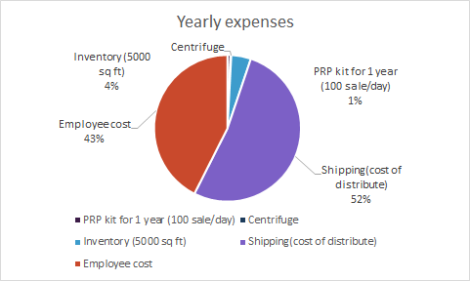

Yearly expenses with shipping cost of 52% and employee cost of 43% were the major and highest cost for the cost of structure.

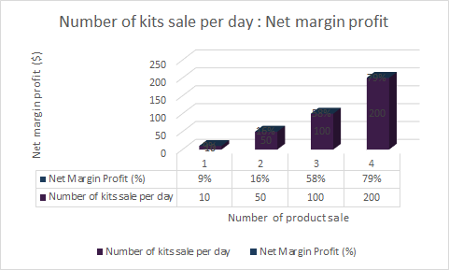

The net margin profit will break even with 50 sales of PRP (platelet-rich plasma) in a day over 1 year. The trend of profit will increase with increase number of PRP kits sale after 51 products to 100 products sale per day in a year. Our company goal is to sale 75 PRP kits per day, in which 27,375 kits per year.