姓名：李忠宁 | 专业：信息管理与信息系统 | 班级：20181171 | 学号：2018117107
科目： Android 开发 |  | 实验日期： 2021.6.11
实验题目： HelloWorld项目的开发
【实验目的】
编写一个HelloWorld项目

【实验内容】
项目整体代码结构
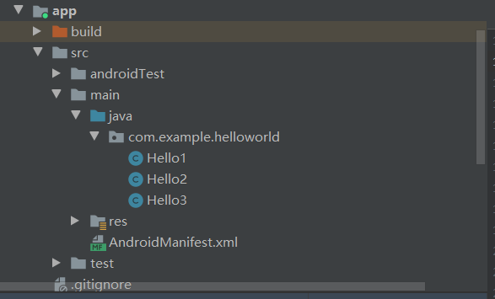

Hello1.java
package com.example.helloworld;

import android.content.Intent;
import android.os.Bundle;
import android.support.v7.app.AppCompatActivity;
import android.util.Log;
import android.view.View;
import android.widget.Button;

public class Hello1 extends AppCompatActivity implements View.OnClickListener {

private static final String TAG = "Hello1";
private static int objCount = 0;
private int mObjCount;

@Override
protected void onCreate(Bundle savedInstanceState) {
super.onCreate(savedInstanceState);
setContentView(R.layout.hello_world_layout);
objCount++;
mObjCount = objCount;
Log.d(TAG, mObjCount + "-onCreate execute");
setTitle("Hello1");
settupButtons();
}

@Override
protected void onStart() {
super.onStart();
Log.d(TAG, mObjCount + "-onStart");
}

@Override
protected void onResume() {
super.onResume();
Log.d(TAG, mObjCount + "-onResume");
}

@Override
protected void onPostResume() {
super.onPostResume();
Log.d(TAG, mObjCount + "-onPostResume");
}

@Override
protected void onPause() {
super.onPause();
Log.d(TAG, mObjCount + "-onPause");
}

@Override
protected void onStop() {
super.onStop();
Log.d(TAG, mObjCount + "-onStop");
}

@Override
protected void onDestroy() {
super.onDestroy();
objCount--;
Log.d(TAG, mObjCount + "-onDestroy");
}

@Override
public void onClick(View v) {
if (v.getId() == R.id.btToHello1) {
Intent intent;
intent = new Intent(this, Hello1.class);
startActivity(intent);
}
if (v.getId() == R.id.btToHello2) {
Intent intent;
intent = new Intent(this, Hello2.class);
startActivity(intent);
}
if (v.getId() == R.id.btToHello3) {
Intent intent;
String string1 = "com.example.helloworld.intent.action.H3";
// intent = new Intent(this, Hello3.class);
intent = new Intent(string1);
startActivity(intent);
// Intent intent1 = new Intent(Intent.ACTION_VIEW);
// intent1.setData(Uri.parse("http://www.hstc.edu.cn"));
// startActivity(intent1);
}
}

private void settupButtons() {
Button b;

b = (Button) findViewById(R.id.btToHello1);
b.setOnClickListener(this);
b = (Button) findViewById(R.id.btToHello2);
b.setOnClickListener(this);
b = (Button) findViewById(R.id.btToHello3);
b.setOnClickListener(this);

}
}

Hello2.java
package com.example.helloworld;

import android.content.Intent;
import android.os.Bundle;
import android.support.v7.app.AppCompatActivity;
import android.util.Log;
import android.view.View;
import android.widget.Button;

public class Hello2 extends AppCompatActivity implements View.OnClickListener {

private final static String TAG = "Hello2";

@Override
protected void onCreate(Bundle savedInstanceState) {
super.onCreate(savedInstanceState);
setContentView(R.layout.activity_hello2);
Log.d(TAG, "onCreate execute");
setTitle("Hello2");
settupButtons();
}

@Override
protected void onStart() {
super.onStart();
Log.d(TAG, "onStart");
}

@Override
protected void onResume() {
super.onResume();
Log.d(TAG, "onResume");
}

@Override
protected void onPostResume() {
super.onPostResume();
Log.d(TAG, "onPostResume");
}

@Override
protected void onPause() {
super.onPause();
Log.d(TAG, "onPause");
}

@Override
protected void onStop() {
super.onStop();
Log.d(TAG, "onStop");
}

@Override
protected void onDestroy() {
super.onDestroy();
Log.d(TAG, "onDestroy");
}

@Override
public void onClick(View v) {
if (v.getId() == R.id.btToHello1) {
Intent intent;
intent = new Intent(this, Hello1.class);
startActivity(intent);
}
if (v.getId() == R.id.btToHello2) {
Intent intent;
intent = new Intent(this, Hello2.class);
startActivity(intent);
}
if (v.getId() == R.id.btToHello3) {
Intent intent;
intent = new Intent(this, Hello3.class);
startActivity(intent);
}
}

private void settupButtons() {
Button b;

b = (Button) findViewById(R.id.btToHello1);
b.setOnClickListener(this);
b = (Button) findViewById(R.id.btToHello2);
b.setOnClickListener(this);
b = (Button) findViewById(R.id.btToHello3);
b.setOnClickListener(this);
}
}

Hello3.java
package com.example.helloworld;

import android.content.Intent;
import android.os.Bundle;
import android.support.v7.app.AppCompatActivity;
import android.util.Log;
import android.view.View;
import android.widget.Button;

public class Hello3 extends AppCompatActivity implements View.OnClickListener {
private final static String TAG = "Hello3";

@Override
protected void onCreate(Bundle savedInstanceState) {
super.onCreate(savedInstanceState);
setContentView(R.layout.activity_hello3);
Log.d(TAG, "onCreate execute");
setTitle("Hello3");
settupButtons();
Intent intent = this.getIntent();
if (intent == null) {
Log.d("test tag", "This activity is invoked without an intent");
}
}

@Override
protected void onStart() {
super.onStart();
Log.d(TAG, "onStart");
}

@Override
protected void onResume() {
super.onResume();
Log.d(TAG, "onResume");
}

@Override
protected void onPostResume() {
super.onPostResume();
Log.d(TAG, "onPostResume");
}

@Override
protected void onPause() {
super.onPause();
Log.d(TAG, "onPause");
}

@Override
protected void onStop() {
super.onStop();
Log.d(TAG, "onStop");
}

@Override
protected void onDestroy() {
super.onDestroy();
Log.d(TAG, "onDestroy");
}

@Override
public void onClick(View v) {
if (v.getId() == R.id.btToHello1) {
Intent intent;
intent = new Intent(this, Hello1.class);
startActivity(intent);
}
if (v.getId() == R.id.btToHello2) {
Intent intent;
intent = new Intent(this, Hello2.class);
startActivity(intent);
}
if (v.getId() == R.id.btToHello3) {
Intent intent;
intent = new Intent(this, Hello3.class);
startActivity(intent);
}
}

private void settupButtons() {
Button b;

b = (Button) findViewById(R.id.btToHello1);
b.setOnClickListener(this);
b = (Button) findViewById(R.id.btToHello2);
b.setOnClickListener(this);
b = (Button) findViewById(R.id.btToHello3);
b.setOnClickListener(this);

}
}

运行结果：
首页
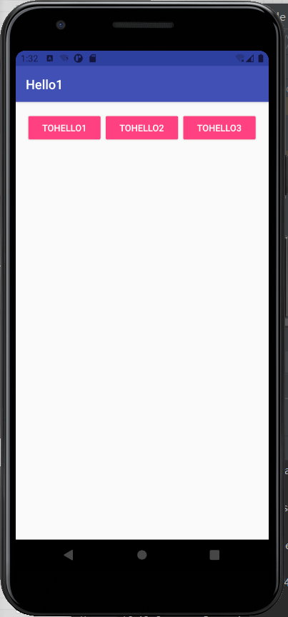
点击“TOHELL02”
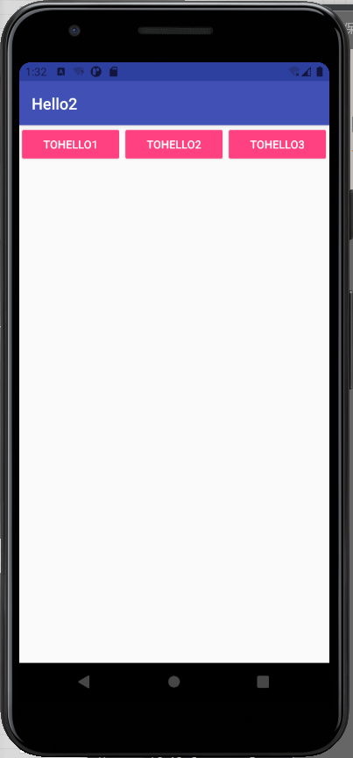

【教师评语和成绩】

成绩： 指导教师： 日期：

