姓名：李忠宁 | 专业：信息管理与信息系统 | 班级：20181171 | 学号：2018117107
科目： Android 开发 |  | 实验日期： 2021.6.11
实验题目： 实现强制下线功能
【实验目的】
实现强制下线功能
【实验内容】
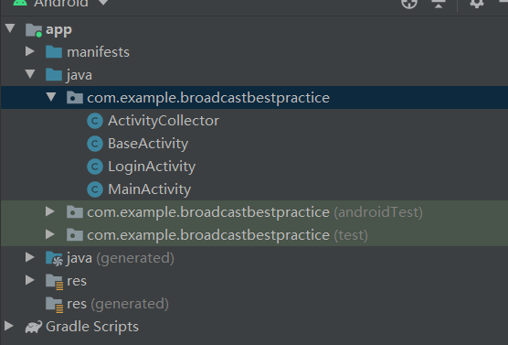

ActivityCollector.java
package com.example.broadcastbestpractice;

import android.app.Activity;

import java.util.ArrayList;
import java.util.List;

public class ActivityCollector {

public static List<Activity> activities = new ArrayList<>();

public static void addActivity(Activity activity) {
activities.add(activity);
}

public static void removeActivity(Activity activity) {
activities.remove(activity);
}

public static void finishAll() {
for (Activity activity : activities) {
if (!activity.isFinishing()) {
activity.finish();
}
}
}

}

BaseActivity.java
package com.example.broadcastbestpractice;

import android.app.AlertDialog;
import android.content.BroadcastReceiver;
import android.content.Context;
import android.content.DialogInterface;
import android.content.Intent;
import android.content.IntentFilter;
import android.os.Bundle;
import android.support.v7.app.AppCompatActivity;

public class BaseActivity extends AppCompatActivity {

private ForceOfflineReceiver receiver;

@Override
protected void onCreate(Bundle savedInstanceState) {
super.onCreate(savedInstanceState);
ActivityCollector.addActivity(this);
}

@Override
protected void onResume() {
super.onResume();
IntentFilter intentFilter = new IntentFilter();
intentFilter.addAction("com.example.broadcastbestpractice.FORCE_OFFLINE");
receiver = new ForceOfflineReceiver();
registerReceiver(receiver, intentFilter);
}

@Override
protected void onPause() {
super.onPause();
if (receiver != null) {
unregisterReceiver(receiver);
receiver = null;
}
}

@Override
protected void onDestroy() {
super.onDestroy();
ActivityCollector.removeActivity(this);
}

class ForceOfflineReceiver extends BroadcastReceiver {

@Override
public void onReceive(final Context context, Intent intent) {
AlertDialog.Builder builder = new AlertDialog.Builder(context);
builder.setTitle("Warning");
builder.setMessage("You are forced to be offline. Please try to login again.");
builder.setCancelable(false);
builder.setPositiveButton("OK", new DialogInterface.OnClickListener() {
@Override
public void onClick(DialogInterface dialog, int which) {
ActivityCollector.finishAll(); // 销毁所有活动
Intent intent = new Intent(context, LoginActivity.class);
context.startActivity(intent); // 重新启动LoginActivity
}
});
builder.show();
}

}

}

LoginActivity.java
package com.example.broadcastbestpractice;

import android.content.Intent;
import android.content.SharedPreferences;
import android.preference.PreferenceManager;
import android.support.v7.app.AppCompatActivity;
import android.os.Bundle;
import android.view.View;
import android.widget.Button;
import android.widget.CheckBox;
import android.widget.EditText;
import android.widget.Toast;

public class LoginActivity extends BaseActivity {

private SharedPreferences pref;

private SharedPreferences.Editor editor;

private EditText accountEdit;

private EditText passwordEdit;

private Button login;

private CheckBox rememberPass;

@Override
protected void onCreate(Bundle savedInstanceState) {
super.onCreate(savedInstanceState);
setContentView(R.layout.activity_login);
pref = PreferenceManager.getDefaultSharedPreferences(this);
accountEdit = (EditText) findViewById(R.id.account);
passwordEdit = (EditText) findViewById(R.id.password);
rememberPass = (CheckBox) findViewById(R.id.remember_pass);
login = (Button) findViewById(R.id.login);
boolean isRemember = pref.getBoolean("remember_password", false);
if (isRemember) {
// 将账号和密码都设置到文本框中
String account = pref.getString("account", "");
String password = pref.getString("password", "");
accountEdit.setText(account);
passwordEdit.setText(password);
rememberPass.setChecked(true);
}
login.setOnClickListener(new View.OnClickListener() {
@Override
public void onClick(View v) {
String account = accountEdit.getText().toString();
String password = passwordEdit.getText().toString();
// 如果账号是admin且密码是123456，就认为登录成功
if (account.equals("admin") && password.equals("123456")) {
editor = pref.edit();
if (rememberPass.isChecked()) { // 检查复选框是否被选中
editor.putBoolean("remember_password", true);
editor.putString("account", account);
editor.putString("password", password);
} else {
editor.clear();
}
editor.apply();
Intent intent = new Intent(LoginActivity.this, MainActivity.class);
startActivity(intent);
finish();
} else {
Toast.makeText(LoginActivity.this, "account or password is invalid",
Toast.LENGTH_SHORT).show();
}
}
});
}

}

MainActivity.java
package com.example.broadcastbestpractice;

import android.content.Intent;
import android.support.v7.app.AppCompatActivity;
import android.os.Bundle;
import android.view.View;
import android.widget.Button;

public class MainActivity extends BaseActivity {

@Override
protected void onCreate(Bundle savedInstanceState) {
super.onCreate(savedInstanceState);
setContentView(R.layout.activity_main);
Button forceOffline = (Button) findViewById(R.id.force_offline);
forceOffline.setOnClickListener(new View.OnClickListener() {
@Override
public void onClick(View v) {
Intent intent = new Intent("com.example.broadcastbestpractice.FORCE_OFFLINE");
sendBroadcast(intent);
}
});
}

}

运行结果：
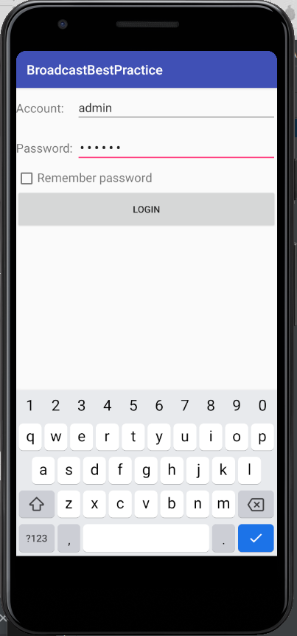

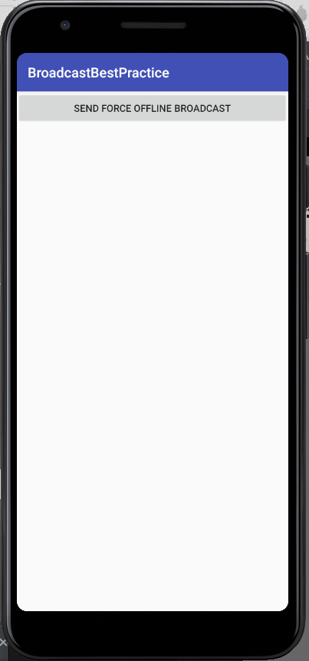

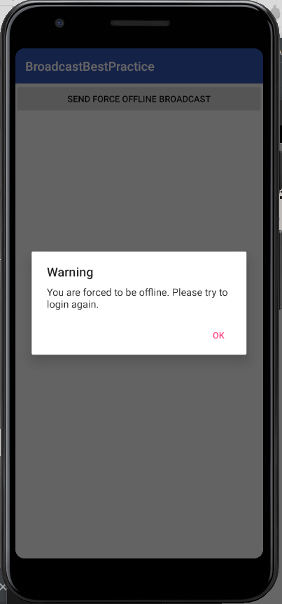

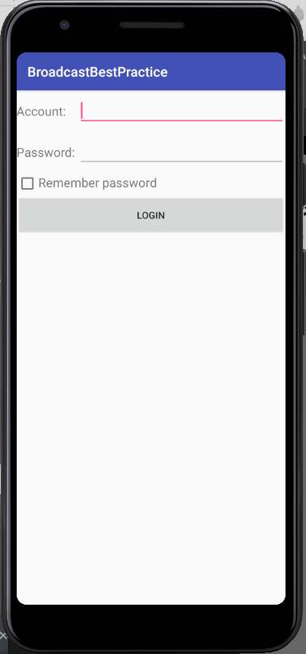

【教师评语和成绩】

成绩： 指导教师： 日期：

