**B18_Ex01_01**

**Exmaple 1: 110011000, 110100101, 011010000**

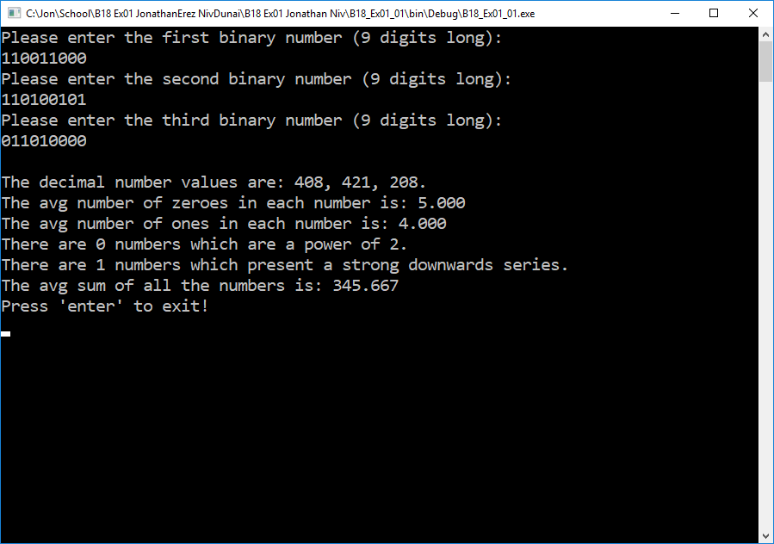

**Exmaple 2: 000101000, 000100000, 000100110**

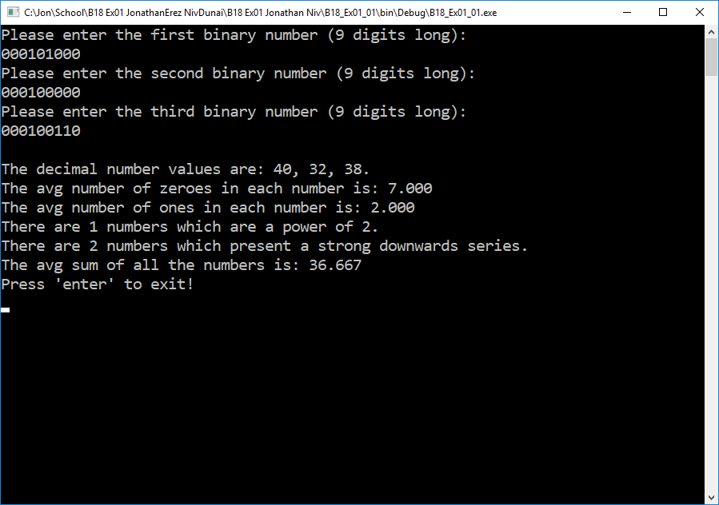

**Exmaple 3: 001101001, 011001101, 010111101**

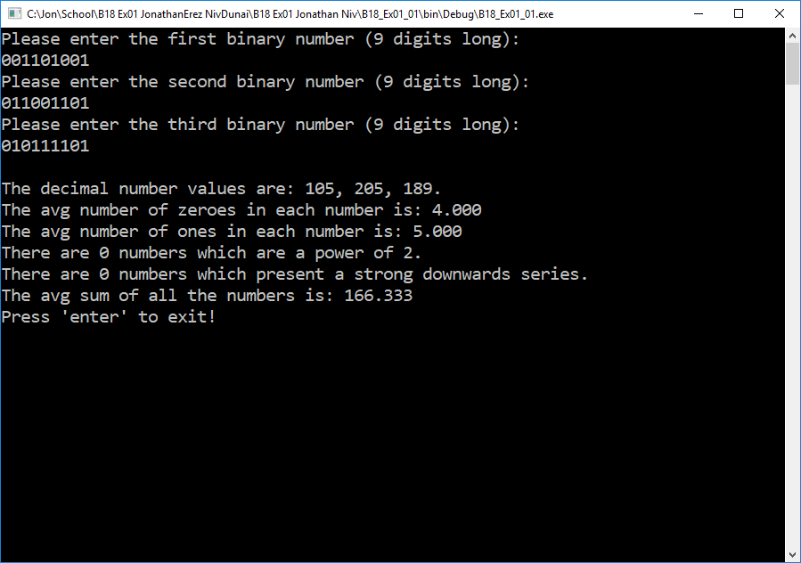

**B18_Ex01_02**

**Exmaple 1:**

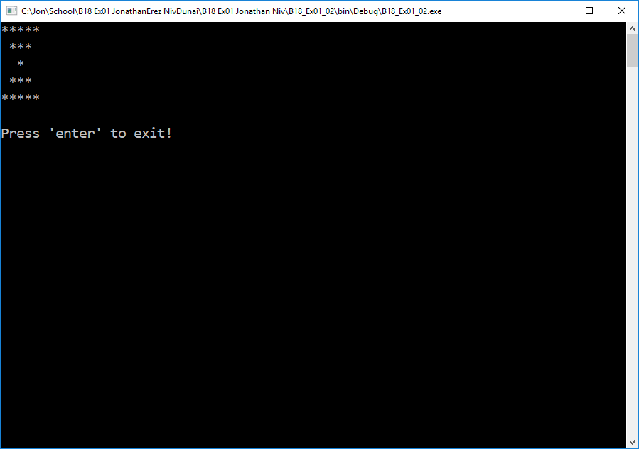

**B18_Ex01_03**

**Exmaple 1: 4**

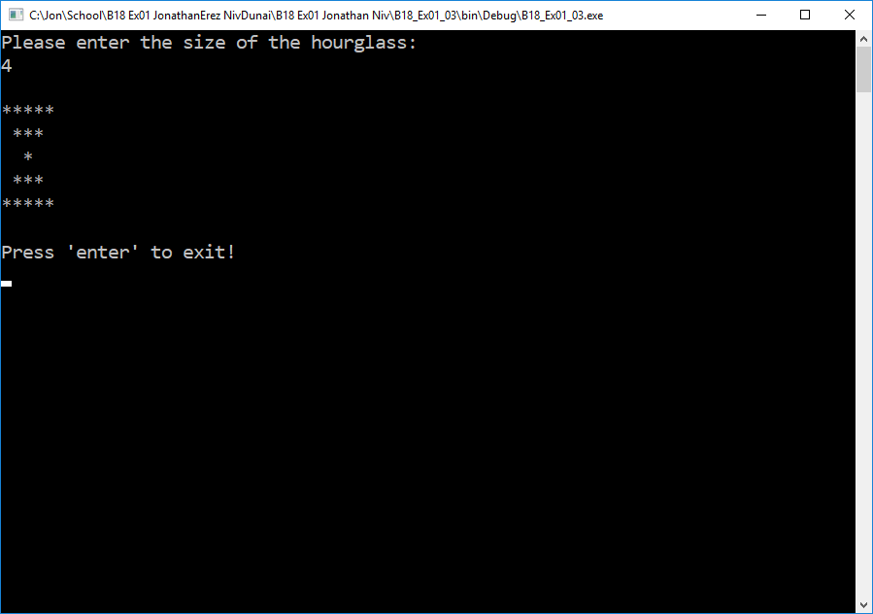

**Exmaple 2: 5**

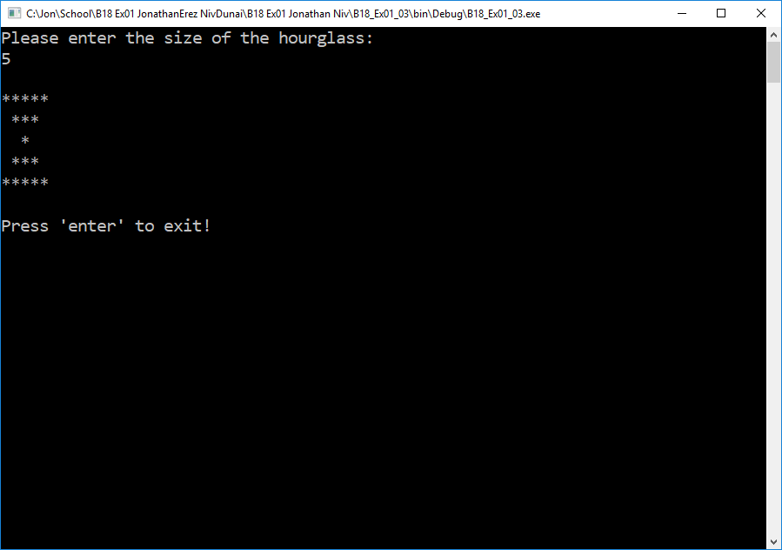

**Exmaple 3: 7**

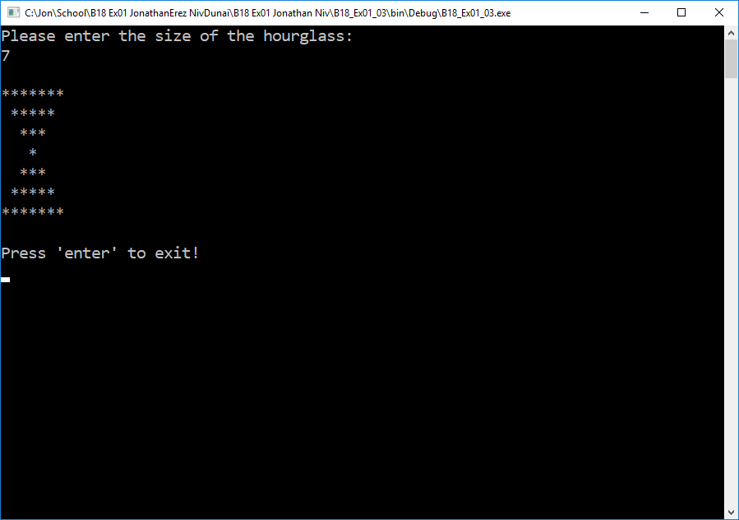

**Exmaple 4: 8**

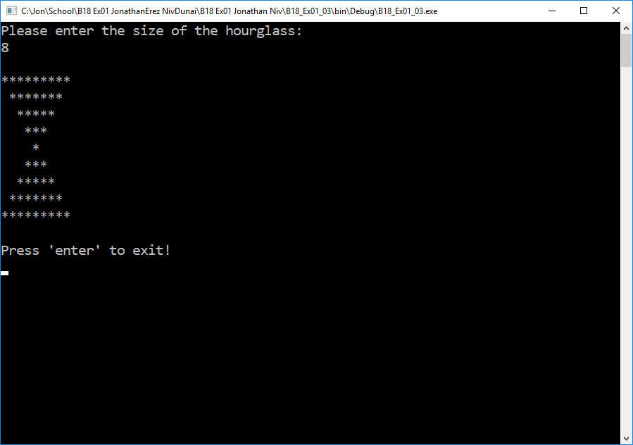

**B18_Ex01_05**

**Exmaple 1: 98766789**

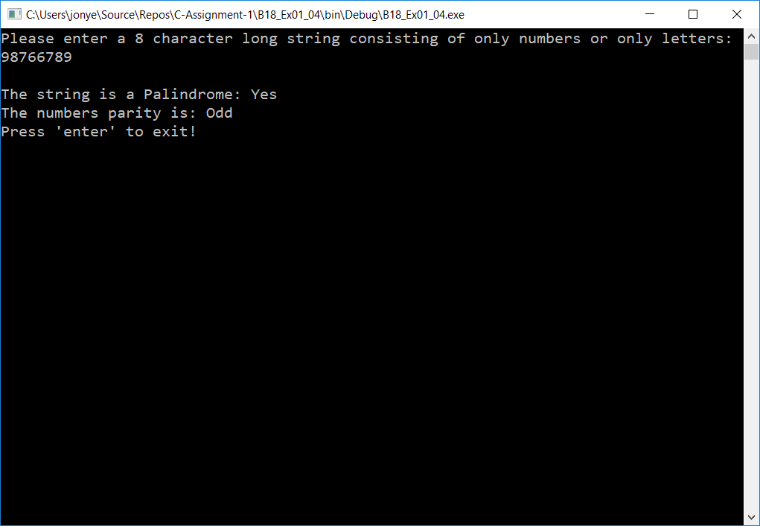

**Exmaple 2: 52963482**

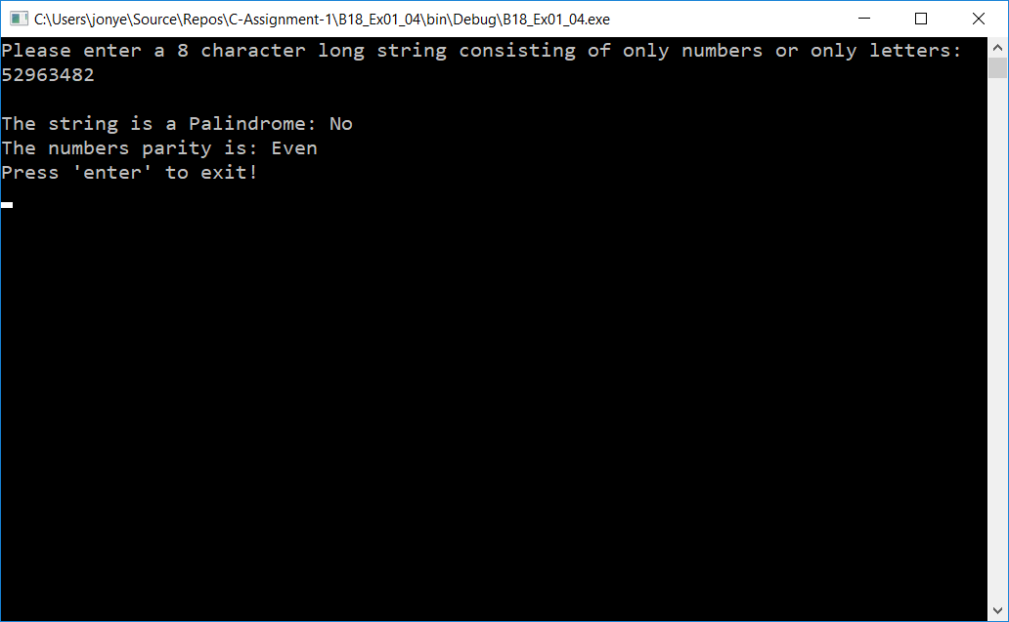

**Exmaple 3: LivEeVil**

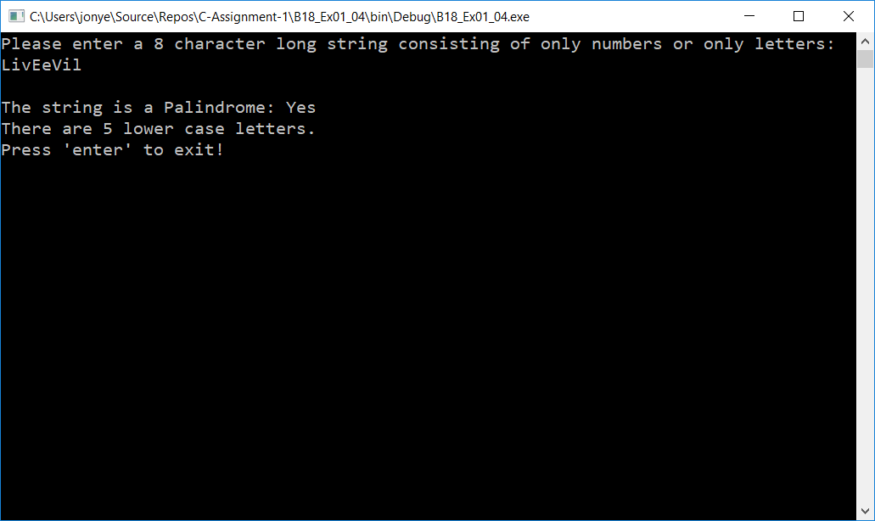

**Exmaple 4: cSharpRoX**

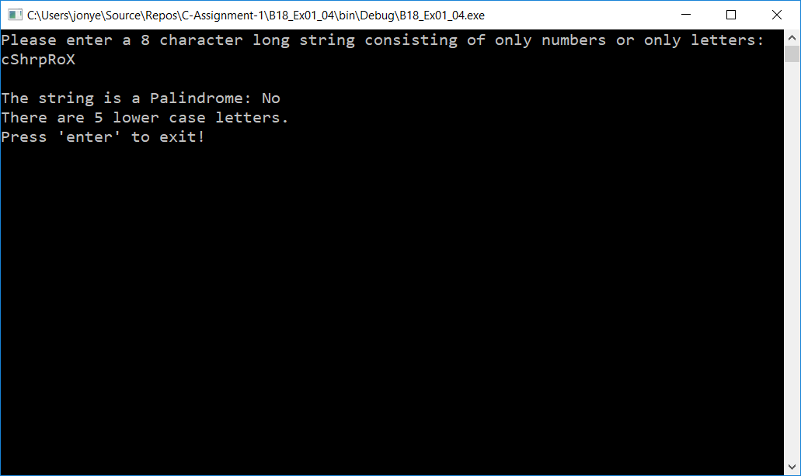

**B18_Ex01_05**

**Exmaple 1: 164825**

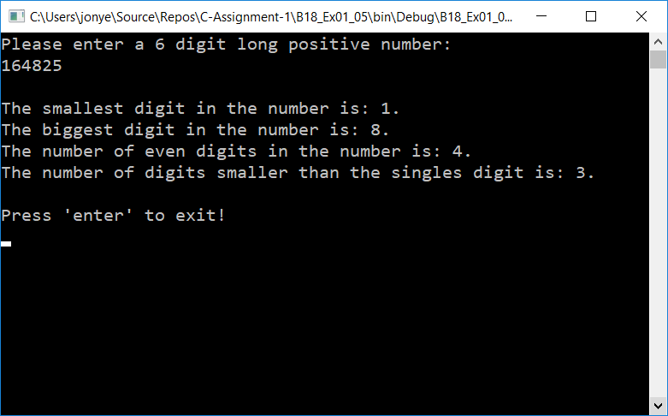

**Exmaple 2: 111111**

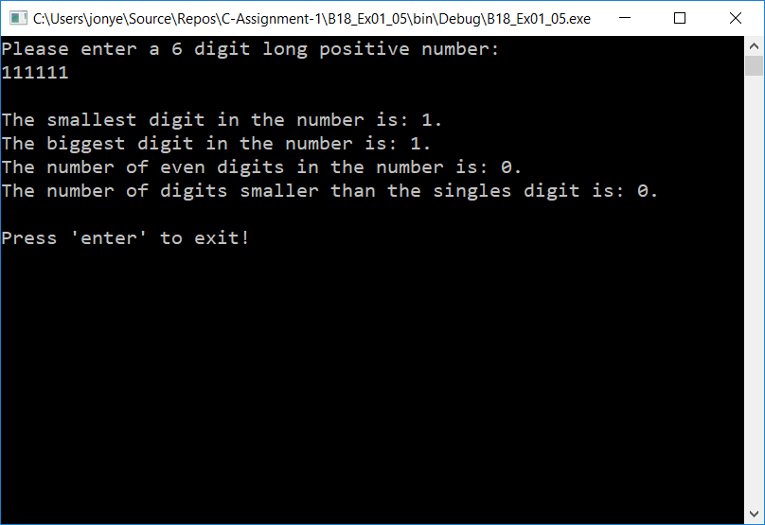

**Exmaple 3: 987329**

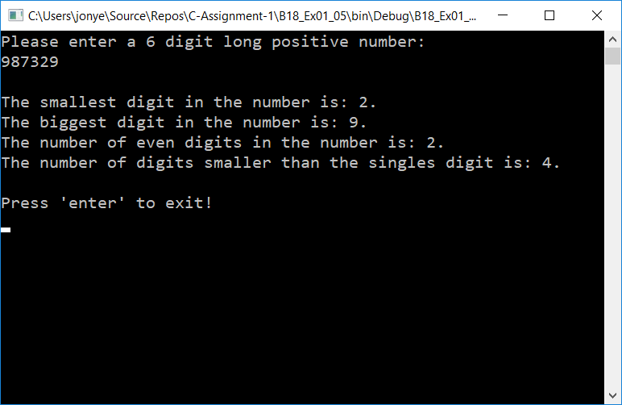

**Exmaple 4: 000312**

