Run_cfd使用说明书

1.功能
本脚本自动化完成从 STL 建筑模型到 OpenFOAM CFD 求解再到平面数据提取的全流程，包括：
1 生成背景网格（blockMesh）
2. 提取几何特征边（surfaceFeatures）
3. 生成细化网格（snappyHexMesh）
4. 设置时变入口风速并运行稳态求解器（simpleFoam）
5. 后处理：在指定高度用 samplePlane 提取平面，并转换为 .npy / .csv 数据

- 先决条件

2.1 OpenFOAM：blueCFD-Core 2020 + OpenFOAM-8
setvars_OF8.bat 和各个可执行文件 (*.exe) 均已安装并可调用
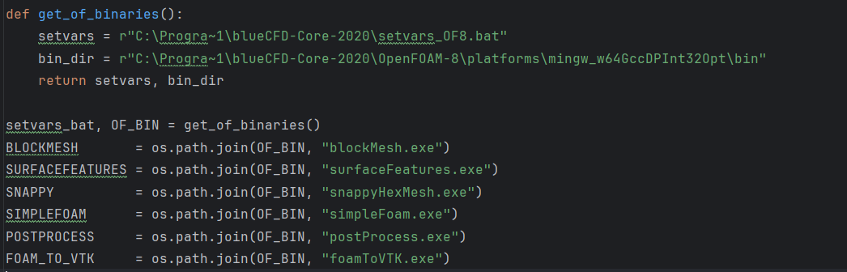
需手动构建执行器索引 如果bin 中对应exe文件缺失 直接将C:\Program Files\blueCFD-Core-2020\OpenFOAM-8\platforms\mingw_w64GccDPInt32Opt\lib下文件复制粘贴到bin下可解决

2.2文件夹结构(示例)
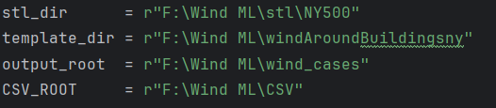
• stl_dir：包含所有 .stl 建筑模型文件的文件夹。
• template_dir：已有的 OpenFOAM case 模板文件夹（除几何和网格生成相关文件外的初始 case 结构）。
• output_root：脚本将为每个 STL+风向组合生成一个 case，放在此处。
• CSV_ROOT：后处理生成的 .npy 与 .csv 数据。

2.3输入结构

2.3.1.风速时序：
times = [0, 3600, 7200, …, 82800] # 24 小时，每小时一个节点
Ux_values = [1.50, 1.20, 1.00, …, 1.50] # 对应的 Ux 分别
time_series = list(zip(times, Ux_values))
时间单位为s 风速单位为m/s

2.3.2.采样参数
cellSize = 2 # 背景网格单元尺寸（m），调大可降低单元数，调小提升精度，如果做米级模拟，尽量不低于4
PLANE_Z = 2 # 提取平面的高度（m）
PLANE_TOL = 0.05 # 提取高度的容差（m）
ANGLES = range(0,360,45) # 风向列表，0°,45°,90°…

3具体功能

3.1背景网格生成（blockMesh）
通过BLOCKMESH_DICT_TEMPLATE(代码中第三个模板)进行，根据输入的stl文件确定参数

3.1.1定义边界盒：
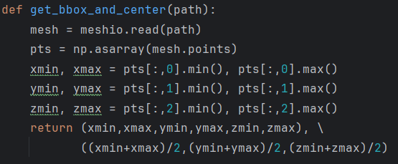
输入：STL 文件路径
输出：模型在 X/Y/Z 三个方向上的最小、最大坐标，以及三维中心点
作用：后续构造包围几何的背景六面体网格时，需要知道边界盒范围和中心。

3.1.2写入 blockMeshDict：
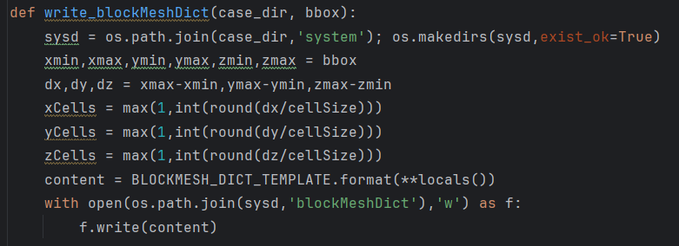
输入：目标 case 目录、边界盒
• 功能：在 case_dir/system/blockMeshDict 中写入背景网格字典，定义：
• 六面体域的顶点与单元分布
• 边界面标签（inlet、outlet、ground、frontAndBack）
• 参数：cellSize 控制网格粗细。

3.1.3调用：run_cmd([BLOCKMESH], case_dir)

3.2特征边提取（surfaceFeatures）
模板名为SNAPPY_DICT_TEMPLATE(第二个) 具体参数见supply
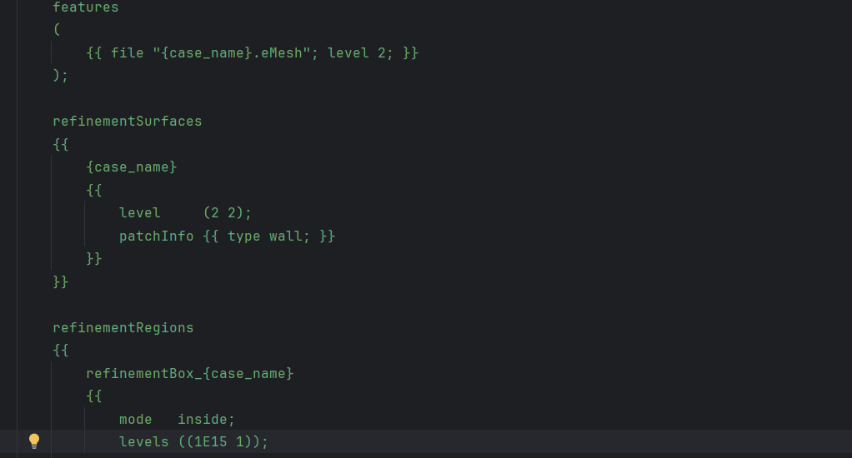主要由这几个level参数控制精度 2~3三级精度差别不大提升1级运算时间提高30~50% 其他关键控制运行时间的参数有nCellsBetweenLevels、resolveFeatureAngle、mergeTolerance等() 按上面几个参数 输出的结果分辨率能达到1m(结果并不均匀1m表示下限)

3.2.1生成字典
以边界盒加缓冲区方式定义 refinementSurfaces、refinementBox
主要字段：
• geometry：指定主体三角面片与“搜索盒”
• castellatedMeshControls.features：加载第 2 步生成的 .eMesh
• refinementSurfaces／refinementRegions：在几何表面与盒内设置细化等级
• snapControls、addLayersControls、meshQualityControls：指定弯曲度、层数、质量阈值等

3.2.2写入 snappyHexMeshDict 并执行
write_snappyDict(case_dir, case, bbox, center)
run_cmd([SNAPPY,'-overwrite'], case_dir)
功能：基于上一节字典，在背景网格上打上几何形状和局部细化。

3.3.控制文件与求解(controDict)
样例如图所示其中deltaT表示每次运算的设定时间间隔(s) interval表示每次输出的运算建格
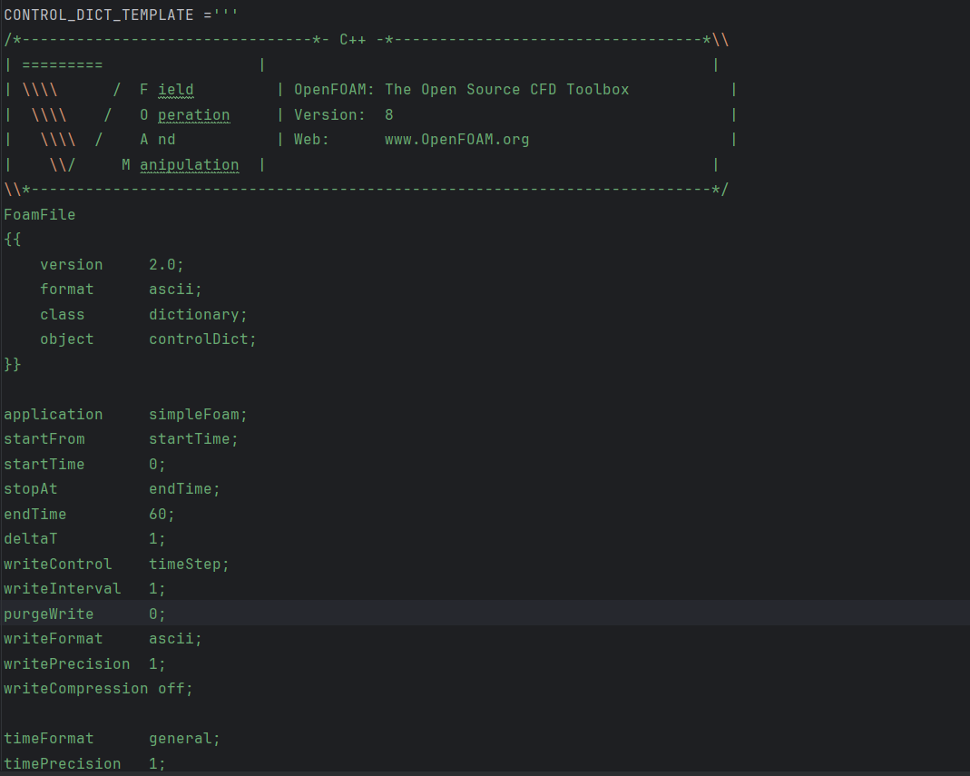

3.3.1 写入 controlDict
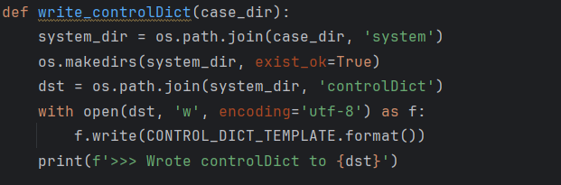
核心内容：
application simpleFoam：稳态不可压缩求解器
functions.samplePlane：调用 libsampling.so 中的 sampledPlane，定期输出平面采样结果

3.3.2 运行求解器
run_cmd([SIMPLEFOAM], case_dir)
过程：读取 0/ 初始条件和 constant/ 中的几何与网格，按 controlDict 中的写频率迭代，直到收敛。



3.4平面采样与后处理

3.4.1 调用 postProcess -func samplePlane
run_cmd([POSTPROCESS, '-func', 'samplePlane'], case_dir)
结果：在 case_dir/VTK/ 根据 functions.samplePlane 指定的时间步，生成一系列 .vtk 文件：
• 内部体（Internal）
• 各补丁（inlet、outlet、ground、frontAndBack）
• 主体（case name patch）

3.4.2 转换与提取
输出为csv文件
def convert_and_extract(case_dir, csv_root, height, tol):
# 1) 扫描所有数值时间文件夹
# 2) 对每个时间调用 foamToVTK -time T
# 3) 读取指定时间的 VTK 目录
# 4) 遍历所有 .vtk，筛选 z≈height 的点
# 5) 计算 WS=||U||、WF=风向
# 6) 保存为纯数字命名的 .npy/.csv

4.supply
Configuration file description
The configuration files are in the case file system folder, and there are three files that need to be moderated:
- blockMeshDict:Defines the initial computational mesh using hexahedral blocks.

BackgroundMesh:Range, resolution of the background grid
Blocks:Define a hexahedral mesh block consisting of 8 points with specified resolution,This can be determined by Cells or a constant can be specified.

- snappyHexMeshDict:Used to tailor complex geometry and generate body meshes based on STL files.There's a lot of parameters. I've come up with a table directly from chat, and the table of important parameters is thick.
Parameter | Description | Suggestions for Higher Resolution
castellatedMesh | Enables the initial mesh refinement phase. | Keep set to on to allow mesh refinement.
snap | Enables the snapping phase to conform the mesh to geometry surfaces. | Keep set to on to ensure mesh conforms to geometry.
addLayers | Enables the addition of boundary layers near surfaces. | Keep set to on to capture boundary layer effects.
geometry | Defines the geometry files and refinement regions. | Ensure high-quality STL files are used; define refinement boxes around areas requiring higher resolution.
features | Specifies feature edge files for edge refinement. | Use surfaceFeatureExtract to generate .eMesh files for sharp edges; increase level to refine edges more.
refinementSurfaces | Sets refinement levels for surfaces. | Increase level values (e.g., from (2 2) to (3 3)) to refine surface meshes.
refinementRegions | Sets refinement levels for specific regions. | Increase levels values (e.g., from ((1E15 2)) to ((1E15 3))) to refine regions of interest.
locationInMesh | A point inside the mesh used to determine which cells to keep. | Ensure this point remains inside the refined mesh.
maxLocalCells | Maximum number of cells per processor during refinement. | Increase to allow more refined cells per processor.
maxGlobalCells | Maximum total number of cells during refinement. | Increase to allow a higher total number of refined cells.
minRefinementCells | Minimum number of cells to refine; prevents excessive refinement of few cells. | Adjust as needed; lower values allow refinement of smaller features.
nCellsBetweenLevels | Number of buffer cells between different refinement levels. | Decrease (e.g., from 3 to 2) for a steeper transition between refinement levels, leading to finer meshes.
resolveFeatureAngle | Angle threshold to detect sharp edges for refinement. | Decrease (e.g., from 120 to 90) to capture sharper features.
explicitFeatureSnap | Enables snapping to explicit feature edges. | Set to true if using .eMesh files for edge snapping.
implicitFeatureSnap | Enables snapping to implicit features based on surface normals. | Keep set to true to allow automatic feature detection.
nSmoothPatch | Number of smoothing iterations for patch surfaces during snapping. | Increase to improve mesh quality near surfaces.
tolerance | Tolerance for snapping; defines how close points must be to snap. | Decrease to make snapping more aggressive, improving conformity to geometry.
nSolveIter | Number of iterations for solving during snapping. | Increase to allow more iterations for better convergence during snapping.
layers | Defines the number of layers to add to specified surfaces. | Increase nSurfaceLayers to add more boundary layers for capturing gradients near walls.
relativeSizes | Determines if layer thicknesses are relative to local cell sizes. | Keep set to true for proportional layer thicknesses; set to false to specify absolute thicknesses.
expansionRatio | Growth rate of successive layers. | Decrease (e.g., from 1.2 to 1.1) for more uniform layer thicknesses.
finalLayerThickness | Thickness of the outermost layer. | Decrease to refine the outermost boundary layer.
minThickness | Minimum overall thickness of all layers. | Decrease to allow thinner boundary layers, capturing finer details.
nGrow | Number of layers to grow outside the specified surfaces. | Increase to extend boundary layers further into the domain.
featureAngle | Angle threshold for adding layers on sharp features. | Decrease to allow layer addition on sharper features.
mergeTolerance | Tolerance for merging points during mesh generation. | Decrease to prevent merging of closely spaced points, preserving small features.
writeFlags | Specifies which mesh data to write. | Ensure necessary data (e.g., scalarLevels, layerSets, layerFields) are included for post-processing and analysis.

- controlDict:Controls the time step of the solving process, the output frequency, the solver function used, etc.
Parameter | Description
application | Specifies the solver to use (e.g., simpleFoam).
startFrom | Determines the start time (startTime, latestTime, etc.).
startTime | Start time for the simulation.
stopAt | Determines when to stop the simulation (endTime, writeNow, etc.).
endTime | End time for the simulation.
deltaT | Time step size.
writeControl | Controls when to write data (timeStep, runTime, etc.).
writeInterval | Interval for writing data based on writeControl.
purgeWrite | Limits the number of time directories stored.
writeFormat | Format for writing data (ascii, binary).
writePrecision | Number of digits for writing data.
writeCompression | Enables or disables compression of output files.
timeFormat | Format for time directory names (general, fixed).
timePrecision | Precision for time directory names.
runTimeModifiable | Allows modification of controlDict during runtime.
functions | Defines function objects for post-processing.

