Hackthebox

[Hack The Box :: Starting Point](https://app.hackthebox.com/starting-point)

Meow

**STEP 1: Discover the network**

We’ll scan the network with **nmap** tool see if there any ports open.

**$ nmap -Pn -sV <IP>**

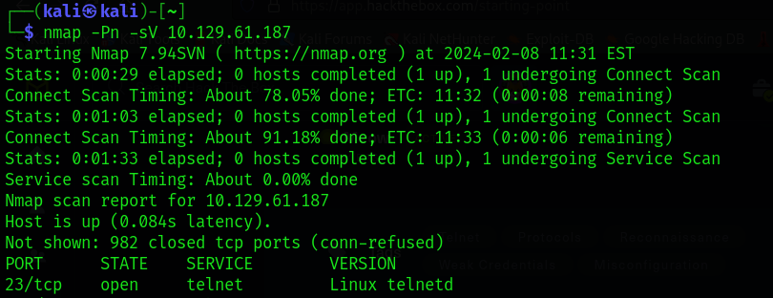

We found one port is open and this is telnet, let's check this port.

**STEP 2: Connection with telnet**

**$ telnet <IP>**



Yeah we can login with user root, let's executed this command

**$ ls**

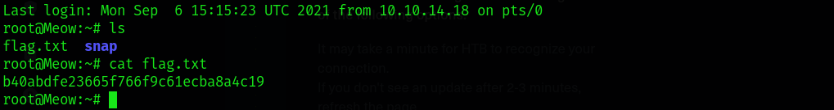

we found the flag.