# Joolyter Demo

# Handbook



## Paul Schmiedtke

## 2023

# Joolyter IDE

Joolyter is the product developed during the course of the Bachelor’s Thesis “A Gamification Approach to the Teaching of Space Flight Mechanics”. It consists of a modified version of the game Kerbal Space Program, Python and much more. Joolyter uses game elements and intends to increase the understanding of rocketry and space flight mechanics. This handbook will lead through the installation process. Please read before you click, as skipping small steps can cause weird behaviour.

## Requirements

Although KSP is available for multiple platforms, Joolyter was developed to be run alongside Kerbal Space Program on Windows operating systems. The game’s recommend system requirements as listed by the publisher are an Intel Core i5 processor, 8 GB of memory, a graphics processing unit capable of DirectX 10 and with at least 1 GB of video random-access memory. The complete installation of Joolyter and all its dependencies may require up to 6 GB of disc space. An active internet connection must be present for the installation only. All software dependencies will be installed if this guide is followed.

## Installation

All files needed offline are in “InstallationContainer.zip”. To continue it needs to be extracted.

## Python

Joolyter is supported by Python 3.8. A graphical installer is included in the installation container folder:

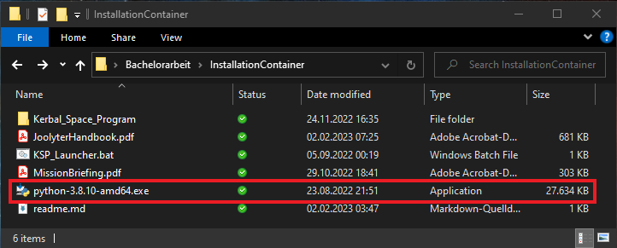

After execution you will be greeted by the installation window. The check box “Add Python 3.8 to PATH” must be checked. It is recommended to use the “Install Now” function but if “Customize installation” is chosen, make sure pip gets installed. After completion the installer may be closed.

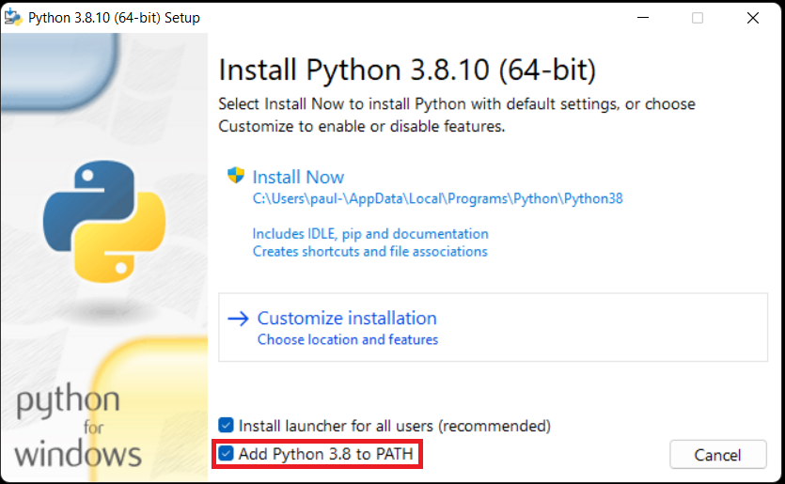

## Additional modules

The next step needs Windows PowerShell to be opened inside the installation container’s directory.

PowerShell can be opened from the Start menu. Now the joolyterdemo module for Python can be installed using pip.

Therefore, use the enter the following command in PowerShell:

pip install joolyterdemo

This might take a while. When all modules are installed, Windows PowerShell may be closed.

If the installation fails (just then!), run:

pip install setuptools==57.5.0

Then try again installing joolyterdemo.

## Getting to know Kerbal Space Program

KSP can now be launched by double clicking the KSP_Launcher.bat inside the installation container.

For users new to KSP it is recommended to get comfortable in the game by playing its training missions focused on flying and orbits. The course’s missions require neither user inputs are nor user-built space crafts but knowing the different views and controls of the camera are an advantage. The training missions can be found under *Start* *Game* -> *Training*. If users decide to explore the game beyond the curated missions and assistance is needed, Scott Manley’s [tutorial series on YouTube](https://www.youtube.com/watch?v=tgPr4q5tj-Q&list=PLYu7z3I8tdEm5nyZU3a-O2ak6mBYXWPAL&index=3) has proven itself to be a good starting point.

## Start Mission

Missions can be started from the “Start Game” screen by clicking on “Play Mission”.

Inside the sub menu “Community Created” in the top left corner must be selected. After choosing one of the two missions (pink rectangle) click the start button (red rectangle).

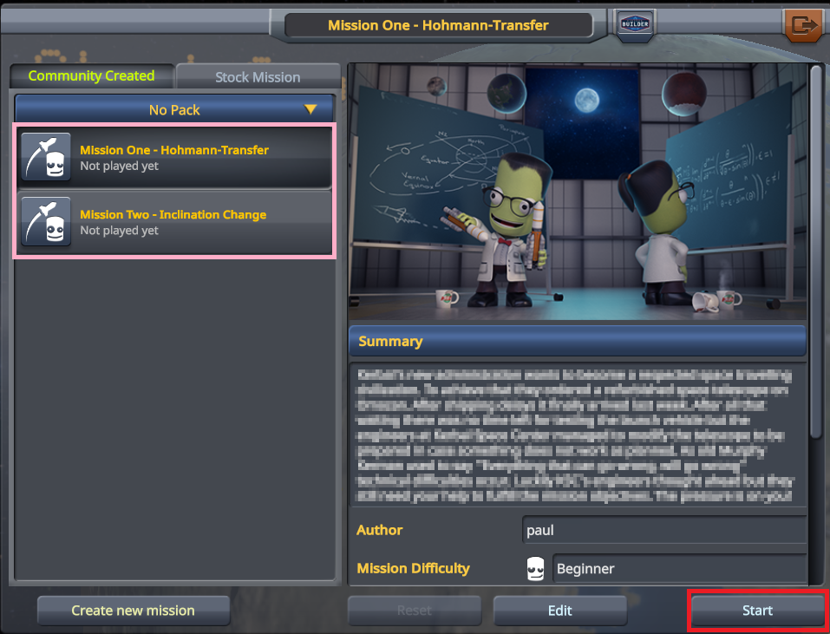

## In-flight User Interface

The training will cover most user interface elements thus, the handbook focuses on elements not included in a stock version of KSP. Some information is presented to the user by context boxes in the course of the missions. A log of all messages is saved and can be accessed by clicking the icon in the top right corner. The network icon launches kRPC – Remote Procedure Call Server for KSP. Joolyter is the integrated development environment in Kerbal Space Program.

## kRPC

To upload your source code to the spacecraft you must establish a connection through kRPC.

The Start-Button on kRPC’s user interface launches the server.

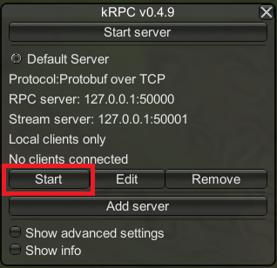

## Joolyter

To create, edit, and launch Python scripts Joolyter needs to be launched. The toolbar at the top consists of a data menu that offers users to open and save scripts. The “+”- and “-“-Buttons in the size menu alter the font size of the areas which are colored in the screenshot below. The Play-Button starts the executes the script inside the blue text area. Framed by the green rectangle is the console output window, where outputs of the executed scripts are displayed. At the bottom is an input field, highlighted in purple, which allows the user to interact with the Python console directly.

Entering the command

clear

into the Python console clears the console output window.

## Installing Jupyter Notebook

To use Joolyter in Jupyter Notebook, its standalone application [JupyterLab Desktop](https://github.com/jupyterlab/jupyterlab-desktop/releases/download/v3.5.0-1/JupyterLab-Setup-Windows.exe) must be installed from [GitHub](https://github.com/jupyterlab/jupyterlab-desktop/releases/download/v3.5.0-1/JupyterLab-Setup-Windows.exe). After launching the path to the Python executable installed earlier must be provided. Therefore, select *Start new local JupyterLab Server* and *Use a custom Python environment*. Paste the path below in the input field and replace the username.

C:\Users\[your_username]\AppData\Local\Programs\Python\Python38\python.exe

The path may vary if you chose to install Python in a custom directory.

To start JupyterLab click on *Apply and restart*. For help on how to use Jupyter please consult the documentation and other tutorials. Furthermore all IDE’s running said Python environment will be able to use Joolyter.

## Starting to code

To use the earlier installed Joolyter Demo package it has to be called by the following command:

import joolyter

Further information on the python package is provided in the mission briefings under *Tips and hints* and [documentation](https://joolyter.github.io/paul-thesis/PythonInput/src/docs/_build/html/index.html).

## Limitations

Due to an error inside a module of KSP’s underlying game engine escape characters such as */n*, */t*, */r*, etc. are always parsed. Using them leads to faulty behaviour of the input fields for scripts and console. Therefore, it is highly recommended to avoid its use and rather user multiple output commands.

## Bugs and errors

If any bugs arise or the plugin behaves unexpectedly, please report them via [e-mail](mailto:p.schmiedtke@campus.tu-berlin.de?subject=[JoolyterDemo]%20Bug%20Report) providing a detailed description of the occurrence, information about the used system and the [KSP.log-file](../Kerbal_Space_Program) from the hyperlink’s directory.