**Foundations of Software Engineering Final Project**

UQU Maps

**Prepared by:**

**Leader: Joory Alzahrani**

ID: #445007343 | Email: [S445007343@uqu.edu.sa](mailto:S445007343@uqu.edu.sa)

**Fatima Khan**

ID: #44510327 | Email: [S44510327@uqu.edu.sa](mailto:S445007343@uqu.edu.sa)

**Asail Alnifiai**

ID: #445004255 | Email: [S445004255@uqu.edu.sa](mailto:S445007343@uqu.edu.sa)

**Esraa AbdElraheem**

ID: #445013921 | Email: [S445013921@uqu.edu.sa](mailto:S445013921@uqu.edu.sa)

**Group #5** Practical Class

**Project Title:** UQU Maps

**28/01/2025**

**Table of Contents**

**1. Introduction 3**

1.1. Purpose 3

1.2. Problems Addressed 3

1.3. Target Users 3

1.4. Definitions, Acronyms, and Abbreviations 4

1.5. Scope 4

1.6. References 4

**2. Overall Description 4**

2.1. Product Perspective 5

2.2. Product Functions 5

2.3. User Characteristics 6

2.4. Constraints 8

2.5. Assumptions and Dependencies 8

**3. Specific Requirements 9**

3.1. Functional Requirements 9

3.2. Non-functional Requirements 13

**4. Use-cases 16**

4.1. Use-case Diagram 16

4.2. Use-Case Tabular Descriptions 17

5. Context diagram 20

**6. Architectural Designs 21**

6.1. Client-Server Diagram 21

6.2. Layered Diagram: 22

**7. Appendix A 22**

# Introduction

## Purpose

The purpose of this Software Requirements Specification (SRS) document is to define and describe the functional and non-functional requirements of the UQU Maps system, a web-based interactive mapping application for Umm Al-Qura University’s Zahir campus.

This document serves as a reference for developers, designers, and stakeholders to ensure a clear understanding of the system’s capabilities, limitations, and expected behavior. It also provides the foundation for design, development, testing, and future maintenance of the system.

## Problems Addressed

* Students who frequently get lost trying to locate lecture halls and navigate buildings.
* Difficulty in finding professors’ offices and their office hours
* Limited visibility for small businesses, making it challenging for them to gain exposure and increase their customer base
* Challenges in finding buses, including their timings and routes

## Target Users

* All university attendees and employees
* Professors
* Students
* Businesses

## Definitions, Acronyms, and Abbreviations

* **UQU**: Umm Al-Qura University
* **API**: Application Programming Interface
* **GPS**: Global Positioning System
* **UI**: User Interface
* **OTP**: One-Time Password
* **FR**: Functional Requirement
* **NFR**: Non-Functional Requirement
* **SRS**: Software Requirement Specification

## 

## Scope

The UQU Maps system provides location-based navigation, class schedule integration, and business visibility within the Umm Al-Qura University campus. It does not cover navigation outside the campus or third-party payment services. The system is limited to the university’s internal environment and data sources.

## References

[1] IEEE Std 830-1998, IEEE Recommended Practice for Software Requirements Specifications.

[2] Google Maps API Documentation, https://developers.google.com/maps/documentation

[3] Umm Al-Qura University Information Systems Portal, https://uqu.edu.sa/

# Overall Description

## Product Perspective

UQU Maps is a unique web-based system designed to assist users in navigating the Umm Al-Qura University (UQU) campus through an interactive and digital map. The system functions as a location and information platform, combining real-time map data, GPS navigation, and user-specific features such as class schedules and event updates.

This system operates as part of the university’s digital ecosystem, integrating with existing UQU databases, Google Maps API, and authentication services to retrieve accurate location and schedule information. It may also communicate with email and content management systems for notifications and data updates.

UQU Maps aims to enhance campus accessibility and efficiency for all stakeholders ,students, faculty members, and on-campus business owners, by providing a centralized, interactive tool that visualizes routes, highlights building details, and supports activity discovery.

## Product Functions

The major functions of UQU Maps include the following:

1. **Interactive Campus Map Display**

* Displays a detailed, scalable map of the UQU campus.
* Allows users to view building details such as classrooms, departments, and offices

1. **User-Specific Schedule Integration**

* Students can log in to view personalized class locations based on their academic timetable
* Faculty members can access their teaching schedules and office locations.

1. **GPS and Navigation Assistance**

* Provides step-by-step navigation to selected destinations using real-time GPS.
* Supports voice-over guidance for accessibility and convenience.

1. **Activity and Event Visualization**

* Displays ongoing campus activities, events, and student club gatherings.
* Highlights nearby facilities or opportunities relevant to user interests.

1. **Business and Service Locator**

* Lists on-campus businesses such as cafés, bookstores, and service points.
* Enables users to discover, rate, and view directions to these locations

1. **Notification and Communication Services**

* Sends email or in-app alerts regarding schedule updates, event reminders, or location changes.

1. **Administrative Management**

* Allows authorized personnel to update building data, schedules, and business listings through the admin panel.

## 

## User Characteristics

* + 1. **Target User Interview Summary**

To better understand the needs of potential users, interviews were conducted with three main user groups: students, professors, and on-campus business owners. The findings from these interviews helped identify the most important features and usability goals for the system.

* Students:  
   Students expressed frequent difficulty in locating classrooms, departments, and event areas within the campus. They emphasized the need for a system that integrates directly with their academic schedules and provides walking directions to their next class. Many students also requested mobile-friendly access and voice-over navigation for ease of use.
* Professors:  
   Professors highlighted the need for an efficient way to find offices, lecture halls, and faculty meeting locations. They valued the idea of synchronizing the map with the university’s scheduling system and having a reliable method to share their office location or office hours with students.
* Business Owners:  
   On-campus business owners were interested in increased visibility of their stores and services. They suggested features for showcasing business information, special offers, and the ability to display their location to attract more customers within the campus.

The interviews revealed a shared interest in accuracy, accessibility, and real-time updates, ensuring that all users can quickly find and interact with campus locations through an intuitive and visually clear interface. Detailed Interviews with recorded responses can be found in the appendix.

* + 1. **User Needs and Expectations**

Based on the interview findings and target user analysis, the following user needs and expectations were identified:

1. **Ease of Navigation:**

Users expect an interactive, simple-to-use map with clear directions and real-time movement tracking.

1. **Personalized Access:**

Students and professors need schedule-based features that automatically display relevant locations and events.

1. **Accurate and Up-to-Date Information:**

All users expect accurate building data, classroom locations, and current updates on events or changes.

1. **Cross-Platform Availability:**

The system should be accessible through both desktop browsers and mobile devices.

1. **Accessibility and Inclusivity:**

Voice-over navigation and readable map labels are expected for inclusive use by individuals with visual or physical accessibility needs.

1. **Visibility for Businesses and Services**:

Business owners expect their locations and details to be easily discoverable through map search and filtering options.

## 2.4. Constraints

The development and operation of UQU Maps are subject to the following constraints:

1. **Data Integration Constraint:** The system depends on access to UQU’s internal databases for schedules and location data, which may be restricted due to privacy or security policies.
2. **API and Internet Dependency:** Real-time navigation and map visualization rely on external APIs (e.g., Google Maps API) and stable internet connectivity.
3. **Device Compatibility:** The system must perform efficiently across various screen sizes and devices, requiring responsive web design.
4. **Privacy and Security:**User authentication and schedule information must comply with data protection regulations, ensuring secure handling of personal data.

## 2.5. Assumptions and Dependencies

1. **Assumptions**

* Users have access to the internet while using UQU Maps.
* UQU’s administrative systems will provide the required schedule and location data through secure access.
* All users have a valid UQU account for authentication.
* Campus locations and data provided are accurate at the time of input.

1. **Dependencies:**

* Integration with Google Maps API for location and route data.
* Integration with UQU’s database for class schedules, faculty data, and building information.
* Functionality of the GPS module for real-time navigation.
* Email and content management systems for notifications and updates.
* Continued maintenance and data updates by the university’s IT department.

# Specific Requirements

## Functional Requirements

1. FR1: The user shall be able to create an account in the case they are a business owner
   1. The system shall provide a registration form for business owners to enter their name, email, and password.
   2. The system shall check if all fields are filled before allowing submission.
   3. The system shall display an error message if the email is invalid or already registered.
   4. The system shall save the account information in the database after successful submission and verification.
   5. The system shall notify the user via email with a verification link when the account is created successfully.
2. FR2: The users shall be able to log in using their emails and passwords.
   1. The system shall allow users to input their email and password on the login page.
   2. The system shall transmit login information securely using encryption.
   3. The system shall verify if the email is registered and display "Email not found" if it is unregistered.
   4. The system shall compare the entered password (after hashing) with the stored hashed password.
   5. The system shall send a unique 6-digit OTP valid for 2 minutes to the user’s email upon each successful password verification
   6. The system shall allow users to input the OTP for verification and validate it.
   7. The system shall allow users to request an additional OTP up to two times before locking the account for 24 hours.
   8. The system shall, upon successful OTP verification, retrieve the user's role and redirect them to the appropriate dashboard.
3. FR3: The user shall be able to view lecture rooms with upcoming classes highlighted on the map.
   1. The system shall retrieve the user's schedule from the university database linked to their email.
   2. The system shall parse the user's schedule to identify the corresponding lecture rooms.
   3. The system shall highlight lecture rooms associated with the user's class schedule for the current day.
   4. The system shall update highlighted locations of any schedule changes or external database updates.
   5. The system shall remove the highlight from lecture rooms after the scheduled class is completed.
   6. The system shall display an error message, "No schedule found," when no schedule data is available for the user.
   7. The system shall display a default campus map when no schedule data is found.
4. FR4: The user shall be able to search for specific locations on the map (including professors' offices, cafes and restaurants, lecture rooms, and gates).
   1. The system shall allow the user to input text in the search box.
   2. The system shall suggest matching locations dynamically as the user types.
   3. The system shall query the database and retrieve location data relevant to the search.
   4. The system shall highlight the selected location on the map based on the user's search query.
   5. The system shall display an error message if no matching location is found.
5. FR5: The user should be able to filter campus locations by category
   1. The system shall store campus location data in a database.
   2. The system shall allow users to filter locations by categories such as lecture halls, buildings, libraries, cafes, restaurants, and offices.
   3. The system shall allow users to filter locations based on specific activities, events, or availability.
   4. The system shall dynamically update filtered results immediately upon database changes or user adjustments.
   5. The system shall display filtered results in an organized manner, showing details such as location name, description, and availability.
   6. The system shall allow users to reset all applied filters and return to the default campus map view.
6. FR6: The user shall be able to view their current location as they navigate the campus map.
   1. The system shall display the user’s real-time location on the campus map using GPS data.
   2. The system shall determine and provide the user’s orientation.
   3. The system shall notify the user with an error message if location data cannot be retrieved due to connectivity issues or if they are outside the campus region.
   4. The system shall provide a static map in the case of the user denying location permissions.
   5. The system should provide the option for the user to select a destination.
   6. The system should display navigation instructions in the form of a visual route.
   7. The system should dynamically update the path if the user deviates from the route.
   8. The system should provide the option to provide voiced-directions.
   9. The system shall provide feedback in the form of route recalculation and display if the user deviates from the path.
   10. The system shall notify the user when they have reached their destination.
7. FR7: The user shall be able to view detailed information about a selected destination.
   1. The system shall display detailed information about a selected destination, including available hours (e.g., office timings, room availability), when the user clicks on the destination on the campus map.
   2. The system shall update the information when changes occur in the database (e.g., schedule updates).
   3. The system shall view a message stating, ‘No information available for this destination,’ if relevant data is unavailable in the database.
   4. The system shall highlight the selected destination on the map for better visibility while displaying the information.
8. FR8: The user shall be able to add public location-based information to the system, depending on their assigned role.
   1. The system shall allow only users with the role of professor to add office-hour timings.
   2. The system shall allow only users with the role of business owner to add menu and opening-closing times
   3. The system shall restrict information editing/uploading privileges to users with appropriate role-based permissions
   4. The system shall store the information in the database and manage role-based information securely

## 

## Non-functional Requirements

1. **Reliability:**
   1. NFR1: The system shall maintain 99.9% uptime during operational hours (6:00 AM to 11:00 PM).
   2. NFR2: The system shall schedule maintenance to occur during late-night hours (11:00 PM to 3:00 AM) to minimize disruptions.
   3. NFR3: The system shall minimize critical issues, such as crashes or map loading errors, to a failure rate of no more than 1 per 1,000 sessions to ensure consistent functionality.
2. **Performance:**
   1. NFR4: The system shall ensure response times of 2 seconds for login and map updates, and 1 second for search results.
   2. NFR5: The system shall support up to 10,000 concurrent users, including 5,000 concurrent users for real-time map updates, without performance degradation.
   3. NFR6: The system shall recover within 1 minute of failure and provide fallback mechanisms to ensure partial functionality during server overload or API outages.
3. **Security**:
   1. NFR7: The system shall restrict access to features based on user roles (student, professor, business owner).
   2. NFR8: The system shall encrypt all sensitive data and enable location tracking only with user consent.
4. **Adaptability:**
   1. NFR9: The system shall adjust to new campus locations or changes with minimal reconfiguration.
5. **Maintainability:** 
   1. NFR10: The system shall provide error logging to assist in troubleshooting. access.
6. **Internationalization:** 
   1. NFR11: The system shall offer both Arabic and English language options for all interfaces and content.
   2. NFR12: The system shall align date formats across Hijri and Gregorian calendars.
7. **Portability:** 
   1. NFR13: The system shall operate smoothly on desktop and mobile web browsers.
   2. NFR14: The system shall be compatible with major web browsers including
8. **Usability:** 
   1. NFR15: Providing an intuitive interface to allow users to navigate the map and access features without prior training
   2. NFR16: Displaying clear and actionable error messages to guide users effectively
   3. NFR17: Supporting features to assist users with disabilities.

# Use-cases

## Use-case Diagram

## Use-Case Tabular Descriptions

| UQU maps: Create account. | |
| --- | --- |
| Actors | Business owner. |
| Data | User details: Name, email, and password. |
| Stimulus | The business owner fills out the registration form and submits it. |
| Response | The system verifies the details, includes a verification step, and sends a confirmation email. |
| Description | The user shall be able to create an account in the case that they are a business owner. |

| UQU maps: Log in account. | |
| --- | --- |
| Actors | User and UQU system. |
| Data | User details: Email, and password. |
| Stimulus | The user provides credentials and clicks the "Log in" button. |
| Response | The system authenticates the user or shows an error message if the credentials are invalid. |
| Description | The users shall log in using their emails and passwords. |

| UQU maps: Search location. | |
| --- | --- |
| Actors | User. |
| Data | Text input (location name, keywords, or room number). |
| Stimulus | The user enters a query in the search bar and submits it. |
| Response | The system displays matching results and provides an option to filter the results. |
| Description | The user shall be able to search for specific locations on the map (including professors' offices, cafes and restaurants, lecture rooms, and gates). |

| UQU maps: Add information. | |
| --- | --- |
| Actors | Professor and Business owner. |
| Data | Text input (location details such as office hours, menus, etc.) |
| Stimulus | The user submits information related to their role. |
| Response | The system updates the map with the new information. |
| Description | The user shall be able to add public location-based information to the system, depending on their assigned role. |

| UQU maps: View location information. | |
| --- | --- |
| Actors | User. |
| Data | Selected destination |
| Stimulus | The user selects a location to see its information |
| Response | The system displays detailed information about the location, such as office hours or menus. |
| Description | The user shall be able to view detailed information about a selected destination. |

| UQU maps: View lecture room with classes. | |
| --- | --- |
| Actors | User. |
| Data | Selected lecture room and lecture schedules |
| Stimulus | The user requests to view highlighted lecture rooms. |
| Response | The system highlights lecture rooms with upcoming classes. |
| Description | The user shall view lecture rooms with upcoming classes highlighted on the map. |

| UQU maps: Navigate campus. | |
| --- | --- |
| Actors | User and Google maps API |
| Data | Geolocation data (current location and destination) |
| Stimulus | The user selects a destination and initiates navigation. |
| Response | The system integrates with Google Maps API to provide step-by-step navigation, allowing the user to view their current location and follow the route to the selected destination. |
| Description | The user shall be able to view their current location whilst navigating the map. |

## Context diagram

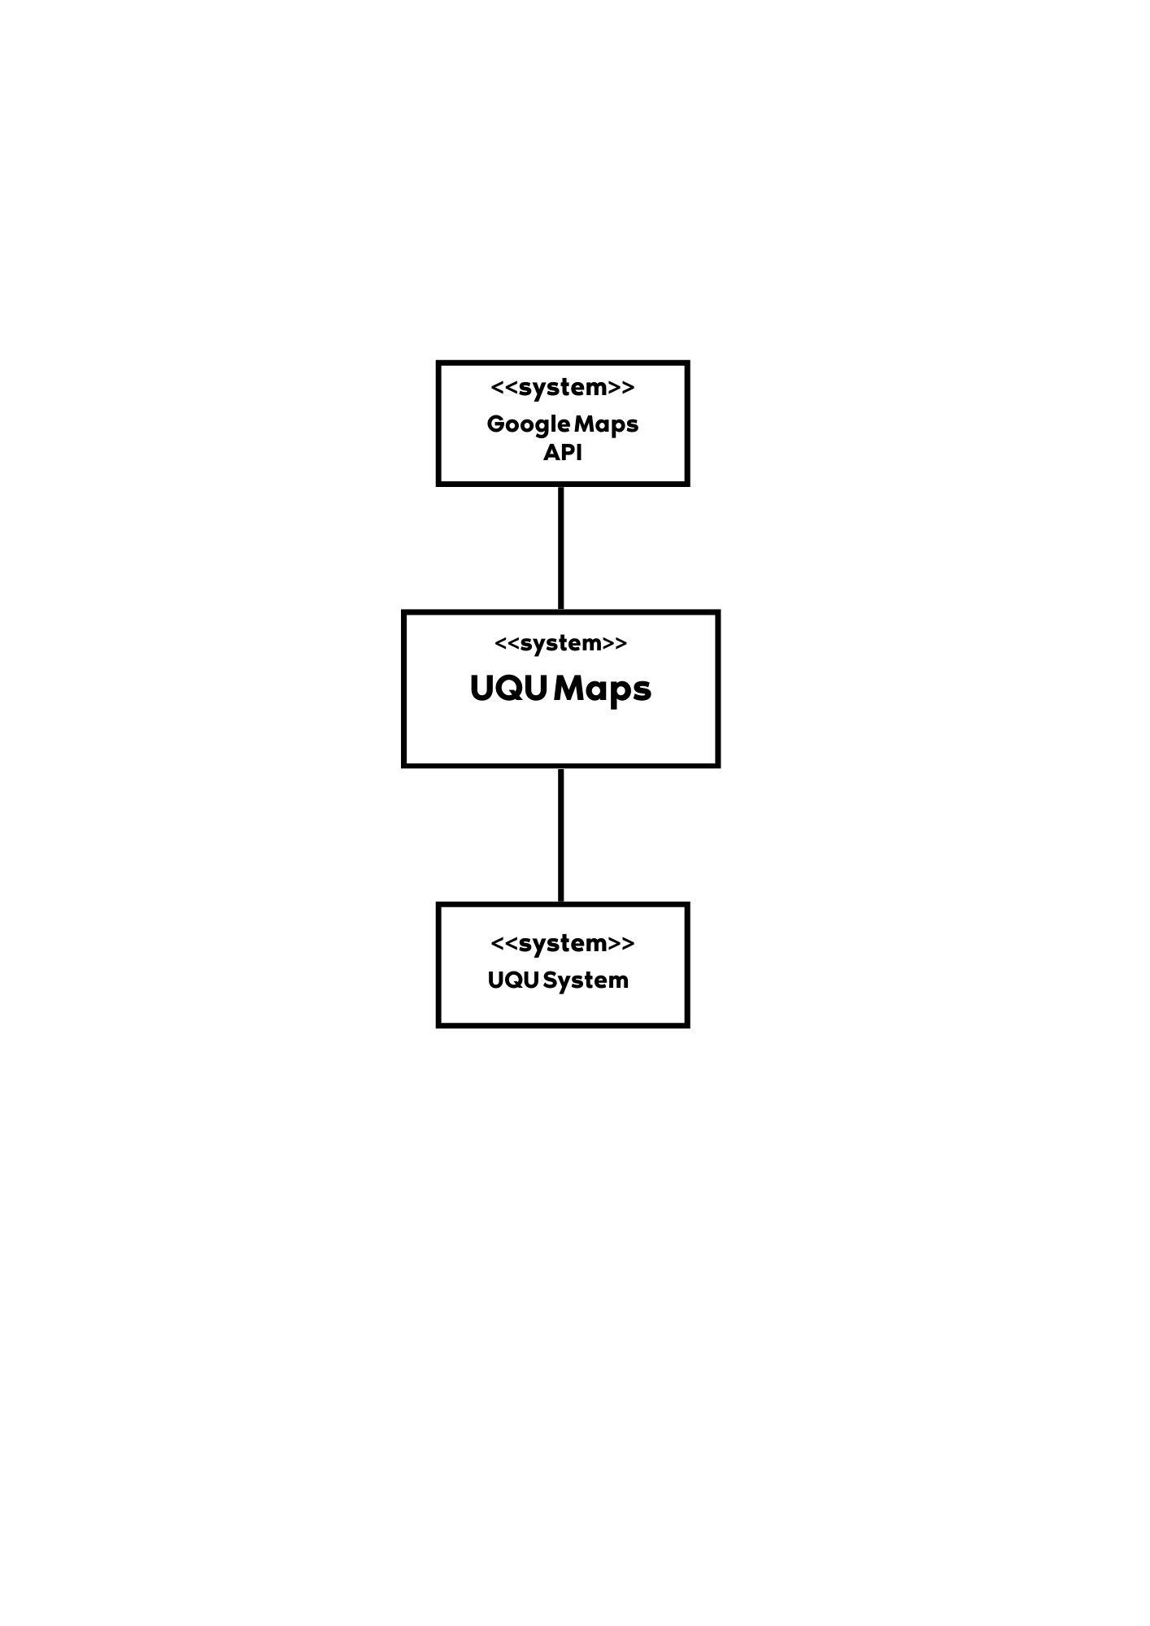

# 

# Architectural Designs

## Client-Server Diagram

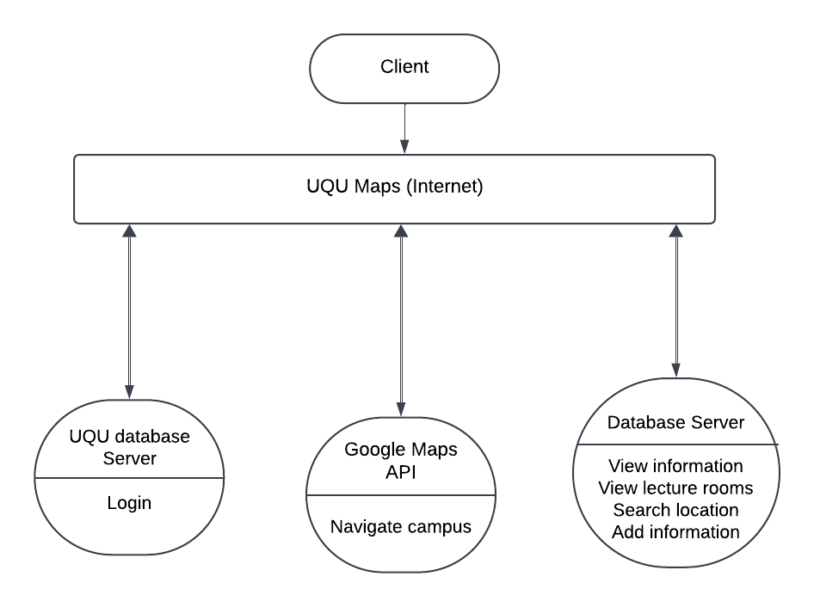

## Layered Diagram:

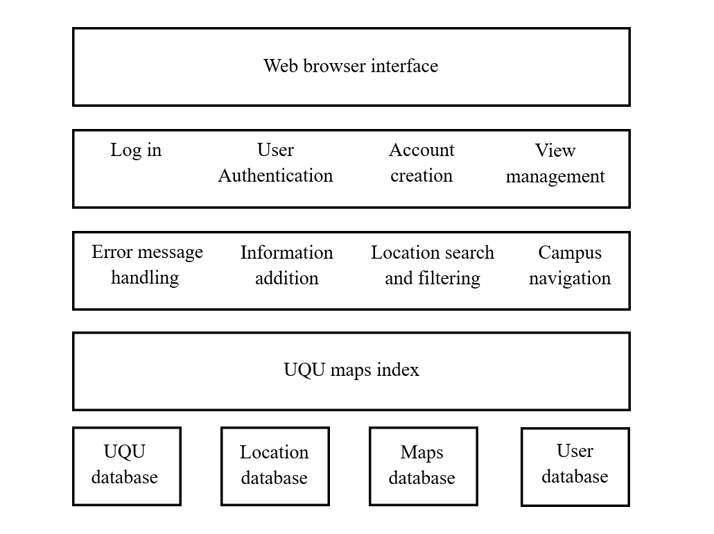

# Appendix A

* 1. **Target User Interview Details:**
     1. **Student Interviews**

| **Interviewee Name** | **Email** | Have you been late to class from getting lost? | Have you had a hard time navigating the campus? And how many times would you say you have been lost? | Have you had a hard time accessing professors' offices? |
| --- | --- | --- | --- | --- |
| Zainab abdullrazzaq fallatah | s445002958@uqu.edu.sa | Yes | Yes , yes about five or more times | Yes |
| Layan Adil Alereinan | s446013127@uqu.edu.sa | Yes, many times due to the buildings | Yes since it’s my first year, I have About 4 times which led me to be late for class but I have been walking with a map which helps a lot. | Not much since most of our professors tell us exactly where to find them from the first lecture |
| Sidra redwan | s446006368@uqu.edu.sa | Yes, I have been late to class especially when it’s on different floors | Yes it’s so big and some buildings look alike, I would say around 5 times one of them being yesterday it’s hard to find the labs | Not really because professors normally provide us the exact location in the first lecture |

* + 1. **Professor Interviews**

| **Interviewee Name** | **Email** | **Have students missed office hours due to location confusion? How often?** | **Have students shown up at the wrong time for office hours? What caused the confusion?** | **Would a clearer, more accessible campus navigation system help students attend office hours or lectures on time?** |
| --- | --- | --- | --- | --- |
| Amirah Alharbi | asauharbi@uqu.edu.sa | Yes, students have occasionally been late or missed office hours due to confusion about the location. This happens infrequently, usually when they are new to the campus or unfamiliar with the building layout. | Yes, there have been instances when students showed up at the wrong time for office hours. This was usually due to misreading the schedule or forgetting the specific time. | Yes, I believe students would be more likely to attend office hours and arrive on time if they had a clearer and more accessible way to navigate the campus, especially to professors’ offices. Better signs, maps (digital), or detailed directions could significantly reduce confusion and improve punctuality. |
| Sarah Alahmadi | smahmadi@uqu.edu.sa | 2 to 5 times every First Semester and the number decreases with time | Yes. Some are inattentive to instructions or do not use reminders. | Yes, a map on google or an app will do. |
| Sohair Soqati | sssoqati@uqu.edu.sa | Yes. | Yes, a map on google or an app will do. | Yes. |

## 

* + 1. **Bus-users**

Interview conducted by Esraa AbdElraheem

| **Interviewee Name** | **Email** | **Have you had any issues with knowing their timings?** | **Have you had any issues with knowing their timings?** |
| --- | --- | --- | --- |
| Shaima Fuad | s445013901@uqu.edu.sa | Yes, I had difficulty at first in locating the bus gate because I did not find any description of the location of the gate | Yes, at first, I didn't know their timings, and it took me some time to figure out their daily schedule |
| Mariam Mohamed | s444015465@uqu.edu.sa | Yes, I didn't even know they existed at first. I found out about them by chance, and when I did, I struggled to figure out where they were located | Yes, I wasn't familiar with their timings, and it took me some time  to find a schedule to follow |
| Shahd Alhuthali | s445006294@uqu.edu.sa | Yes, I learned about their existence through an announcement ,but i didn’t know where they were located, which made it difficult at first | No, I didn't have a problem knowing the times because they were posted at the gate, but if I didn't know where the gate was, I would still be lost |

* + 1. **Business Interviews**

| **Interviewee Name** | **Email** | **Has the unclear location affected your revenue?** | **Do you think the lack of customers is due to poor marketing or unclear location?** |
| --- | --- | --- | --- |
| Nouf Alsufyani | inouf3o@gmail.com | Yes, most students spend a long time asking and searching for the location, and the short time between lectures forces them to go to class without buying anything. | Both. Marketing requires clear promotion of the product list along with precise location details. |
| Amal Alzahrani | vamal.f9@gmail.com | Yes, this has led to a decrease in student purchases and the loss of some products due to expiration. | The unclear location is the main reason. Our marketing is strong, but we receive many comments about the difficulty in finding our place. Despite our photos and posts, some students still don’t know where we are located. |
| Shaima Althobaity | lovelyshai33i@gmail.com | Yes, according to many students, some cafeterias/coffee shops are unknown to them, and sometimes they close before students even find out about their existence. | Both. Many students don't know about the opening of a new cafeteria/coffee shop unless it is advertised on social media platforms. The location also plays a big role, as students usually go to well-known places like cafeterias or coffee shops located in the university garden. |