  - DATABASE DESIGN & REFERENCE

SmartFleet
Schema V1 | PostgreSQL | October 2026
System architecture, entity relationships, operational rules and developer guide
Source of truth: SQL migrations 001–022 supplied with this project. Validation evidence: manual integrity checks and corrected automated suite (18 PASS, 0 FAIL), run by the project owner.

At a glance
28 tables | 40 documented FK links* | 22 schema migrations
* Includes the transfer_id relationship introduced in migration 022; relationship count is extracted from SQL source and may omit programmatic/deferred link checks.

1. The database in plain English
SmartFleet is a digital record book for a small bus transport business. It stores which buses and drivers the business has, who was assigned to a bus and when, how much cash the owner received, what the business spent, and what it owes or is owed. The money records connect back to specific events: for example, a bus cashing collection must agree with the cash received in the account; a driver salary payment must agree with the ledger and any advances recovered; and a bank transfer must account for both sides and its fee. PostgreSQL holds these records in linked tables and checks the important rules automatically, reducing the risk of missing, duplicated or contradictory financial entries. The first application is a Streamlit web interface, but the database is designed to remain usable if the interface later changes to FastAPI and React.

How to read the diagrams
Each rectangle is a database table. Arrows point from the table holding the foreign key to the referenced table. Labels on arrows identify the referencing column. Diagrams are grouped to stay legible on a standard printed page; certain shared tables are repeated for context. Some relationships are enforced by integrity triggers rather than ordinary foreign keys, and are described in the rules section.

2. Architecture and relationship diagrams

Fleet & people
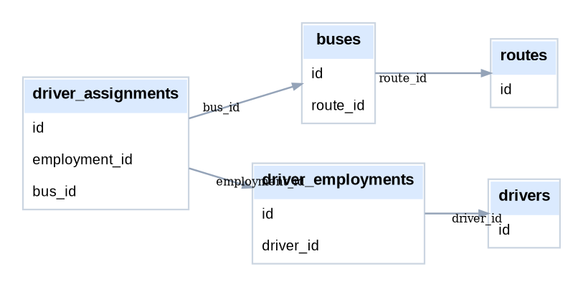
Relationship diagram — Fleet & people

Money & liabilities
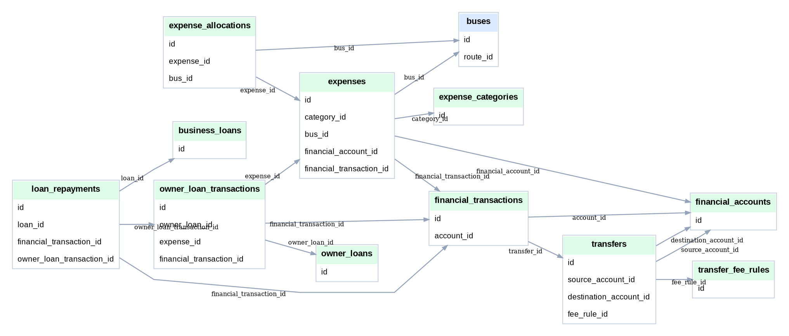
Relationship diagram — Money & liabilities

Revenue & remittances
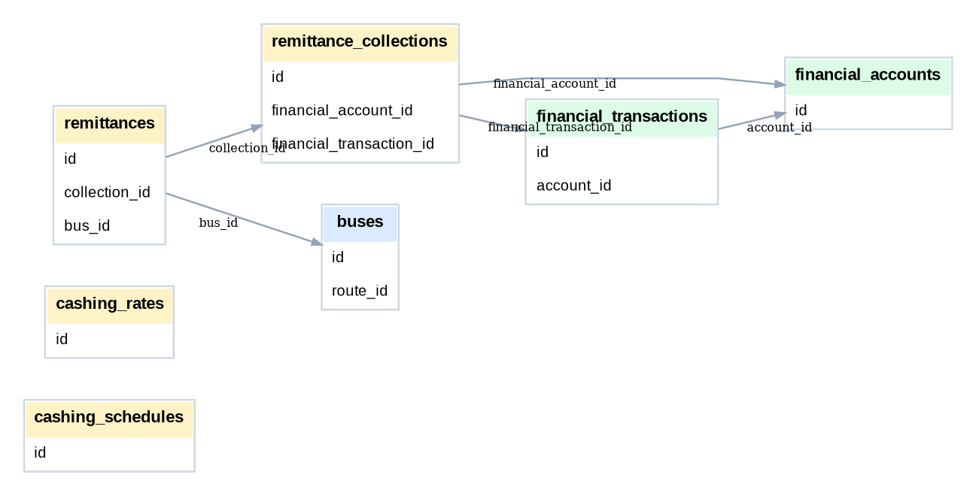
Relationship diagram — Revenue & remittances

Drivers & payroll
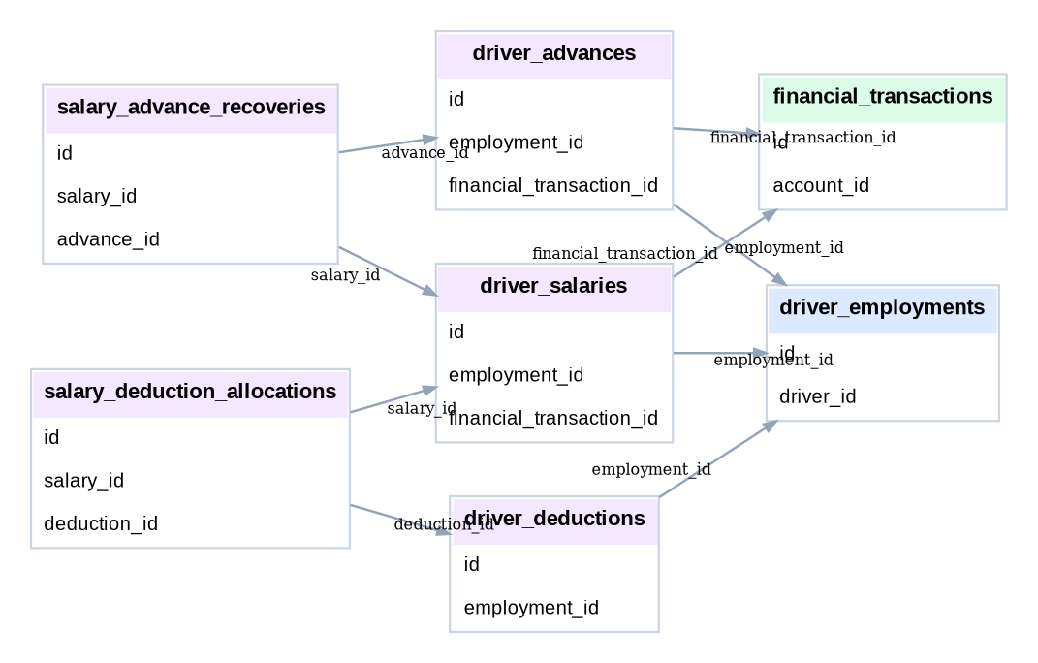
Relationship diagram — Drivers & payroll

Maintenance & reminders
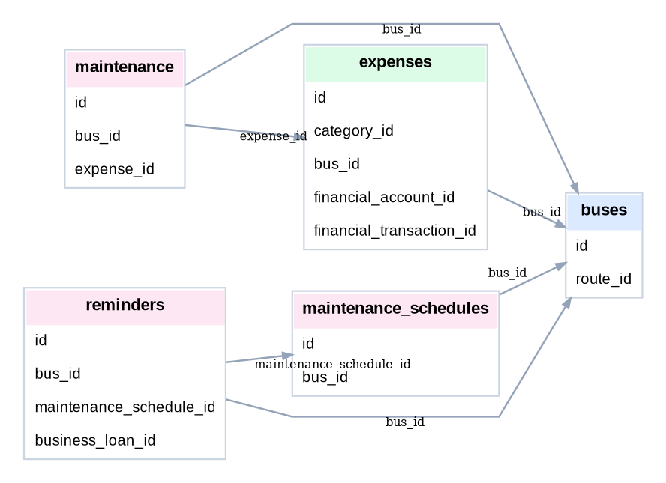
Relationship diagram — Maintenance & reminders

3. Table catalogue
The definitions below list the original creation migration and column definitions, including defaults, generated values and nullable fields where available. Migration 022 adds additional enforcement, which is summarised in the integrity section. PK means primary key; FK means foreign key.

Fleet & people

routes
Introduced in 001 — 001_create_routes.sql
Column | Definition (from CREATE TABLE)
id | INTEGER GENERATED ALWAYS AS IDENTITY PRIMARY KEY
description | TEXT
active | BOOLEAN NOT NULL DEFAULT TRUE
created_at | TIMESTAMP NOT NULL DEFAULT CURRENT_TIMESTAMP
updated_at | TIMESTAMP NOT NULL DEFAULT CURRENT_TIMESTAMP
Relationships: No outgoing foreign keys in source definition.

buses
Introduced in 002 — 002_create_buses.sql
Column | Definition (from CREATE TABLE)
id | INTEGER GENERATED ALWAYS AS IDENTITY PRIMARY KEY
route_id | INTEGER NOT NULL
date_acquired | DATE
notes | TEXT
created_at | TIMESTAMP NOT NULL DEFAULT CURRENT_TIMESTAMP
updated_at | TIMESTAMP NOT NULL DEFAULT CURRENT_TIMESTAMP
Relationships: route_id → routes.id

drivers
Introduced in 003 — 003_create_drivers.sql
Column | Definition (from CREATE TABLE)
id | INTEGER GENERATED ALWAYS AS IDENTITY PRIMARY KEY
address | TEXT
notes | TEXT
created_at | TIMESTAMP NOT NULL DEFAULT CURRENT_TIMESTAMP
updated_at | TIMESTAMP NOT NULL DEFAULT CURRENT_TIMESTAMP
Relationships: No outgoing foreign keys in source definition.

driver_employments
Introduced in 004 — 004_create_driver_employments.sql
Column | Definition (from CREATE TABLE)
id | INTEGER GENERATED ALWAYS AS IDENTITY PRIMARY KEY
driver_id | INTEGER NOT NULL
start_date | DATE NOT NULL
end_date | DATE
notes | TEXT
created_at | TIMESTAMP NOT NULL DEFAULT CURRENT_TIMESTAMP
updated_at | TIMESTAMP NOT NULL DEFAULT CURRENT_TIMESTAMP
Relationships: driver_id → drivers.id

driver_assignments
Introduced in 005 — 005_create_driver_assignments.sql
Column | Definition (from CREATE TABLE)
id | INTEGER GENERATED ALWAYS AS IDENTITY PRIMARY KEY
employment_id | INTEGER NOT NULL
bus_id | INTEGER NOT NULL
start_date | DATE NOT NULL
end_date | DATE
notes | TEXT
created_at | TIMESTAMP NOT NULL DEFAULT CURRENT_TIMESTAMP
updated_at | TIMESTAMP NOT NULL DEFAULT CURRENT_TIMESTAMP
Relationships: employment_id → driver_employments.id; bus_id → buses.id

Money & liabilities

financial_accounts
Introduced in 006 — 006_create_financial_accounts.sql
Column | Definition (from CREATE TABLE)
id | INTEGER GENERATED ALWAYS AS IDENTITY PRIMARY KEY
active | BOOLEAN NOT NULL DEFAULT TRUE
notes | TEXT
created_at | TIMESTAMP NOT NULL DEFAULT CURRENT_TIMESTAMP
updated_at | TIMESTAMP NOT NULL DEFAULT CURRENT_TIMESTAMP
Relationships: No outgoing foreign keys in source definition.

financial_transactions
Introduced in 007 — 007_create_financial_transactions.sql
Column | Definition (from CREATE TABLE)
id | INTEGER GENERATED ALWAYS AS IDENTITY PRIMARY KEY
account_id | INTEGER NOT NULL
transaction_date | DATE NOT NULL
description | TEXT
notes | TEXT
created_at | TIMESTAMP NOT NULL DEFAULT CURRENT_TIMESTAMP
updated_at | TIMESTAMP NOT NULL DEFAULT CURRENT_TIMESTAMP
Relationships: account_id → financial_accounts.id; transfer_id → transfers.id

transfers
Introduced in 008 — 008_create_transfers.sql
Column | Definition (from CREATE TABLE)
id | INTEGER GENERATED ALWAYS AS IDENTITY PRIMARY KEY
transfer_date | DATE NOT NULL
source_account_id | INTEGER NOT NULL
destination_account_id | INTEGER
fee_rule_id | INTEGER
notes | TEXT
created_at | TIMESTAMP NOT NULL DEFAULT CURRENT_TIMESTAMP
updated_at | TIMESTAMP NOT NULL DEFAULT CURRENT_TIMESTAMP
Relationships: source_account_id → financial_accounts.id; destination_account_id → financial_accounts.id; fee_rule_id → transfer_fee_rules.id

transfer_fee_rules
Introduced in 008 — 008_create_transfers.sql
Column | Definition (from CREATE TABLE)
id | INTEGER GENERATED ALWAYS AS IDENTITY PRIMARY KEY
active | BOOLEAN NOT NULL DEFAULT TRUE
notes | TEXT
created_at | TIMESTAMP NOT NULL DEFAULT CURRENT_TIMESTAMP
updated_at | TIMESTAMP NOT NULL DEFAULT CURRENT_TIMESTAMP
Relationships: No outgoing foreign keys in source definition.

expense_categories
Introduced in 010 — 010_create_expenses.sql
Column | Definition (from CREATE TABLE)
id | INTEGER GENERATED ALWAYS AS IDENTITY PRIMARY KEY
active | BOOLEAN NOT NULL DEFAULT TRUE
notes | TEXT
created_at | TIMESTAMP NOT NULL DEFAULT CURRENT_TIMESTAMP
updated_at | TIMESTAMP NOT NULL DEFAULT CURRENT_TIMESTAMP
Relationships: No outgoing foreign keys in source definition.

expenses
Introduced in 010 — 010_create_expenses.sql
Column | Definition (from CREATE TABLE)
id | INTEGER GENERATED ALWAYS AS IDENTITY PRIMARY KEY
expense_date | DATE NOT NULL
category_id | INTEGER NOT NULL
description | TEXT NOT NULL
bus_id | INTEGER
financial_account_id | INTEGER
financial_transaction_id | INTEGER
notes | TEXT
created_at | TIMESTAMP NOT NULL DEFAULT CURRENT_TIMESTAMP
updated_at | TIMESTAMP NOT NULL DEFAULT CURRENT_TIMESTAMP
Relationships: category_id → expense_categories.id; bus_id → buses.id; financial_account_id → financial_accounts.id; financial_transaction_id → financial_transactions.id

expense_allocations
Introduced in 011 — 011_create_expense_allocations.sql
Column | Definition (from CREATE TABLE)
id | INTEGER GENERATED ALWAYS AS IDENTITY PRIMARY KEY
expense_id | INTEGER NOT NULL
bus_id | INTEGER NOT NULL
notes | TEXT
created_at | TIMESTAMP NOT NULL DEFAULT CURRENT_TIMESTAMP
Relationships: expense_id → expenses.id; bus_id → buses.id

owner_loans
Introduced in 012 — 012_create_owner_loans.sql
Column | Definition (from CREATE TABLE)
id | INTEGER GENERATED ALWAYS AS IDENTITY PRIMARY KEY
active | BOOLEAN NOT NULL DEFAULT TRUE
notes | TEXT
created_at | TIMESTAMP NOT NULL DEFAULT CURRENT_TIMESTAMP
updated_at | TIMESTAMP NOT NULL DEFAULT CURRENT_TIMESTAMP
Relationships: No outgoing foreign keys in source definition.

owner_loan_transactions
Introduced in 012 — 012_create_owner_loans.sql
Column | Definition (from CREATE TABLE)
id | INTEGER GENERATED ALWAYS AS IDENTITY PRIMARY KEY
owner_loan_id | INTEGER NOT NULL
transaction_date | DATE NOT NULL
description | TEXT NOT NULL
expense_id | INTEGER
financial_transaction_id | INTEGER
notes | TEXT
created_at | TIMESTAMP NOT NULL DEFAULT CURRENT_TIMESTAMP
Relationships: owner_loan_id → owner_loans.id; expense_id → expenses.id; financial_transaction_id → financial_transactions.id

business_loans
Introduced in 013 — 013_create_business_loans.sql
Column | Definition (from CREATE TABLE)
id | INTEGER GENERATED ALWAYS AS IDENTITY PRIMARY KEY
start_date | DATE NOT NULL
term_months | INTEGER
notes | TEXT
created_at | TIMESTAMP NOT NULL DEFAULT CURRENT_TIMESTAMP
updated_at | TIMESTAMP NOT NULL DEFAULT CURRENT_TIMESTAMP
Relationships: No outgoing foreign keys in source definition.

loan_repayments
Introduced in 013 — 013_create_business_loans.sql
Column | Definition (from CREATE TABLE)
id | INTEGER GENERATED ALWAYS AS IDENTITY PRIMARY KEY
loan_id | INTEGER NOT NULL
repayment_date | DATE NOT NULL
financial_transaction_id | INTEGER
owner_loan_transaction_id | INTEGER
notes | TEXT
created_at | TIMESTAMP NOT NULL DEFAULT CURRENT_TIMESTAMP
Relationships: loan_id → business_loans.id; financial_transaction_id → financial_transactions.id; owner_loan_transaction_id → owner_loan_transactions.id

Revenue & remittances

cashing_schedules
Introduced in 014 — 014_create_remittances.sql
Column | Definition (from CREATE TABLE)
id | INTEGER GENERATED ALWAYS AS IDENTITY PRIMARY KEY
day_of_week | INTEGER NOT NULL
active | BOOLEAN NOT NULL DEFAULT TRUE
notes | TEXT
created_at | TIMESTAMP NOT NULL DEFAULT CURRENT_TIMESTAMP
updated_at | TIMESTAMP NOT NULL DEFAULT CURRENT_TIMESTAMP
Relationships: No outgoing foreign keys in source definition.

cashing_rates
Introduced in 021 — 021_add_cashing_rate_configuration.sql
Column | Definition (from CREATE TABLE)
id | INTEGER GENERATED ALWAYS AS IDENTITY PRIMARY KEY
active | BOOLEAN NOT NULL DEFAULT TRUE
effective_from | DATE NOT NULL DEFAULT CURRENT_DATE
effective_to | DATE
notes | TEXT
created_at | TIMESTAMP NOT NULL DEFAULT CURRENT_TIMESTAMP
updated_at | TIMESTAMP NOT NULL DEFAULT CURRENT_TIMESTAMP
Relationships: No outgoing foreign keys in source definition.

remittance_collections
Introduced in 014 — 014_create_remittances.sql
Column | Definition (from CREATE TABLE)
id | INTEGER GENERATED ALWAYS AS IDENTITY PRIMARY KEY
collection_date | DATE NOT NULL
financial_account_id | INTEGER NOT NULL
financial_transaction_id | INTEGER
notes | TEXT
created_at | TIMESTAMP NOT NULL DEFAULT CURRENT_TIMESTAMP
updated_at | TIMESTAMP NOT NULL DEFAULT CURRENT_TIMESTAMP
Relationships: financial_account_id → financial_accounts.id; financial_transaction_id → financial_transactions.id

remittances
Introduced in 014 — 014_create_remittances.sql
Column | Definition (from CREATE TABLE)
id | INTEGER GENERATED ALWAYS AS IDENTITY PRIMARY KEY
collection_id | INTEGER NOT NULL
bus_id | INTEGER NOT NULL
normal_days | INTEGER NOT NULL DEFAULT 0
sunday_days | INTEGER NOT NULL DEFAULT 0
explanation | TEXT
notes | TEXT
created_at | TIMESTAMP NOT NULL DEFAULT CURRENT_TIMESTAMP
updated_at | TIMESTAMP NOT NULL DEFAULT CURRENT_TIMESTAMP
Relationships: collection_id → remittance_collections.id; bus_id → buses.id

Drivers & payroll

driver_advances
Introduced in 016 — 016_create_driver_finances.sql
Column | Definition (from CREATE TABLE)
id | INTEGER GENERATED ALWAYS AS IDENTITY PRIMARY KEY
employment_id | INTEGER NOT NULL
advance_date | DATE NOT NULL
financial_transaction_id | INTEGER
reason | TEXT
notes | TEXT
created_at | TIMESTAMP NOT NULL DEFAULT CURRENT_TIMESTAMP
updated_at | TIMESTAMP NOT NULL DEFAULT CURRENT_TIMESTAMP
Relationships: employment_id → driver_employments.id; financial_transaction_id → financial_transactions.id

driver_deductions
Introduced in 016 — 016_create_driver_finances.sql
Column | Definition (from CREATE TABLE)
id | INTEGER GENERATED ALWAYS AS IDENTITY PRIMARY KEY
employment_id | INTEGER NOT NULL
deduction_date | DATE NOT NULL
reason | TEXT NOT NULL
applied | BOOLEAN NOT NULL DEFAULT FALSE
notes | TEXT
created_at | TIMESTAMP NOT NULL DEFAULT CURRENT_TIMESTAMP
updated_at | TIMESTAMP NOT NULL DEFAULT CURRENT_TIMESTAMP
Relationships: employment_id → driver_employments.id

driver_salaries
Introduced in 017 — 017_create_driver_salaries.sql
Column | Definition (from CREATE TABLE)
id | INTEGER GENERATED ALWAYS AS IDENTITY PRIMARY KEY
employment_id | INTEGER NOT NULL
salary_year | INTEGER NOT NULL
salary_month | INTEGER NOT NULL
payment_date | DATE
financial_transaction_id | INTEGER
notes | TEXT
created_at | TIMESTAMP NOT NULL DEFAULT CURRENT_TIMESTAMP
updated_at | TIMESTAMP NOT NULL DEFAULT CURRENT_TIMESTAMP
Relationships: employment_id → driver_employments.id; financial_transaction_id → financial_transactions.id

salary_advance_recoveries
Introduced in 019 — 019_add_integrity_and_indexes.sql
Column | Definition (from CREATE TABLE)
id | INTEGER GENERATED ALWAYS AS IDENTITY PRIMARY KEY
salary_id | INTEGER NOT NULL
advance_id | INTEGER NOT NULL
created_at | TIMESTAMP NOT NULL DEFAULT CURRENT_TIMESTAMP
Relationships: salary_id → driver_salaries.id; advance_id → driver_advances.id

salary_deduction_allocations
Introduced in 019 — 019_add_integrity_and_indexes.sql
Column | Definition (from CREATE TABLE)
id | INTEGER GENERATED ALWAYS AS IDENTITY PRIMARY KEY
salary_id | INTEGER NOT NULL
deduction_id | INTEGER NOT NULL
created_at | TIMESTAMP NOT NULL DEFAULT CURRENT_TIMESTAMP
Relationships: salary_id → driver_salaries.id; deduction_id → driver_deductions.id

Maintenance & reminders

maintenance
Introduced in 015 — 015_create_maintenance.sql
Column | Definition (from CREATE TABLE)
id | INTEGER GENERATED ALWAYS AS IDENTITY PRIMARY KEY
bus_id | INTEGER NOT NULL
description | TEXT NOT NULL
reported_date | DATE NOT NULL
start_date | DATE
completed_date | DATE
expense_id | INTEGER
downtime_start | DATE
downtime_end | DATE
notes | TEXT
created_at | TIMESTAMP NOT NULL DEFAULT CURRENT_TIMESTAMP
updated_at | TIMESTAMP NOT NULL DEFAULT CURRENT_TIMESTAMP
Relationships: bus_id → buses.id; expense_id → expenses.id

maintenance_schedules
Introduced in 015 — 015_create_maintenance.sql
Column | Definition (from CREATE TABLE)
id | INTEGER GENERATED ALWAYS AS IDENTITY PRIMARY KEY
bus_id | INTEGER NOT NULL
interval_days | INTEGER NOT NULL DEFAULT 35
last_completed_date | DATE
next_due_date | DATE
active | BOOLEAN NOT NULL DEFAULT TRUE
notes | TEXT
created_at | TIMESTAMP NOT NULL DEFAULT CURRENT_TIMESTAMP
updated_at | TIMESTAMP NOT NULL DEFAULT CURRENT_TIMESTAMP
Relationships: bus_id → buses.id

reminders
Introduced in 018 — 018_create_reminders.sql
Column | Definition (from CREATE TABLE)
id | INTEGER GENERATED ALWAYS AS IDENTITY PRIMARY KEY
description | TEXT
due_date | DATE NOT NULL
bus_id | INTEGER
maintenance_schedule_id | INTEGER
business_loan_id | INTEGER
completed_date | DATE
notes | TEXT
created_at | TIMESTAMP NOT NULL DEFAULT CURRENT_TIMESTAMP
updated_at | TIMESTAMP NOT NULL DEFAULT CURRENT_TIMESTAMP
Relationships: bus_id → buses.id; maintenance_schedule_id → maintenance_schedules.id; business_loan_id → business_loans.id

4. Understanding the principal workflows

Bus and driver records
A bus belongs to a route. Drivers are people, employments describe the period they work for the business, and driver assignments connect an employment to a bus over a date range. Historical records are retained rather than overwritten.

Cashing and account balance
A remittance_collection describes an occasion on which money is received; its remittances describe contributions from individual buses. A linked inbound financial_transaction records the same total in the selected financial account. Expected amounts are derived from the stored day counts/rates; variance explains differences from actual cash.

Expenses and owner-paid costs
An expense describes what was purchased or paid for and which bus(es) or general business activity it relates to. BUSINESS_ACCOUNT expenses must match an outgoing ledger movement. OWNER_PERSONAL expenses are paid with the owner’s money, so they create an owner-loan obligation instead of a business-account cash movement.

Transfers between accounts
The transfer record describes an outgoing account, incoming account, amount, fee and type. Matched ledger movements represent the source outflow and destination inflow, plus any fee charged. An external transfer may have different accounting treatment; use the deferred validator as authority.

Borrowing and repayment
Business borrowing/repayments and owner funding are tracked separately. When the owner directly pays an outside business lender, the debt is effectively transferred from that lender to the owner without pretending that business cash changed hands.

Driver salary and advances
Advance payments are recorded and connected to outgoing financial entries. Salaries calculate the payable net amount after recoveries and deductions. Allocation tables assign recoveries to specific advances/deductions, preventing an advance being recovered twice or against the wrong driver.

Maintenance and reminders
Maintenance is an operational event, not automatically an expense. It can refer to a corresponding expense when money is spent, but a complimentary check can have no expense. Maintenance schedules and reminders help track future work.

5. Constraints, indexes, triggers and integrity guarantees
The database uses conventional primary keys, foreign keys, uniqueness checks, controlled status/type values, valid date/amount checks, selective unique indexes and deferred cross-table validation. Deferred checks allow one application transaction to insert interconnected records in any appropriate order, then validate their final combined state when constraints are forced immediate or at COMMIT.

Migration 022 verification functions
- sf_suggest_transfer_fee — suggest transfer fee
- sf_is_external_transfer — is external transfer
- sf_assert_transfer — Validate transfer
- sf_assert_expense — Validate expense
- sf_assert_collection — Validate collection
- sf_assert_advance — Validate advance
- sf_assert_deduction — Validate deduction
- sf_assert_salary — Validate salary
- sf_assert_owner_loan_transaction — Validate owner loan transaction
- sf_assert_owner_balance — Validate owner balance
- sf_assert_loan_repayment — Validate loan repayment
- sf_assert_business_loan — Validate business loan
- sf_assert_employment — Validate employment
- sf_assert_maintenance — Validate maintenance
- sf_assert_ledger — Validate ledger
- sf_assert_rate — Validate rate
- sf_assert_fee_rule — Validate fee rule
- sf_integrity_deferred — integrity deferred
- sf_preserve_account_type — preserve account type
- sf_touch_updated_at — touch updated at

Examples of database-enforced invariants
- Cashing collection amount must reconcile with individual bus remittances and inbound account ledger.
- Business-funded expenses must match an outgoing ledger item of the correct amount, date and account.
- Owner-funded expenses require matching OWNER_FUNDED evidence and must not fabricate a cash outflow from a business account.
- Transfers require matching entries for movement between accounts and any fee.
- Paid driver salaries must reconcile with the matching payment and recovery allocation records.
- Recovery allocations must belong to the same employment and cannot exceed an advance or deduction.
- Business loan repayments cannot exceed the outstanding loan amount.
- Maintenance cannot be attached to an expense belonging to a different bus; no-cost events need no expense.
- Configured fee bands and effective cashing rates cannot overlap improperly.
- Employment and bus assignment periods/status must be compatible.
- updated_at is automatically touched by a trigger for supported tables.

6. Migration history
001_create_routes.sql — Create routes.
002_create_buses.sql — Create buses.
003_create_drivers.sql — Create drivers.
004_create_driver_employments.sql — Create driver employments.
005_create_driver_assignments.sql — Create driver assignments.
006_create_financial_accounts.sql — Create financial accounts.
007_create_financial_transactions.sql — Create financial transactions.
008_create_transfers.sql — Create transfers.
009_seed_transfer_fee_rules.sql — Seed transfer fee rules.
010_create_expenses.sql — Create expenses.
011_create_expense_allocations.sql — Create expense allocations.
012_create_owner_loans.sql — Create owner loans.
013_create_business_loans.sql — Create business loans.
014_create_remittances.sql — Create remittances.
015_create_maintenance.sql — Create maintenance.
016_create_driver_finances.sql — Create driver finances.
017_create_driver_salaries.sql — Create driver salaries.
018_create_reminders.sql — Create reminders.
019_add_integrity_and_indexes.sql — Add integrity and indexes.
020_seed_initial_configuration.sql — Seed initial configuration.
021_add_cashing_rate_configuration.sql — Add cashing rate configuration.
022_smartfleet_schema_v1_hardening_corrected.sql — Schema V1 hardening: additional structural checks, matching-ledger validators, deferred constraint triggers, fee/rate overlap and timestamp protection.

7. Validation evidence
Before the automated run, ten manual integrity scenarios passed, covering remittance totals, transfer reconciliation, expense/ledger matching and unsupported owner funding. The corrected automated script then reported 18 tests, 18 passes and 0 failures, with a final ROLLBACK. An initial version reported 16/18 because of test-fixture dependencies; it was corrected and re-run. These results are evidence of the tested invariants, not proof of exhaustive correctness or security.
# | Scenario | Result
01 | Owner personal expense + loan | PASS
02 | Unbacked owner repayment rejected | PASS
03 | Matched owner deposit | PASS
04 | Overpaid business loan rejected | PASS
05 | Owner pays business lender | PASS
06 | Matching driver advance | PASS
07 | Mismatched driver advance rejected | PASS
08 | Missing salary recovery allocation rejected | PASS
09 | Cross-driver recovery rejected | PASS
10 | Matching paid payroll | PASS
11 | Wrong-bus maintenance expense rejected | PASS
12 | No-cost completed maintenance | PASS
13 | Automatic updated_at | PASS
14 | Overlapping fee rule rejected | PASS
15 | Overlapping cashing rate rejected | PASS
16 | Fee suggestion calculations | PASS
17 | Terminated assignment rejected | PASS
18 | Advance over-recovery rejected | PASS

8. Implementation guidance and operating practices

Keep operations atomic
Create a single application transaction for business operations involving several tables. Insert the necessary records; validate the final state; commit only when every component succeeds. Roll back on exceptions.

Separate the API from the database
Streamlit may initially call a Python service/repository layer, but avoid writing business logic only in UI handlers. A future FastAPI endpoint can reuse the same domain operations and database rules.

Calculate rather than duplicate
Use generated columns and server-side validations as the authoritative result for net salary, cashing variance and financially significant relationships. Do not rely only on UI arithmetic.

Accountability
Use least-privilege database roles, prepared statements/parameterised queries, environment-managed secrets, secure passwords and tested backups before live deployment. Authentication and access policies remain a separate application/security phase.

Versioning and changes
Treat migrations as append-only history after application. Never casually re-run 022 on a database where it has already been committed; introduce a new numbered migration for future schema changes. Keep corrected source files with one canonical filename.

Testing
Rerun the test suite in a disposable development/test database after every migration, and add tests for every discovered defect. The suite intentionally ROLLBACKs; do not use it as a live-data import.

Performance
Monitor query plans before adding indexes indiscriminately. Pay particular attention to date-filtered financial reports, current bus assignments, loan balances and salary reporting.

9. Scope boundaries and open decisions
- The MVP does not require recording individual journeys or tracking fuel consumption.
- No-cost maintenance is permitted; maintenance records are not forcibly treated as payments.
- The schema records operational/financial data; it is not by itself a complete authentication, authorization or audit-log solution.
- Business policy should still settle reporting definitions (gross vs net), company-wide versus bus expenses, and operational permissions.
- Actual application end-to-end tests, concurrent-session tests, backup/restore drills and permissions testing remain future work.

Appendix A — Foreign-key relationship register
Dependent table.column | References
buses.route_id | routes.id
driver_advances.employment_id | driver_employments.id
driver_advances.financial_transaction_id | financial_transactions.id
driver_assignments.bus_id | buses.id
driver_assignments.employment_id | driver_employments.id
driver_deductions.employment_id | driver_employments.id
driver_employments.driver_id | drivers.id
driver_salaries.employment_id | driver_employments.id
driver_salaries.financial_transaction_id | financial_transactions.id
expense_allocations.bus_id | buses.id
expense_allocations.expense_id | expenses.id
expenses.bus_id | buses.id
expenses.category_id | expense_categories.id
expenses.financial_account_id | financial_accounts.id
expenses.financial_transaction_id | financial_transactions.id
financial_transactions.account_id | financial_accounts.id
financial_transactions.transfer_id | transfers.id
loan_repayments.financial_transaction_id | financial_transactions.id
loan_repayments.loan_id | business_loans.id
loan_repayments.owner_loan_transaction_id | owner_loan_transactions.id
maintenance.bus_id | buses.id
maintenance.expense_id | expenses.id
maintenance_schedules.bus_id | buses.id
owner_loan_transactions.expense_id | expenses.id
owner_loan_transactions.financial_transaction_id | financial_transactions.id
owner_loan_transactions.owner_loan_id | owner_loans.id
reminders.bus_id | buses.id
reminders.business_loan_id | business_loans.id
reminders.maintenance_schedule_id | maintenance_schedules.id
remittance_collections.financial_account_id | financial_accounts.id
remittance_collections.financial_transaction_id | financial_transactions.id
remittances.bus_id | buses.id
remittances.collection_id | remittance_collections.id
salary_advance_recoveries.advance_id | driver_advances.id
salary_advance_recoveries.salary_id | driver_salaries.id
salary_deduction_allocations.deduction_id | driver_deductions.id
salary_deduction_allocations.salary_id | driver_salaries.id
transfers.destination_account_id | financial_accounts.id
transfers.fee_rule_id | transfer_fee_rules.id
transfers.source_account_id | financial_accounts.id

Appendix B — Provenance
Compiled from the uploaded migrations.zip containing migrations 001–022 and smartfleet_integrity_tests_corrected.sql. This is source-derived documentation, not a fresh introspection of a running PostgreSQL instance. The applied database and source migrations should remain in sync.

