Part 1

Number of inliers: 25

Average residual for inliers: 12627.442554473877

inlier matches on both images

The code provided wasn’t displaying the points correctly so I removed them and printed them out. I hope that is ok. The first two columns are points on the left image the next two are points on the right.

[[144.32453918 233.30786133 626.2166748 220.44540405]]

[[144.32453918 233.30786133 626.2166748 220.44540405]]

[[147.52110291 239.19352722 628.40960693 225.61329651]]

[[152.2006073 235.10426331 632.11047363 221.97640991]]

[[152.2006073 235.10426331 632.11047363 221.97640991]]

[[153.67512512 248.99191284 633.59002686 234.04315186]]

[[160.7375946 259.9354248 639.05322266 243.58189392]]

[[160.9717865 244.85514832 638.65063477 229.87854004]]

[[162.96340942 262.09185791 641.37457275 245.46795654]]

[[168.41984558 250.50714111 644.63891602 235.14878845]]

[[168.62832642 241.3445282 646.25109863 227.35877991]]

[[175.55024719 247.13389587 650.29449463 232.01254272]]

[[175.68890381 241.36856079 650.70397949 226.8812561 ]]

[[179.45954895 241.89733887 653.42956543 227.36500549]]

[[182.2063446 252.02983093 656.38952637 236.18432617]]

[[187.77606201 248.39355469 660.97149658 233.03985596]]

[[190.00354004 243.41711426 662.61529541 228.34895325]]

[[192.83633423 241.34741211 664.88189697 226.47108459]]

[[196.71009827 253.73652649 668.76324463 237.43945312]]

[[198.72183228 246.12512207 669.62640381 230.48876953]]

[[203.87217712 250.09638977 674.4486084 234.04595947]]

[[206.62162781 245.55010986 676.07995605 229.91464233]]

[[208.16035461 243.24491882 677.87164307 227.77636719]]

[[220.59849548 246.93249512 689.00842285 230.62268066]]

[[224.10609436 253.04472351 692.60144043 236.08215332]]

[[227.2865448 241.92651367 694.97833252 226.19482422]]

[[238.24319458 237.91766357 705.61523438 222.39398193]]

[[269.13250732 303.91470337 742.79772949 279.04769897]]

[[269.13250732 303.91470337 742.79772949 279.04769897]]

[[272.81616211 231.83233643 742.10131836 213.47471619]]

[[273.6668396 290.33288574 746.60845947 266.67816162]]

[[273.6668396 290.33288574 746.60845947 266.67816162]]

[[273.75692749 255.47097778 744.21417236 234.94943237]]

[[274.60421753 321.21429443 749.87670898 295.00863647]]

[[274.69815063 293.42495728 748.03308105 269.55389404]]

[[274.99533081 287.1322937 747.89251709 263.53036499]]

[[276.21923828 207.77636719 741.0090332 191.83172607]]

[[276.69631958 190.19692993 740.85247803 176.05149841]]

[[276.92941284 247.32873535 746.44238281 227.28184509]]

[[277.65881348 319.28878784 752.88946533 293.80502319]]

[[278.17993164 312.58840942 752.8838501 287.43496704]]

[[279.34729004 250.43692017 749.43133545 230.38517761]]

[[279.34729004 250.43692017 749.43133545 230.38517761]]

[[280.77578735 231.85339355 750.46472168 213.23910522]]

[[280.92260742 292.76272583 754.00927734 268.89477539]]

[[282.96789551 209.10546875 747.76971436 192.72618103]]

[[283.87741089 298.13717651 757.61877441 273.90161133]]

[[284.88613892 303.89324951 759.38482666 279.32553101]]

[[285.37615967 268.03610229 756.69946289 246.85108948]]

[[286.19302368 308.94155884 760.38336182 283.7243042 ]]

[[286.32012939 256.33258057 756.20910645 235.55647278]]

[[286.32012939 256.33258057 756.20910645 235.55647278]]

[[288.17443848 279.11752319 760.19067383 256.27770996]]

[[288.49993896 302.82241821 762.41290283 277.99298096]]

[[288.97659302 200.83357239 753.36322021 185.05911255]]

[[289.78134155 307.49957275 764.62719727 282.56640625]]

[[290.01876831 232.02746582 760.02526855 213.20300293]]

[[290.1895752 259.04681396 760.50952148 238.10993958]]

[[290.28076172 208.45527649 755.36315918 191.83274841]]

[[291.02752686 179.76538086 752.96331787 166.26525879]]

[[291.28695679 211.75912476 756.04974365 195.01646423]]

[[291.62908936 250.03898621 761.32171631 229.60025024]]

[[291.70251465 255.86538696 762.04711914 234.93824768]]

[[291.89053345 274.68106079 763.42749023 251.86747742]]

[[292.26693726 289.10839844 765.40802002 265.32623291]]

[[293.59970093 246.95014954 763.21191406 226.48814392]]

[[294.21148682 228.18066406 762.5144043 209.6399231 ]]

[[295.8265686 176.25396729 757.79296875 162.55149841]]

[[296.00976562 238.34216309 765.83508301 218.87159729]]

[[296.39123535 189.0531311 759.41577148 173.94197083]]

[[296.50213623 256.63552856 767.1005249 235.55050659]]

[[296.58132935 164.59422302 756.89324951 152.26295471]]

[[298.18005371 179.19848633 760.62426758 164.88368225]]

[[298.44903564 183.02690125 761.03668213 168.5793457 ]]

[[298.98687744 211.98381042 763.87762451 195.05888367]]

[[299.03341675 294.64880371 772.76483154 270.36413574]]

[[300.00588989 260.04074097 771.06707764 238.75621033]]

[[301.21395874 272.27801514 773.29803467 249.61183167]]

[[303.78543091 243.42585754 774.04949951 223.30749512]]

[[304.25509644 312.06002808 778.39276123 286.67269897]]

[[304.87915039 280.05163574 777.30377197 257.00643921]]

[[305.54776001 294.06634521 779.31951904 269.98239136]]

[[305.5531311 283.28869629 778.4543457 259.99905396]]

[[305.76989746 291.11798096 778.99926758 267.13848877]]

[[305.76989746 291.11798096 778.99926758 267.13848877]]

[[306.98348999 288.4770813 780.33361816 264.69787598]]

[[307.19949341 193.61782837 771.06427002 177.96559143]]

[[308.01040649 232.43972778 778.67712402 213.01063538]]

[[308.03277588 256.13278198 779.10357666 234.89468384]]

[[308.10067749 238.5045166 778.28668213 218.56884766]]

[[308.92260742 273.52966309 781.48669434 251.00027466]]

[[309.05218506 280.52963257 782.18988037 257.29055786]]

[[310.728302 247.85514832 780.93212891 226.95103455]]

[[311.10220337 253.17327881 781.82910156 232.1322937 ]]

[[312.20025635 256.67755127 783.51342773 235.22459412]]

[[312.42047119 276.9520874 784.95825195 253.91755676]]

[[315.18270874 276.79052734 788.0010376 253.45855713]]

[[315.34292603 232.49411011 786.22564697 212.90901184]]

[[315.61413574 306.49728394 790.65911865 281.31192017]]

[[316.06369019 238.50547791 786.68878174 218.35273743]]

[[316.18395996 310.21395874 791.40960693 284.87173462]]

[[319.07632446 303.1423645 794.32611084 277.99353027]]

[[320.11453247 211.97259521 785.5880127 194.21936035]]

[[320.2227478 232.73739624 790.72186279 212.98858643]]

[[320.23565674 239.46316528 790.69024658 219.4553833 ]]

[[324.04211426 203.75239563 788.88891602 186.69410706]]

[[324.2043457 210.62217712 789.14215088 193.01411438]]

[[324.2043457 210.62217712 789.14215088 193.01411438]]

Show final composite image

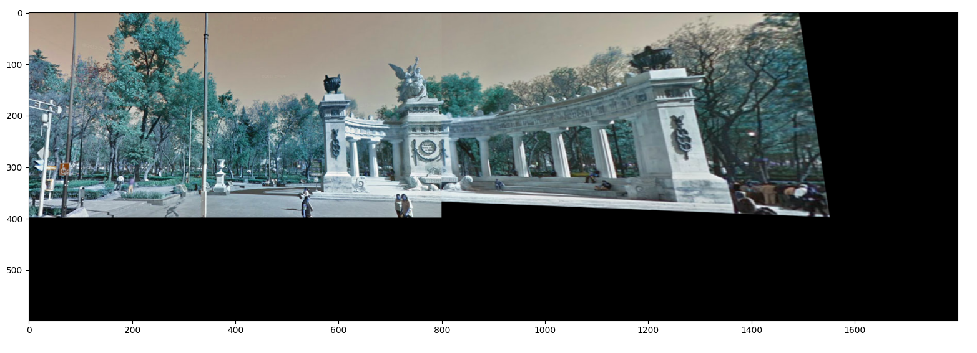

Description of Solution

I implemented the function return_pairs, make_correspondence_list, and homography. Homagraphy has several different functions which I used to come up with the solution. The key method is ransac. The parameters I used were 170 for the distance threshold, and 10 for the homography.ransac threshold.

|  |  |
| --- | --- |
| Distance threshold param | 170 |
| Ransac threshold param | 10.0 |