**Question1**

The provided code to display the image isn’t working correctly. I used my time to debug my Fundamental Matrix algorithm and not on the provided code to get the most points. Below you can see the lines it was able to draw without the image displayed.

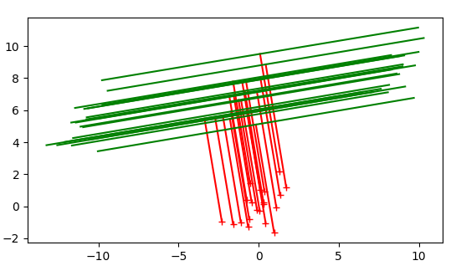

Here is the image without the **# ax.imshow(np.array(I2).astype(float))** commented out. You can see that the image is covering the lines so you can see them.

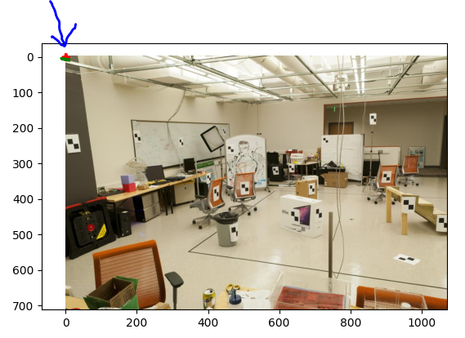

**2. Camera calibration** calculate the camera projection matrices by using 2D matches

The provided code it not working. I did not have time to debug the code so I created my own function to calculate the residual.

camera projection matrices

Matrix 1 on first image

[-7.52854819e-03 9.16157158e-03 -1.88196659e-02 1.80100646e-02

-2.48034349e-03 -2.72894315e-03 2.00368374e-02 9.99367750e-01

-1.23820782e-05 -9.25192866e-06 3.94612486e-05 5.46523038e-03]

Matrix 2 on second image

[[-5.16994125e-02 5.25794245e-02 -1.96761474e-02 1.51630904e-02]

[-1.14744166e-02 4.17061089e-03 3.79988332e-02 9.96113148e-01]

[-5.54842179e-05 3.20363698e-05 -1.25116468e-04 1.05410338e-02]]

Residual

18.3734724596336

3. **Calculate the camera centers** using the estimated or provided projection matrices for both pairs.

Camera center 1

[[305.4281775 311.33418738 30.33474436]]

Camera center 2

[[296.80175427 302.83673714 30.17196943]]

