Invasion of the Chinese mitten crab

Development of a monitoring sensor: sensor alternative

# Proposal

I think it is possible to make a decent crab counting sensor without the need for more advanced technologies like machine learning etc. I hope to accomplish this by making use of some of the natural characteristics of the crabs. The main ones being: they can survive outside of water, they can climb vertically on a mesh and they are the only species found in Flemish waters with these two characteristics. This sensor would consist of a tube that is laid flat on the river bed aligned with the flow of the water to not disrupt the natural flow. Above the tube is a smaller tube filled with air. The crabs can reach this air pocket by climbing a mesh that prevents them from going straight in the ground tube. This mesh stops the crabs but lets water, mud, small stones and small organisms pass freely. Once in the air pocket the crabs would move forward and fall into the water tube again. While they are falling they can be counted with a sensor that works based on the disruption of a light beam. They can not go back since the exist does not have a mesh, preventing a crab from being counted twice. The whole setup is held in place by a heavy piece of stone.

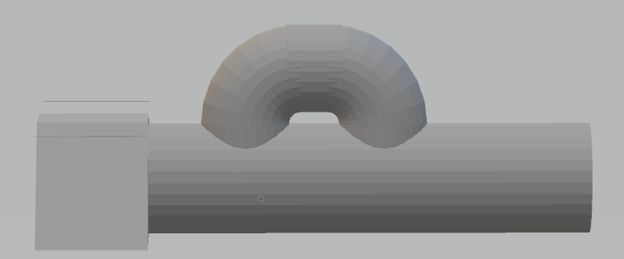

: side view

The front of the picture above is the weight to keep the contraption at its desired position. The middle is the ground tube, which rests on the river surface and is filled with water. The top is the air/counting chamber. It is important that the contraption never rolls over otherwise the top chamber can fill with water. That is why the weight at the front has a trapezoid shape.

: front view

The mesh is located right after the first hole leading to the top chamber. Giving access to the entrance of the top chamber but not to the exit.

3: top chamber entrance

4: top chamber exit

It might be necessary to make the top chamber longer to prevent the crabs from climbing up at the exit again. But in general because of the crabs migrating behaviour I do not think many will try to go against the alignment of the trap (trap has to be aligned correctly ofc.) The trap in the pictures is configured to count crabs going with the flow of water. The trap can also be used for crabs going in the other direction by changing the position of the weight from the front to the back.

The crabs are counted when they interrupt a light source while falling from the end of the air chambre back into the water tube. They can not go back up because there is no mesh to climb at the exit.

5: route illustration

Blue: waterflow, black: waterline, white: mesh, red: counting sensor, orange: crab route, green: crab trying to go back.

The light beam sensor sends signals trough a waterproof cable to the shore. The data arriving at the shore is processed by a microcontroller (add 1 for each pulse to count). From here on the data can be stored on site and await collection or can be transmitted trough a low power wide area network.

|  |  |
| --- | --- |
| Advantages | Disadvantages |
| Low-tech | Tube can clog |
| Easy to place/ maintain | Air chamber can fill with water destroying equipment |
| Natural waterflow not disrupted | Mesh would catch bigger rocks or would not catch smaller crabs |
| Low maintenance | Crab might prefer other route |
| Low cost | A lot of crabs might clog the system |
| Crab can not keep standing in front of sensor | A lot of crabs might give some inaccuracies when counting |
| Crab only counted once if we can assume that they don’t turn back and go around the contraption back to the entrance | Crab can be counted twice if it for some reason decides to go around the contraption and enters from the entrance again. |

# Questions

1. Can we assume the crabs to be evenly distributed over the ground surface of the water body?
   1. If yes -> can use math to calculate approximation of crabs passing point in river.
   2. If no -> need some sort of funnelling system to only allow crabs to pass trough certain points without disrupting natural water flow.
2. Do crabs prefer to go trough tubes? Or do they hate it?
3. Are crabs smart enough (or maybe instinct or something) to go to the upper air chamber instead of just all clogging the entrance or even preferring to move back?
   1. If no -> Can angle the mesh a bit to smooth transition
4. What is the smallest space a small crab can fit through?
   1. To decide optimal mesh size
5. How long can we assume this system to remain operational until segment build-up, rocks and plants clog it?
6. …