Report Online Food Order

Introduction: ONLINE FOOD ORDER is a website designed primarily for use in the food delivery industry. This system will allow hotels and restaurants to increase scope of business by reducing the labor cost involved.

Features:

* User Registration
* Food Menu
* Food Order
* Food Cart
* Order History
* Admin

Functions:

* Create an account
* Log in to the System
* Place order from Food Menu

Online Food Order Systems:

* Web Ordering System - provides the functionality for customers to place their order and supply necessary details.
* Menu Management - allows the restaurant to control what can be ordered by the customers.
* Order Retrieval System - This is a final logical component. Allows restaurant to keep track of all orders placed. This component takes care of order retrieving and displaying order information.

System Visualization:

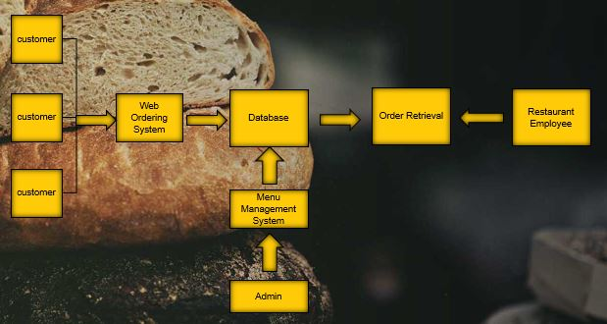

Technology Used:

* PHP
* BOOTSTRAP
* JAVASCRIPT
* HTML & CSS

ERD Diagram:

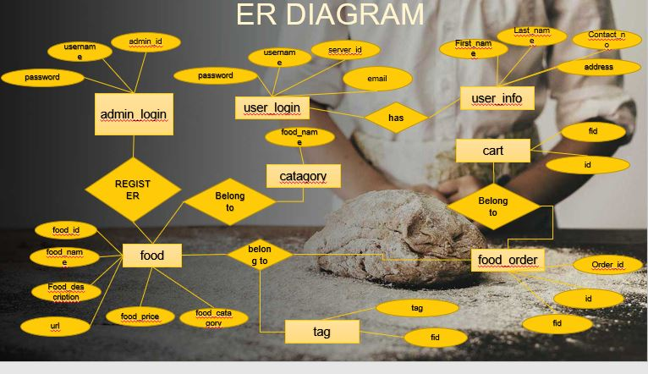

Database Design:

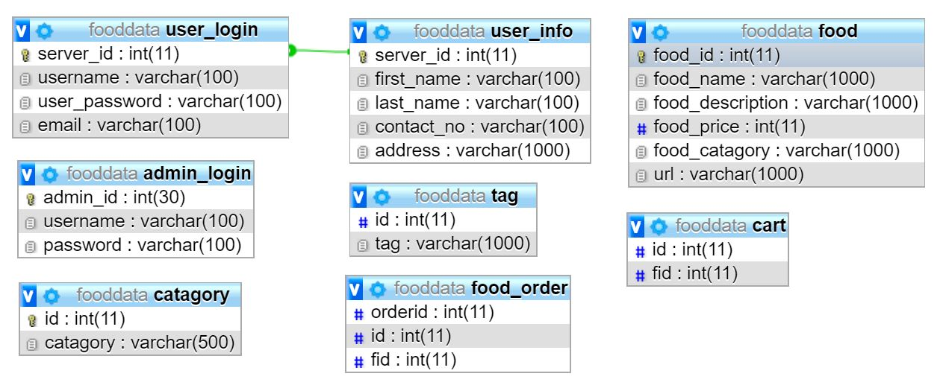

Full Web View of Online Food

Homepage



User Signup Form

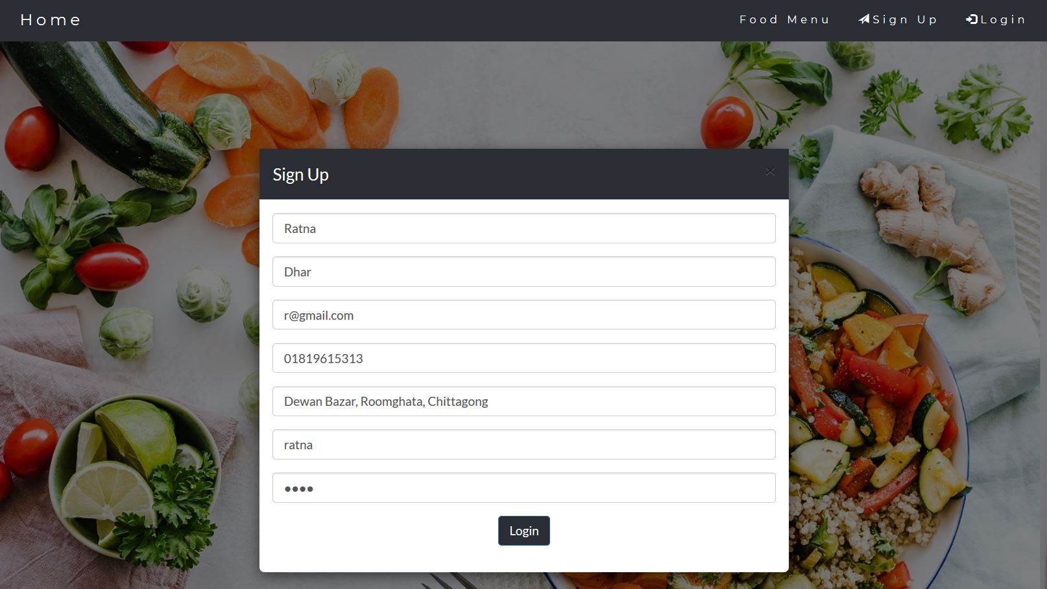

Login User

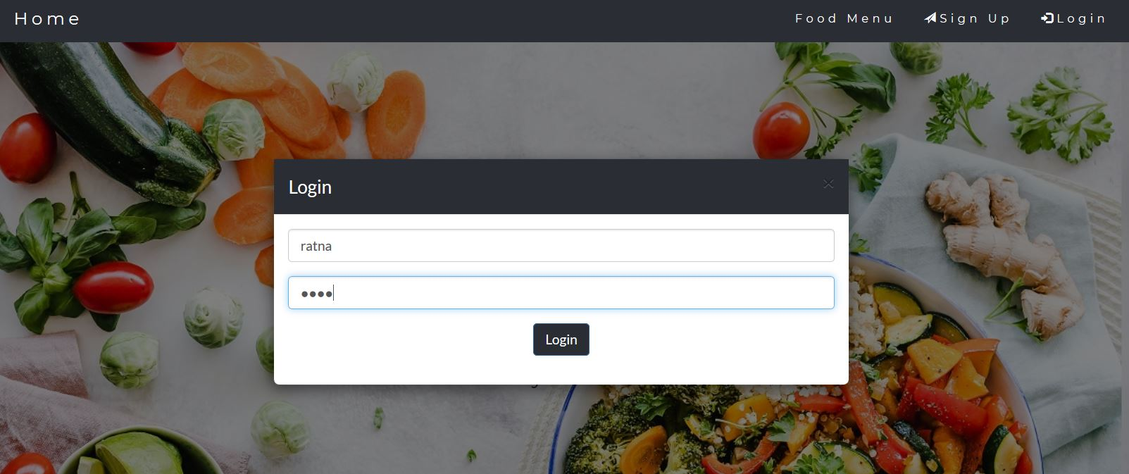

User Profile View

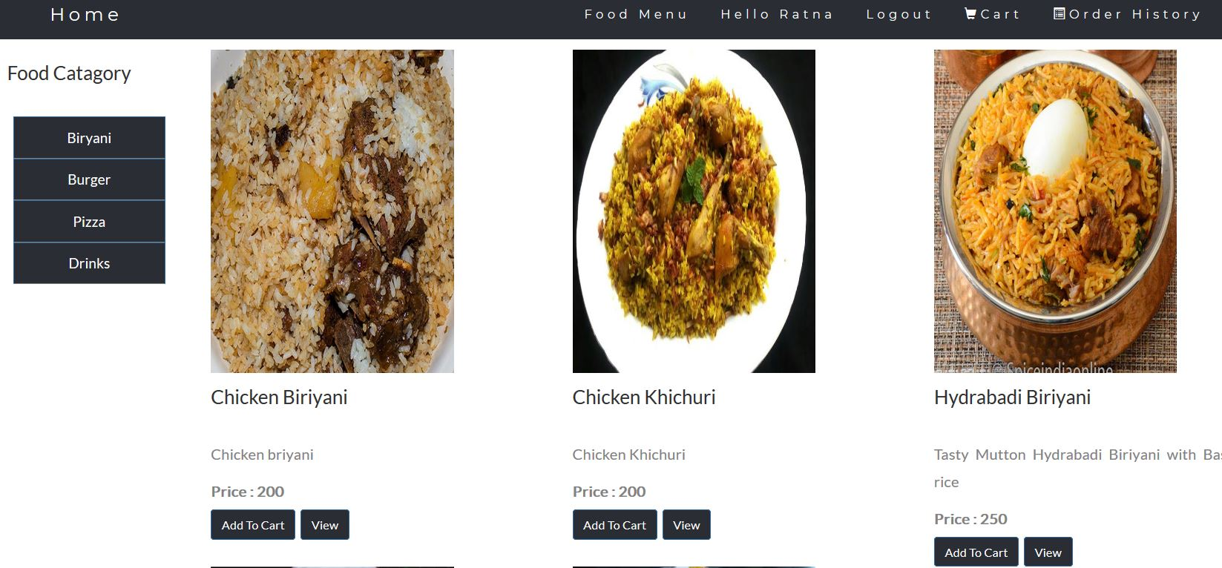

User Food Cart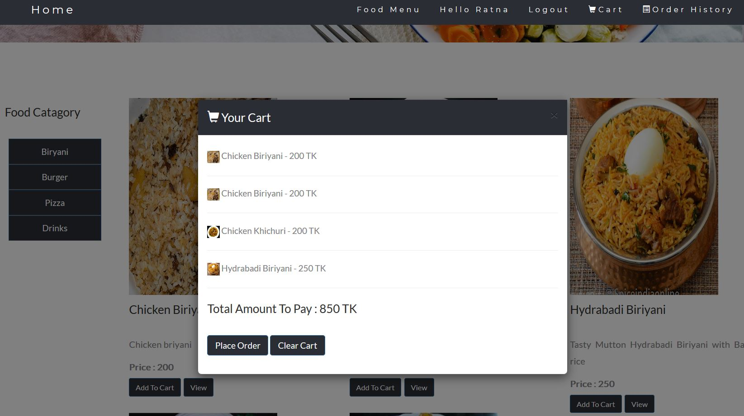

After User Order Placed

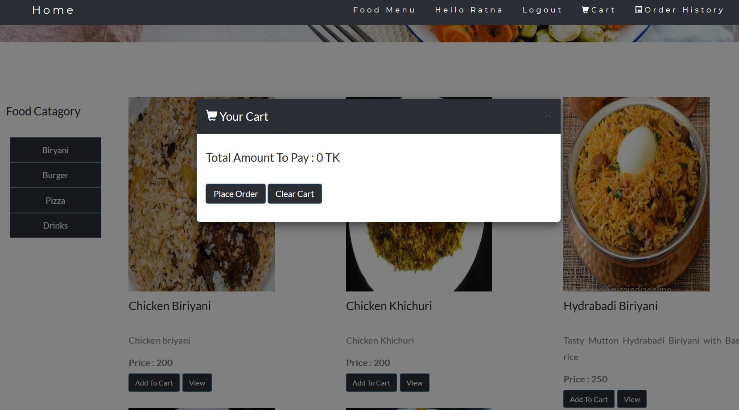

User Order History

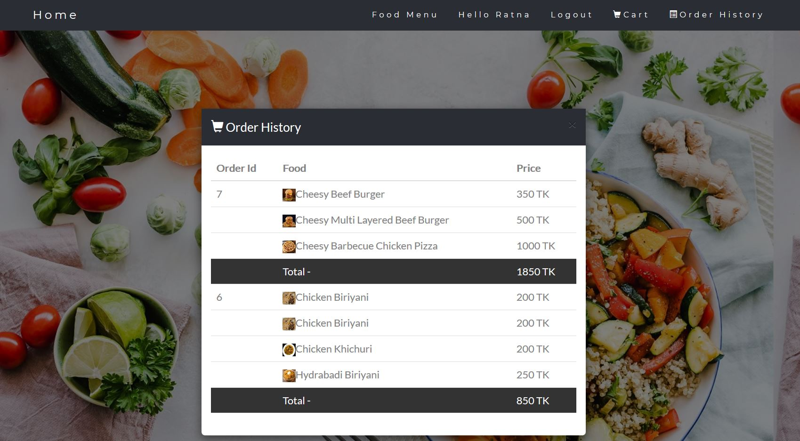

User Food Menu Category Wise

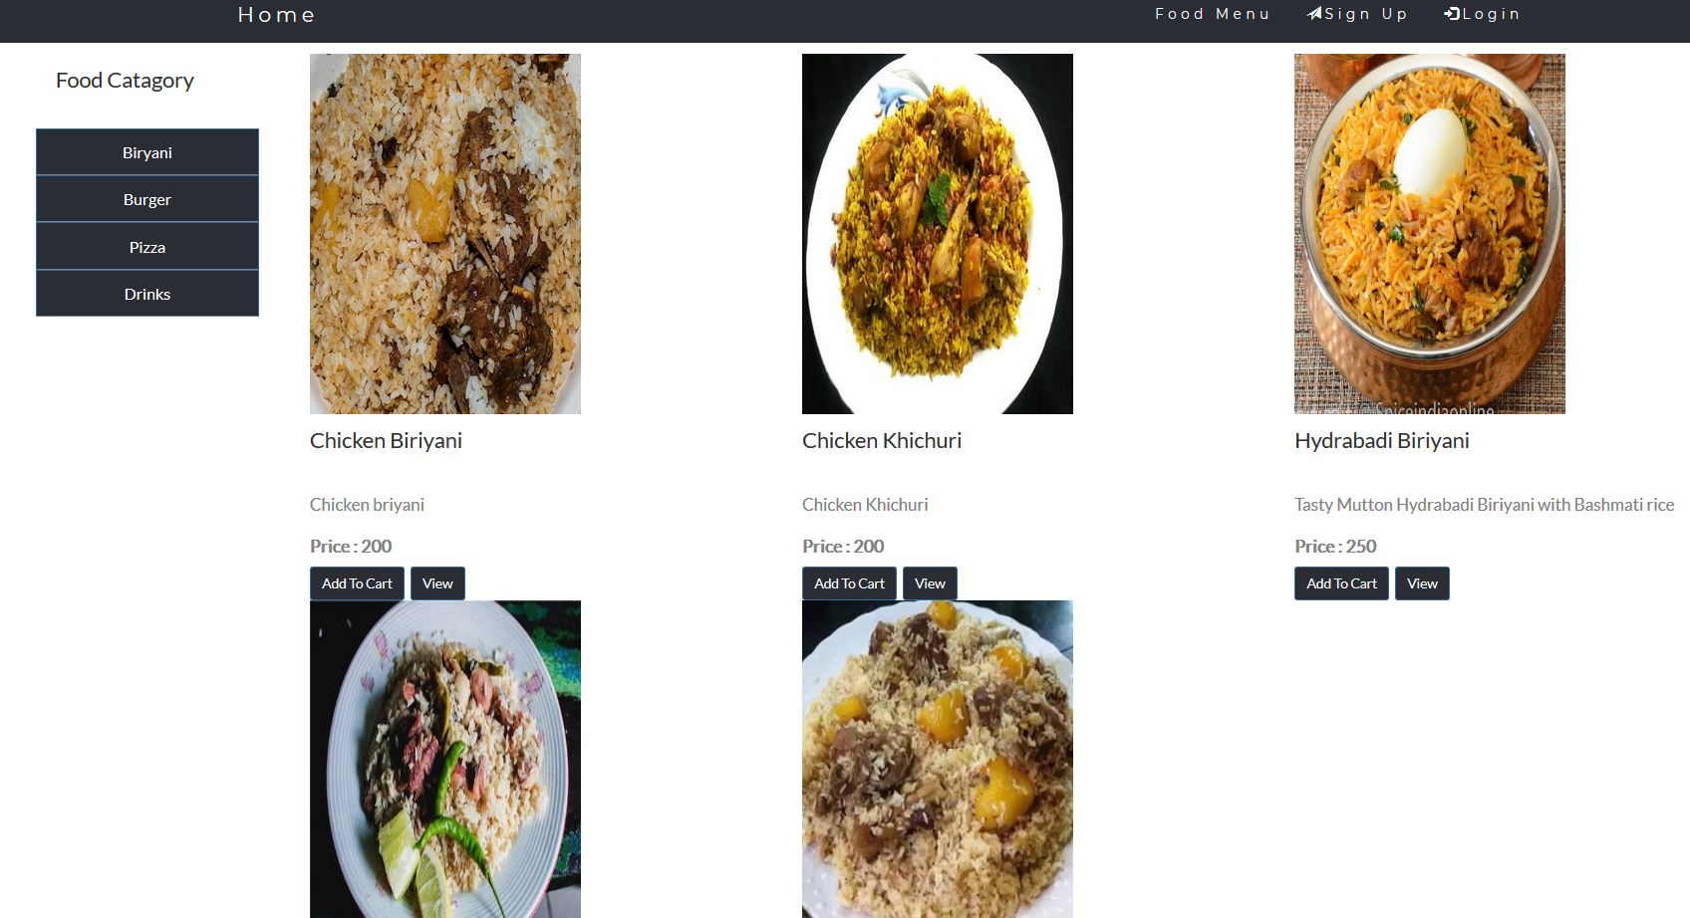

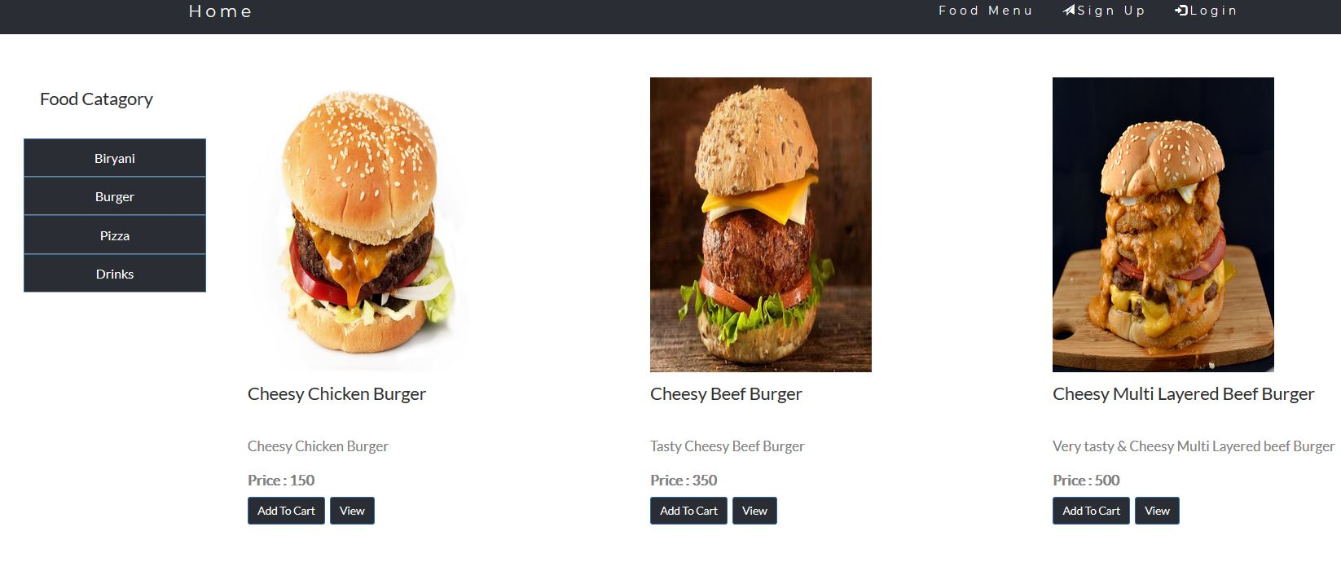

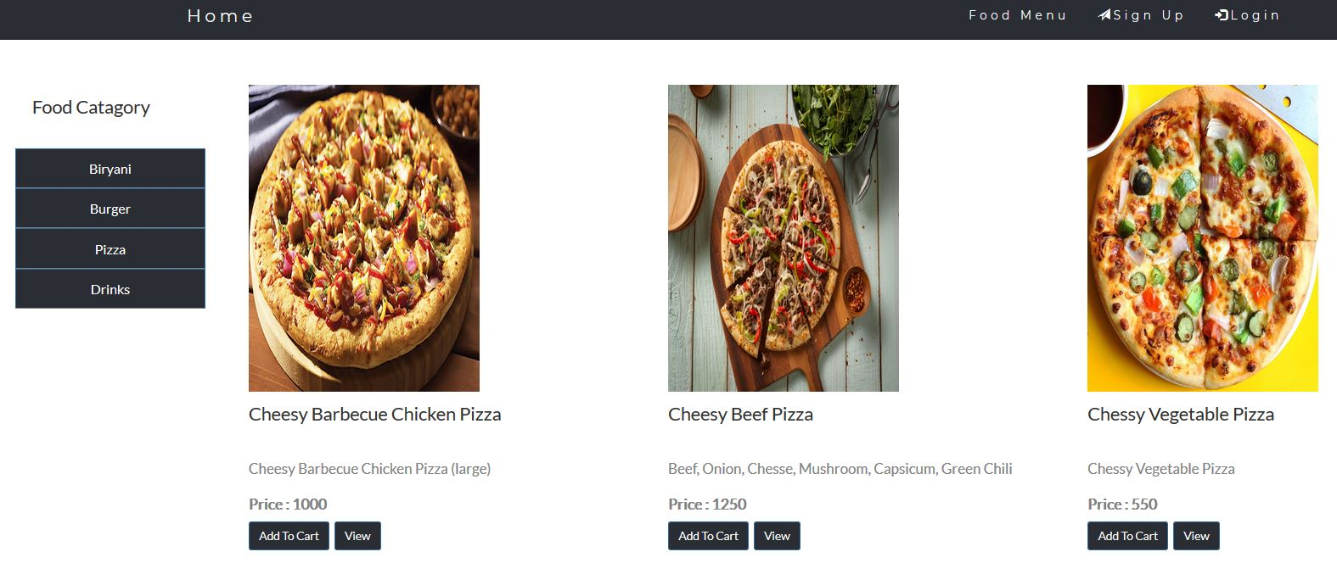

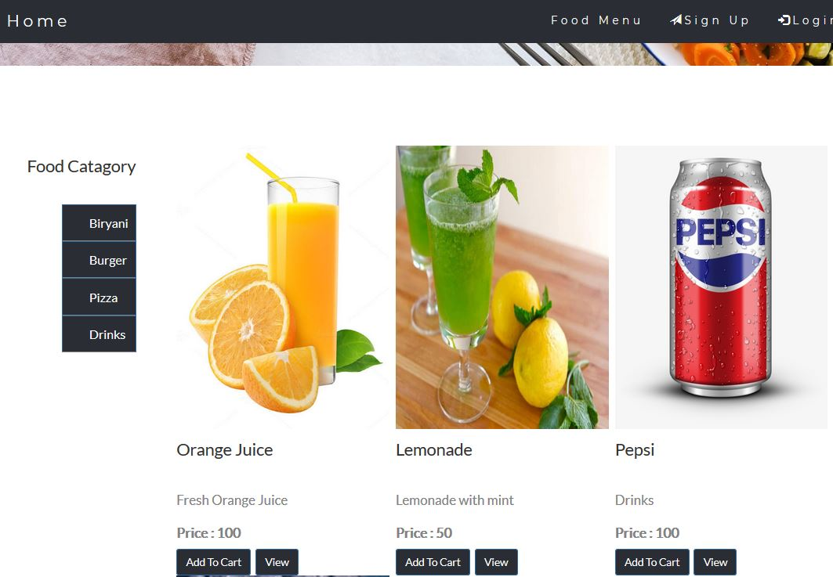

Order Placed History

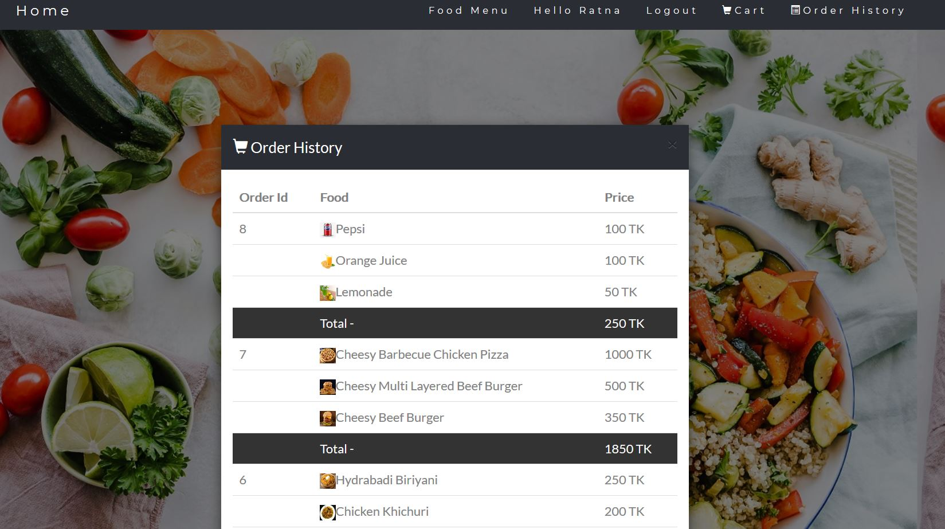

Order History

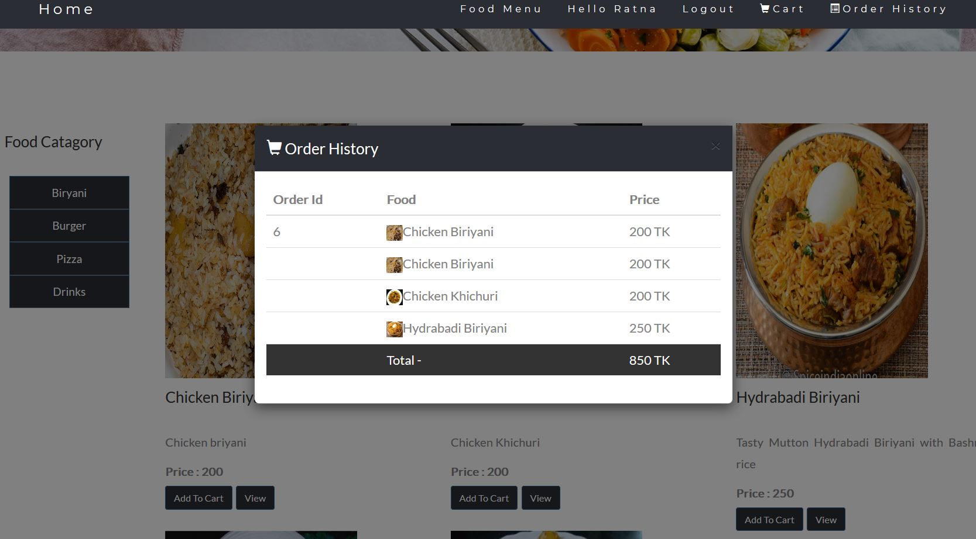

Admin Login

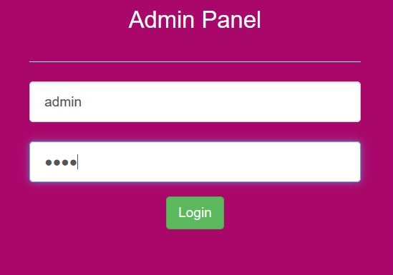

Admin Add Food

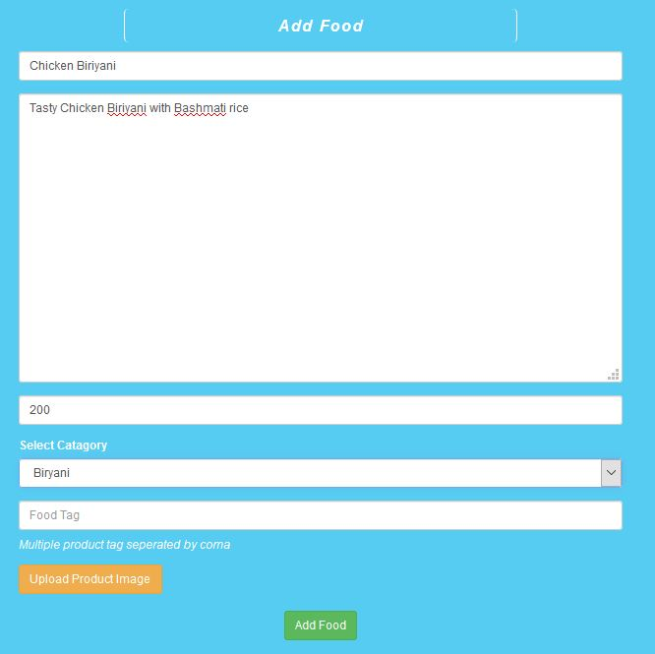

Admin Upload Image

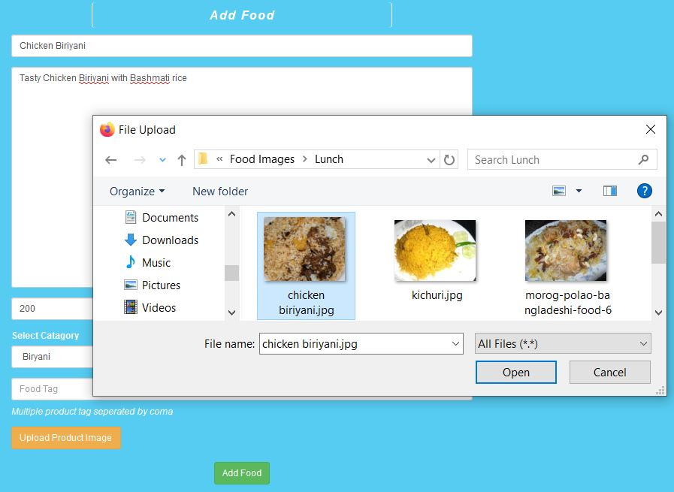

Mobile View

