



BAXTER HOMECHOICE

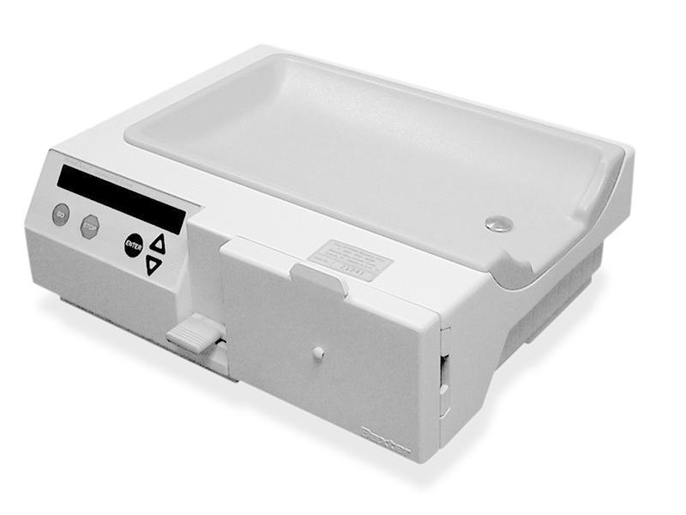

AUTOMATED PERITONEAL DIALYSIS SYSTEM

Patient Guide

CONTENTS

HomeChoice Dialysis Machine 3

Enter your Patient Activation Code 4

Confirm Configuration Settings 5

Setting up the HomeChoice Machine 7

Taking a PD Specimen 9

Coming off the HomeChoice Machine 10

HomeChoice System Error Alarm 11

What to do if? 12

Power Failure 13

HOMECHOICE DIALYSIS MACHINE

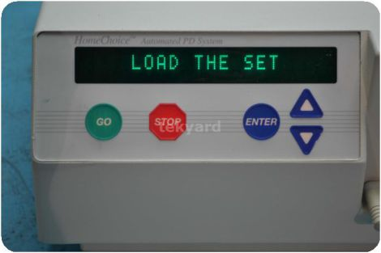

(Green Circle) = GO (Yes/OK)

(Red Hexagon) = STOP (No/Not OK)

(Blue Down Arrow) = Down

(Blue Up Arrow) = Up

(Blue Circle) = ENTER (do this)

ENTER YOUR PATIENT ACTIVATION CODE

1. Ensure your modem is connected to the system and is powered on.
2. Press the On/Off switch to the ON position. The switch is located at the rear of the machine.
3. Wait until the **ENTER ACTIVATION CODE: 0000000000** message appears.

* This 10 digit code is unique to you.

NOTE: Entering the Patient Activation Code is only required during the initial setup of your system.

4. Press (blue circle). The first digit of the code will begin flashing.

5. Press (blue down arrow) or (blue up arrow) to enter the first digit of your code.

6. Press (blue circle) to advance to the next digit.

NOTE: To revise an incorrect entry, continue to press (blue circle) until you advance to the first digit and then re-enter the activation code.

7. Repeat steps 5 and 6 until all 10 digits of your code are correctly entered.

You will exit the Patient Activation Code edit mode after the tenth digit is put in and (blue circle) is pressed.

8. Press (green circle).

* **CONNECTION TO NETWORK…** appears until communication with the **Sharesource** connectivity platform is established.
* This may take several minutes.

CONFIRM CONFIGURATION SETTINGS

CONFIRM CONFIGURATIONS appears if it is the first time you entered your Patient Activation Code into the system or if your therapy settings have changed. Only the settings that changed appear for your review.

* If a therapy setting displayed is **not** correct, contact your dialysis centre.

Refer to Table 8-2 in the **Homechoice Claria** *APD System Patient At-Home Guide* for therapy setting descriptions.

* Press (blue circle). Your name appears.
* If your name is correct, press (blue circle).

NOTE: If your name is incorrect, press (red hexagon).

IDENTIFICATION REJECTED will appear. Refer to Section 7.4 in the **Homechoice Claria** *APD System Patient At-Home Guide* for more information.

1. The Patient Consent screen appears. The system prompts you to select with whom you consent to share your therapy information. Your options are to share your information with:

* Your dialysis clinic and Baxter
* Baxter only

After initial acceptance, the Patient Consent screen only appears when there are revisions to the policy that require you to review and consent.

NOTE: Refer to section 7.5 in the **Homechoice Claria** *APD System Patient At-Home Guide* for the full **Sharesource** Patient Consent Policy.

1. To consent to share your data with both your clinic and Baxter, press (green circle).

* NEW PROGRAM RECEIVED / REVIEW NEW PROGRAM appears.

NOTE: To change your consent to share with Baxter onlym refer to Section 7.3.2, *Confirm Configuration Settings*, in the **Homechoice Claria** *APD System Patient At-Home Guide.*

1. When NEW PROGRAM RECEIVED / REVIEW NEW PROGRAM is displayed, press (blue circle) and your updated therapy settings appear.

* Verify each setting as it appears. If correct, press (blue circle) or (blue down arrow) to progress to the next setting.
* If you want to go back to a previous setting, press (blue up arrow).
* If a setting appears that is not correct, press (red hexagon). You will need to contact your dialysis centre when a setting is incorrect.
* When IS PROGRAM CORRECT? is displayed, press (green circle) if all settings are correct.
* The system briefly displays CYCLES and DWELL TIME.
* PROGRAM ACCEPTED BY CYCLER then appears.
* If any of your settings are not correct, press (red hexagon) and contact your dialysis centre.

1. The system then prompts you to enter additional data that your nephrologist or nurse programmed.

Weight – Press blue circle. The display will flash. Adjust up or down using the blue arrows or then press the blue circle to enter.

BP – Arrow down to the next option BP. Press the blue circle - the display will flash. Adjust up or down using the blue arrows or then the blue circle to enter.

Fluid 1 – Heater Fluid. Press (blue circle) to enter.

Fluid 2 – Supply. Press (blue circle) to enter.

* Press (red hexagon) when all your data has been entered.
* PRESS GO TO START appears.
* The system is ready for you to begin your therapy.

NOTE: Refer to Sections 7.3.3 and 7.3.4 in the **Homechoice Claria** *APD System Patient At-Home Guide* for information on data entry prompts.

SETTING UP THE HOMECHOICE MACHINE

Before you set up the dialysis machine make sure you have all the equipment you need out and ready for use.

You will need:

* Dialysis bags (check expiry dates, strength, colour, amount and bag is intact).
* Disposable Cassette (4 prong, 8 prong or Low Fill).
* Drainage Bag(s) – Manifold (Y piece).
* Minicap and Connection Shield (check expiry dates).
* Handrub
* Drapes

Wash hands and apply handrub.

Open the dialysis bags and check pull ring and medication port are in place. Break seals on bag of physioneal and hang to mix prior to placing on dialysis machine. Position one supply bag on heater ensuring bag covers sensor button. Put any other supply bags to side of machine.

Turn machine on (black button at back). The machine will display the current operating mode (Standard Mode or Low Flow Mode).

The machine will then display “PRESS GO TO START”.

Press GO (green circle). The machine will say, “LOAD THE SET”.

Open the cassette packet.

Open door on the machine and load the set. Close the door and place the blue holder (organiser) onto groove on front of the machine.

Close all clamps.

Drain line/Right side of organiser – No clamp…. (Specimen port with clamp further down the line).

Attach drain bags to the drain line.

Close large clamp on the drain bags.

Press GO (green circle). The machine will now read “SELF TESTING”. This test takes about one minute.

Mixed bag warning, press green circle to proceed.

The screen automatically tells you when to “CONNECT BAGS”.

Wash hands and apply handrub.

Connect bags – Remove blue tag from the dialysis bag and attached;

Red Clamp to the Heater bag

White Clamp to the Supply bag.

Blue Clamp – Last fill bag (or extra supply bag if required).

*REMEMBER TO APPLY HANDRUB BETWEEN EACH BAG CONNECTION*

Break the seals and open the clamps:

* On the lines attached to the supply bags.
* On the patient line.
* On the drain bags – DO NOT OPEN THE LARGE CLAMP.

Press GO (green circle) to prime. The screen will read “PRIMING” – this takes about 6 minutes.

Wait until the screen reads “CONNECT YOURSELF” – check patient line is fully primed with fluid then clamp the patient line.

Make sure catheter is easily accessible.

Place drape beneath catheter.

Apply handrub.

Open Connection Shield packet.

Wash hands and apply handrub.

Place drape beneath catheter, remove minicap and connect to patient line.

Place Connection Shield around the join between catheter and patient line (Standard Set).

Open the twist clamp on the catheter.

Press GO (green circle) to start treatment.

TAKING A PD SPECIMEN

You will need:

* Sterile Gallipot
* Multistix 8 SG
* Handrub

The specimen should be taken during the drain phase after the first cycle.

*Handy Hint: During the dwell phase damp the patient line. This will cause a machine alarm when draining starts and avoid missing the first drain.*

* Wash and dry hands.
* Open the package on the Gallipot.
* Open the clamp on the patient line (if closed).
* During the drain phase press (blue down arrow) to read how many mls have drained.
* When 50mls have drained, press STOP button (red hexagon).
* Close the clamp on the drainage bag.
* Wash and dry hands. Apply handrub.
* Remove the cap from the sample line open the clamp and press GO (green circle) to start drain again. Hold gallipot at sample line to obtain fluid and close clamp when sufficient obtained (5-10mls).
* Re-open main drain line clamp and press GO (green circle) to finish drain phase.

Check sample using Multistix 8 SG test strips, note result and report positive results to either Renal Unit or Renal Liaison Sisters.

*Use sterile universal container to send specimen if*:

* PD fluid is cloudy.
* Test strip is positive.
* Child is unwell.

COMING OFF THE HOMECHOICE MACHINE

*Remember when handling lines use aseptic techniques – thorough hand washing is essential to prevent infection*.

Wait until screen reads: “END OF THERAPY”.

You need to record the readings from the machine:

* Press (blue arrow down) screen will read “UF:……….mls”
* Press (blue arrow down) screen will read “INITIAL DRAIN………mls”
* Press (blue arrow down) screen will read “AVERAGE DWELL….mls”
* Press (blue arrow down) screen will read “LOST/ADDED DWELL……..mins”
* Press (green circle) screen will read “CLOSE ALL CLAMPS”.

Wash and dry hands and close the twist clamp on the catheter then close all the other clamps including the patient line and drain bags.

* Press (green circle) screen will read “DISCONNECT YOURSELF”.

Wash hands and place drape under catheter and open Minicap packet.

Wash hands and disconnect the dialysis line and attach Minicap.

* Press (green circle) screen will read “TURN ME OFF”.

Open door, remove cassette and discard. Check the fluid in drain bag and if satisfied that everything looks all right, empty fluid down the toilet. Equipment should be disposed of in an appropriate waste bag.

HOMECHOICE SYSTEM ERROR ALARM

Should a problem occur inside the HomeChoice machine the alarm will sound and the screen will read “SYSTEM ERROR: nnn”.

* Press (red hexagon) to mute the alarm.
* Write down the system error number (nnn) and the therapy phase that appears on the screen.
* Turn the machine off (black button at back).
* Wait 10 seconds.
* Turn the machine back on (black button at back).
* Press (red hexagon) to mute the alarm.
* Press (green circle). If the system has cleared, the therapy will continue.

If the system error has not cleared, contact:

BAXTER HELPDESK – The number is on the machine.

WHAT TO DO IF?

The line has a hole in it: -

* Determine the exact location of the hole, i.e. on the extension set or the catheter itself.
* Disconnect dialysis – follow steps for Manual Drain (take a sample of PO Fluid using the sterile universal container) and end therapy early.
* Clamp the line above the hole using blue scissor clamp. This may be close to your child.
* Phone the ward to let them know what has happened and that you will be coming in to have the catheter repaired and the PO fluid sent to the Lab.
* Bring your child up to the Renal Unit where you can have the catheter examined, repaired (if possible), extension set changed and antibiotics prescribed.

The cap comes off: -

* Phone the ward to let them know what has happened.
* Bring your child to the Renal Unit where we will obtain a specimen of PO fluid, replace the extension set and have antibiotics prescribed.

Patients who live some distance from the Renal Unit should phone the ward for advice. You may be asked to send a sample of PO fluid and have arrangements made to have your child examined. You may be advised to start antibiotics and change the extension set.

POWER FAILURE

If Power Failure occurs, the HomeChoice machine will stop the therapy and the display will turn off.

If the power is restored within 30 minutes:

* The system will automatically resume therapy without any alarms.
* During the first 30 minutes of a power failure, you can press any key to retrieve therapy information. If you do so you will have to press STOP (red hexagon) then GO (green circle) to start therapy after the power is restored.

If the power is not restored within 30 minutes:

* An alarm will occur after 30 minutes without power. Press STOP (red hexagon) to mute the alarm.
* Retrieve therapy information by pressing (blue down arrow).
* If power is restored within approximately two hours, the therapy can be restarted from where it left off. An alarm will occur again when power is restored.
* Press STOP (red hexagon) then GO (green circle) to restart therapy.

If power is not restored within two hours, you must End Therapy.

When power is eventually restored you can then restart your therapy from the beginning, if needed. If in doubt, phone the Renal Unit for clarification.

Renal Unit, Ward 3C (RHC) - 0141 452 4520 (24 hour service)

Sister Claire Hagerty - 07966 945132 (Mon-Thurs 9am-5pm)

Sister Kirsty Scott - 07811 065961 (Tues/Thurs/Fri 9am-5pm)

Sister Diane King - 07966 945882 (Mon-Fri 9am-5pm)