**Quiz ADA - Jonathan Prasetyo – 2501982613**

**MCQ**

1. A. Yes
2. A. The graph have a lot of edges
3. B. To find the shortest path

**Essay**

1. Dynamic Programming is a technique in computer programming that helps to efficiently solve a class of problems that have overlapping subproblems and optimal substructure property. Dynamic programming works by storing the result of subproblems so that when their solutions are required, they are at hand and we do not need to recalculate them.
2. The Different Between Brute Force and Dynamic Programming:

|  |  |  |
| --- | --- | --- |
| **Parameters of Comparison** | **Brute Force** | **Dynamic Programming** |
| Methodology | It finds all the possible outcomes of a given problem | It also finds all the possible outcomes, but avoids recomputation by storing solutions of the subproblems. |
| Time Complexity | It could be anything, sometimes even in exponential terms | It helps us optimize the brute force approach, sometimes exponential terms are improved to polynomial terms (ex. factorial program). |
| Iterations | The number of iterations is more than dynamic programming | The number of iterations is less than brute force (in terms of n) |
| Efficiency | It is less efficient | It is more efficient |
| Storage | Generally, requires no extra space for storing results of sub-problems | It requires extra space for storing the solutions to the sub-problems, which could be further used when required. |

1. We only need 4 coins 1 coin each of $10, $1, and 2 coin of $2, to return $15 with the available quantity of $1, $2, and $10. We can simply find out how many coins needed using greedy algorithm.

* Denominations = $1, $2, $10
* Value = 15
* $15 - $10 = $5 ( 1 coin of $10 ) *10*
* $5 - $2 = $3 ( 1 coin of 2 ) *10, 2*
* $3 - $2 = $1 ( 1 coin of 2 ) *10, 2, 2*
* $1 - $1 = $0 ( 1 coin of 1 ) *10, 2, 2, 1*

1. The way to cut:

* 3 and 2 = $10
* 2 and 2 and 1 = $7
* 3 and 1 and 1 = $5
* 2 and 1 and 1 and 1 = $2
* 1 and 1 and 1 and 1 and 1 = $-3

So, The Highest price for the length of 5 is $10 ( 3 and 2 )

1. Frequency: A = 10, B = 22, C = 5, D = 18, E = 12, F = 15, G = 16

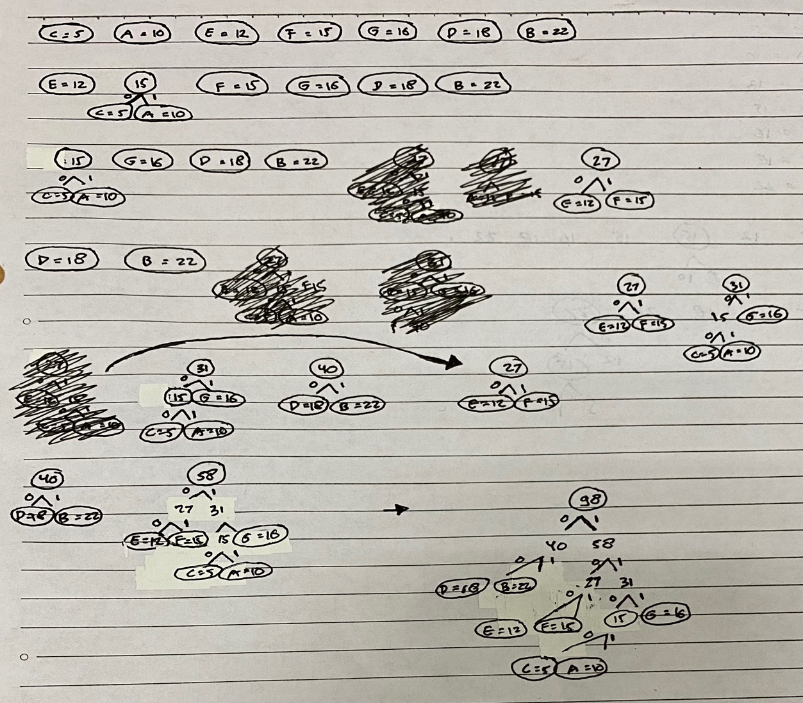

|  |  |  |  |
| --- | --- | --- | --- |
| Char | Code | Frequency | Total Bits |
| A | 1 1 0 1 | 10 | 40 |
| B | 0 1 | 22 | 44 |
| C | 1 1 0 0 | 5 | 20 |
| D | 0 0 | 18 | 36 |
| E | 1 0 0 | 12 | 36 |
| F | 1 0 1 | 15 | 45 |
| G | 1 1 1 | 16 | 48 |

1. Memoization is an optimization technique that makes applications more efficient and hence faster. It does this by storing computation results in cache, and retrieving that same information from the cache the next time it's needed instead of computing it again. The Memoization is used to speed up computer programs by eliminating the repetitive computation of results, and by avoiding repeated calls to functions that process the same input.

