Test Cases use for Database

TC-001 Cash Sale Creation
Objective:
Verify inventory decreases after sale.
SQL Executed:
-- Create test product
INSERT INTO Product
(
Name,
Unit,
CostPrice,
SellingPrice,
StockQty
)
VALUES
(
'Coke',
'Bottle',
15,
20,
100
);

-- Create Sale
INSERT INTO Sale
(
SaleDate,
Total
)
VALUES
(
NOW(),
20
);

-- Create Sale Item
INSERT INTO Sale_Item
(
SaleID,
ProductID,
Qty,
Price
)
VALUES
(
1,
1,
1,
20
);
Expected:
StockQty decreases by quantity sold.
Actual:
StockQty changed from 149 to 148.
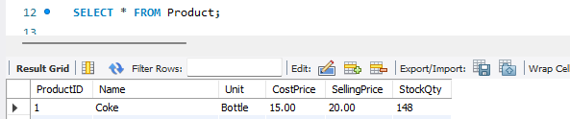
Status:
PASS

TC-002 | Create Customer Debt (Utang Sale)
Objective:
Verify if Debt created after Utang Sale.
SQL Executed:
INSERT INTO Customer(Name)
VALUES
(
'Tony Stark'
);

-- Create Sale
INSERT INTO Sale
(
SaleDate,
Total
)
VALUES
(
NOW(),
100
);

-- Create Debt
INSERT INTO Customer_Debt
(
CustomerID,
SaleID,
Amount,
DateCreated,
DueDate,
Status
)
VALUES
(
3,
2,
100,
NOW(),
CURDATE(),
'Active'
);
Expected:
Debt created automatically
Actual:
Debt created with Active status
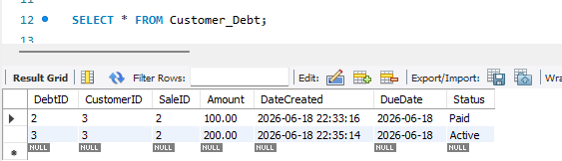
Status:
PASS

TC-003 | Prevent Multiple Active Debts
Objective:
Verify that cannot create new debt if customer still has active/unpaid debt.
SQL Executed:
INSERT INTO Customer_Debt
(
CustomerID,
SaleID,
Amount,
DateCreated,
DueDate,
Status
)
VALUES
(
3,
2,
50,
NOW(),
CURDATE(),
'Active'
);
Expected:
Transaction blocked.
Actual:
Error displayed: Customer still has unpaid debt.
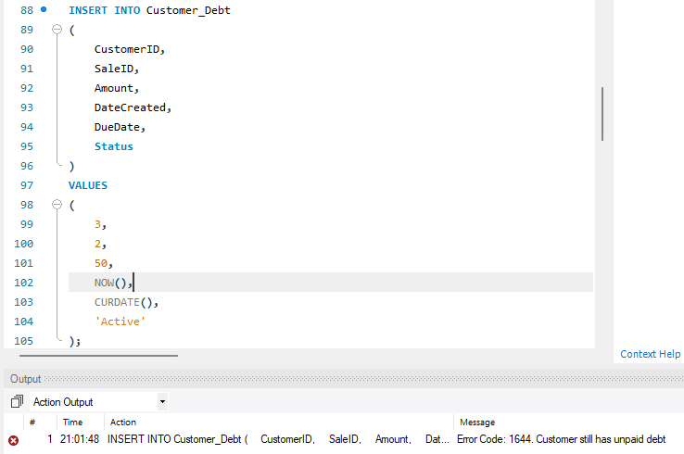
Status:
PASS

TC-004 Full Debt Payment
Objective:
Verify that Debt active status will update to paid status when debt is paid.
SQL Executed:
UPDATE Customer_Debt
SET Status = 'Paid'
WHERE DebtID = 2;
Expected:
Debt marked Paid.
Actual:
Debt status updated to Paid.
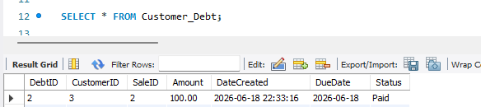
Status:
PASS

TC-005 New Debt After Payment
Objective:
Verify that can create new Debt after Debt Payment.
SQL Executed:
INSERT INTO Customer_Debt
(
CustomerID,
SaleID,
Amount,
DateCreated,
DueDate,
Status
)
VALUES
(
3,
2,
200,
NOW(),
CURDATE(),
'Active'
);
Expected:
Create new Debt after Debt is paid in full.
Actual:
New Debt is created.
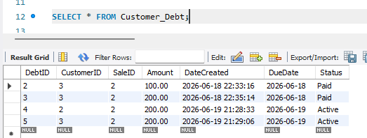
Status:
PASS

TC-006 Purchase Restocking
Objective:
Verify stock increases after Purchase.
SQL Executed:
-- Create Supplier
INSERT INTO Supplier(Name)
VALUES
(
'Pepsi Distributor'
);

-- Create Purchase
INSERT INTO Purchase
(
SupplierID,
PurchaseDate,
Total
)
VALUES
(
3,
NOW(),
300
);

-- Add Purchase Item
INSERT INTO Purchase_Item
(
PurchaseID,
ProductID,
Qty,
CostPrice
)
VALUES
(
1,
1,
50,
750
);

Expected:
Stock increases
Actual:
Stock increased from 148 to 198.
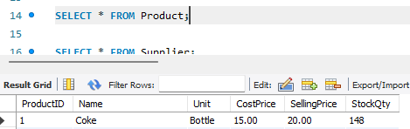
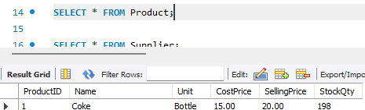
Status:
PASS

TC-007 Prevent Negative Inventory
Objective:
Verify stock cannot have negative inventory.
SQL Executed:
INSERT INTO Sale_Item
(
SaleID,
ProductID,
Qty,
Price
)
VALUES
(
1,
1,
1000,
20
);
Expected:
Transaction blocked.
Actual:
Error Code: 1644. Insufficient stock available.
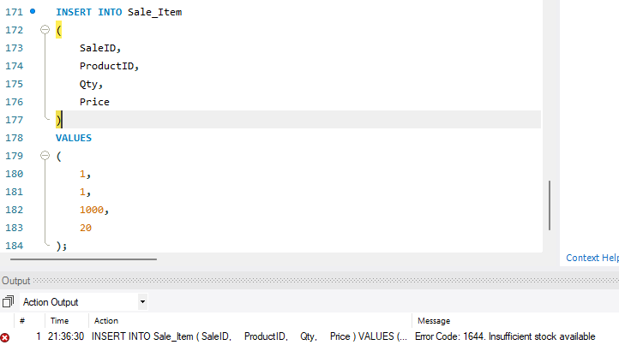
Status:
PASS

