Data Analytics Academy 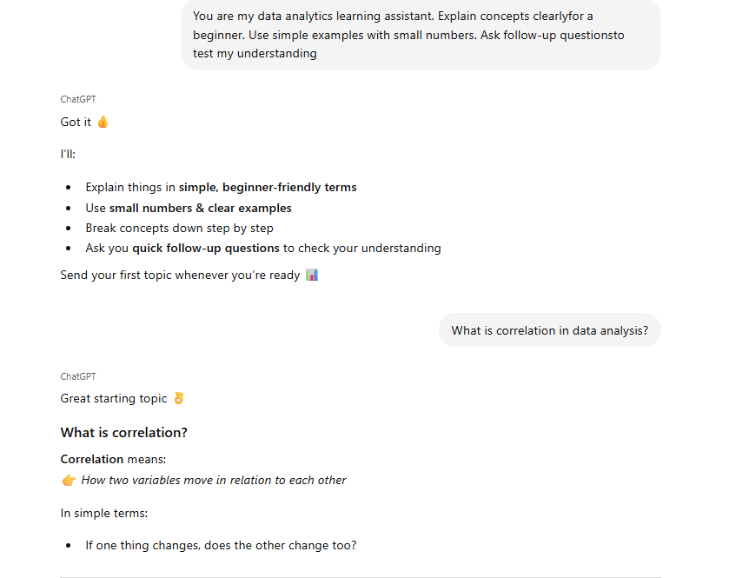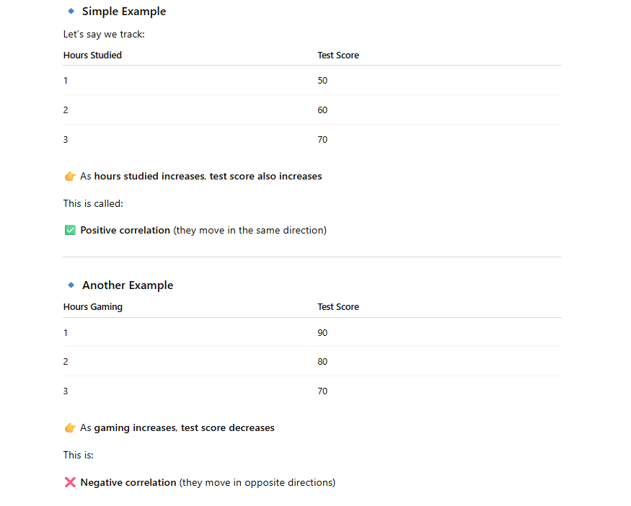
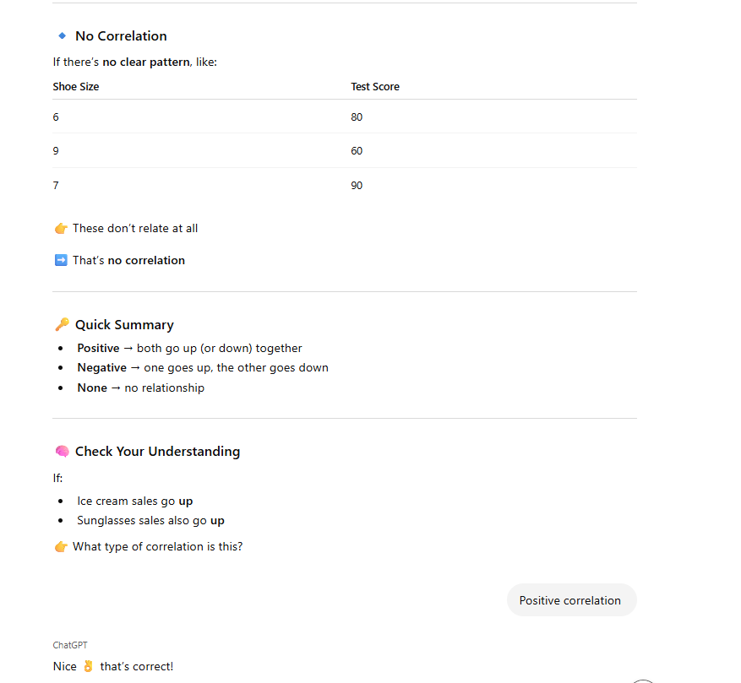

Summary:
The added pretense to the question adds so much to ChatGPT; instead of just telling me a definition, it went through and taught me. It focused on giving me examples and then even following up with a question. Without this, ChatGPT would have told me a definition, and would I really learn anything from that?

