Explain regression in simple terms including what it is used for the different types and an example of how it works with data.
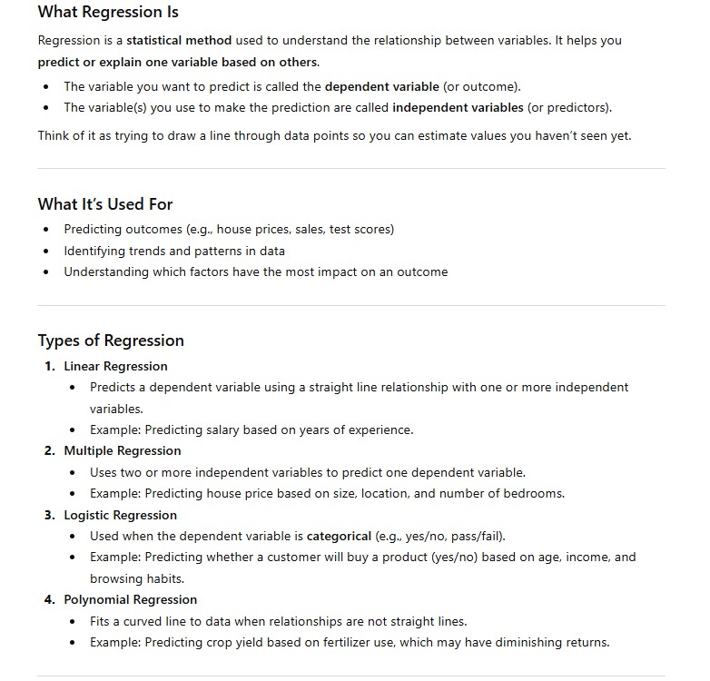
Please give me a beginner friendly intro of SQL.
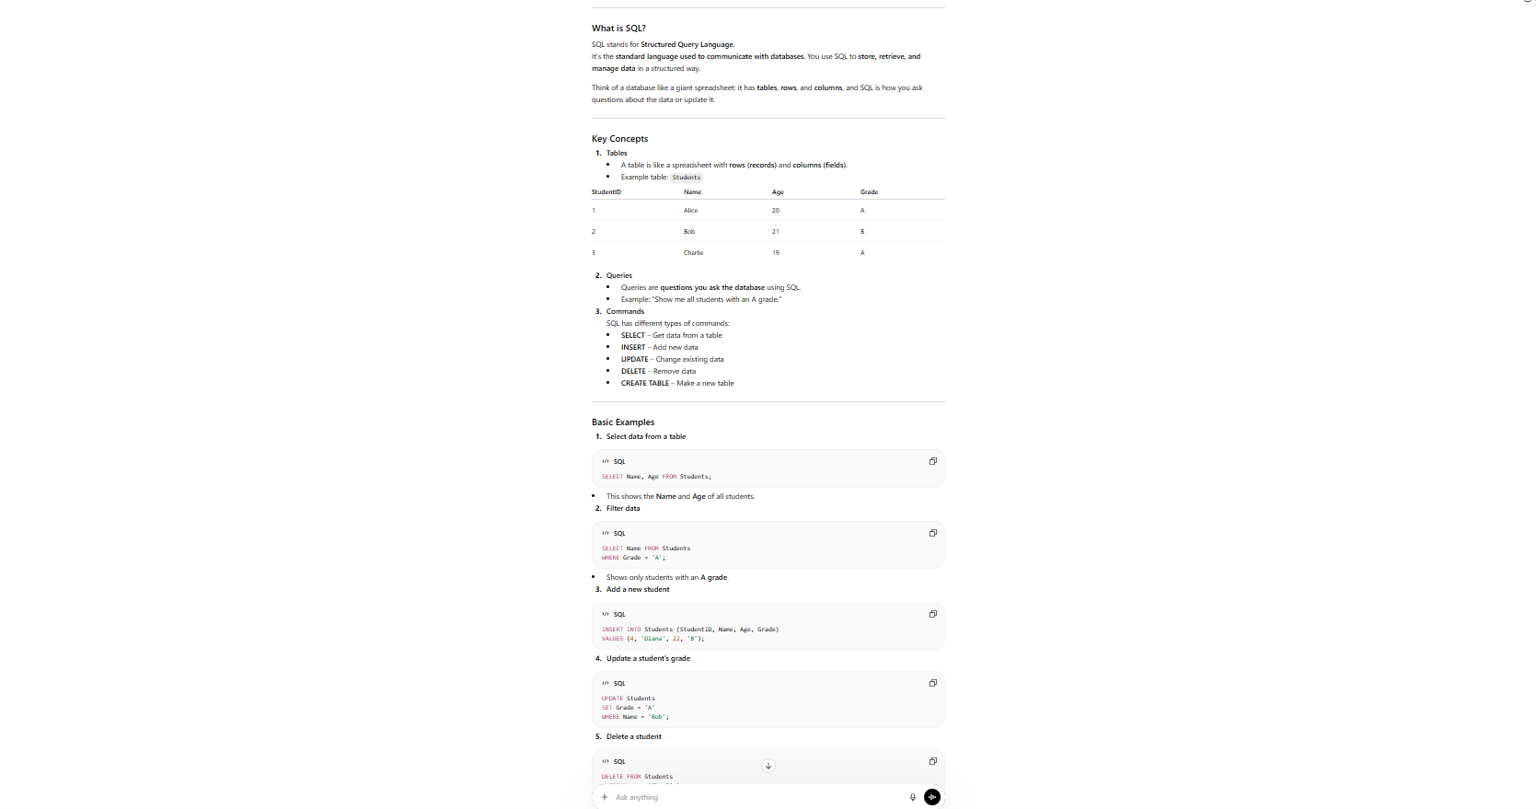
Create a dataset of 10 fictional employees showing their name, age, department and monthly salary.
