

DODINSTRUCTION 5000.02

OPERATION OF THE ADAPTIVE ACQUISITION FRAMEWORK

|  |  |
| --- | --- |
| **Originating Component: Effective:**  **Change 1 Effective:**  **Releasability:** | Office of the Under Secretary of Defense for Acquisition and Sustainment January 23, 2020  June 8, 2022  Cleared for public release. Available on the Directives Division Website |

at https://www.esd.whs.mil/DD/.

**Reissues and Cancels:**  See Paragraph 1.4.

**Approved by:**  Ellen M. Lord, Under Secretary of Defense for Acquisition and Sustainment   
**Change 1 Approved by:**  William A. LaPlante, Under Secretary of Defense for Acquisition and Sustainment

**Purpose:** In accordance with the authority in DoD Directive (DoDD) 5135.02 and the December 20, 2019 Deputy Secretary of Defense (DepSecDef) Memorandum, this issuance:

•Establishes policy and prescribes procedures for managing acquisition programs, pursuant to the relevant sections of Title 10, United States Code.

•Assigns acquisition program management responsibilities in accordance with the authority in DoDDs 5135.02, 5137.02, and 5000.01.

•Describes the responsibilities of principal acquisition officials and the purpose and key characteristics of the acquisition pathways.

•Restructures defense acquisition guidance to improve process effectiveness and implement the Adaptive Acquisition Framework (AAF). As a result of that restructuring, this issuance has been renamed “Operation of the Adaptive Acquisition Framework,” to better reflect the current content.

*DoDI 5000.02, January 23, 2020*   
*Change 1, June 8, 2022*

**TABLE OF CONTENTS**

SECTION 1:GENERAL ISSUANCE INFORMATION .............................................................................. 4 1.1. Applicability. .................................................................................................................... 4 1.2. Policy. ............................................................................................................................... 4 1.3. Purpose of the AAF. ......................................................................................................... 4 1.4. Transition Plan. ................................................................................................................. 4 1.5. Summary of Change 1. ..................................................................................................... 6 SECTION 2:RESPONSIBILITIES ......................................................................................................... 7 2.1. Under Secretary of Defense for Acquisition and Sustainment (USD(A&S)). .................. 7 2.2. Under Secretary of Defense for Research and Engineering (USD(R&E)). ...................... 7 2.3. DoD Component Heads. ................................................................................................... 8 2.4. Component Acquisition Executive (CAE). ....................................................................... 8 2.5. Executive Director, Joint Rapid Acquisition Cell. ............................................................ 8 SECTION 3:PROGRAM MANAGEMENT AUTHORITIES ...................................................................... 9 3.1. MDA/DA. ......................................................................................................................... 9 3.2. Program Executive Officer (PEO). ................................................................................... 9 3.3. PM. .................................................................................................................................... 9 3.4. Product Support Manager. ................................................................................................ 9 SECTION 4:PROCEDURES .............................................................................................................. 10 4.1. General Procedures. ........................................................................................................ 10 4.2. AAF Pathways. ............................................................................................................... 12 a. Urgent Capability Acquisition. .................................................................................... 12 b. MTA. ............................................................................................................................ 13 c. Major Capability Acquisition. ...................................................................................... 13 d. Software Acquisition. .................................................................................................. 14 e. Defense Business Systems (DBS) Acquisition. ........................................................... 15 f. Defense Acquisition of Services. .................................................................................. 16 4.3. Additional Direction. ...................................................................................................... 16 GLOSSARY ..................................................................................................................................... 17 G.1. Acronyms. ...................................................................................................................... 17 G.2. Definitions. ..................................................................................................................... 17 REFERENCES .................................................................................................................................. 18

TABLES

Table 1. Completed Transition Plan .............................................................................................. 5

FIGURES

Figure 1. AAF .............................................................................................................................. 10 Figure 2. Urgent Capability Acquisition Pathway ....................................................................... 12 Figure 3. MTA Pathway .............................................................................................................. 13 Figure 4. Major Capability Acquisition Pathway ........................................................................ 14 Figure 5. Software Acquisition Pathway ..................................................................................... 14 Figure 6. DBS Pathway................................................................................................................ 15

TABLE OF CONTENTS 2

*DoDI 5000.02, January 23, 2020*   
*Change 1, June 8, 2022*

Figure 7. Acquisition of Services Pathway .................................................................................. 16

TABLE OF CONTENTS 3

*DoDI 5000.02, January 23, 2020*   
*Change 1, June 8, 2022*

**SECTION 1:GENERAL ISSUANCE INFORMATION**

**1.1. APPLICABILITY.**

a. This issuance applies to OSD, the Military Departments, the Office of the Chairman of the Joint Chiefs of Staff and the Joint Staff, the Combatant Commands, the Office of Inspector General of the Department of Defense, the Defense Agencies, the DoD Field Activities, and all other organizational entities within the DoD (referred to collectively in this issuance as the “DoD Components”).

b. The policies in this instruction are applicable to all systems and services acquired via the Defense Acquisition System (DAS).

**1.2. POLICY.**

The DAS supports the National Defense Strategy through the development of a lethal and effective force based on U.S. technological innovation and a culture of performance that yields decisive and sustained U.S. military advantage. To achieve that objective, the DoD will employ an AAF.

**1.3. PURPOSE OF THE AAF.**

The AAF supports the DAS with the objective of delivering effective, suitable, survivable, sustainable, and affordable solutions to the end user in a timely manner. To achieve those objectives, Milestone Decision Authorities (MDAs), other Decision Authorities (DAs), and Program Managers (PMs) have broad authority to plan and manage their programs consistent with sound business practice. The AAF acquisition pathways provide opportunities for MDAs/DAs and PMs to develop acquisition strategies and employ acquisition processes that match the characteristics of the capability being acquired.

**1.4. TRANSITION PLAN.**

This issuance lays the groundwork for operation of the AAF, which is part of the DAS described in DoDD 5000.01. Change 1 to this issuance cancelled the January 7, 2015 version of DoD Instruction (DoDI) 5000.02; that version was renumbered DoDI 5000.02T (Transition) during the transition period to establish a distinction between the two issuances.

a. As agreed to during the 2020 coordination of this issuance, when the AAF realignment was completed, an administrative change to this issuance (Change 1) cancelled DoDI 5000.02T.

b. Table 1 details the transition plan and the location of information formerly found in the January 7, 2015 edition of DoDI 5000.02.

SECTION 1:GENERAL ISSUANCE INFORMATION 4

*DoDI 5000.02, January 23, 2020*   
*Change 1, June 8, 2022*

**Table 1. Completed Transition Plan**

|  |  |
| --- | --- |
| **Information in 2015 DoDI 5000.02** | **New Location** |
| Core Acquisition Policy (Paragraph 6, Procedures) | DoDI 5000.85, “Major Capability Acquisition” |
| Enclosure 1. Acquisition Program Categories and Compliance Requirements   -- Information Requirements Tables | •DoDI 5000.85, “Major Capability Acquisition” •Tables authorized by DoDI 5000.85 are posted on  the AAF website |
| Enclosure 2. Program Management | •DoDI 5000.85, “Major Capability Acquisition” •DoDI 5010.44, “Intellectual Property (IP)   Acquisition and Licensing,” October 16, 2019 has replaced “IP Strategy” (formerly Paragraph 6.a.(4)) |
| Enclosure 3. Systems Engineering | DoDI 5000.88, “Engineering of Defense Systems” |
| •Enclosure 4. Developmental Test and  Evaluation (DT&E)  •Enclosure 5. Operational and Live Fire Test and Evaluation (OT&E and LFT&E) | DoDI 5000.89, “Test and Evaluation” |
| Enclosure 6. Life-Cycle Sustainment | DoDI 5000.91, “Product Support Management for The Adaptive Acquisition Framework” |
| Enclosure 7. Human Systems Integration (HSI) | DoDI 5000.95, “Human Systems Integration in Defense Acquisition” |
| Enclosure 8. Affordability Analysis and Investment Constraints | Replaced by direction in Section 807 of Public Law 114-328 |
| Enclosure 9. Analysis of Alternatives (AoA) | Necessary information is in DoDD 5105.84,  “Director of Cost Assessment and Program  Evaluation,” and the “Analysis of Alternatives Cost Estimating Handbook” |
| Enclosure 10. Cost Estimating and Reporting | Necessary guidance is available in DoDI 5000.73, “Cost Analysis Guidance and Procedures.” |
| Enclosure 11. Requirements Applicable to All Programs Containing Information Technology (IT) | DoDI 5000.82, “Acquisition of Information Technology (IT)” |
| Enclosure 12. Urgent Capability Acquisition | DoDI 5000.81, “Urgent Capability Acquisition” |
| Enclosure 13. Cybersecurity in the Defense Acquisition System | •DoDI 5000.90, “Cybersecurity for Acquisition Decision Authorities and Program Managers” •DoDI 5000.83, “Technology and Program   Protection to Maintain Technological Advantage” |

SECTION 1:GENERAL ISSUANCE INFORMATION 5

*DoDI 5000.02, January 23, 2020*   
*Change 1, June 8, 2022*

**1.5. SUMMARY OF CHANGE 1.**

Change 1 to this issuance is administrative and:

a. Cancels DoDI 5000.02T in accordance with the 2020 coordination of this issuance and subsequent approval of the transition plan. AAF realignment was completed upon the approval and publication of DoDI 5000.95.

b. Updates the transition plan in Paragraph 1.4. to document its completion and final location of information previously in the January 7, 2015 version of DoDI 5000.02.

SECTION 1:GENERAL ISSUANCE INFORMATION 6

*DoDI 5000.02, January 23, 2020*   
*Change 1, June 8, 2022*

**SECTION 2:RESPONSIBILITIES**

**2.1. UNDER SECRETARY OF DEFENSE FOR ACQUISITION AND SUSTAINMENT (USD(A&S)).**

The USD(A&S):

a. Executes the acquisition responsibilities in the DoDD 5135.02.

b. In accordance with the November 16, 2018 DepSecDef memorandum, serves as an advisor in the preparation of major defense acquisition program (MDAP) analysis of alternatives study guidance.

c. In accordance with the December 20, 2019 DepSecDef memorandum:

(1) Serves as the MDA for the Materiel Development Decision, Milestone A, the Request for Proposal Release Decision Point for the Engineering and Manufacturing Development Phase, Milestone B, and Milestone C for acquisition category (ACAT) ID programs.

(2) Issues and maintains requirements for the content, and the review and approval process for ACAT ID acquisition strategies, and approves the acquisition strategies for ACAT ID programs.

(3) Publishes all middle tier of acquisition (MTA) policy, to include MTA rapid prototyping policy and MTA rapid fielding policy. USD(A&S) written approval is required prior to using the MTA pathway for a program that exceeds the MDAP dollar threshold.

**2.2. UNDER SECRETARY OF DEFENSE FOR RESEARCH AND ENGINEERING (USD(R&E)).**

The USD(R&E):

a. Executes the research and engineering responsibilities in DoDD 5137.02.

b. In accordance with the November 16, 2018 DepSecDef memorandum:

(1) Serves as a technical advisor in the preparation of MDAP analysis of alternatives study guidance.

(2) Confirms that a materiel solution that addresses the validated need or capability gap for the MDAP is technically feasible and achievable.

c. In accordance with the December 20, 2019 DepSecDef Memorandum:

SECTION 2:RESPONSIBILITIES 7

*DoDI 5000.02, January 23, 2020*   
*Change 1, June 8, 2022*

(1) Conducts and approves independent technical risk assessments (ITRAs) for ACAT ID Programs.

(2) Provides guidance for Military Department-conducted ITRAs for ACAT IB and IC programs. The USD(R&E) will approve Military Department-conducted ITRAs (the number of Military Department ITRAs that USD(R&E) reviews will be at USD(R&E)’s discretion).

Military Department ITRAs conducted on non-MDAP programs will follow USD(R&E)-published ITRA policy.

(3) Maintains authority over early development prototyping policy outside of MTA.

(4) Approves the development testing and evaluation in the Test and Evaluation Master Plan.

**2.3. DOD COMPONENT HEADS.**

The DoD Component heads are responsible for aligning the management of acquisition programs with the three principal DoD processes to support affordable design, development, production and sustainment of mission effective capability and services. These processes are the:

a. Joint Capabilities Integration and Development System.

b. Planning, Programming, Budgeting and Execution System.

c. DAS.

**2.4. COMPONENT ACQUISITION EXECUTIVE (CAE).**

Under the authority, direction, and control of the appropriate DoD Component head, a CAE:

a. Implements the direction in this instruction and DoDD 5000.01.

b. When necessary, submits waivers or requests for exception to the provisions in this instruction to the applicable authority. Statutory requirements cannot be waived unless a statute permits.

c. May delegate program decision authority to the lowest appropriate level unless otherwise specified.

**2.5. EXECUTIVE DIRECTOR, JOINT RAPID ACQUISITION CELL.**

Under the authority, direction, and operational control of the DepSecDef, the Director, Joint Rapid Acquisition Cell, manages the urgent capability acquisition pathway in accordance with DoDD 5000.71.

SECTION 2:RESPONSIBILITIES 8

*DoDI 5000.02, January 23, 2020*   
*Change 1, June 8, 2022*

**SECTION 3:PROGRAM MANAGEMENT AUTHORITIES**

DoD acquisition managers will exercise the following authorities within the DAS:

**3.1. MDA/DA.**

The MDA/DA is the program decision authority and specifies the decision points and procedures for assigned programs. MDAs/DAs will tailor program strategies and oversight, phase content, the timing and scope of decision reviews, and decision levels based on the characteristics of the capability being acquired (including complexity, risk, and urgency) to satisfy user requirements. MDAs for MDAPs and major systems will approve, as appropriate, the acquisition strategy at all major decision points.

**3.2. PROGRAM EXECUTIVE OFFICER (PEO).**

The PEO balances the risk, cost, schedule, performance, interoperability, sustainability, and affordability of a portfolio of acquisition programs and delivers an integrated suite of mission effective capability to users.

**3.3. PM.**

Under the supervision of PEOs and CAEs, PMs:

a. Plan acquisition programs, prepare programs for key decisions, and execute approved acquisition and product support strategies.

b. Employ a thoughtful, innovative, and disciplined approach to program management.

**3.4. PRODUCT SUPPORT MANAGER.**

Under the supervision of PMs, product support managers develop, plan, and implement a comprehensive product support strategy for all integrated product support elements and their material readiness. Product support managers will make use of data-driven decision making tools with appropriate predictive analysis capabilities to improve systems availability and reduce costs.

SECTION 3:PROGRAM MANAGEMENT AUTHORITIES 9

*DoDI 5000.02, January 23, 2020*   
*Change 1, June 8, 2022*

**SECTION 4:PROCEDURES**

**4.1. GENERAL PROCEDURES.**

PMs will develop an acquisition strategy for MDA approval that matches the acquisition pathway (see Figure 1) processes, reviews, documents, and metrics to the character and risk of the capability being acquired.

**Figure 1. AAF**

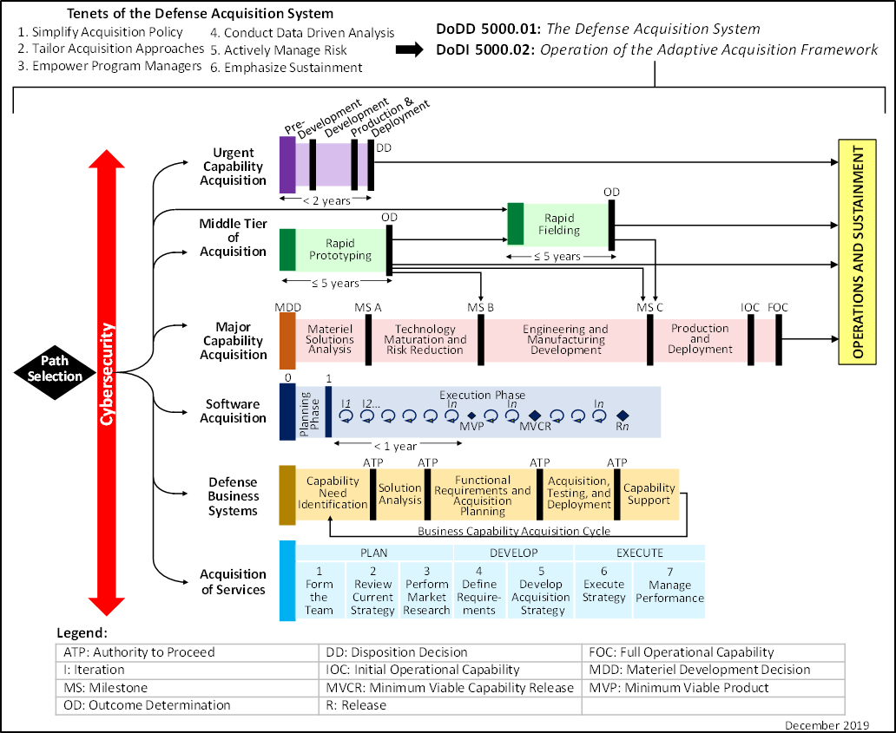

a. PMs, with the approval of MDAs/DAs, may leverage a combination of acquisition pathways to provide value not otherwise available through use of a single pathway. The use of multiple pathways does not affect the application of statutory thresholds otherwise applicable to the program as a whole, such as the MDAP or major system (ACAT II) thresholds unless a statute permits. PMs employing multiple pathways will:

SECTION 4:PROCEDURES 10

*DoDI 5000.02, January 23, 2020*   
*Change 1, June 8, 2022*

(1) Define the transition points from one pathway to another pathway.

(2) Anticipate, develop, and coordinate the information requirements required at the new pathway entry point. Links provided in Paragraph 4.3. identify regulatory and statutory information requirements for major capability acquisition, and the statutory requirements for other pathways.

(3) Ensure a smooth transition.

b. In addition, PMs will:

(1) “Tailor in” the regulatory information requirements that will be used to describe the management of the program. In this context, “tailoring-in” means that the PM will identify, and recommend for MDA/DA approval, the regulatory information that will be employed to document program plans and how that information will be formatted and provided for review by the MDA/DA. The PM’s recommendation will be reviewed by the MDA/DA, and the   
MDA/DA’s decision will be documented in an acquisition decision memorandum. MDAs/DAs will coordinate, when necessary, with other regulatory document approval authorities to facilitate implementation of this approach. Statutory requirements will not be waived unless a statute permits.

(2) Design program and business strategies to facilitate the acquisition of appropriate and cost effective technology solutions and achieve mission success while being mutually   
advantageous to the DoD and its industry partners. Similarly, PMs will consider acquisition strategies that leverage international acquisition and supportability planning to improve   
economies of scale, strengthen the defense industrial base, and enhance coalition partner capabilities to prepare for joint operations.

(3) Recognize that cybersecurity is a critical aspect of program planning. It must be addressed early and continuously during the program life cycle to ensure cybersecurity operational and technical risks are identified and reduced and that fielded systems are capable, effective, and resilient.

(4) Consider the procurement of data deliverables and associated license rights needed to support competitive acquisition and life-cycle sustainment strategies.

(5) Prioritize product support and affordability during early program planning to ensure sustained mission effectiveness.

(6) Establish a risk management program to ensure program cost, schedule, and performance objectives are achieved, and to communicate the process for managing program uncertainty. In consultation with the user representative, the PM will determine which environment, safety, and occupational health risks must be eliminated or mitigated, and which risks can be accepted.

(7) When consistent with pathway requirements, develop engineering plans and processes applicable to the pathways to mature technology, conduct necessary systems

SECTION 4:PROCEDURES 11

*DoDI 5000.02, January 23, 2020*   
*Change 1, June 8, 2022*

engineering tradeoffs, and produce and manage appropriate technical baselines through the use of systems engineering technical reviews.

**4.2. AAF PATHWAYS.**

The following pathways describe multiple acquisition approaches that provide capability to the user while capitalizing on advanced acquisition methods and improving the DoD’s ability to benefit from commercial innovation. There are six pathways:

**a. Urgent Capability Acquisition.**

(1) Purpose.

To field capabilities to fulfill urgent existing or emerging operational needs or quick reactions in less than 2 years.

(2) Characteristics.

The DoD’s highest priority is to provide warfighters with the capabilities urgently needed to overcome unforeseen threats, achieve mission success, and reduce risk of casualties. Urgent operational needs and other quick reaction capabilities are identified and approved for resolution by designated authorities. The estimated cost of any single solution must not exceed $525 million in research, development, and test and evaluation; or $3.065 billion procurement in Fiscal Year 2020 constant dollars. The acquisition; product support and sustainment processes; reviews; and documents are aggressively streamlined due to operational urgency. The goal is to plan for the capability in a few weeks, with development and production measured in months.

The imperative is to quickly deliver useful capability to the warfighter in a timely fashion. Figure 2 illustrates the urgent capability acquisition pathway.

(3) References.

DoDD 5000.71 and DoDI 5000.81 establish policies and provide procedures for urgent operational needs and other quick reaction capabilities acquisition.

**Figure 2. Urgent Capability Acquisition Pathway**

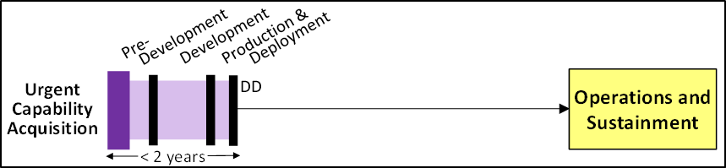

SECTION 4:PROCEDURES 12

*DoDI 5000.02, January 23, 2020*   
*Change 1, June 8, 2022*

**b. MTA.**

(1) Purpose.

To rapidly develop fieldable prototypes within an acquisition program to demonstrate new capabilities or rapidly field production quantities of systems with proven technologies that require minimal development.

(2) Characteristics.

The MTA pathway includes rapid prototyping and rapid fielding activities. The objective of rapid prototyping is to field a prototype meeting defined requirements that can be   
demonstrated in an operational environment and provide for residual operational capability within 5 years of the MTA program start date. The objective of rapid fielding is to begin production within 6 months and complete fielding within 5 years of the MTA program start date. These activities will not be subject to the Joint Capabilities Integration and Development System or the procedures outlined in DoDD 5000.01, except to the extent specifically provided in the guidance. PMs will “tailor-in” reviews, assessments, and relevant documentation that results in an acquisition strategy customized to the unique characteristics and risks of their program. PMs will ensure operational, technical, and security risks are identified and reduced so that fielded systems are capable, effective, and resilient. PMs will comply with statutory requirements unless waived in accordance with a relevant provision.

(3) References.

DoDI 5000.80 establishes policy, assigns responsibilities, and prescribes procedures for the MTA pathway, illustrated in Figure 3.

**Figure 3. MTA Pathway**

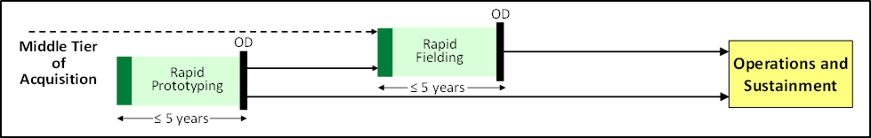

**c. Major Capability Acquisition.**

(1) Purpose.

To acquire and modernize military unique programs that provide enduring capability.

(2) Characteristics.

These acquisitions typically follow a structured analyze, design, develop, integrate, test, evaluate, produce, and support approach. This process is designed to support MDAPs, major systems, and other complex acquisitions. Acquisition and product support processes, reviews, and documentation will be tailored based on the program size, complexity, risk, urgency, and

SECTION 4:PROCEDURES 13

*DoDI 5000.02, January 23, 2020*   
*Change 1, June 8, 2022*

other factors. Software-intensive components may be acquired via the software acquisition pathway, with the outputs and dependencies integrated with the overall major capability pathway.

(3) References.

DoDI 5000.85 establishes policy, assigns responsibilities, and prescribes procedures for the major capability acquisition pathway, illustrated in Figure 4.

**Figure 4. Major Capability Acquisition Pathway**

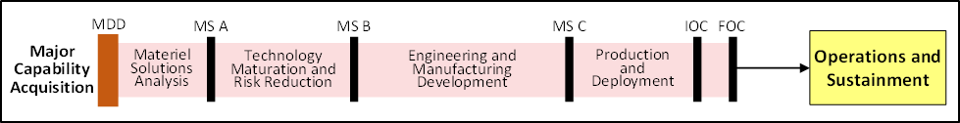

**d. Software Acquisition.**

(1) Purpose.

To facilitate rapid and iterative delivery of software capability (e.g., software-intensive systems or software-intensive components or sub-systems) to the user.

(2) Characteristics.

This pathway integrates modern software development practice such as Agile Software Development, Development, Security, and Operations, and Lean Practices. Small cross-functional teams that include operational users, developmental and operational testers, software developers, and cybersecurity experts leverage enterprise services to deliver software rapidly and iteratively to meet the highest priority user needs. These mission-focused, government-industry teams leverage automated tools for iterative development, builds, integration, testing, production, certification, and deployment of capabilities to the operational environment.

(3) References.

DoDI 5000.87 establishes policy, assigns responsibilities, and prescribes procedures for the software acquisition pathway, illustrated in Figure 5.

**Figure 5. Software Acquisition Pathway**

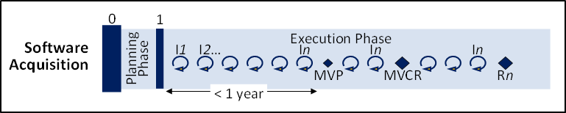

SECTION 4:PROCEDURES 14

*DoDI 5000.02, January 23, 2020*   
*Change 1, June 8, 2022*

**e. Defense Business Systems (DBS) Acquisition.**

(1) Purpose.

To acquire information systems that support DoD business operations. This pathway: (a) Applies to defense business capabilities and their supporting business systems, including those with “as-a-service” solutions to include:   
 1. Financial and financial data feeder.

2. Contracting.

3. Logistics.

4. Planning and budgeting.

5. Installations management.

6. Human resources management.

7. Training and readiness systems.

(b) May also be used to acquire non-developmental, software intensive programs that are not business systems.

(2) Characteristics.

This pathway assesses the business environment and identifies existing commercial or government solutions that could be adopted to satisfy DoD needs. The DoD reviews its business processes and revises them to align more closely with commercial or government information technology best practices. Customization of a selected information technology solution is minimal. The DoD reduces risk and maximizes benefits by using commercial-off-the-shelf software that has been successfully demonstrated in the commercial marketplace.

(3) Reference.

DoDI 5000.75 establishes policies and provides procedures for the DBS acquisition pathway, illustrated in Figure 6.

**Figure 6. DBS Pathway**

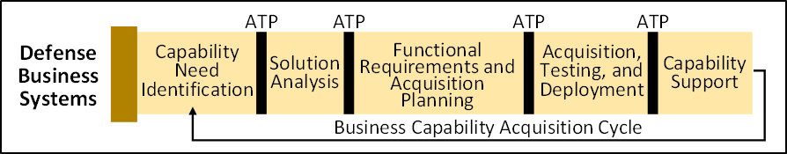

SECTION 4:PROCEDURES 15

*DoDI 5000.02, January 23, 2020*   
*Change 1, June 8, 2022*

**f. Defense Acquisition of Services.**

(1) Purpose.

To acquire services from the private sector including knowledge-based, construction, electronics and communications, equipment, facilities, product support, logistics, medical, research and development, and transportation services.

(2) Characteristics.

This pathway is intended to identify the required services, research the potential contractors, contract for the services, and manage performance. The seven steps of the pathway are grouped into three phases: Plan, Develop, and Execute.

(3) Reference.

DoDI 5000.74 and the online Service Acquisition Mall establish policies and provide procedures for the defense acquisition of services pathway, illustrated in Figure 7.

**Figure 7. Acquisition of Services Pathway**

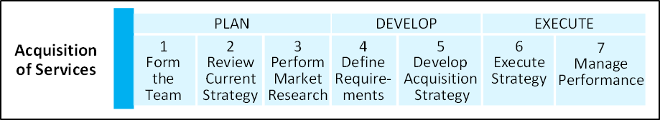

**4.3. ADDITIONAL DIRECTION.**

a. Additional details on each pathway of the AAF can be found at https://aaf.dau.edu/.

b. A table identifying references that provide additional policy direction, applicable to the pathways described in this issuance, is available at   
https://www.dau.edu/aafdid/Pages/About.aspx.

SECTION 4:PROCEDURES 16

*DoDI 5000.02, January 23, 2020*

*Change 1, June 8, 2022*

**GLOSSARY**

**G.1. ACRONYMS.**

**ACRONYM**  **MEANING**

AAF adaptive acquisition framework

ACAT acquisition category

CAE Component acquisition executive

DA decision authority

DAS Defense Acquisition System

DBS defense business systems

DepSecDef Deputy Secretary of Defense

DoDD DoD directive

DoDI DoD instruction

ITRA independent technical risk assessment

MDA milestone decision authority

MDAP major defense acquisition program

MTA middle tier of acquisition

PEO program executive officer

PM program manager

USD(A&S) Under Secretary of Defense for Acquisition and Sustainment

USD(R&E) Under Secretary of Defense for Research and Engineering

**G.2. DEFINITIONS.**

A complete Glossary of acquisition terms is maintained on the Defense Acquisition University

website. The Defense Acquisition University Glossary can be found at

https://www.dau.edu/tools/t/DAU-Glossary.

GLOSSARY 17

*DoDI 5000.02, January 23, 2020*   
*Change 1, June 8, 2022*

**REFERENCES**

Adaptive Acquisition Framework Documentation Identification (AAFDID) Tool1   
Cost Assessment and Program Evaluation, “Analysis of Alternatives Cost Estimating   
 Handbook,” current edition2   
Deputy Secretary of Defense Memorandum, “Procedures for the Establishment of Program Cost, Fielding, and Performance Goals for Major Defense Acquisition Programs,” November 16, 2018   
Deputy Secretary of Defense Memorandum, “Acquisition Roles and Responsibilities,”   
 December 20, 2019   
DoD Directive 5000.01, “The Defense Acquisition System,” September 9, 2020   
DoD Directive 5000.71, “Rapid Fulfillment of Combatant Commander Urgent Operational Needs,” August 24, 2012, as amended   
DoD Directive 5105.84, “Director of Cost Assessment and Program Evaluation,” August 14, 2020   
DoD Directive 5135.02, “Under Secretary of Defense for Acquisition and Sustainment   
 (USD(A&S)),” July 15, 2020   
DoD Directive 5137.02, “Under Secretary of Defense for Research and Engineering   
 (USD(R&E)),” July 15, 2020   
DoD Instruction 5000.73, “Cost Analysis Guidance and Procedures,” March 13, 2020   
DoD Instruction 5000.74, “Defense Acquisition of Services,” January 10, 2020, as amended DoD Instruction 5000.75, “Business Systems Requirements and Acquisition,” February 2, 2017, as amended   
DoD Instruction 5000.80, “Operation of the Middle Tier of Acquisition (MTA),”   
 December 30, 2019   
DoD Instruction 5000.81, “Urgent Capability Acquisition,” December 31, 2019   
DoD Instruction 5000.82, “Acquisition of Information Technology (IT),” April 21, 2020 DoD Instruction 5000.83, “Technology and Program Protection to Maintain Technological Advantage,” July 20, 2020, as amended   
DoD Instruction 5000.85, “Major Capability Acquisition,” August 6, 2020, as amended DoD Instruction 5000.87, “Operation of the Software Acquisition Pathway”, October 2, 2020 DoD Instruction 5000.88, “Engineering of Defense Systems,” November 18, 2020   
DoD Instruction 5000.89, “Test and Evaluation,” November 19, 2020   
DoD Instruction 5000.90, “Cybersecurity for Acquisition Decision Authorities and Program Managers,” December 31, 2020   
DoD Instruction 5000.91, “Product Support Management for the Adaptive Acquisition   
 Framework,” November 4, 2021

1 Available at https://www.dau.edu/aafdid/Pages/About.aspx 2 Available at https://www.cape.osd.mil/#CAPEPublicReports

REFERENCES 18

*DoDI 5000.02, January 23, 2020*   
*Change 1, June 8, 2022*

DoD Instruction 5000.95, “Human Systems Integration in Defense Acquisition,” April 1, 2022 DoD Instruction 5010.44, “Intellectual Property (IP) Acquisition and Licensing,”   
 October 16, 2019   
Public Law 114-328, Section 807, “National Defense Authorization Act for Fiscal Year 2017,” December 23, 2016   
The On-line Service Acquisition Mall3   
United States Code, Title 10

3 Available at https://www.dau.edu/tools/Documents/SAM/home.html

REFERENCES 19