**DECIBELS**

What is a decibel?

WATCH. THE. VIDEO. Please. It explains it so well.

***As so astutely noted by Dave Jones, a decibel is a ratio of one quantity to another (EEVblog, 2009). Most commonly, in the context of circuits, a decibel is usually defined by the two equations below:***

$$dB = 10\log{\frac{P_{1}}{P_{2 (REF)}}}$$

***where P represents power. Or, for voltage or current:***

$$dB = 20\log{\frac{V_{1}}{V_{2 (REF)}}}$$

***where V represents voltage.***

***This can be useful in many contexts. For example, humans do not perceive sound in the linear scale (e.g., the difference between 1,000 Hz and 1,100 Hz is not perceived as notably as the difference between 10,000 Hz and 10,100 Hz).***

A decibel is just a way of comparing one quantity to a reference quantity. It is good for seeing large differences, as it is on a log scale as opposed to a linear scale. Confusing, I know.

Let’s say you had a reference signal that is 5 volts.

If another signal is 3.3 volts, what is the ratio of these signals? $\frac{3.3 V}{5.0 V}=0.66$

What is the decibel level? $20\log_{10}{\frac{3.3 V}{5.0 V}}≅-3.61 dB$

Another signal is 1 volt. What is the ratio? $\frac{1.0 V}{5.0 V}=0.20$

What is the decibel level? $20\log_{10}{\frac{1.0 V}{5.0 V}}≅-13.97 dB$

Another signal is .5 volts. What is the ratio? $\frac{0.5 V}{5.0 V}=0.1 V$

What is the decibel level? $20\log_{10}{\frac{0.5 V}{5.0 V}}=-20.0 dB$

Another signal is .1 volt. What is the ratio? $\frac{0.1 V}{5.0 V}=0.02 V$

What is the decibel level? $20\log_{10}{\frac{0.1 V}{5.0 V}}≅-33.98 dB$

Determine the transfer function of the following circuit from the voltage source to Vout. Keep everything in symbolic form until you have the transfer function simplified.

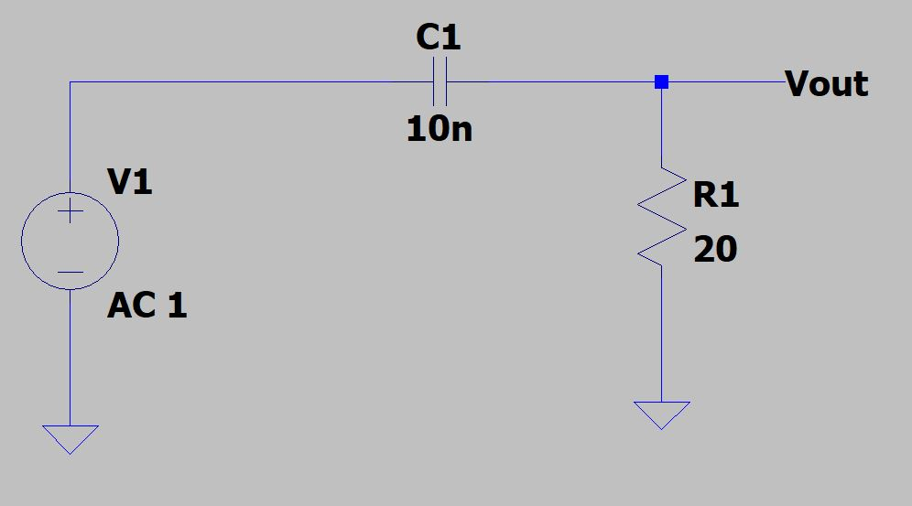

H(s) = $\frac{Vout}{V1}$ = $\frac{G0s}{(G1s+1)}$:

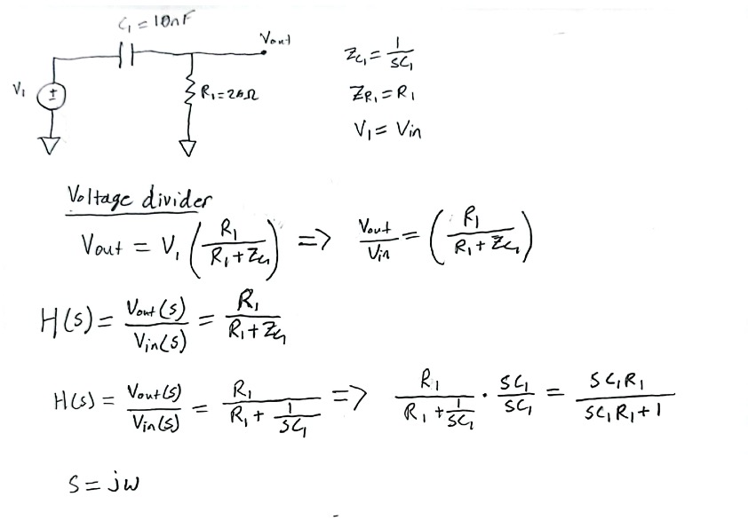

Use Excel to plot the magnitude versus frequency for this complex equation.

First write the **magnitude** equation of Equation (1) in the box below. Do this by replacing $s=jω.$ Recall: magnitude of a complex number is: $\left|a+bj\right|=\sqrt{a^{2}+b^{2}}$

**Note: the magnitude default units are V/V and rad/sec.**

Use Excel to create plots of magnitude versus frequency and phase versus frequency:

Create a column for angular frequency ($ω$), frequency (Hz), magnitude (V/V), and dB.

Vary the angular frequency from 0.1 to 63x106. Include $f=1,000, 10,000, 100,000, 1,000,000,$ and $10,000,000$ Hz. Use that column to create frequency (Hz). Recall: $ω=2πf$. Use the equation above for the magnitude. Use dB = 20*log10(magnitude in V/V).

Create 2 scatter plots: (1) Magnitude versus Hz and (2) dB versus Hz. Change both the x-axis to be a “log” scale. Also add the minor grids to see the graphs easier.

**Figure 1:** Magnitude of Transfer Function in V/V versus Frequency in Hz

**Figure 2:** Magnitude of Transfer Function in dB versus Frequency in Hz

**Figure 3:** Magnitude of Transfer Function in V/V versus Frequency in rad/s

**Figure 4:** Magnitude of Transfer Function in dB versus Frequency in rad/s

**Figure 5:** Phase in Degrees versus Frequency in Hz

**Figure 6:** Phase in Degrees versus Frequency in rad/s