**BJT TRANSISTORS:**

The circuit below is an example of the base-emitter junction of a BJT being used as a diode.

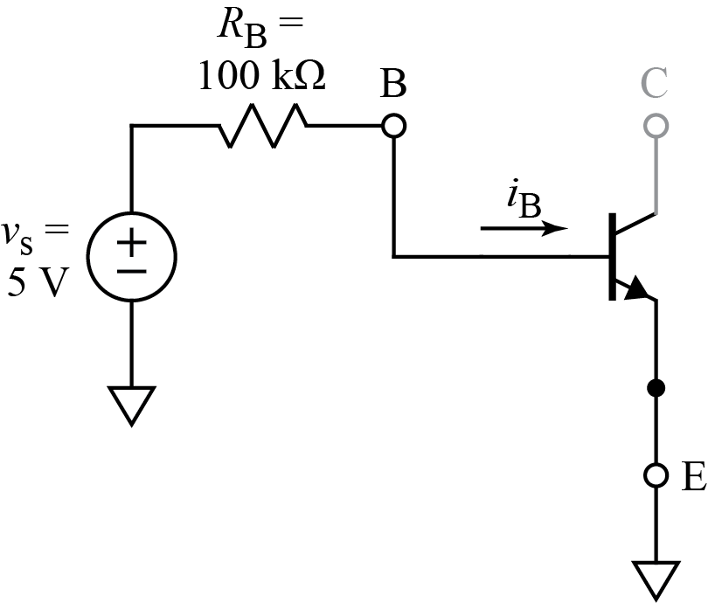

The schematic below shows the base-emitter diode and the dependent source in the transistor.

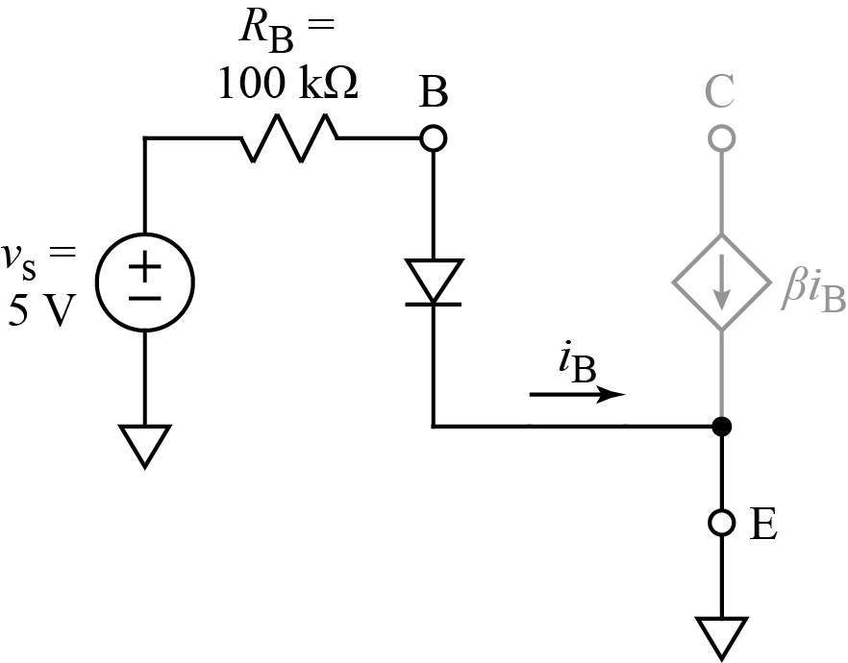

The dependent source in the collector is grayed out to indicate that it cannot pass current. The collector may be thought of as a current *limiter* that requires an external source to supply the current.

Using the usual model of a diode, we have the picture below. What is the value of the current, *I*B, in the base-emitter junction? $I_{B} =\frac{5V - 0.7V}{100 kΩ} = 43 uA$

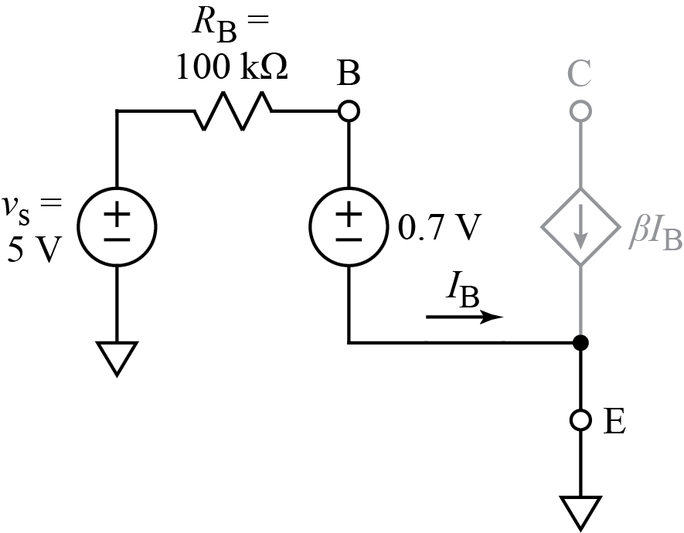

Now suppose the collector is connected to a voltage source, VCC, of 5 V as shown below.

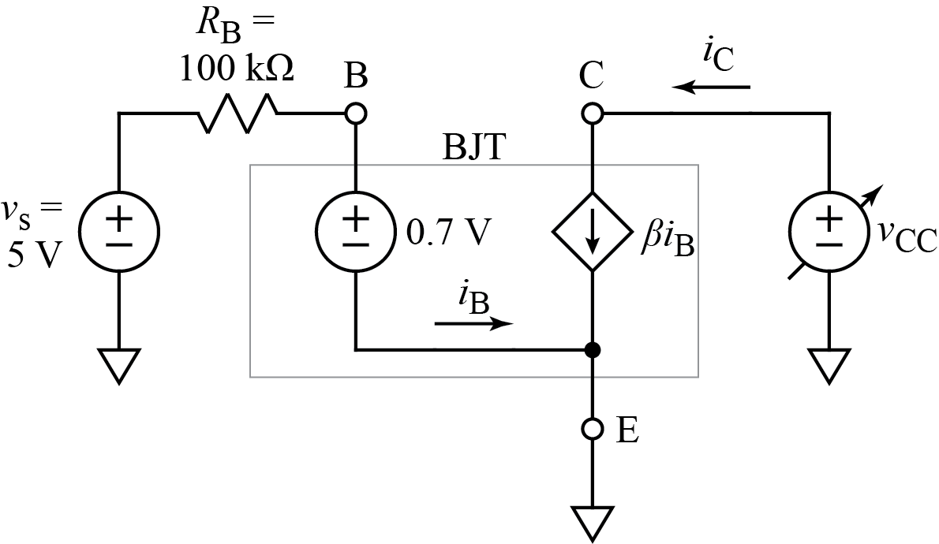

The VCC source will push as much current as the circuit will let it. According to theory, which is correct!, the dependent source will pass a current that is β (beta) times the current in the base (your first answer), and the datasheet for the 2N3904 states a small-signal current gain, hfe, of 100 to 400. The small signal gain and β are technically different things, but it common practice to assume a DC gain of at least β = 100.

If β = 100, how much current flows into the collector? $I_{C} =100 * 43 uA=4.3 mA$

If we set VCC = 5V and add a resistor, *R*C, in series with the collector, as shown below, it will have a voltage drop of *I*C times *R*C.

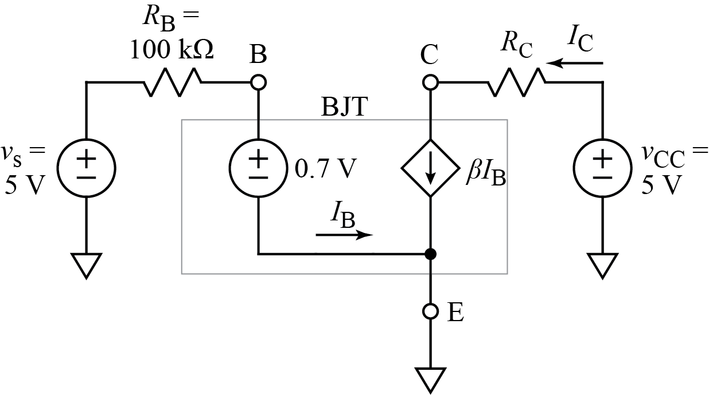

The collector voltage will then be lower than *V*CC = 5 V by the voltage drop on *R*C.

If β = 100, what value of resistor will cause the voltage at the collector to be 1V?

$R_{C} =-\frac{V_{RC} - V_{CC}}{β {* I}_{B}}=-\frac{1 V - 5 V}{4.3 mA}=930.23 Ω$

Note, however, that the transistor could have much more gain than we expect.

If β = 400, what value of resistor will cause the voltage at the collector to be 1V?

$$R_{C} =\frac{V_{RC} - V_{CC}}{β {* I}_{B}}=-\frac{1 V - 5 V}{100 * 43 uA}=232.56 Ω$$

This exercise illustrates that variable gain in transistors is one of the issues that must be considered in circuit design. We can get big swings in voltage at the collector in response to small changes in base current, but we have to deal with the variability of the transistor gain.