IRAOD 多种子结果与证据覆盖报告
结果状态：partial。本文件是消费者产物，报告生成成功不等于实验或全部八项任务完成。
输入清单：/mnt/shared/zechuan/iraod_artifacts/comparison/xaf_student_quant_20260908/ports108_collection_752a139/report-manifest.json
消费者提交：752a139c969911608b8807db2839332ddf6e2aae

主要观察与统计限制
诊断更新：限定的只读检查已确认五个RSAR种子44零检测单元是数值失败，最终Student、EMA和优化器状态均含NaN，不是单纯的有限模型差表现。所有原始零分、原生输出及既有均值/统计保持不变。
五个受影响EMA各有195/343个浮点张量含NaN；IRG Student为213/361，LPLD/SFUT Student为195/343。日志在截至240的块仍有限，截至250和260的块为NaN；没有健康的中间检查点，首个算术算子尚未确定。
唯一对照为IRG/point_target/seed43：Student、EMA和优化器均有限，原生检测103767个、mAP50=52.6134%。不能据此宣称其余103个运行全部健康；其中只检查了这个对照。
六个检查对象的原生检查点路径、配置、代码版本、类别和8538个图像记录一致，EMA键/形状与对照一致，没有原生评估加载不匹配。IRG缺少18个新辅助参数的source初始化警告也出现在健康对照中，不是缺失检测器权重的证据。
本报告仍记录108个EMA加12个固定source的120/120原生量化产物完整性；这不等于数值健康。RSAR mPC仍为A31.7142%、IRG30.6249%、LPLD28.8620%、SFUT32.2515%；DIOR仍为A27.1185%、IRG27.3923%、LPLD27.5468%、SFUT27.2890%。统计不删除失败种子，也不应解释成三次均成功的有限训练重复。
种子44的RSAR point_target/EMA与noise_suppression/EMA联合组须明确显示数值失败导致的缺失可用点，不能伪造点、静默去掉方法、换种子或调整阈值。后续仅增加非有限值失败检测；本诊断没有执行重放、重训或调参。

Source producer 元数据更正审计
以下仅更正报告中的 source producer 解释：原 sidecar 保留，权重、预测、实际图像 ID 和 mAP 均不改变，不因此重训或重推理。recorded 与 actual 明确分列；B–F 的适配训练 producer 不套用 source producer。
数据集/域 | sidecar recorded | source actual | 原始依据
RSAR/clean | 0f98a48b539f9260055fc305784ffbc924f50451 | b474aaa5f7718746215ce13beceb071617bb823e | /mnt/shared/zechuan/iraod_artifacts/rsar_source/seed42-orthonet-ddp4-gpu4567-spg16-gbs64/reproducibility/git_commit.txt
RSAR/chaff | 0f98a48b539f9260055fc305784ffbc924f50451 | b474aaa5f7718746215ce13beceb071617bb823e | /mnt/shared/zechuan/iraod_artifacts/rsar_source/seed42-orthonet-ddp4-gpu4567-spg16-gbs64/reproducibility/git_commit.txt
RSAR/gaussian_white_noise | 0f98a48b539f9260055fc305784ffbc924f50451 | b474aaa5f7718746215ce13beceb071617bb823e | /mnt/shared/zechuan/iraod_artifacts/rsar_source/seed42-orthonet-ddp4-gpu4567-spg16-gbs64/reproducibility/git_commit.txt
RSAR/point_target | 0f98a48b539f9260055fc305784ffbc924f50451 | b474aaa5f7718746215ce13beceb071617bb823e | /mnt/shared/zechuan/iraod_artifacts/rsar_source/seed42-orthonet-ddp4-gpu4567-spg16-gbs64/reproducibility/git_commit.txt
RSAR/noise_suppression | 0f98a48b539f9260055fc305784ffbc924f50451 | b474aaa5f7718746215ce13beceb071617bb823e | /mnt/shared/zechuan/iraod_artifacts/rsar_source/seed42-orthonet-ddp4-gpu4567-spg16-gbs64/reproducibility/git_commit.txt
RSAR/am_noise_horizontal | 0f98a48b539f9260055fc305784ffbc924f50451 | b474aaa5f7718746215ce13beceb071617bb823e | /mnt/shared/zechuan/iraod_artifacts/rsar_source/seed42-orthonet-ddp4-gpu4567-spg16-gbs64/reproducibility/git_commit.txt
RSAR/smart_suppression | 0f98a48b539f9260055fc305784ffbc924f50451 | b474aaa5f7718746215ce13beceb071617bb823e | /mnt/shared/zechuan/iraod_artifacts/rsar_source/seed42-orthonet-ddp4-gpu4567-spg16-gbs64/reproducibility/git_commit.txt
RSAR/am_noise_vertical | 0f98a48b539f9260055fc305784ffbc924f50451 | b474aaa5f7718746215ce13beceb071617bb823e | /mnt/shared/zechuan/iraod_artifacts/rsar_source/seed42-orthonet-ddp4-gpu4567-spg16-gbs64/reproducibility/git_commit.txt

1. 统计单位与适用范围
实验单位为适配种子 42、43、44。先在每个种子内对全部腐蚀域求 mPC，并在同域求相对固定 A 的差值后平均，再跨种子计算均值与样本标准差（ddof=1）。A 仅一次固定 source 测量，不复制成三次独立测量；所有区间只反映条件于固定 source 的适配随机性。不把类别、图像或腐蚀域当作独立种子，也不要求 B–D 单卡和 E/F 双卡具有相同 GPU UUID。
n=3，检验低功效。95% CI 为 100000 次 seed-block 百分位 bootstrap（随机种子 42），小样本下不稳定。双侧 t 检验施于三个种子级配对差值，依赖差值正态假设；零方差时 t 检验未定义。精确 sign-flip 枚举 8 种符号，其最小双侧 p=0.25。Holm 按清单预先声明的方法、数据集、角色、指标及比较组校正；家族不完整不输出调整后 p 值。
声明方法：A, IRG, LPLD, SFUT
common_one_epoch 为共同一轮预算；AASFOD 使用已披露的预算缩放移植。SFYOLO 为 extended_two_epoch_TAM，两轮最终标签 RSAR531 / DIOR369，不与一轮方法合并排名或统计。LoRA-CGA / LoRA-CGA+VLST 如被声明，仅在 target_supervised_appendix 中展示，绝不计入 strict main。各表与图按清单顺序而非结果排序；固定 A 在各组仅作同一参考，并非新增测量。
历史 rPC 始终为 100 × mPC / 固定 A clean TEST；method_clean_normalized_percent 另列，分母为同方法同种子的独立 clean 适配实测值。缺域或缺种子时不生成完整多种子均值、标准差或 CI，不据少量已完成结果排名。
Recovery ratio = (方法 corruption AP50 − A corruption AP50) / (A clean TEST AP50 − A corruption AP50)。分母非正时未定义，接近零时不稳定；不截断负值或大于 1 的值，不据此排名，逐种子逐域数值见 recovery.csv。

2. 量化与逐实例覆盖
Explicit-method quantitative TEST collection only; parent extensions incomplete. Full TEST RoI, fixed visualizations and joint t-SNE remain pending.
本次只收集声明角色的全 TEST 量化结果；不把既有 core 的定性覆盖分母当作扩展任务范围。新增 RoI、固定可视化与联合嵌入仍由已批准扩展清单跟踪。
证据类型 | 已完成 / 预期 | 范围
量化单元 | 120 / 120 | 全 TEST predictions；需实际有序 image-ID 证据
predictions.pkl 与原生 image-ID 顺序是量化证据，不包含 fc_cls 特征，不能替代全 TEST aligned RoI；定性导出未在本次执行。

common_one_epoch
数据集/域 | 方法/角色 | n | 均值 | 样本 std | 状态
RSAR/clean | A/source | 1 | 0.5314 | N/A | fixed_source
RSAR/clean | IRG/ema | 3 | 0.548037 | 0.00238568 | complete_low_power
RSAR/clean | LPLD/ema | 3 | 0.533946 | 0.00314361 | complete_low_power
RSAR/clean | SFUT/ema | 3 | 0.546414 | 0.00202157 | complete_low_power
RSAR/chaff | A/source | 1 | 0.471931 | N/A | fixed_source
RSAR/chaff | IRG/ema | 3 | 0.490408 | 0.0080862 | complete_low_power
RSAR/chaff | LPLD/ema | 3 | 0.479142 | 0.00207382 | complete_low_power
RSAR/chaff | SFUT/ema | 3 | 0.484269 | 0.0016733 | complete_low_power
RSAR/gaussian_white_noise | A/source | 1 | 0.528137 | N/A | fixed_source
RSAR/gaussian_white_noise | IRG/ema | 3 | 0.547409 | 0.00355565 | complete_low_power
RSAR/gaussian_white_noise | LPLD/ema | 3 | 0.533572 | 0.00351447 | complete_low_power
RSAR/gaussian_white_noise | SFUT/ema | 3 | 0.539022 | 0.00361984 | complete_low_power
RSAR/point_target | A/source | 1 | 0.51584 | N/A | fixed_source
RSAR/point_target | IRG/ema | 3 | 0.350819 | 0.303818 | complete_low_power
RSAR/point_target | LPLD/ema | 3 | 0.345463 | 0.299213 | complete_low_power
RSAR/point_target | SFUT/ema | 3 | 0.522725 | 0.00134027 | complete_low_power
RSAR/noise_suppression | A/source | 1 | 0.163407 | N/A | fixed_source
RSAR/noise_suppression | IRG/ema | 3 | 0.128399 | 0.111279 | complete_low_power
RSAR/noise_suppression | LPLD/ema | 3 | 0.124092 | 0.107469 | complete_low_power
RSAR/noise_suppression | SFUT/ema | 3 | 0.116738 | 0.101099 | complete_low_power
RSAR/am_noise_horizontal | A/source | 1 | 0.206206 | N/A | fixed_source
RSAR/am_noise_horizontal | IRG/ema | 3 | 0.220627 | 0.0036059 | complete_low_power
RSAR/am_noise_horizontal | LPLD/ema | 3 | 0.195088 | 0.00534889 | complete_low_power
RSAR/am_noise_horizontal | SFUT/ema | 3 | 0.220683 | 0.00197723 | complete_low_power
RSAR/smart_suppression | A/source | 1 | 0.143726 | N/A | fixed_source
RSAR/smart_suppression | IRG/ema | 3 | 0.159513 | 0.00760352 | complete_low_power
RSAR/smart_suppression | LPLD/ema | 3 | 0.13723 | 0.0199218 | complete_low_power
RSAR/smart_suppression | SFUT/ema | 3 | 0.1474 | 0.00141567 | complete_low_power
RSAR/am_noise_vertical | A/source | 1 | 0.190744 | N/A | fixed_source
RSAR/am_noise_vertical | IRG/ema | 3 | 0.246566 | 0.00671072 | complete_low_power
RSAR/am_noise_vertical | LPLD/ema | 3 | 0.205754 | 0.0270974 | complete_low_power
RSAR/am_noise_vertical | SFUT/ema | 3 | 0.226769 | 0.00619668 | complete_low_power
DIOR/clean | A/source | 1 | 0.2949 | N/A | fixed_source
DIOR/clean | IRG/ema | 3 | 0.297763 | 0.000336837 | complete_low_power
DIOR/clean | LPLD/ema | 3 | 0.298629 | 0.00156137 | complete_low_power
DIOR/clean | SFUT/ema | 3 | 0.29599 | 0.000125011 | complete_low_power
DIOR/brightness | A/source | 1 | 0.241684 | N/A | fixed_source
DIOR/brightness | IRG/ema | 3 | 0.244225 | 0.000921654 | complete_low_power
DIOR/brightness | LPLD/ema | 3 | 0.247827 | 0.000395481 | complete_low_power
DIOR/brightness | SFUT/ema | 3 | 0.242009 | 0.000232165 | complete_low_power
DIOR/cloudy | A/source | 1 | 0.290268 | N/A | fixed_source
DIOR/cloudy | IRG/ema | 3 | 0.2933 | 0.00178494 | complete_low_power
DIOR/cloudy | LPLD/ema | 3 | 0.293215 | 0.00236902 | complete_low_power
DIOR/cloudy | SFUT/ema | 3 | 0.293876 | 0.000181506 | complete_low_power
DIOR/contrast | A/source | 1 | 0.281603 | N/A | fixed_source
DIOR/contrast | IRG/ema | 3 | 0.284244 | 0.000770519 | complete_low_power
DIOR/contrast | LPLD/ema | 3 | 0.285362 | 0.00141068 | complete_low_power
DIOR/contrast | SFUT/ema | 3 | 0.282786 | 7.95348e-05 | complete_low_power

3. 多种子汇总

common_one_epoch
数据集/角色 | 方法 | 指标 | n | 均值 | 样本 std | 95% CI | 状态
RSAR/source | A | mPC | 1 | 0.317142 | N/A | [N/A, N/A] | fixed_source
RSAR/source | A | delta_A | 1 | 0 | N/A | [N/A, N/A] | fixed_source
RSAR/source | A | rPC_percent | 1 | 59.6804 | N/A | [N/A, N/A] | fixed_source
RSAR/source | A | method_clean_normalized_percent | 0 | N/A | N/A | [N/A, N/A] | incomplete
RSAR/source | A | clean_mAP50 | 1 | 0.5314 | N/A | [N/A, N/A] | fixed_source
RSAR/source | A | clean_delta_A | 1 | 0 | N/A | [N/A, N/A] | fixed_source
RSAR/ema | IRG | mPC | 3 | 0.306249 | 0.0597151 | [0.237296, 0.340998] | complete_low_power
RSAR/ema | IRG | delta_A | 3 | -0.0108928 | 0.0597151 | [-0.0798452, 0.0238564] | complete_low_power
RSAR/ema | IRG | rPC_percent | 3 | 57.6306 | 11.2373 | [44.655, 64.1698] | complete_low_power
RSAR/ema | IRG | method_clean_normalized_percent | 3 | 55.8501 | 10.68 | [43.518, 62.0734] | complete_low_power
RSAR/ema | IRG | clean_mAP50 | 3 | 0.548037 | 0.00238568 | [0.545283, 0.549481] | complete_low_power
RSAR/ema | IRG | clean_delta_A | 3 | 0.016637 | 0.00238568 | [0.0138834, 0.0180809] | complete_low_power
RSAR/ema | LPLD | mPC | 3 | 0.28862 | 0.062491 | [0.216506, 0.326856] | complete_low_power
RSAR/ema | LPLD | delta_A | 3 | -0.0285214 | 0.062491 | [-0.100636, 0.00971431] | complete_low_power
RSAR/ema | LPLD | rPC_percent | 3 | 54.3132 | 11.7597 | [40.7425, 61.5085] | complete_low_power
RSAR/ema | LPLD | method_clean_normalized_percent | 3 | 54.014 | 11.4556 | [40.8016, 61.1718] | complete_low_power
RSAR/ema | LPLD | clean_mAP50 | 3 | 0.533946 | 0.00314361 | [0.530631, 0.536884] | complete_low_power
RSAR/ema | LPLD | clean_delta_A | 3 | 0.00254647 | 0.00314361 | [-0.000769019, 0.00548404] | complete_low_power
RSAR/ema | SFUT | mPC | 3 | 0.322515 | 0.0131876 | [0.307293, 0.330488] | complete_low_power
RSAR/ema | SFUT | delta_A | 3 | 0.00537347 | 0.0131876 | [-0.00984852, 0.0133461] | complete_low_power
RSAR/ema | SFUT | rPC_percent | 3 | 60.6916 | 2.48167 | [57.8271, 62.1919] | complete_low_power
RSAR/ema | SFUT | method_clean_normalized_percent | 3 | 59.0256 | 2.46487 | [56.1848, 60.5979] | complete_low_power
RSAR/ema | SFUT | clean_mAP50 | 3 | 0.546414 | 0.00202157 | [0.544184, 0.548126] | complete_low_power
RSAR/ema | SFUT | clean_delta_A | 3 | 0.0150145 | 0.00202157 | [0.0127844, 0.0167267] | complete_low_power
DIOR/source | A | mPC | 1 | 0.271185 | N/A | [N/A, N/A] | fixed_source
DIOR/source | A | delta_A | 1 | 0 | N/A | [N/A, N/A] | fixed_source
DIOR/source | A | rPC_percent | 1 | 91.9584 | N/A | [N/A, N/A] | fixed_source
DIOR/source | A | method_clean_normalized_percent | 0 | N/A | N/A | [N/A, N/A] | incomplete
DIOR/source | A | clean_mAP50 | 1 | 0.2949 | N/A | [N/A, N/A] | fixed_source
DIOR/source | A | clean_delta_A | 1 | 0 | N/A | [N/A, N/A] | fixed_source
DIOR/ema | IRG | mPC | 3 | 0.273923 | 0.00110865 | [0.272814, 0.275031] | complete_low_power
DIOR/ema | IRG | delta_A | 3 | 0.00273774 | 0.00110865 | [0.001629, 0.0038463] | complete_low_power
DIOR/ema | IRG | rPC_percent | 3 | 92.8868 | 0.37594 | [92.5108, 93.2627] | complete_low_power
DIOR/ema | IRG | method_clean_normalized_percent | 3 | 91.9933 | 0.268952 | [91.7185, 92.256] | complete_low_power
DIOR/ema | IRG | clean_mAP50 | 3 | 0.297763 | 0.000336837 | [0.297447, 0.298118] | complete_low_power
DIOR/ema | IRG | clean_delta_A | 3 | 0.00286358 | 0.000336837 | [0.00254741, 0.00321785] | complete_low_power
DIOR/ema | LPLD | mPC | 3 | 0.275468 | 0.00133457 | [0.274205, 0.276864] | complete_low_power
DIOR/ema | LPLD | delta_A | 3 | 0.00428269 | 0.00133457 | [0.00302013, 0.00567917] | complete_low_power
DIOR/ema | LPLD | rPC_percent | 3 | 93.4107 | 0.45255 | [92.9825, 93.8842] | complete_low_power
DIOR/ema | LPLD | method_clean_normalized_percent | 3 | 92.245 | 0.46157 | [91.7476, 92.6594] | complete_low_power
DIOR/ema | LPLD | clean_mAP50 | 3 | 0.298629 | 0.00156137 | [0.29699, 0.3001] | complete_low_power
DIOR/ema | LPLD | clean_delta_A | 3 | 0.00372941 | 0.00156137 | [0.0020906, 0.00519967] | complete_low_power
DIOR/ema | SFUT | mPC | 3 | 0.27289 | 5.87917e-05 | [0.272823, 0.272934] | complete_low_power
DIOR/ema | SFUT | delta_A | 3 | 0.00170525 | 5.87917e-05 | [0.00163829, 0.00174841] | complete_low_power
DIOR/ema | SFUT | rPC_percent | 3 | 92.5367 | 0.0199362 | [92.5139, 92.5513] | complete_low_power
DIOR/ema | SFUT | method_clean_normalized_percent | 3 | 92.1958 | 0.058023 | [92.129, 92.2328] | complete_low_power
DIOR/ema | SFUT | clean_mAP50 | 3 | 0.29599 | 0.000125011 | [0.295897, 0.296132] | complete_low_power
DIOR/ema | SFUT | clean_delta_A | 3 | 0.00109018 | 0.000125011 | [0.000997216, 0.0012323] | complete_low_power
RSAR_ema_common_one_epoch_mpc.png：仅展示完整种子块，误差棒为样本标准差；A 无重复测量误差棒。
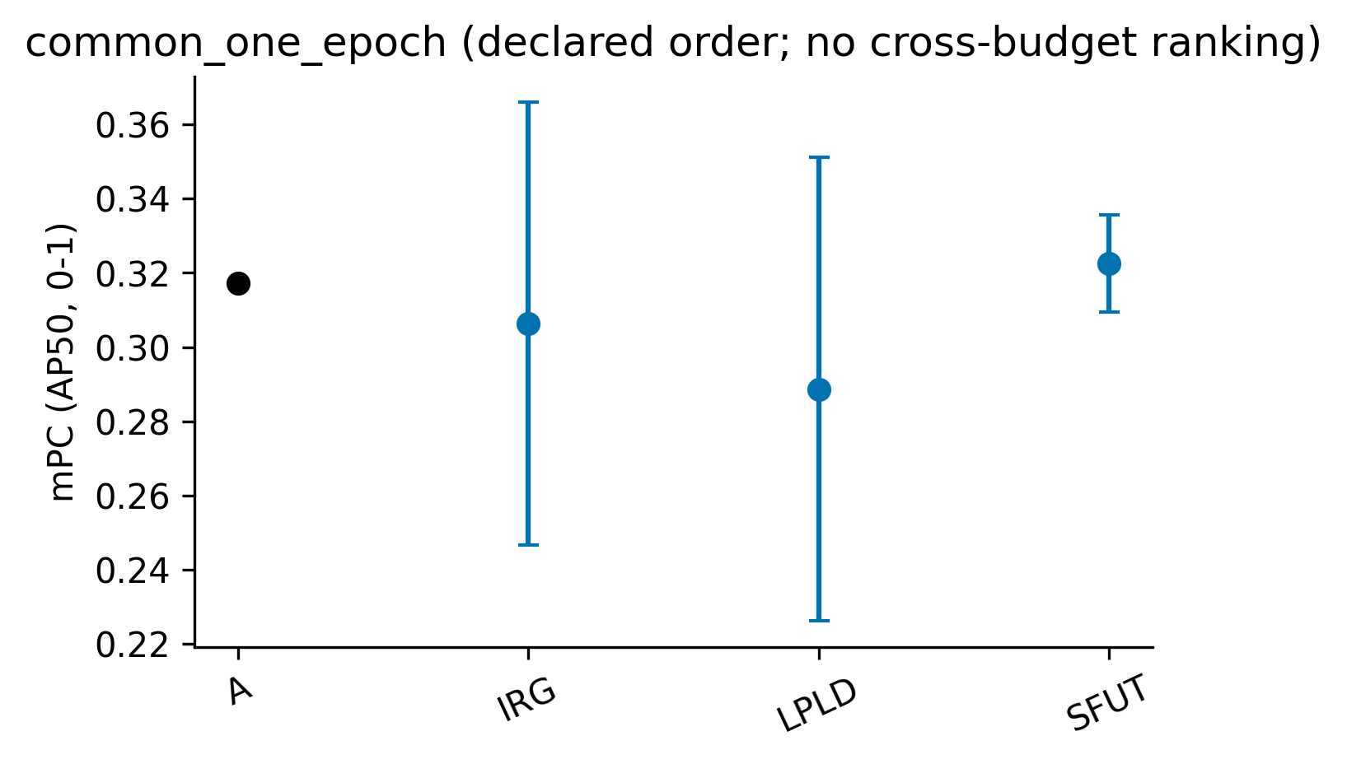
DIOR_ema_common_one_epoch_mpc.png：仅展示完整种子块，误差棒为样本标准差；A 无重复测量误差棒。
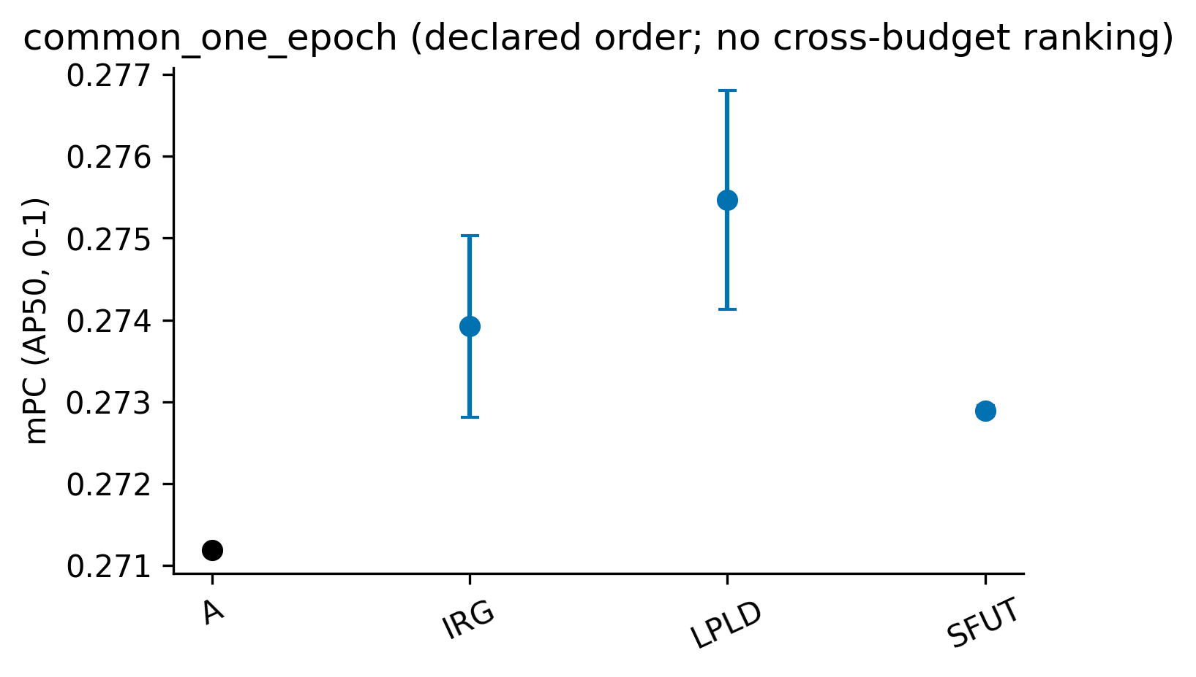

4. 配对统计

common_one_epoch
数据集/角色 | 方法 | 指标 | n | t p | sign-flip p | Holm t / sign | 状态
RSAR/ema | IRG | delta_A | 3 | 0.781966 | 1 | 1 / 1 | complete_low_power
RSAR/ema | IRG | clean_delta_A | 3 | 0.00678446 | 0.25 | 0.0179655 / 0.75 | complete_low_power
RSAR/ema | LPLD | delta_A | 3 | 0.512073 | 1 | 1 / 1 | complete_low_power
RSAR/ema | LPLD | clean_delta_A | 3 | 0.295703 | 0.5 | 0.295703 / 0.75 | complete_low_power
RSAR/ema | SFUT | delta_A | 3 | 0.553474 | 0.5 | 1 / 1 | complete_low_power
RSAR/ema | SFUT | clean_delta_A | 3 | 0.00598849 | 0.25 | 0.0179655 / 0.75 | complete_low_power
DIOR/ema | IRG | delta_A | 3 | 0.0505524 | 0.25 | 0.061755 / 0.75 | complete_low_power
DIOR/ema | IRG | clean_delta_A | 3 | 0.00458046 | 0.25 | 0.0130635 / 0.75 | complete_low_power
DIOR/ema | LPLD | delta_A | 3 | 0.0308775 | 0.25 | 0.061755 / 0.75 | complete_low_power
DIOR/ema | LPLD | clean_delta_A | 3 | 0.0537586 | 0.25 | 0.0537586 / 0.75 | complete_low_power
DIOR/ema | SFUT | delta_A | 3 | 0.000395984 | 0.25 | 0.00118795 / 0.75 | complete_low_power
DIOR/ema | SFUT | clean_delta_A | 3 | 0.00435449 | 0.25 | 0.0130635 / 0.75 | complete_low_power

5. 原始值、精度与未完成项
raw_results.csv 保留完整 metric.mAP，不使用已舍入的 metric.AP50。historical/ 逐字节保留输入的历史 seed42 CSV；原始 seed42 mAP 锁定，重评差异另存 eval_mAP50 并标记 metric_conflict，不静默改写旧值。per_class.csv 来自 class_ap.txt，通常仅三位小数，不反算总 mAP。prediction_image_coverage.csv、roi_vis_coverage.csv 和 embedding_index.csv 是三种不同范围的证据。
数据集/域 | 方法/角色/种子 | 状态 | 原因
全部原始行与每种子聚合见 raw_results.csv、per_seed.csv；本报告不声称完成其他基线移植或未在输入证据中完成的项目。

