IRAOD 多种子结果与证据覆盖报告
结果状态：partial。本文件是消费者产物，报告生成成功不等于实验或全部八项任务完成。
输入清单：/mnt/shared/zechuan/iraod_artifacts/comparison/xaf_student_quant_20260908/student_collection_84a1aeb/report-manifest.json
消费者提交：84a1aebcdf9fa6f710acc5c031dc12d4c0d465be

主要观察与统计限制
RSAR：A 的观察 mPC 均值最高，为 31.7142%。F 相对固定 A 的配对平均增益为 -16.6831 个百分点。最高均值不等于方法间差异显著；不因负结果删除或重调方法。
RSAR 的 ΔA 双侧 t 检验 Holm p（B–F）：B=0.00397602、C=0.000916056、D=0.0136891、E=0.00397602、F=0.00537322。这些是固定 source 条件下、依赖差值正态假设的 n=3 检验，不能与无分布假设的证据强度混同。
DIOR：A 的观察 mPC 均值最高，为 27.1185%。F 相对固定 A 的配对平均增益为 -9.1877 个百分点。最高均值不等于方法间差异显著；不因负结果删除或重调方法。
DIOR 的 ΔA 双侧 t 检验 Holm p（B–F）：B=0.0115459、C=0.00445011、D=0.00552415、E=0.0446932、F=0.00369274。这些是固定 source 条件下、依赖差值正态假设的 n=3 检验，不能与无分布假设的证据强度混同。
ΔA 精确双侧 sign-flip 最小原始 p=0.25；最小 Holm p=1。仅 8 种符号排列，低功效；本次不据此宣称分布无关的显著提升。腐蚀域不是独立重复样本，置信区间仅反映适配随机性。

Source producer 元数据更正审计
以下仅更正报告中的 source producer 解释：原 sidecar 保留，权重、预测、实际图像 ID 和 mAP 均不改变，不因此重训或重推理。recorded 与 actual 明确分列；B–F 的适配训练 producer 不套用 source producer。
数据集/域 | sidecar recorded | source actual | 原始依据
RSAR/clean | 0f98a48b539f9260055fc305784ffbc924f50451 | b474aaa5f7718746215ce13beceb071617bb823e | /mnt/shared/zechuan/iraod_artifacts/rsar_source/seed42-orthonet-ddp4-gpu4567-spg16-gbs64/reproducibility/git_commit.txt
RSAR/chaff | 0f98a48b539f9260055fc305784ffbc924f50451 | b474aaa5f7718746215ce13beceb071617bb823e | /mnt/shared/zechuan/iraod_artifacts/rsar_source/seed42-orthonet-ddp4-gpu4567-spg16-gbs64/reproducibility/git_commit.txt
RSAR/gaussian_white_noise | 0f98a48b539f9260055fc305784ffbc924f50451 | b474aaa5f7718746215ce13beceb071617bb823e | /mnt/shared/zechuan/iraod_artifacts/rsar_source/seed42-orthonet-ddp4-gpu4567-spg16-gbs64/reproducibility/git_commit.txt
RSAR/point_target | 0f98a48b539f9260055fc305784ffbc924f50451 | b474aaa5f7718746215ce13beceb071617bb823e | /mnt/shared/zechuan/iraod_artifacts/rsar_source/seed42-orthonet-ddp4-gpu4567-spg16-gbs64/reproducibility/git_commit.txt
RSAR/noise_suppression | 0f98a48b539f9260055fc305784ffbc924f50451 | b474aaa5f7718746215ce13beceb071617bb823e | /mnt/shared/zechuan/iraod_artifacts/rsar_source/seed42-orthonet-ddp4-gpu4567-spg16-gbs64/reproducibility/git_commit.txt
RSAR/am_noise_horizontal | 0f98a48b539f9260055fc305784ffbc924f50451 | b474aaa5f7718746215ce13beceb071617bb823e | /mnt/shared/zechuan/iraod_artifacts/rsar_source/seed42-orthonet-ddp4-gpu4567-spg16-gbs64/reproducibility/git_commit.txt
RSAR/smart_suppression | 0f98a48b539f9260055fc305784ffbc924f50451 | b474aaa5f7718746215ce13beceb071617bb823e | /mnt/shared/zechuan/iraod_artifacts/rsar_source/seed42-orthonet-ddp4-gpu4567-spg16-gbs64/reproducibility/git_commit.txt
RSAR/am_noise_vertical | 0f98a48b539f9260055fc305784ffbc924f50451 | b474aaa5f7718746215ce13beceb071617bb823e | /mnt/shared/zechuan/iraod_artifacts/rsar_source/seed42-orthonet-ddp4-gpu4567-spg16-gbs64/reproducibility/git_commit.txt

1. 统计单位与适用范围
实验单位为适配种子 42、43、44。先在每个种子内对全部腐蚀域求 mPC，并在同域求相对固定 A 的差值后平均，再跨种子计算均值与样本标准差（ddof=1）。A 仅一次固定 source 测量，不复制成三次独立测量；所有区间只反映条件于固定 source 的适配随机性。不把类别、图像或腐蚀域当作独立种子，也不要求 B–D 单卡和 E/F 双卡具有相同 GPU UUID。
n=3，检验低功效。95% CI 为 100000 次 seed-block 百分位 bootstrap（随机种子 42），小样本下不稳定。双侧 t 检验施于三个种子级配对差值，依赖差值正态假设；零方差时 t 检验未定义。精确 sign-flip 枚举 8 种符号，其最小双侧 p=0.25。Holm 分别用于各数据集/角色/指标的五个 B–F 比较，家族不完整时不输出调整后 p 值。
历史 rPC 始终为 100 × mPC / 固定 A clean TEST；method_clean_normalized_percent 另列，分母为同方法同种子的独立 clean 适配实测值。缺域或缺种子时不生成完整多种子均值、标准差或 CI，不据少量已完成结果排名。
Recovery ratio = (方法 corruption AP50 − A corruption AP50) / (A clean TEST AP50 − A corruption AP50)。分母非正时未定义，接近零时不稳定；不截断负值或大于 1 的值，不据此排名，逐种子逐域数值见 recovery.csv。

公平性与方法边界
方法 | 公平组 | 框 | VLM | 目标标签 | 状态
A | Source-Free | OBB | none | eval_only | complete
B | Source-Free | OBB | none | eval_only | complete
C | Source-Free | OBB | CLIP-RN50x64 | eval_only | complete
D | Source-Free | OBB | SARCLIP-ViT-B-32 | eval_only | complete
E | Source-Free | OBB | SARCLIP-ViT-B-32 | eval_only | complete
F | Source-Free | OBB | SARCLIP-ViT-B-32 | eval_only | complete
本报告的 Source-Free A–F 为同一比较组。B/D/E/F 为已有组件组合比较，不冒充额外消融训练。未列出分数的扩展方法与 target-supervised oracle不在本报告的结果范围内；这不表示它们未获批准或已完成。

2. 量化与逐实例覆盖
180 native Student TEST evaluations plus12 reused source evaluations; no new ROI, visualization, embedding or other extension completion is claimed
本次只收集 Student 全 TEST 量化结果；不把既有 core 的定性覆盖分母当作扩展任务范围。新增 RoI、固定可视化与联合嵌入仍由已批准扩展清单跟踪。
证据类型 | 已完成 / 预期 | 范围
量化单元 | 192 / 192 | 全 TEST predictions；需实际有序 image-ID 证据
全 TEST 图片的 aligned RoI 保存全部 post-NMS 检测，不受展示阈值 0.3 二次截断；检测器自身的 score threshold、NMS 和 max_per_img 仍生效。可视化仅使用冻结的 RSAR32/DIOR16 子集；不影响全量 RoI 完成。旧 v2 子集不计入 full-test 完成。predictions.pkl 不含 fc_cls 特征，不能替代 aligned RoI；pred_count 相符也不能替代图像顺序证据。
数据集/域 | 方法/角色 | n | 均值 | 样本 std | 状态
RSAR/clean | A/source | 1 | 0.5314 | N/A | fixed_source
RSAR/clean | B/student | 3 | 0.283377 | 0.017197 | complete_low_power
RSAR/clean | C/student | 3 | 0.326715 | 0.0105431 | complete_low_power
RSAR/clean | D/student | 3 | 0.334615 | 0.0422383 | complete_low_power
RSAR/clean | E/student | 3 | 0.245983 | 0.0101883 | complete_low_power
RSAR/clean | F/student | 3 | 0.259129 | 0.0249236 | complete_low_power
RSAR/chaff | A/source | 1 | 0.471931 | N/A | fixed_source
RSAR/chaff | B/student | 3 | 0.241931 | 0.0158773 | complete_low_power
RSAR/chaff | C/student | 3 | 0.292863 | 0.00805109 | complete_low_power
RSAR/chaff | D/student | 3 | 0.280422 | 0.0543154 | complete_low_power
RSAR/chaff | E/student | 3 | 0.223982 | 0.00849366 | complete_low_power
RSAR/chaff | F/student | 3 | 0.22165 | 0.0497174 | complete_low_power
RSAR/gaussian_white_noise | A/source | 1 | 0.528137 | N/A | fixed_source
RSAR/gaussian_white_noise | B/student | 3 | 0.278153 | 0.0167284 | complete_low_power
RSAR/gaussian_white_noise | C/student | 3 | 0.317033 | 0.00292785 | complete_low_power
RSAR/gaussian_white_noise | D/student | 3 | 0.321325 | 0.058111 | complete_low_power
RSAR/gaussian_white_noise | E/student | 3 | 0.247263 | 0.0216239 | complete_low_power
RSAR/gaussian_white_noise | F/student | 3 | 0.267591 | 0.0194968 | complete_low_power
RSAR/point_target | A/source | 1 | 0.51584 | N/A | fixed_source
RSAR/point_target | B/student | 3 | 0.273305 | 0.0044299 | complete_low_power
RSAR/point_target | C/student | 3 | 0.319694 | 0.0119472 | complete_low_power
RSAR/point_target | D/student | 3 | 0.311289 | 0.038273 | complete_low_power
RSAR/point_target | E/student | 3 | 0.249047 | 0.0295696 | complete_low_power
RSAR/point_target | F/student | 3 | 0.273387 | 0.00961843 | complete_low_power
RSAR/noise_suppression | A/source | 1 | 0.163407 | N/A | fixed_source
RSAR/noise_suppression | B/student | 3 | 0.138887 | 0.018075 | complete_low_power
RSAR/noise_suppression | C/student | 3 | 0.182366 | 0.00703754 | complete_low_power
RSAR/noise_suppression | D/student | 3 | 0.0988181 | 0.0121759 | complete_low_power
RSAR/noise_suppression | E/student | 3 | 0.135233 | 0.0122258 | complete_low_power
RSAR/noise_suppression | F/student | 3 | 0.104974 | 0.0290189 | complete_low_power
RSAR/am_noise_horizontal | A/source | 1 | 0.206206 | N/A | fixed_source
RSAR/am_noise_horizontal | B/student | 3 | 0.112082 | 0.00919499 | complete_low_power
RSAR/am_noise_horizontal | C/student | 3 | 0.122517 | 0.0231446 | complete_low_power
RSAR/am_noise_horizontal | D/student | 3 | 0.0620864 | 0.0255804 | complete_low_power
RSAR/am_noise_horizontal | E/student | 3 | 0.117469 | 0.0156375 | complete_low_power
RSAR/am_noise_horizontal | F/student | 3 | 0.0515174 | 0.0045961 | complete_low_power
RSAR/smart_suppression | A/source | 1 | 0.143726 | N/A | fixed_source
RSAR/smart_suppression | B/student | 3 | 0.127353 | 0.0205941 | complete_low_power
RSAR/smart_suppression | C/student | 3 | 0.181476 | 0.0107745 | complete_low_power
RSAR/smart_suppression | D/student | 3 | 0.100689 | 0.0172993 | complete_low_power
RSAR/smart_suppression | E/student | 3 | 0.10412 | 0.00418772 | complete_low_power
RSAR/smart_suppression | F/student | 3 | 0.0790678 | 0.0359546 | complete_low_power
RSAR/am_noise_vertical | A/source | 1 | 0.190744 | N/A | fixed_source
RSAR/am_noise_vertical | B/student | 3 | 0.115298 | 0.021167 | complete_low_power
RSAR/am_noise_vertical | C/student | 3 | 0.128531 | 0.0109191 | complete_low_power
RSAR/am_noise_vertical | D/student | 3 | 0.0493505 | 0.0126582 | complete_low_power
RSAR/am_noise_vertical | E/student | 3 | 0.130252 | 0.0302232 | complete_low_power
RSAR/am_noise_vertical | F/student | 3 | 0.0539878 | 0.0178621 | complete_low_power
DIOR/clean | A/source | 1 | 0.2949 | N/A | fixed_source
DIOR/clean | B/student | 3 | 0.275905 | 0.00430943 | complete_low_power
DIOR/clean | C/student | 3 | 0.26698 | 0.00635659 | complete_low_power
DIOR/clean | D/student | 3 | 0.207323 | 0.00844055 | complete_low_power
DIOR/clean | E/student | 3 | 0.266037 | 0.0101531 | complete_low_power
DIOR/clean | F/student | 3 | 0.199148 | 0.00543203 | complete_low_power
DIOR/brightness | A/source | 1 | 0.241684 | N/A | fixed_source
DIOR/brightness | B/student | 3 | 0.233937 | 0.00168836 | complete_low_power
DIOR/brightness | C/student | 3 | 0.232025 | 0.00468051 | complete_low_power
DIOR/brightness | D/student | 3 | 0.180476 | 0.0075678 | complete_low_power
DIOR/brightness | E/student | 3 | 0.231935 | 0.00613485 | complete_low_power
DIOR/brightness | F/student | 3 | 0.155574 | 0.00803055 | complete_low_power
DIOR/cloudy | A/source | 1 | 0.290268 | N/A | fixed_source
DIOR/cloudy | B/student | 3 | 0.267322 | 0.00623577 | complete_low_power
DIOR/cloudy | C/student | 3 | 0.264126 | 0.00463847 | complete_low_power
DIOR/cloudy | D/student | 3 | 0.200823 | 0.014875 | complete_low_power
DIOR/cloudy | E/student | 3 | 0.267832 | 0.0080141 | complete_low_power
DIOR/cloudy | F/student | 3 | 0.184331 | 0.0085277 | complete_low_power
DIOR/contrast | A/source | 1 | 0.281603 | N/A | fixed_source
DIOR/contrast | B/student | 3 | 0.26292 | 0.00300039 | complete_low_power
DIOR/contrast | C/student | 3 | 0.256692 | 0.00182682 | complete_low_power
DIOR/contrast | D/student | 3 | 0.199499 | 0.0113557 | complete_low_power
DIOR/contrast | E/student | 3 | 0.258264 | 0.00750203 | complete_low_power
DIOR/contrast | F/student | 3 | 0.198021 | 0.00518141 | complete_low_power

3. 多种子汇总
数据集/角色 | 方法 | 指标 | n | 均值 | 样本 std | 95% CI | 状态
RSAR/source | A | mPC | 1 | 0.317142 | N/A | [N/A, N/A] | fixed_source
RSAR/source | A | delta_A | 1 | 0 | N/A | [N/A, N/A] | fixed_source
RSAR/source | A | rPC_percent | 1 | 59.6804 | N/A | [N/A, N/A] | fixed_source
RSAR/source | A | method_clean_normalized_percent | 0 | N/A | N/A | [N/A, N/A] | incomplete
RSAR/source | A | clean_mAP50 | 1 | 0.5314 | N/A | [N/A, N/A] | fixed_source
RSAR/source | A | clean_delta_A | 1 | 0 | N/A | [N/A, N/A] | fixed_source
RSAR/student | B | mPC | 3 | 0.183859 | 0.00808319 | [0.174669, 0.189868] | complete_low_power
RSAR/student | B | delta_A | 3 | -0.133283 | 0.00808319 | [-0.142473, -0.127274] | complete_low_power
RSAR/student | B | rPC_percent | 3 | 34.5989 | 1.52111 | [32.8696, 35.7297] | complete_low_power
RSAR/student | B | method_clean_normalized_percent | 3 | 64.9773 | 3.43669 | [61.7515, 68.5918] | complete_low_power
RSAR/student | B | clean_mAP50 | 3 | 0.283377 | 0.017197 | [0.270433, 0.30289] | complete_low_power
RSAR/student | B | clean_delta_A | 3 | -0.248023 | 0.017197 | [-0.260967, -0.228509] | complete_low_power
RSAR/student | C | mPC | 3 | 0.22064 | 0.00226272 | [0.218735, 0.223141] | complete_low_power
RSAR/student | C | delta_A | 3 | -0.0965015 | 0.00226272 | [-0.0984065, -0.0940004] | complete_low_power
RSAR/student | C | rPC_percent | 3 | 41.5205 | 0.425804 | [41.162, 41.9912] | complete_low_power
RSAR/student | C | method_clean_normalized_percent | 3 | 67.5722 | 1.92863 | [66.4102, 69.7985] | complete_low_power
RSAR/student | C | clean_mAP50 | 3 | 0.326715 | 0.0105431 | [0.315256, 0.336004] | complete_low_power
RSAR/student | C | clean_delta_A | 3 | -0.204685 | 0.0105431 | [-0.216144, -0.195395] | complete_low_power
RSAR/student | D | mPC | 3 | 0.174854 | 0.0291346 | [0.154244, 0.208186] | complete_low_power
RSAR/student | D | delta_A | 3 | -0.142287 | 0.0291346 | [-0.162898, -0.108955] | complete_low_power
RSAR/student | D | rPC_percent | 3 | 32.9045 | 5.48261 | [29.026, 39.177] | complete_low_power
RSAR/student | D | method_clean_normalized_percent | 3 | 52.1262 | 3.12495 | [48.5626, 54.3989] | complete_low_power
RSAR/student | D | clean_mAP50 | 3 | 0.334615 | 0.0422383 | [0.303522, 0.382703] | complete_low_power
RSAR/student | D | clean_delta_A | 3 | -0.196785 | 0.0422383 | [-0.227878, -0.148696] | complete_low_power
RSAR/student | E | mPC | 3 | 0.172481 | 0.00790551 | [0.164028, 0.179693] | complete_low_power
RSAR/student | E | delta_A | 3 | -0.144661 | 0.00790551 | [-0.153113, -0.137449] | complete_low_power
RSAR/student | E | rPC_percent | 3 | 32.4578 | 1.48768 | [30.8672, 33.815] | complete_low_power
RSAR/student | E | method_clean_normalized_percent | 3 | 70.1486 | 2.8857 | [67.6992, 73.3297] | complete_low_power
RSAR/student | E | clean_mAP50 | 3 | 0.245983 | 0.0101883 | [0.236295, 0.256607] | complete_low_power
RSAR/student | E | clean_delta_A | 3 | -0.285417 | 0.0101883 | [-0.295105, -0.274793] | complete_low_power
RSAR/student | F | mPC | 3 | 0.150311 | 0.0150077 | [0.135495, 0.165504] | complete_low_power
RSAR/student | F | delta_A | 3 | -0.166831 | 0.0150077 | [-0.181646, -0.151638] | complete_low_power
RSAR/student | F | rPC_percent | 3 | 28.2858 | 2.82419 | [25.4978, 31.1448] | complete_low_power
RSAR/student | F | method_clean_normalized_percent | 3 | 58.7383 | 11.6825 | [49.4229, 71.8458] | complete_low_power
RSAR/student | F | clean_mAP50 | 3 | 0.259129 | 0.0249236 | [0.23036, 0.274155] | complete_low_power
RSAR/student | F | clean_delta_A | 3 | -0.27227 | 0.0249236 | [-0.30104, -0.257245] | complete_low_power
DIOR/source | A | mPC | 1 | 0.271185 | N/A | [N/A, N/A] | fixed_source
DIOR/source | A | delta_A | 1 | 0 | N/A | [N/A, N/A] | fixed_source
DIOR/source | A | rPC_percent | 1 | 91.9584 | N/A | [N/A, N/A] | fixed_source
DIOR/source | A | method_clean_normalized_percent | 0 | N/A | N/A | [N/A, N/A] | incomplete
DIOR/source | A | clean_mAP50 | 1 | 0.2949 | N/A | [N/A, N/A] | fixed_source
DIOR/source | A | clean_delta_A | 1 | 0 | N/A | [N/A, N/A] | fixed_source
DIOR/student | B | mPC | 3 | 0.254726 | 0.00217543 | [0.253127, 0.257204] | complete_low_power
DIOR/student | B | delta_A | 3 | -0.0164588 | 0.00217543 | [-0.0180581, -0.0139816] | complete_low_power
DIOR/student | B | rPC_percent | 3 | 86.3772 | 0.737683 | [85.835, 87.2173] | complete_low_power
DIOR/student | B | method_clean_normalized_percent | 3 | 92.3308 | 0.658271 | [91.5729, 92.7597] | complete_low_power
DIOR/student | B | clean_mAP50 | 3 | 0.275905 | 0.00430943 | [0.273179, 0.280873] | complete_low_power
DIOR/student | B | clean_delta_A | 3 | -0.018995 | 0.00430943 | [-0.0217208, -0.0140268] | complete_low_power
DIOR/student | C | mPC | 3 | 0.250947 | 0.00117016 | [0.249799, 0.252138] | complete_low_power
DIOR/student | C | delta_A | 3 | -0.0202379 | 0.00117016 | [-0.0213865, -0.0190473] | complete_low_power
DIOR/student | C | rPC_percent | 3 | 85.0958 | 0.396798 | [84.7063, 85.4995] | complete_low_power
DIOR/student | C | method_clean_normalized_percent | 3 | 94.0235 | 1.79864 | [92.2085, 95.8054] | complete_low_power
DIOR/student | C | clean_mAP50 | 3 | 0.26698 | 0.00635659 | [0.260736, 0.273443] | complete_low_power
DIOR/student | C | clean_delta_A | 3 | -0.0279203 | 0.00635659 | [-0.0341642, -0.0214567] | complete_low_power
DIOR/student | D | mPC | 3 | 0.193599 | 0.00577451 | [0.189171, 0.200131] | complete_low_power
DIOR/student | D | delta_A | 3 | -0.0775858 | 0.00577451 | [-0.0820143, -0.0710546] | complete_low_power
DIOR/student | D | rPC_percent | 3 | 65.6492 | 1.95813 | [64.1475, 67.8639] | complete_low_power
DIOR/student | D | method_clean_normalized_percent | 3 | 93.4128 | 1.52023 | [92.3094, 95.1469] | complete_low_power
DIOR/student | D | clean_mAP50 | 3 | 0.207323 | 0.00844055 | [0.19882, 0.2157] | complete_low_power
DIOR/student | D | clean_delta_A | 3 | -0.0875764 | 0.00844055 | [-0.09608, -0.0792003] | complete_low_power
DIOR/student | E | mPC | 3 | 0.252677 | 0.00701442 | [0.245792, 0.259814] | complete_low_power
DIOR/student | E | delta_A | 3 | -0.0185081 | 0.00701442 | [-0.0253937, -0.0113716] | complete_low_power
DIOR/student | E | rPC_percent | 3 | 85.6824 | 2.37858 | [83.3475, 88.1023] | complete_low_power
DIOR/student | E | method_clean_normalized_percent | 3 | 95.0087 | 1.53592 | [93.5053, 96.5752] | complete_low_power
DIOR/student | E | clean_mAP50 | 3 | 0.266037 | 0.0101531 | [0.254508, 0.273644] | complete_low_power
DIOR/student | E | clean_delta_A | 3 | -0.0288626 | 0.0101531 | [-0.0403918, -0.0212556] | complete_low_power
DIOR/student | F | mPC | 3 | 0.179308 | 0.0043271 | [0.175717, 0.184112] | complete_low_power
DIOR/student | F | delta_A | 3 | -0.0918768 | 0.0043271 | [-0.0954683, -0.0870727] | complete_low_power
DIOR/student | F | rPC_percent | 3 | 60.8032 | 1.46731 | [59.5853, 62.4322] | complete_low_power
DIOR/student | F | method_clean_normalized_percent | 3 | 90.1149 | 4.44905 | [87.2799, 95.2427] | complete_low_power
DIOR/student | F | clean_mAP50 | 3 | 0.199148 | 0.00543203 | [0.193309, 0.204051] | complete_low_power
DIOR/student | F | clean_delta_A | 3 | -0.0957522 | 0.00543203 | [-0.101591, -0.0908484] | complete_low_power
RSAR_student_mpc.png：仅展示完整种子块，误差棒为样本标准差；A 无重复测量误差棒。
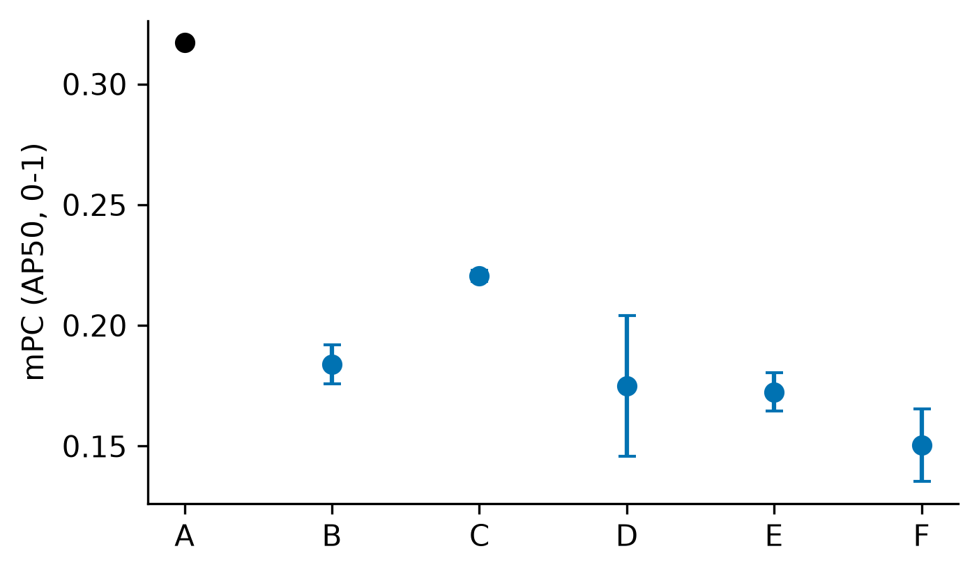
DIOR_student_mpc.png：仅展示完整种子块，误差棒为样本标准差；A 无重复测量误差棒。
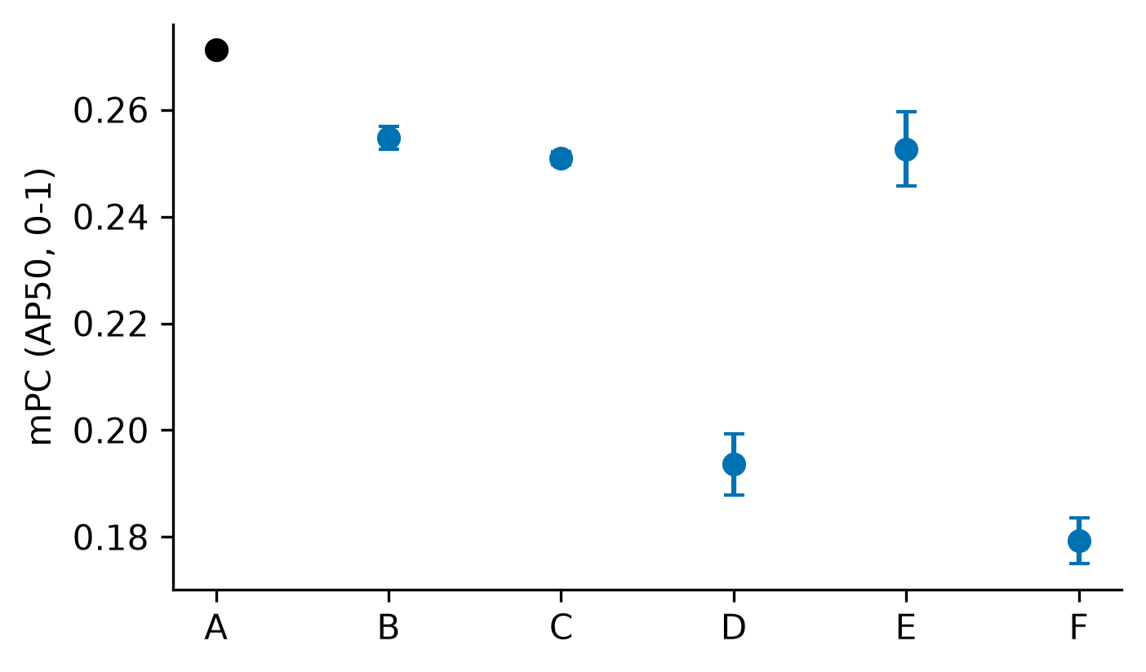

4. 配对统计
数据集/角色 | 方法 | 指标 | n | t p | sign-flip p | Holm t / sign | 状态
RSAR/student | B | delta_A | 3 | 0.00122376 | 0.25 | 0.00397602 / 1 | complete_low_power
RSAR/student | B | clean_delta_A | 3 | 0.00159867 | 0.25 | 0.00479601 / 1 | complete_low_power
RSAR/student | C | delta_A | 3 | 0.000183211 | 0.25 | 0.000916056 / 1 | complete_low_power
RSAR/student | C | clean_delta_A | 3 | 0.000883219 | 0.25 | 0.00353287 / 1 | complete_low_power
RSAR/student | D | delta_A | 3 | 0.0136891 | 0.25 | 0.0136891 / 1 | complete_low_power
RSAR/student | D | clean_delta_A | 3 | 0.0150121 | 0.25 | 0.0150121 / 1 | complete_low_power
RSAR/student | E | delta_A | 3 | 0.000994006 | 0.25 | 0.00397602 / 1 | complete_low_power
RSAR/student | E | clean_delta_A | 3 | 0.000424471 | 0.25 | 0.00212236 / 1 | complete_low_power
RSAR/student | F | delta_A | 3 | 0.00268661 | 0.25 | 0.00537322 / 1 | complete_low_power
RSAR/student | F | clean_delta_A | 3 | 0.00278153 | 0.25 | 0.00556305 / 1 | complete_low_power
DIOR/student | B | delta_A | 3 | 0.00577293 | 0.25 | 0.0115459 / 1 | complete_low_power
DIOR/student | B | clean_delta_A | 3 | 0.0167276 | 0.25 | 0.0501827 / 1 | complete_low_power
DIOR/student | C | delta_A | 3 | 0.00111253 | 0.25 | 0.00445011 / 1 | complete_low_power
DIOR/student | C | clean_delta_A | 3 | 0.0168425 | 0.25 | 0.0501827 / 1 | complete_low_power
DIOR/student | D | delta_A | 3 | 0.00184138 | 0.25 | 0.00552415 / 1 | complete_low_power
DIOR/student | D | clean_delta_A | 3 | 0.00308202 | 0.25 | 0.0123281 / 1 | complete_low_power
DIOR/student | E | delta_A | 3 | 0.0446932 | 0.25 | 0.0446932 / 1 | complete_low_power
DIOR/student | E | clean_delta_A | 3 | 0.03886 | 0.25 | 0.0501827 / 1 | complete_low_power
DIOR/student | F | delta_A | 3 | 0.000738549 | 0.25 | 0.00369274 / 1 | complete_low_power
DIOR/student | F | clean_delta_A | 3 | 0.00107105 | 0.25 | 0.00535523 / 1 | complete_low_power

5. 原始值、精度与未完成项
raw_results.csv 保留完整 metric.mAP，不使用已舍入的 metric.AP50。historical/ 逐字节保留输入的历史 seed42 CSV；原始 seed42 mAP 锁定，重评差异另存 eval_mAP50 并标记 metric_conflict，不静默改写旧值。per_class.csv 来自 class_ap.txt，通常仅三位小数，不反算总 mAP。prediction_image_coverage.csv、roi_vis_coverage.csv 和 embedding_index.csv 是三种不同范围的证据。
数据集/域 | 方法/角色/种子 | 状态 | 原因
全部原始行与每种子聚合见 raw_results.csv、per_seed.csv；本报告不声称完成其他基线移植或未在输入证据中完成的项目。

