IRAOD 多种子结果与证据覆盖报告
结果状态：declared_scopes_complete。本文件是消费者产物，报告生成成功不等于实验或全部八项任务完成。
输入清单：/mnt/shared/zechuan/iraod_artifacts/comparison/final_delivery_20260908_4a6bc50/input/report-manifest.json
消费者提交：4a6bc50dee983d44b1598ab2aef93968ca622b50

主要观察与统计限制
RSAR：C 的观察 mPC 均值最高，为 33.0836%。F 相对固定 A 的配对平均增益为 -2.1606 个百分点。最高均值不等于方法间差异显著；不因负结果删除或重调方法。
RSAR 的 ΔA 双侧 t 检验 Holm p（B–F）：B=0.0402699、C=0.0516306、D=0.0516306、E=0.0232656、F=0.0402699。这些是固定 source 条件下、依赖差值正态假设的 n=3 检验，不能与无分布假设的证据强度混同。
DIOR：E 的观察 mPC 均值最高，为 27.5755%。F 相对固定 A 的配对平均增益为 -0.2561 个百分点。最高均值不等于方法间差异显著；不因负结果删除或重调方法。
DIOR 的 ΔA 双侧 t 检验 Holm p（B–F）：B=0.0375993、C=0.000522512、D=0.0375993、E=0.0180695、F=0.139461。这些是固定 source 条件下、依赖差值正态假设的 n=3 检验，不能与无分布假设的证据强度混同。
ΔA 精确双侧 sign-flip 最小原始 p=0.25；最小 Holm p=1。仅 8 种符号排列，低功效；本次不据此宣称分布无关的显著提升。腐蚀域不是独立重复样本，置信区间仅反映适配随机性。

Source producer 元数据更正审计
以下仅更正报告中的 source producer 解释：原 sidecar 保留，权重、预测、实际图像 ID 和 mAP 均不改变，不因此重训或重推理。recorded 与 actual 明确分列；B–F 的适配训练 producer 不套用 source producer。
数据集/域 | sidecar recorded | source actual | 原始依据
RSAR/clean | 0f98a48b539f9260055fc305784ffbc924f50451 | b474aaa5f7718746215ce13beceb071617bb823e | /mnt/shared/zechuan/iraod_artifacts/rsar_source/seed42-orthonet-ddp4-gpu4567-spg16-gbs64/reproducibility/git_commit.txt
RSAR/chaff | 0f98a48b539f9260055fc305784ffbc924f50451 | b474aaa5f7718746215ce13beceb071617bb823e | /mnt/shared/zechuan/iraod_artifacts/rsar_source/seed42-orthonet-ddp4-gpu4567-spg16-gbs64/reproducibility/git_commit.txt
RSAR/gaussian_white_noise | 0f98a48b539f9260055fc305784ffbc924f50451 | b474aaa5f7718746215ce13beceb071617bb823e | /mnt/shared/zechuan/iraod_artifacts/rsar_source/seed42-orthonet-ddp4-gpu4567-spg16-gbs64/reproducibility/git_commit.txt
RSAR/point_target | 0f98a48b539f9260055fc305784ffbc924f50451 | b474aaa5f7718746215ce13beceb071617bb823e | /mnt/shared/zechuan/iraod_artifacts/rsar_source/seed42-orthonet-ddp4-gpu4567-spg16-gbs64/reproducibility/git_commit.txt
RSAR/noise_suppression | 0f98a48b539f9260055fc305784ffbc924f50451 | b474aaa5f7718746215ce13beceb071617bb823e | /mnt/shared/zechuan/iraod_artifacts/rsar_source/seed42-orthonet-ddp4-gpu4567-spg16-gbs64/reproducibility/git_commit.txt
RSAR/am_noise_horizontal | 0f98a48b539f9260055fc305784ffbc924f50451 | b474aaa5f7718746215ce13beceb071617bb823e | /mnt/shared/zechuan/iraod_artifacts/rsar_source/seed42-orthonet-ddp4-gpu4567-spg16-gbs64/reproducibility/git_commit.txt
RSAR/smart_suppression | 0f98a48b539f9260055fc305784ffbc924f50451 | b474aaa5f7718746215ce13beceb071617bb823e | /mnt/shared/zechuan/iraod_artifacts/rsar_source/seed42-orthonet-ddp4-gpu4567-spg16-gbs64/reproducibility/git_commit.txt
RSAR/am_noise_vertical | 0f98a48b539f9260055fc305784ffbc924f50451 | b474aaa5f7718746215ce13beceb071617bb823e | /mnt/shared/zechuan/iraod_artifacts/rsar_source/seed42-orthonet-ddp4-gpu4567-spg16-gbs64/reproducibility/git_commit.txt

1. 统计单位与适用范围
实验单位为适配种子 42、43、44。先在每个种子内对全部腐蚀域求 mPC，并在同域求相对固定 A 的差值后平均，再跨种子计算均值与样本标准差（ddof=1）。A 仅一次固定 source 测量，不复制成三次独立测量；所有区间只反映条件于固定 source 的适配随机性。不把类别、图像或腐蚀域当作独立种子，也不要求 B–D 单卡和 E/F 双卡具有相同 GPU UUID。
n=3，检验低功效。95% CI 为 100000 次 seed-block 百分位 bootstrap（随机种子 42），小样本下不稳定。双侧 t 检验施于三个种子级配对差值，依赖差值正态假设；零方差时 t 检验未定义。精确 sign-flip 枚举 8 种符号，其最小双侧 p=0.25。Holm 分别用于各数据集/角色/指标的五个 B–F 比较，家族不完整时不输出调整后 p 值。
历史 rPC 始终为 100 × mPC / 固定 A clean TEST；method_clean_normalized_percent 另列，分母为同方法同种子的独立 clean 适配实测值。缺域或缺种子时不生成完整多种子均值、标准差或 CI，不据少量已完成结果排名。
Recovery ratio = (方法 corruption AP50 − A corruption AP50) / (A clean TEST AP50 − A corruption AP50)。分母非正时未定义，接近零时不稳定；不截断负值或大于 1 的值，不据此排名，逐种子逐域数值见 recovery.csv。

公平性与方法边界
方法 | 公平组 | 框 | VLM | 目标标签 | 状态
A | Source-Free | OBB | none | eval_only | complete
B | Source-Free | OBB | none | eval_only | complete
C | Source-Free | OBB | CLIP-RN50x64 | eval_only | complete
D | Source-Free | OBB | SARCLIP-ViT-B-32 | eval_only | complete
E | Source-Free | OBB | SARCLIP-ViT-B-32 | eval_only | complete
F | Source-Free | OBB | SARCLIP-ViT-B-32 | eval_only | complete
G_oracle | Target-supervised | OBB | SARCLIP-LoRA | train | not_run
IRG | Source-Free | OBB | none | eval_only | not_run
LPLD | Source-Free | OBB | none | eval_only | not_run
Source-Free A–F 为同一主表组；source-available 未运行，target-supervised oracle 未运行。B/D/E/F 为已有组件组合比较，不冒充额外消融训练。IRG/LPLD 等未移植方法无虚构分数。

2. 量化与逐实例覆盖
证据类型 | 已完成 / 预期 | 范围
量化单元 | 192 / 192 | 全 TEST predictions；需实际有序 image-ID 证据
RoI | 1267816 / 1267816 | 全 TEST 对齐逐实例
可视化 | 3520 / 3520 | 固定子集，展示阈值 0.3
joint embedding | 24 / 24 | 采样分析；不是全量预测实例
全 TEST 图片的 aligned RoI 保存全部 post-NMS 检测，不受展示阈值 0.3 二次截断；检测器自身的 score threshold、NMS 和 max_per_img 仍生效。可视化仅使用冻结的 RSAR32/DIOR16 子集；不影响全量 RoI 完成。旧 v2 子集不计入 full-test 完成。predictions.pkl 不含 fc_cls 特征，不能替代 aligned RoI；pred_count 相符也不能替代图像顺序证据。
数据集/域 | 方法/角色 | n | 均值 | 样本 std | 状态
RSAR/clean | A/source | 1 | 0.5314 | N/A | fixed_source
RSAR/clean | B/ema | 3 | 0.524447 | 0.00434537 | complete_low_power
RSAR/clean | C/ema | 3 | 0.521243 | 0.00955602 | complete_low_power
RSAR/clean | D/ema | 3 | 0.510367 | 0.000744126 | complete_low_power
RSAR/clean | E/ema | 3 | 0.527061 | 0.00157453 | complete_low_power
RSAR/clean | F/ema | 3 | 0.514667 | 0.00365906 | complete_low_power
RSAR/chaff | A/source | 1 | 0.471931 | N/A | fixed_source
RSAR/chaff | B/ema | 3 | 0.464935 | 0.00311649 | complete_low_power
RSAR/chaff | C/ema | 3 | 0.467692 | 0.00269166 | complete_low_power
RSAR/chaff | D/ema | 3 | 0.46035 | 0.00426059 | complete_low_power
RSAR/chaff | E/ema | 3 | 0.465382 | 0.0021514 | complete_low_power
RSAR/chaff | F/ema | 3 | 0.448383 | 0.00196125 | complete_low_power
RSAR/gaussian_white_noise | A/source | 1 | 0.528137 | N/A | fixed_source
RSAR/gaussian_white_noise | B/ema | 3 | 0.520518 | 0.00801208 | complete_low_power
RSAR/gaussian_white_noise | C/ema | 3 | 0.520271 | 0.00303187 | complete_low_power
RSAR/gaussian_white_noise | D/ema | 3 | 0.513029 | 0.00428537 | complete_low_power
RSAR/gaussian_white_noise | E/ema | 3 | 0.519505 | 0.00391171 | complete_low_power
RSAR/gaussian_white_noise | F/ema | 3 | 0.517318 | 0.00343302 | complete_low_power
RSAR/point_target | A/source | 1 | 0.51584 | N/A | fixed_source
RSAR/point_target | B/ema | 3 | 0.499056 | 0.00524569 | complete_low_power
RSAR/point_target | C/ema | 3 | 0.507501 | 0.0129471 | complete_low_power
RSAR/point_target | D/ema | 3 | 0.500435 | 0.00291712 | complete_low_power
RSAR/point_target | E/ema | 3 | 0.50654 | 0.00395882 | complete_low_power
RSAR/point_target | F/ema | 3 | 0.504744 | 0.00358036 | complete_low_power
RSAR/noise_suppression | A/source | 1 | 0.163407 | N/A | fixed_source
RSAR/noise_suppression | B/ema | 3 | 0.176107 | 0.00583923 | complete_low_power
RSAR/noise_suppression | C/ema | 3 | 0.183222 | 0.00252602 | complete_low_power
RSAR/noise_suppression | D/ema | 3 | 0.172379 | 0.00705746 | complete_low_power
RSAR/noise_suppression | E/ema | 3 | 0.177172 | 0.00734234 | complete_low_power
RSAR/noise_suppression | F/ema | 3 | 0.15321 | 0.0108576 | complete_low_power
RSAR/am_noise_horizontal | A/source | 1 | 0.206206 | N/A | fixed_source
RSAR/am_noise_horizontal | B/ema | 3 | 0.224837 | 0.00241719 | complete_low_power
RSAR/am_noise_horizontal | C/ema | 3 | 0.216124 | 0.0113641 | complete_low_power
RSAR/am_noise_horizontal | D/ema | 3 | 0.171922 | 0.0174269 | complete_low_power
RSAR/am_noise_horizontal | E/ema | 3 | 0.23287 | 0.00233128 | complete_low_power
RSAR/am_noise_horizontal | F/ema | 3 | 0.150446 | 0.0130754 | complete_low_power
RSAR/smart_suppression | A/source | 1 | 0.143726 | N/A | fixed_source
RSAR/smart_suppression | B/ema | 3 | 0.147854 | 0.0041577 | complete_low_power
RSAR/smart_suppression | C/ema | 3 | 0.190105 | 0.0079523 | complete_low_power
RSAR/smart_suppression | D/ema | 3 | 0.147993 | 0.00804805 | complete_low_power
RSAR/smart_suppression | E/ema | 3 | 0.158455 | 0.00362304 | complete_low_power
RSAR/smart_suppression | F/ema | 3 | 0.133042 | 0.016341 | complete_low_power
RSAR/am_noise_vertical | A/source | 1 | 0.190744 | N/A | fixed_source
RSAR/am_noise_vertical | B/ema | 3 | 0.234508 | 0.00210508 | complete_low_power
RSAR/am_noise_vertical | C/ema | 3 | 0.230935 | 0.00778294 | complete_low_power
RSAR/am_noise_vertical | D/ema | 3 | 0.17249 | 0.00463368 | complete_low_power
RSAR/am_noise_vertical | E/ema | 3 | 0.248052 | 0.0045334 | complete_low_power
RSAR/am_noise_vertical | F/ema | 3 | 0.161604 | 0.01876 | complete_low_power
DIOR/clean | A/source | 1 | 0.2949 | N/A | fixed_source
DIOR/clean | B/ema | 3 | 0.298109 | 0.000976571 | complete_low_power
DIOR/clean | C/ema | 3 | 0.296718 | 0.00108343 | complete_low_power
DIOR/clean | D/ema | 3 | 0.29938 | 0.000780193 | complete_low_power
DIOR/clean | E/ema | 3 | 0.299515 | 0.00200727 | complete_low_power
DIOR/clean | F/ema | 3 | 0.297721 | 0.00268281 | complete_low_power
DIOR/brightness | A/source | 1 | 0.241684 | N/A | fixed_source
DIOR/brightness | B/ema | 3 | 0.245527 | 0.000917942 | complete_low_power
DIOR/brightness | C/ema | 3 | 0.247416 | 8.96335e-05 | complete_low_power
DIOR/brightness | D/ema | 3 | 0.239884 | 0.000281995 | complete_low_power
DIOR/brightness | E/ema | 3 | 0.245531 | 0.000938949 | complete_low_power
DIOR/brightness | F/ema | 3 | 0.240077 | 0.00159489 | complete_low_power
DIOR/cloudy | A/source | 1 | 0.290268 | N/A | fixed_source
DIOR/cloudy | B/ema | 3 | 0.2965 | 0.00105428 | complete_low_power
DIOR/cloudy | C/ema | 3 | 0.294268 | 5.48424e-05 | complete_low_power
DIOR/cloudy | D/ema | 3 | 0.286295 | 0.000469386 | complete_low_power
DIOR/cloudy | E/ema | 3 | 0.296793 | 0.000977245 | complete_low_power
DIOR/cloudy | F/ema | 3 | 0.285355 | 0.00217988 | complete_low_power
DIOR/contrast | A/source | 1 | 0.281603 | N/A | fixed_source
DIOR/contrast | B/ema | 3 | 0.284435 | 0.00113177 | complete_low_power
DIOR/contrast | C/ema | 3 | 0.28459 | 0.000269805 | complete_low_power
DIOR/contrast | D/ema | 3 | 0.279365 | 0.00200711 | complete_low_power
DIOR/contrast | E/ema | 3 | 0.284941 | 0.000300147 | complete_low_power
DIOR/contrast | F/ema | 3 | 0.280442 | 0.001831 | complete_low_power

3. 多种子汇总
数据集/角色 | 方法 | 指标 | n | 均值 | 样本 std | 95% CI | 状态
RSAR/source | A | mPC | 1 | 0.317142 | N/A | [N/A, N/A] | fixed_source
RSAR/source | A | delta_A | 1 | 0 | N/A | [N/A, N/A] | fixed_source
RSAR/source | A | rPC_percent | 1 | 59.6804 | N/A | [N/A, N/A] | fixed_source
RSAR/source | A | method_clean_normalized_percent | 0 | N/A | N/A | [N/A, N/A] | incomplete
RSAR/source | A | clean_mAP50 | 1 | 0.5314 | N/A | [N/A, N/A] | fixed_source
RSAR/source | A | clean_delta_A | 1 | 0 | N/A | [N/A, N/A] | fixed_source
RSAR/ema | B | mPC | 3 | 0.323973 | 0.00131707 | [0.322673, 0.325306] | complete_low_power
RSAR/ema | B | delta_A | 3 | 0.0068319 | 0.00131707 | [0.00553096, 0.00816453] | complete_low_power
RSAR/ema | B | rPC_percent | 3 | 60.9661 | 0.247849 | [60.7212, 61.2168] | complete_low_power
RSAR/ema | B | method_clean_normalized_percent | 3 | 61.7767 | 0.488101 | [61.415, 62.3319] | complete_low_power
RSAR/ema | B | clean_mAP50 | 3 | 0.524447 | 0.00434537 | [0.519705, 0.528238] | complete_low_power
RSAR/ema | B | clean_delta_A | 3 | -0.00695306 | 0.00434537 | [-0.0116949, -0.00316143] | complete_low_power
RSAR/ema | C | mPC | 3 | 0.330836 | 0.00388661 | [0.326391, 0.333596] | complete_low_power
RSAR/ema | C | delta_A | 3 | 0.0136941 | 0.00388661 | [0.00924949, 0.0164547] | complete_low_power
RSAR/ema | C | rPC_percent | 3 | 62.2574 | 0.731391 | [61.421, 62.7769] | complete_low_power
RSAR/ema | C | method_clean_normalized_percent | 3 | 63.4758 | 0.439097 | [63.1375, 63.972] | complete_low_power
RSAR/ema | C | clean_mAP50 | 3 | 0.521243 | 0.00955602 | [0.510209, 0.52686] | complete_low_power
RSAR/ema | C | clean_delta_A | 3 | -0.0101567 | 0.00955602 | [-0.0211905, -0.00453949] | complete_low_power
RSAR/ema | D | mPC | 3 | 0.305514 | 0.00401514 | [0.301049, 0.308827] | complete_low_power
RSAR/ema | D | delta_A | 3 | -0.0116276 | 0.00401514 | [-0.016093, -0.00831489] | complete_low_power
RSAR/ema | D | rPC_percent | 3 | 57.4923 | 0.755578 | [56.652, 58.1157] | complete_low_power
RSAR/ema | D | method_clean_normalized_percent | 3 | 59.8612 | 0.728582 | [59.0343, 60.409] | complete_low_power
RSAR/ema | D | clean_mAP50 | 3 | 0.510367 | 0.000744126 | [0.50992, 0.511226] | complete_low_power
RSAR/ema | D | clean_delta_A | 3 | -0.0210327 | 0.000744126 | [-0.0214798, -0.0201737] | complete_low_power
RSAR/ema | E | mPC | 3 | 0.329711 | 0.00149027 | [0.328467, 0.331363] | complete_low_power
RSAR/ema | E | delta_A | 3 | 0.0125693 | 0.00149027 | [0.0113256, 0.0142211] | complete_low_power
RSAR/ema | E | rPC_percent | 3 | 62.0457 | 0.280442 | [61.8117, 62.3566] | complete_low_power
RSAR/ema | E | method_clean_normalized_percent | 3 | 62.5564 | 0.146392 | [62.3886, 62.6581] | complete_low_power
RSAR/ema | E | clean_mAP50 | 3 | 0.527061 | 0.00157453 | [0.525855, 0.528842] | complete_low_power
RSAR/ema | E | clean_delta_A | 3 | -0.00433862 | 0.00157453 | [-0.00554478, -0.0025574] | complete_low_power
RSAR/ema | F | mPC | 3 | 0.295535 | 0.00378355 | [0.291179, 0.298] | complete_low_power
RSAR/ema | F | delta_A | 3 | -0.0216063 | 0.00378355 | [-0.0259626, -0.0191414] | complete_low_power
RSAR/ema | F | rPC_percent | 3 | 55.6145 | 0.711997 | [54.7947, 56.0783] | complete_low_power
RSAR/ema | F | method_clean_normalized_percent | 3 | 57.4211 | 0.332097 | [57.0445, 57.6718] | complete_low_power
RSAR/ema | F | clean_mAP50 | 3 | 0.514667 | 0.00365906 | [0.510442, 0.51684] | complete_low_power
RSAR/ema | F | clean_delta_A | 3 | -0.0167332 | 0.00365906 | [-0.0209577, -0.0145594] | complete_low_power
DIOR/source | A | mPC | 1 | 0.271185 | N/A | [N/A, N/A] | fixed_source
DIOR/source | A | delta_A | 1 | 0 | N/A | [N/A, N/A] | fixed_source
DIOR/source | A | rPC_percent | 1 | 91.9584 | N/A | [N/A, N/A] | fixed_source
DIOR/source | A | method_clean_normalized_percent | 0 | N/A | N/A | [N/A, N/A] | incomplete
DIOR/source | A | clean_mAP50 | 1 | 0.2949 | N/A | [N/A, N/A] | fixed_source
DIOR/source | A | clean_delta_A | 1 | 0 | N/A | [N/A, N/A] | fixed_source
DIOR/ema | B | mPC | 3 | 0.275487 | 0.000842146 | [0.274656, 0.27634] | complete_low_power
DIOR/ema | B | delta_A | 3 | 0.00430215 | 0.000842146 | [0.00347102, 0.0051549] | complete_low_power
DIOR/ema | B | rPC_percent | 3 | 93.4173 | 0.28557 | [93.1354, 93.7064] | complete_low_power
DIOR/ema | B | method_clean_normalized_percent | 3 | 92.4125 | 0.445952 | [91.9068, 92.7493] | complete_low_power
DIOR/ema | B | clean_mAP50 | 3 | 0.298109 | 0.000976571 | [0.297, 0.298842] | complete_low_power
DIOR/ema | B | clean_delta_A | 3 | 0.00320882 | 0.000976571 | [0.00210035, 0.0039424] | complete_low_power
DIOR/ema | C | mPC | 3 | 0.275425 | 7.50706e-05 | [0.275341, 0.275485] | complete_low_power
DIOR/ema | C | delta_A | 3 | 0.00423947 | 7.50706e-05 | [0.0041555, 0.00430008] | complete_low_power
DIOR/ema | C | rPC_percent | 3 | 93.396 | 0.0254563 | [93.3675, 93.4166] | complete_low_power
DIOR/ema | C | method_clean_normalized_percent | 3 | 92.8245 | 0.35635 | [92.4718, 93.1844] | complete_low_power
DIOR/ema | C | clean_mAP50 | 3 | 0.296718 | 0.00108343 | [0.295595, 0.297756] | complete_low_power
DIOR/ema | C | clean_delta_A | 3 | 0.00181845 | 0.00108343 | [0.000694722, 0.00285649] | complete_low_power
DIOR/ema | D | mPC | 3 | 0.268515 | 0.000579537 | [0.268092, 0.269175] | complete_low_power
DIOR/ema | D | delta_A | 3 | -0.00267045 | 0.000579537 | [-0.00309365, -0.00200992] | complete_low_power
DIOR/ema | D | rPC_percent | 3 | 91.0529 | 0.19652 | [90.9094, 91.2768] | complete_low_power
DIOR/ema | D | method_clean_normalized_percent | 3 | 89.6907 | 0.32111 | [89.3211, 89.9011] | complete_low_power
DIOR/ema | D | clean_mAP50 | 3 | 0.29938 | 0.000780193 | [0.298584, 0.300144] | complete_low_power
DIOR/ema | D | clean_delta_A | 3 | 0.00448031 | 0.000780193 | [0.00368443, 0.00524381] | complete_low_power
DIOR/ema | E | mPC | 3 | 0.275755 | 0.000533781 | [0.275263, 0.276322] | complete_low_power
DIOR/ema | E | delta_A | 3 | 0.00456966 | 0.000533781 | [0.00407745, 0.00513705] | complete_low_power
DIOR/ema | E | rPC_percent | 3 | 93.508 | 0.181004 | [93.3411, 93.7004] | complete_low_power
DIOR/ema | E | method_clean_normalized_percent | 3 | 92.0705 | 0.775266 | [91.2038, 92.6978] | complete_low_power
DIOR/ema | E | clean_mAP50 | 3 | 0.299515 | 0.00200727 | [0.298089, 0.301811] | complete_low_power
DIOR/ema | E | clean_delta_A | 3 | 0.00461526 | 0.00200727 | [0.00318947, 0.00691071] | complete_low_power
DIOR/ema | F | mPC | 3 | 0.268625 | 0.00185634 | [0.267203, 0.270725] | complete_low_power
DIOR/ema | F | delta_A | 3 | -0.00256057 | 0.00185634 | [-0.00398204, -0.000460391] | complete_low_power
DIOR/ema | F | rPC_percent | 3 | 91.0901 | 0.629481 | [90.6081, 91.8023] | complete_low_power
DIOR/ema | F | method_clean_normalized_percent | 3 | 90.2297 | 0.671002 | [89.4596, 90.689] | complete_low_power
DIOR/ema | F | clean_mAP50 | 3 | 0.297721 | 0.00268281 | [0.294637, 0.299516] | complete_low_power
DIOR/ema | F | clean_delta_A | 3 | 0.00282106 | 0.00268281 | [-0.000262976, 0.00461614] | complete_low_power
RSAR_ema_mpc.png：仅展示完整种子块，误差棒为样本标准差；A 无重复测量误差棒。
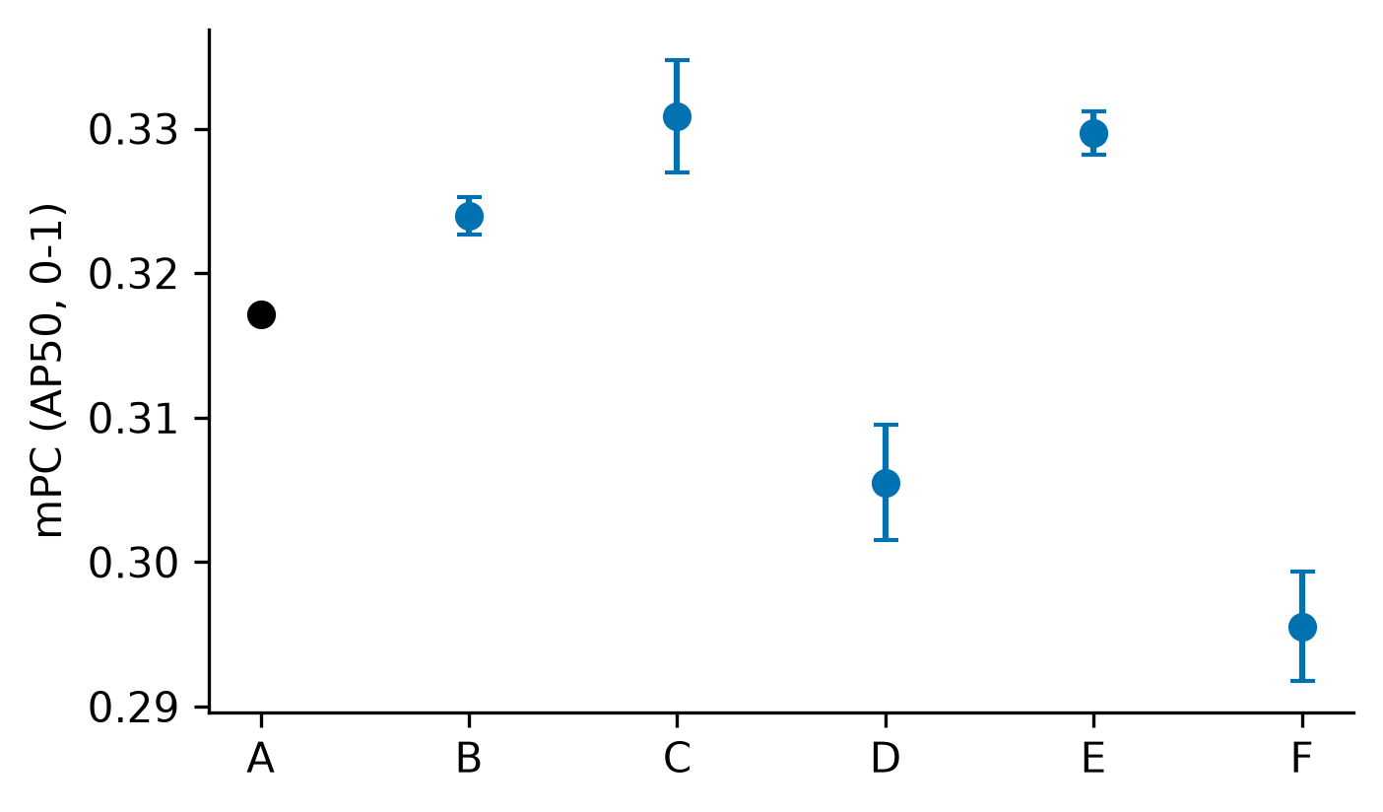
DIOR_ema_mpc.png：仅展示完整种子块，误差棒为样本标准差；A 无重复测量误差棒。
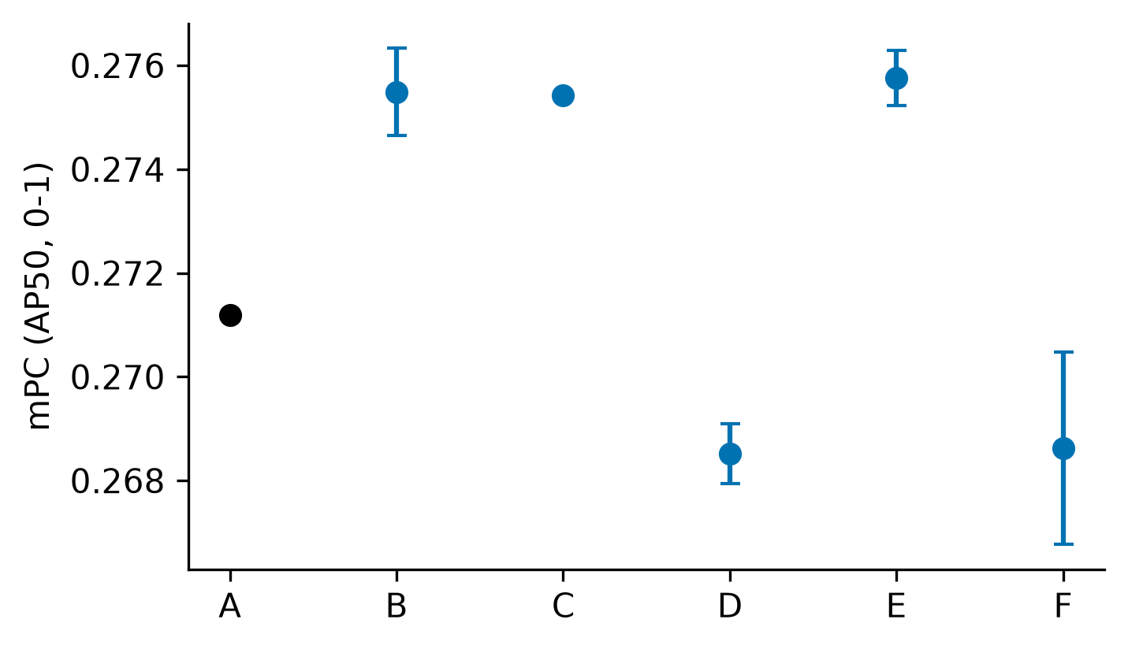

4. 配对统计
数据集/角色 | 方法 | 指标 | n | t p | sign-flip p | Holm t / sign | 状态
RSAR/ema | B | delta_A | 3 | 0.0121628 | 0.25 | 0.0402699 / 1 | complete_low_power
RSAR/ema | B | clean_delta_A | 3 | 0.109264 | 0.25 | 0.218528 / 1 | complete_low_power
RSAR/ema | C | delta_A | 3 | 0.0258153 | 0.25 | 0.0516306 / 1 | complete_low_power
RSAR/ema | C | clean_delta_A | 3 | 0.206983 | 0.25 | 0.218528 / 1 | complete_low_power
RSAR/ema | D | delta_A | 3 | 0.0375235 | 0.25 | 0.0516306 / 1 | complete_low_power
RSAR/ema | D | clean_delta_A | 3 | 0.000416976 | 0.25 | 0.00208488 / 1 | complete_low_power
RSAR/ema | E | delta_A | 3 | 0.00465313 | 0.25 | 0.0232656 / 1 | complete_low_power
RSAR/ema | E | clean_delta_A | 3 | 0.0412067 | 0.25 | 0.12362 / 1 | complete_low_power
RSAR/ema | F | delta_A | 3 | 0.0100675 | 0.25 | 0.0402699 / 1 | complete_low_power
RSAR/ema | F | clean_delta_A | 3 | 0.0155677 | 0.25 | 0.0622709 / 1 | complete_low_power
DIOR/ema | B | delta_A | 3 | 0.0125331 | 0.25 | 0.0375993 / 1 | complete_low_power
DIOR/ema | B | clean_delta_A | 3 | 0.0295143 | 0.25 | 0.118057 / 1 | complete_low_power
DIOR/ema | C | delta_A | 3 | 0.000104502 | 0.25 | 0.000522512 / 1 | complete_low_power
DIOR/ema | C | clean_delta_A | 3 | 0.100758 | 0.25 | 0.201517 / 1 | complete_low_power
DIOR/ema | D | delta_A | 3 | 0.0153388 | 0.25 | 0.0375993 / 1 | complete_low_power
DIOR/ema | D | clean_delta_A | 3 | 0.00995729 | 0.25 | 0.0497865 / 1 | complete_low_power
DIOR/ema | E | delta_A | 3 | 0.00451737 | 0.25 | 0.0180695 / 1 | complete_low_power
DIOR/ema | E | clean_delta_A | 3 | 0.0576534 | 0.25 | 0.17296 / 1 | complete_low_power
DIOR/ema | F | delta_A | 3 | 0.139461 | 0.25 | 0.139461 / 1 | complete_low_power
DIOR/ema | F | clean_delta_A | 3 | 0.210153 | 0.5 | 0.210153 / 1 | complete_low_power

5. 原始值、精度与未完成项
raw_results.csv 保留完整 metric.mAP，不使用已舍入的 metric.AP50。historical/ 逐字节保留输入的历史 seed42 CSV；原始 seed42 mAP 锁定，重评差异另存 eval_mAP50 并标记 metric_conflict，不静默改写旧值。per_class.csv 来自 class_ap.txt，通常仅三位小数，不反算总 mAP。prediction_image_coverage.csv、roi_vis_coverage.csv 和 embedding_index.csv 是三种不同范围的证据。
数据集/域 | 方法/角色/种子 | 状态 | 原因
全部原始行与每种子聚合见 raw_results.csv、per_seed.csv；本报告不声称完成其他基线移植或未在输入证据中完成的项目。

