IRAOD 多种子结果与证据覆盖报告
结果状态：partial。本文件是消费者产物，报告生成成功不等于实验或全部八项任务完成。
输入清单：/mnt/HDD_14TB/zechuan/iraod_artifacts/comparison/xaf_student_quant_20260908/report_checkpoint_breg_f_ema_20260909T2102Z/collection_mapped/report-manifest.json
消费者提交：44ac42177eafaac4b2b8312414a254f0b0add17b

Source producer 元数据更正审计
以下仅更正报告中的 source producer 解释：原 sidecar 保留，权重、预测、实际图像 ID 和 mAP 均不改变，不因此重训或重推理。recorded 与 actual 明确分列；B–F 的适配训练 producer 不套用 source producer。
数据集/域 | sidecar recorded | source actual | 原始依据
RSAR/clean | 0f98a48b539f9260055fc305784ffbc924f50451 | b474aaa5f7718746215ce13beceb071617bb823e | /home/zechuan/iraod_artifacts/rsar_source/seed42-orthonet-ddp4-gpu4567-spg16-gbs64/reproducibility/git_commit.txt
RSAR/chaff | 0f98a48b539f9260055fc305784ffbc924f50451 | b474aaa5f7718746215ce13beceb071617bb823e | /home/zechuan/iraod_artifacts/rsar_source/seed42-orthonet-ddp4-gpu4567-spg16-gbs64/reproducibility/git_commit.txt
RSAR/gaussian_white_noise | 0f98a48b539f9260055fc305784ffbc924f50451 | b474aaa5f7718746215ce13beceb071617bb823e | /home/zechuan/iraod_artifacts/rsar_source/seed42-orthonet-ddp4-gpu4567-spg16-gbs64/reproducibility/git_commit.txt
RSAR/point_target | 0f98a48b539f9260055fc305784ffbc924f50451 | b474aaa5f7718746215ce13beceb071617bb823e | /home/zechuan/iraod_artifacts/rsar_source/seed42-orthonet-ddp4-gpu4567-spg16-gbs64/reproducibility/git_commit.txt
RSAR/noise_suppression | 0f98a48b539f9260055fc305784ffbc924f50451 | b474aaa5f7718746215ce13beceb071617bb823e | /home/zechuan/iraod_artifacts/rsar_source/seed42-orthonet-ddp4-gpu4567-spg16-gbs64/reproducibility/git_commit.txt
RSAR/am_noise_horizontal | 0f98a48b539f9260055fc305784ffbc924f50451 | b474aaa5f7718746215ce13beceb071617bb823e | /home/zechuan/iraod_artifacts/rsar_source/seed42-orthonet-ddp4-gpu4567-spg16-gbs64/reproducibility/git_commit.txt
RSAR/smart_suppression | 0f98a48b539f9260055fc305784ffbc924f50451 | b474aaa5f7718746215ce13beceb071617bb823e | /home/zechuan/iraod_artifacts/rsar_source/seed42-orthonet-ddp4-gpu4567-spg16-gbs64/reproducibility/git_commit.txt
RSAR/am_noise_vertical | 0f98a48b539f9260055fc305784ffbc924f50451 | b474aaa5f7718746215ce13beceb071617bb823e | /home/zechuan/iraod_artifacts/rsar_source/seed42-orthonet-ddp4-gpu4567-spg16-gbs64/reproducibility/git_commit.txt

1. 统计单位与适用范围
实验单位为适配种子 42、43、44。先在每个种子内对全部腐蚀域求 mPC，并在同域求相对固定 A 的差值后平均，再跨种子计算均值与样本标准差（ddof=1）。A 仅一次固定 source 测量，不复制成三次独立测量；所有区间只反映条件于固定 source 的适配随机性。不把类别、图像或腐蚀域当作独立种子，也不要求 B–D 单卡和 E/F 双卡具有相同 GPU UUID。
n=3，检验低功效。95% CI 为 100000 次 seed-block 百分位 bootstrap（随机种子 42），小样本下不稳定。双侧 t 检验施于三个种子级配对差值，依赖差值正态假设；零方差时 t 检验未定义。精确 sign-flip 枚举 8 种符号，其最小双侧 p=0.25。Holm 按清单预先声明的方法、数据集、角色、指标及比较组校正；家族不完整不输出调整后 p 值。
声明方法：A, B_REG, F_text_only, F_veto_only
common_one_epoch 为共同一轮预算；AASFOD 使用已披露的预算缩放移植。SFYOLO 为 extended_two_epoch_TAM，两轮最终标签 RSAR531 / DIOR369，不与一轮方法合并排名或统计。LoRA-CGA / LoRA-CGA+VLST 如被声明，仅在 target_supervised_appendix 中展示，绝不计入 strict main。各表与图按清单顺序而非结果排序；固定 A 在各组仅作同一参考，并非新增测量。
历史 rPC 始终为 100 × mPC / 固定 A clean TEST；method_clean_normalized_percent 另列，分母为同方法同种子的独立 clean 适配实测值。缺域或缺种子时不生成完整多种子均值、标准差或 CI，不据少量已完成结果排名。
Recovery ratio = (方法 corruption AP50 − A corruption AP50) / (A clean TEST AP50 − A corruption AP50)。分母非正时未定义，接近零时不稳定；不截断负值或大于 1 的值，不据此排名，逐种子逐域数值见 recovery.csv。

2. 量化与逐实例覆盖
Explicit-method quantitative TEST collection only; parent extensions incomplete. Full TEST RoI, fixed visualizations and joint t-SNE remain pending.
本次只收集声明角色的全 TEST 量化结果；不把既有 core 的定性覆盖分母当作扩展任务范围。新增 RoI、固定可视化与联合嵌入仍由已批准扩展清单跟踪。
证据类型 | 已完成 / 预期 | 范围
量化单元 | 87 / 120 | 全 TEST predictions；需实际有序 image-ID 证据
predictions.pkl 与原生 image-ID 顺序是量化证据，不包含 fc_cls 特征，不能替代全 TEST aligned RoI；定性导出未在本次执行。

common_one_epoch
数据集/域 | 方法/角色 | n | 均值 | 样本 std | 状态
RSAR/clean | A/source | 1 | 0.5314 | N/A | fixed_source
RSAR/clean | B_REG/ema | 0 | N/A | N/A | incomplete
RSAR/clean | F_text_only/ema | 2 | N/A | N/A | incomplete
RSAR/clean | F_veto_only/ema | 1 | N/A | N/A | incomplete
RSAR/chaff | A/source | 1 | 0.471931 | N/A | fixed_source
RSAR/chaff | B_REG/ema | 0 | N/A | N/A | incomplete
RSAR/chaff | F_text_only/ema | 3 | 0.449521 | 0.00238819 | complete_low_power
RSAR/chaff | F_veto_only/ema | 3 | 0.465615 | 0.00144575 | complete_low_power
RSAR/gaussian_white_noise | A/source | 1 | 0.528137 | N/A | fixed_source
RSAR/gaussian_white_noise | B_REG/ema | 0 | N/A | N/A | incomplete
RSAR/gaussian_white_noise | F_text_only/ema | 2 | N/A | N/A | incomplete
RSAR/gaussian_white_noise | F_veto_only/ema | 2 | N/A | N/A | incomplete
RSAR/point_target | A/source | 1 | 0.51584 | N/A | fixed_source
RSAR/point_target | B_REG/ema | 0 | N/A | N/A | incomplete
RSAR/point_target | F_text_only/ema | 3 | 0.498442 | 0.00734273 | complete_low_power
RSAR/point_target | F_veto_only/ema | 3 | 0.505232 | 0.00428297 | complete_low_power
RSAR/noise_suppression | A/source | 1 | 0.163407 | N/A | fixed_source
RSAR/noise_suppression | B_REG/ema | 0 | N/A | N/A | incomplete
RSAR/noise_suppression | F_text_only/ema | 2 | N/A | N/A | incomplete
RSAR/noise_suppression | F_veto_only/ema | 3 | 0.174862 | 0.00615677 | complete_low_power
RSAR/am_noise_horizontal | A/source | 1 | 0.206206 | N/A | fixed_source
RSAR/am_noise_horizontal | B_REG/ema | 0 | N/A | N/A | incomplete
RSAR/am_noise_horizontal | F_text_only/ema | 1 | N/A | N/A | incomplete
RSAR/am_noise_horizontal | F_veto_only/ema | 2 | N/A | N/A | incomplete
RSAR/smart_suppression | A/source | 1 | 0.143726 | N/A | fixed_source
RSAR/smart_suppression | B_REG/ema | 0 | N/A | N/A | incomplete
RSAR/smart_suppression | F_text_only/ema | 3 | 0.137376 | 0.00738176 | complete_low_power
RSAR/smart_suppression | F_veto_only/ema | 3 | 0.153659 | 0.00149707 | complete_low_power
RSAR/am_noise_vertical | A/source | 1 | 0.190744 | N/A | fixed_source
RSAR/am_noise_vertical | B_REG/ema | 0 | N/A | N/A | incomplete
RSAR/am_noise_vertical | F_text_only/ema | 3 | 0.159418 | 0.0082969 | complete_low_power
RSAR/am_noise_vertical | F_veto_only/ema | 3 | 0.24424 | 0.00299861 | complete_low_power
DIOR/clean | A/source | 1 | 0.2949 | N/A | fixed_source
DIOR/clean | B_REG/ema | 3 | 0.299849 | 0.000498477 | complete_low_power
DIOR/clean | F_text_only/ema | 3 | 0.298264 | 0.000988778 | complete_low_power
DIOR/clean | F_veto_only/ema | 3 | 0.299108 | 0.000592755 | complete_low_power
DIOR/brightness | A/source | 1 | 0.241684 | N/A | fixed_source
DIOR/brightness | B_REG/ema | 3 | 0.246272 | 0.000587204 | complete_low_power
DIOR/brightness | F_text_only/ema | 3 | 0.239364 | 0.000444222 | complete_low_power
DIOR/brightness | F_veto_only/ema | 3 | 0.245967 | 0.00108344 | complete_low_power
DIOR/cloudy | A/source | 1 | 0.290268 | N/A | fixed_source
DIOR/cloudy | B_REG/ema | 3 | 0.297514 | 0.000507004 | complete_low_power
DIOR/cloudy | F_text_only/ema | 3 | 0.285348 | 0.00133539 | complete_low_power
DIOR/cloudy | F_veto_only/ema | 3 | 0.296854 | 0.0012693 | complete_low_power
DIOR/contrast | A/source | 1 | 0.281603 | N/A | fixed_source
DIOR/contrast | B_REG/ema | 3 | 0.283015 | 0.00147041 | complete_low_power
DIOR/contrast | F_text_only/ema | 3 | 0.279967 | 0.00161592 | complete_low_power
DIOR/contrast | F_veto_only/ema | 3 | 0.284912 | 0.000110095 | complete_low_power

3. 多种子汇总

common_one_epoch
数据集/角色 | 方法 | 指标 | n | 均值 | 样本 std | 95% CI | 状态
RSAR/source | A | mPC | 1 | 0.317142 | N/A | [N/A, N/A] | fixed_source
RSAR/source | A | delta_A | 1 | 0 | N/A | [N/A, N/A] | fixed_source
RSAR/source | A | rPC_percent | 1 | 59.6804 | N/A | [N/A, N/A] | fixed_source
RSAR/source | A | method_clean_normalized_percent | 0 | N/A | N/A | [N/A, N/A] | incomplete
RSAR/source | A | clean_mAP50 | 1 | 0.5314 | N/A | [N/A, N/A] | fixed_source
RSAR/source | A | clean_delta_A | 1 | 0 | N/A | [N/A, N/A] | fixed_source
RSAR/ema | B_REG | mPC | 0 | N/A | N/A | [N/A, N/A] | incomplete
RSAR/ema | B_REG | delta_A | 0 | N/A | N/A | [N/A, N/A] | incomplete
RSAR/ema | B_REG | rPC_percent | 0 | N/A | N/A | [N/A, N/A] | incomplete
RSAR/ema | B_REG | method_clean_normalized_percent | 0 | N/A | N/A | [N/A, N/A] | incomplete
RSAR/ema | B_REG | clean_mAP50 | 0 | N/A | N/A | [N/A, N/A] | incomplete
RSAR/ema | B_REG | clean_delta_A | 0 | N/A | N/A | [N/A, N/A] | incomplete
RSAR/ema | F_text_only | mPC | 0 | N/A | N/A | [N/A, N/A] | incomplete
RSAR/ema | F_text_only | delta_A | 0 | N/A | N/A | [N/A, N/A] | incomplete
RSAR/ema | F_text_only | rPC_percent | 0 | N/A | N/A | [N/A, N/A] | incomplete
RSAR/ema | F_text_only | method_clean_normalized_percent | 0 | N/A | N/A | [N/A, N/A] | incomplete
RSAR/ema | F_text_only | clean_mAP50 | 2 | N/A | N/A | [N/A, N/A] | incomplete
RSAR/ema | F_text_only | clean_delta_A | 2 | N/A | N/A | [N/A, N/A] | incomplete
RSAR/ema | F_veto_only | mPC | 1 | N/A | N/A | [N/A, N/A] | incomplete
RSAR/ema | F_veto_only | delta_A | 1 | N/A | N/A | [N/A, N/A] | incomplete
RSAR/ema | F_veto_only | rPC_percent | 1 | N/A | N/A | [N/A, N/A] | incomplete
RSAR/ema | F_veto_only | method_clean_normalized_percent | 1 | N/A | N/A | [N/A, N/A] | incomplete
RSAR/ema | F_veto_only | clean_mAP50 | 1 | N/A | N/A | [N/A, N/A] | incomplete
RSAR/ema | F_veto_only | clean_delta_A | 1 | N/A | N/A | [N/A, N/A] | incomplete
DIOR/source | A | mPC | 1 | 0.271185 | N/A | [N/A, N/A] | fixed_source
DIOR/source | A | delta_A | 1 | 0 | N/A | [N/A, N/A] | fixed_source
DIOR/source | A | rPC_percent | 1 | 91.9584 | N/A | [N/A, N/A] | fixed_source
DIOR/source | A | method_clean_normalized_percent | 0 | N/A | N/A | [N/A, N/A] | incomplete
DIOR/source | A | clean_mAP50 | 1 | 0.2949 | N/A | [N/A, N/A] | fixed_source
DIOR/source | A | clean_delta_A | 1 | 0 | N/A | [N/A, N/A] | fixed_source
DIOR/ema | B_REG | mPC | 3 | 0.2756 | 0.00053525 | [0.275097, 0.276163] | complete_low_power
DIOR/ema | B_REG | delta_A | 3 | 0.00441528 | 0.00053525 | [0.00391192, 0.00497754] | complete_low_power
DIOR/ema | B_REG | rPC_percent | 3 | 93.4556 | 0.181502 | [93.2849, 93.6463] | complete_low_power
DIOR/ema | B_REG | method_clean_normalized_percent | 3 | 91.9131 | 0.181307 | [91.7107, 92.0607] | complete_low_power
DIOR/ema | B_REG | clean_mAP50 | 3 | 0.299849 | 0.000498477 | [0.299304, 0.300282] | complete_low_power
DIOR/ema | B_REG | clean_delta_A | 3 | 0.00494939 | 0.000498477 | [0.00440428, 0.005382] | complete_low_power
DIOR/ema | F_text_only | mPC | 3 | 0.268226 | 0.000731116 | [0.267427, 0.268862] | complete_low_power
DIOR/ema | F_text_only | delta_A | 3 | -0.00295909 | 0.000731116 | [-0.00375815, -0.00232364] | complete_low_power
DIOR/ema | F_text_only | rPC_percent | 3 | 90.955 | 0.24792 | [90.684, 91.1705] | complete_low_power
DIOR/ema | F_text_only | method_clean_normalized_percent | 3 | 89.93 | 0.489961 | [89.5479, 90.4824] | complete_low_power
DIOR/ema | F_text_only | clean_mAP50 | 3 | 0.298264 | 0.000988778 | [0.297142, 0.299009] | complete_low_power
DIOR/ema | F_text_only | clean_delta_A | 3 | 0.00336443 | 0.000988778 | [0.00224259, 0.00410917] | complete_low_power
DIOR/ema | F_veto_only | mPC | 3 | 0.275911 | 0.000555645 | [0.275408, 0.276507] | complete_low_power
DIOR/ema | F_veto_only | delta_A | 3 | 0.00472606 | 0.000555645 | [0.00422267, 0.00532227] | complete_low_power
DIOR/ema | F_veto_only | rPC_percent | 3 | 93.561 | 0.188418 | [93.3903, 93.7632] | complete_low_power
DIOR/ema | F_veto_only | method_clean_normalized_percent | 3 | 92.2451 | 0.350425 | [92.0213, 92.649] | complete_low_power
DIOR/ema | F_veto_only | clean_mAP50 | 3 | 0.299108 | 0.000592755 | [0.298446, 0.29959] | complete_low_power
DIOR/ema | F_veto_only | clean_delta_A | 3 | 0.00420815 | 0.000592755 | [0.00354648, 0.00469065] | complete_low_power
RSAR_ema_common_one_epoch_mpc.png：仅展示完整种子块，误差棒为样本标准差；A 无重复测量误差棒。
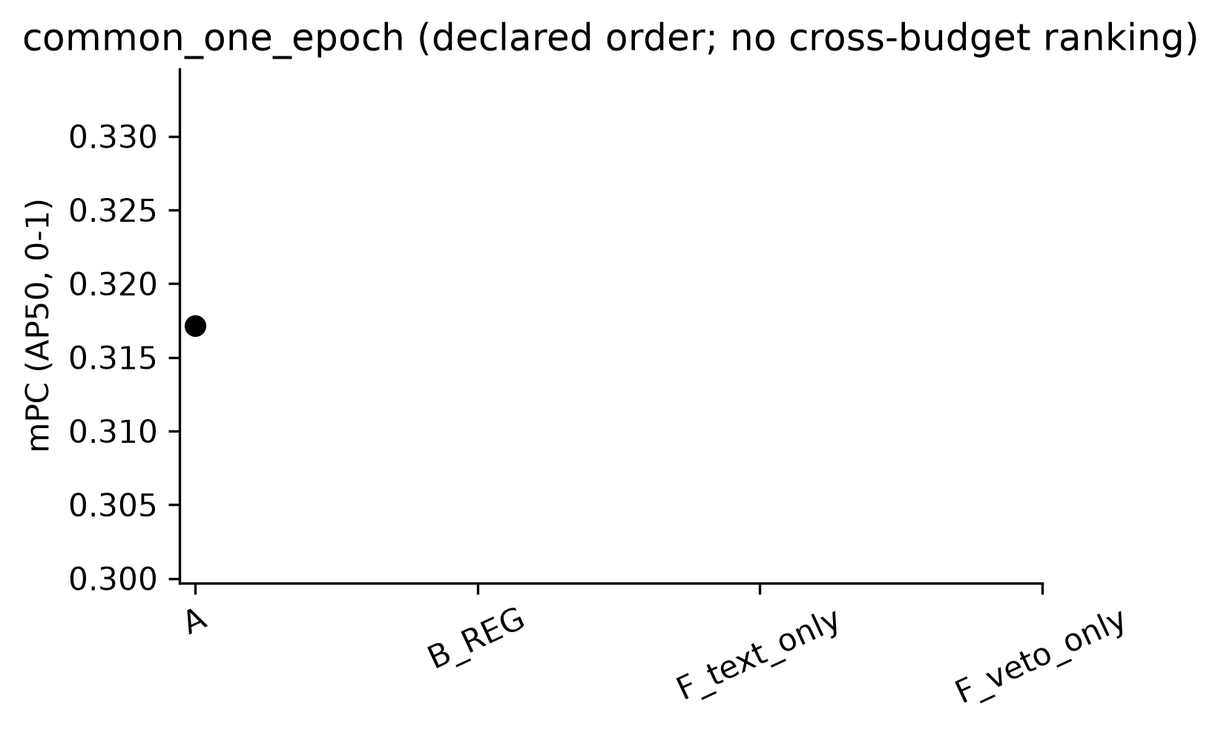
DIOR_ema_common_one_epoch_mpc.png：仅展示完整种子块，误差棒为样本标准差；A 无重复测量误差棒。
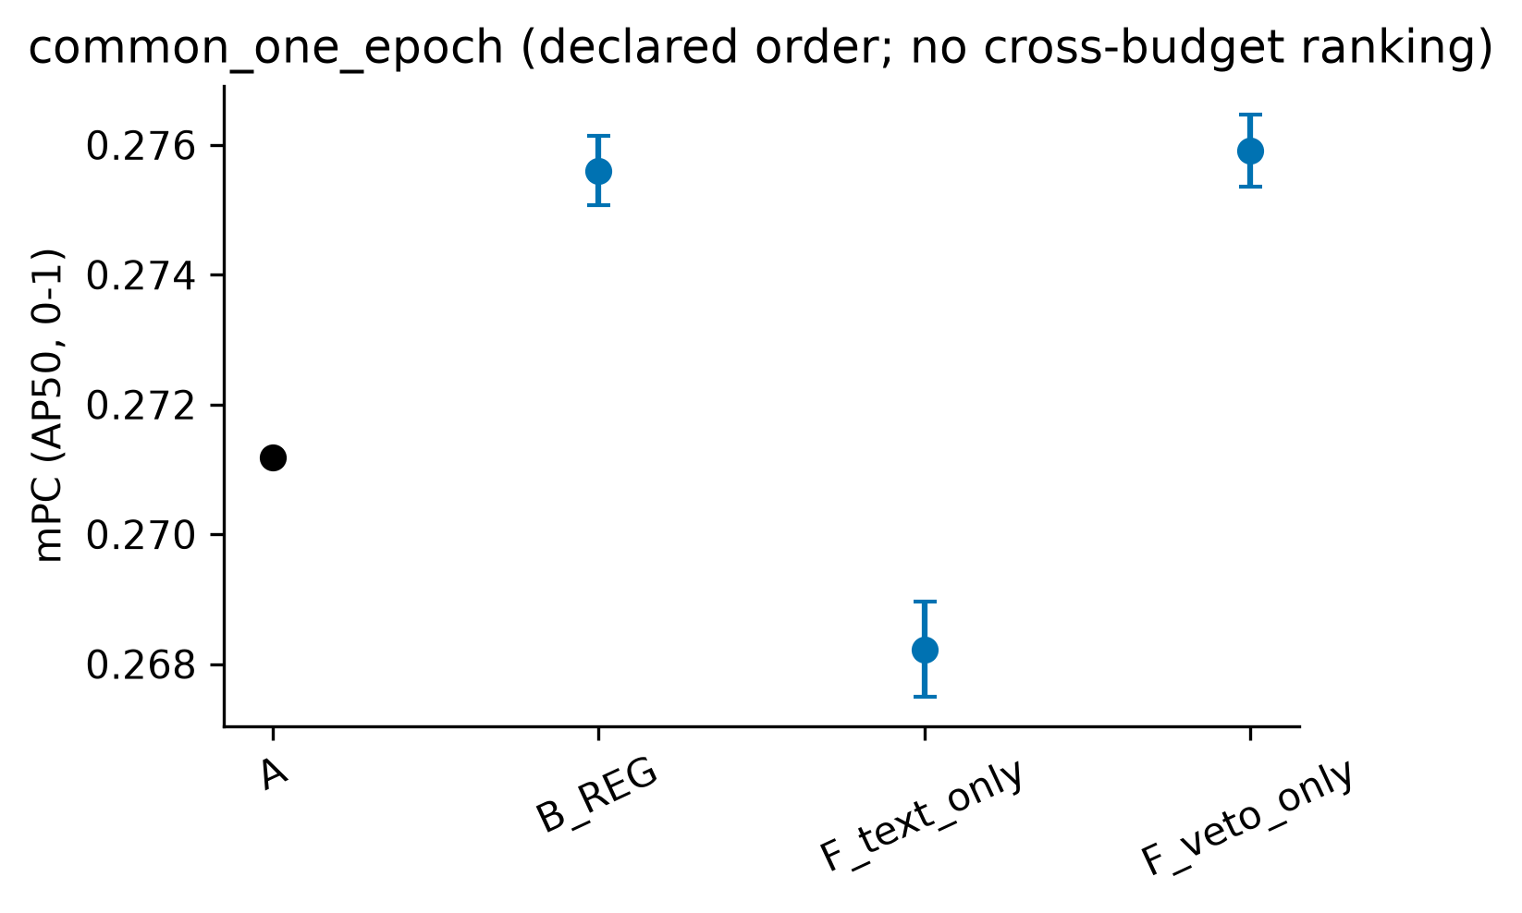

4. 配对统计

common_one_epoch
数据集/角色 | 方法 | 指标 | n | t p | sign-flip p | Holm t / sign | 状态
RSAR/ema | B_REG | delta_A | 0 | N/A | N/A | N/A / N/A | incomplete
RSAR/ema | B_REG | clean_delta_A | 0 | N/A | N/A | N/A / N/A | incomplete
RSAR/ema | F_text_only | delta_A | 0 | N/A | N/A | N/A / N/A | incomplete
RSAR/ema | F_text_only | clean_delta_A | 2 | N/A | N/A | N/A / N/A | incomplete
RSAR/ema | F_veto_only | delta_A | 1 | N/A | N/A | N/A / N/A | incomplete
RSAR/ema | F_veto_only | clean_delta_A | 1 | N/A | N/A | N/A / N/A | incomplete
DIOR/ema | B_REG | delta_A | 3 | 0.00486294 | 0.25 | 0.013728 / 0.75 | complete_low_power
DIOR/ema | B_REG | clean_delta_A | 3 | 0.00336411 | 0.25 | 0.0100923 / 0.75 | complete_low_power
DIOR/ema | F_text_only | delta_A | 3 | 0.0197479 | 0.25 | 0.0197479 / 0.75 | complete_low_power
DIOR/ema | F_text_only | clean_delta_A | 3 | 0.0276042 | 0.25 | 0.0276042 / 0.75 | complete_low_power
DIOR/ema | F_veto_only | delta_A | 3 | 0.004576 | 0.25 | 0.013728 / 0.75 | complete_low_power
DIOR/ema | F_veto_only | clean_delta_A | 3 | 0.00654885 | 0.25 | 0.0130977 / 0.75 | complete_low_power

5. 原始值、精度与未完成项
raw_results.csv 保留完整 metric.mAP，不使用已舍入的 metric.AP50。historical/ 逐字节保留输入的历史 seed42 CSV；原始 seed42 mAP 锁定，重评差异另存 eval_mAP50 并标记 metric_conflict，不静默改写旧值。per_class.csv 来自 class_ap.txt，通常仅三位小数，不反算总 mAP。prediction_image_coverage.csv、roi_vis_coverage.csv 和 embedding_index.csv 是三种不同范围的证据。
数据集/域 | 方法/角色/种子 | 状态 | 原因
RSAR/clean | B_REG/ema/42 | incomplete | missing_eval_json; checkpoint_missing_or_size_changed; missing_native_execution_binding; checkpoint_unverified_or_wrong_source; missing_eval_status; missing_class_ap; missing_predictions; missing_pred_count; missing_eval_json; missing_prediction_image_order
RSAR/clean | B_REG/ema/43 | incomplete | missing_eval_json; checkpoint_missing_or_size_changed; missing_native_execution_binding; checkpoint_unverified_or_wrong_source; missing_eval_status; missing_class_ap; missing_predictions; missing_pred_count; missing_eval_json; missing_prediction_image_order
RSAR/clean | B_REG/ema/44 | incomplete | missing_eval_json; checkpoint_missing_or_size_changed; missing_native_execution_binding; checkpoint_unverified_or_wrong_source; missing_eval_status; missing_class_ap; missing_predictions; missing_pred_count; missing_eval_json; missing_prediction_image_order
RSAR/clean | F_text_only/ema/42 | incomplete | missing_eval_json; checkpoint_missing_or_size_changed; missing_native_execution_binding; checkpoint_unverified_or_wrong_source; missing_eval_status; missing_class_ap; missing_predictions; missing_pred_count; missing_eval_json; missing_prediction_image_order
RSAR/clean | F_veto_only/ema/42 | incomplete | missing_eval_json; checkpoint_missing_or_size_changed; missing_native_execution_binding; checkpoint_unverified_or_wrong_source; missing_eval_status; missing_class_ap; missing_predictions; missing_pred_count; missing_eval_json; missing_prediction_image_order
RSAR/clean | F_veto_only/ema/43 | incomplete | missing_eval_json; checkpoint_missing_or_size_changed; missing_native_execution_binding; checkpoint_unverified_or_wrong_source; missing_eval_status; missing_class_ap; missing_predictions; missing_pred_count; missing_eval_json; missing_prediction_image_order
RSAR/chaff | B_REG/ema/42 | incomplete | missing_eval_json; checkpoint_missing_or_size_changed; missing_native_execution_binding; checkpoint_unverified_or_wrong_source; missing_eval_status; missing_class_ap; missing_predictions; missing_pred_count; missing_eval_json; missing_prediction_image_order
RSAR/chaff | B_REG/ema/43 | incomplete | missing_eval_json; checkpoint_missing_or_size_changed; missing_native_execution_binding; checkpoint_unverified_or_wrong_source; missing_eval_status; missing_class_ap; missing_predictions; missing_pred_count; missing_eval_json; missing_prediction_image_order
RSAR/chaff | B_REG/ema/44 | incomplete | missing_eval_json; checkpoint_missing_or_size_changed; missing_native_execution_binding; checkpoint_unverified_or_wrong_source; missing_eval_status; missing_class_ap; missing_predictions; missing_pred_count; missing_eval_json; missing_prediction_image_order
RSAR/gaussian_white_noise | B_REG/ema/42 | incomplete | missing_eval_json; checkpoint_missing_or_size_changed; missing_native_execution_binding; checkpoint_unverified_or_wrong_source; missing_eval_status; missing_class_ap; missing_predictions; missing_pred_count; missing_eval_json; missing_prediction_image_order
RSAR/gaussian_white_noise | B_REG/ema/43 | incomplete | missing_eval_json; checkpoint_missing_or_size_changed; missing_native_execution_binding; checkpoint_unverified_or_wrong_source; missing_eval_status; missing_class_ap; missing_predictions; missing_pred_count; missing_eval_json; missing_prediction_image_order
RSAR/gaussian_white_noise | B_REG/ema/44 | incomplete | missing_eval_json; checkpoint_missing_or_size_changed; missing_native_execution_binding; checkpoint_unverified_or_wrong_source; missing_eval_status; missing_class_ap; missing_predictions; missing_pred_count; missing_eval_json; missing_prediction_image_order
RSAR/gaussian_white_noise | F_text_only/ema/44 | incomplete | missing_eval_json; checkpoint_missing_or_size_changed; missing_native_execution_binding; checkpoint_unverified_or_wrong_source; missing_eval_status; missing_class_ap; missing_predictions; missing_pred_count; missing_eval_json; missing_prediction_image_order
RSAR/gaussian_white_noise | F_veto_only/ema/42 | incomplete | missing_eval_json; checkpoint_missing_or_size_changed; missing_native_execution_binding; checkpoint_unverified_or_wrong_source; missing_eval_status; missing_class_ap; missing_predictions; missing_pred_count; missing_eval_json; missing_prediction_image_order
RSAR/point_target | B_REG/ema/42 | incomplete | missing_eval_json; checkpoint_missing_or_size_changed; missing_native_execution_binding; checkpoint_unverified_or_wrong_source; missing_eval_status; missing_class_ap; missing_predictions; missing_pred_count; missing_eval_json; missing_prediction_image_order
RSAR/point_target | B_REG/ema/43 | incomplete | missing_eval_json; checkpoint_missing_or_size_changed; missing_native_execution_binding; checkpoint_unverified_or_wrong_source; missing_eval_status; missing_class_ap; missing_predictions; missing_pred_count; missing_eval_json; missing_prediction_image_order
RSAR/point_target | B_REG/ema/44 | incomplete | missing_eval_json; checkpoint_missing_or_size_changed; missing_native_execution_binding; checkpoint_unverified_or_wrong_source; missing_eval_status; missing_class_ap; missing_predictions; missing_pred_count; missing_eval_json; missing_prediction_image_order
RSAR/noise_suppression | B_REG/ema/42 | incomplete | missing_eval_json; checkpoint_missing_or_size_changed; missing_native_execution_binding; checkpoint_unverified_or_wrong_source; missing_eval_status; missing_class_ap; missing_predictions; missing_pred_count; missing_eval_json; missing_prediction_image_order
RSAR/noise_suppression | B_REG/ema/43 | incomplete | missing_eval_json; checkpoint_missing_or_size_changed; missing_native_execution_binding; checkpoint_unverified_or_wrong_source; missing_eval_status; missing_class_ap; missing_predictions; missing_pred_count; missing_eval_json; missing_prediction_image_order
RSAR/noise_suppression | B_REG/ema/44 | incomplete | missing_eval_json; checkpoint_missing_or_size_changed; missing_native_execution_binding; checkpoint_unverified_or_wrong_source; missing_eval_status; missing_class_ap; missing_predictions; missing_pred_count; missing_eval_json; missing_prediction_image_order
RSAR/noise_suppression | F_text_only/ema/42 | incomplete | missing_eval_json; checkpoint_missing_or_size_changed; missing_native_execution_binding; checkpoint_unverified_or_wrong_source; missing_eval_status; missing_class_ap; missing_predictions; missing_pred_count; missing_eval_json; missing_prediction_image_order
RSAR/am_noise_horizontal | B_REG/ema/42 | incomplete | missing_eval_json; checkpoint_missing_or_size_changed; missing_native_execution_binding; checkpoint_unverified_or_wrong_source; missing_eval_status; missing_class_ap; missing_predictions; missing_pred_count; missing_eval_json; missing_prediction_image_order
RSAR/am_noise_horizontal | B_REG/ema/43 | incomplete | missing_eval_json; checkpoint_missing_or_size_changed; missing_native_execution_binding; checkpoint_unverified_or_wrong_source; missing_eval_status; missing_class_ap; missing_predictions; missing_pred_count; missing_eval_json; missing_prediction_image_order
RSAR/am_noise_horizontal | B_REG/ema/44 | incomplete | missing_eval_json; checkpoint_missing_or_size_changed; missing_native_execution_binding; checkpoint_unverified_or_wrong_source; missing_eval_status; missing_class_ap; missing_predictions; missing_pred_count; missing_eval_json; missing_prediction_image_order
RSAR/am_noise_horizontal | F_text_only/ema/43 | incomplete | missing_eval_json; checkpoint_missing_or_size_changed; missing_native_execution_binding; checkpoint_unverified_or_wrong_source; missing_eval_status; missing_class_ap; missing_predictions; missing_pred_count; missing_eval_json; missing_prediction_image_order
RSAR/am_noise_horizontal | F_text_only/ema/44 | incomplete | missing_eval_json; checkpoint_missing_or_size_changed; missing_native_execution_binding; checkpoint_unverified_or_wrong_source; missing_eval_status; missing_class_ap; missing_predictions; missing_pred_count; missing_eval_json; missing_prediction_image_order
RSAR/am_noise_horizontal | F_veto_only/ema/43 | incomplete | missing_eval_json; checkpoint_missing_or_size_changed; missing_native_execution_binding; checkpoint_unverified_or_wrong_source; missing_eval_status; missing_class_ap; missing_predictions; missing_pred_count; missing_eval_json; missing_prediction_image_order
RSAR/smart_suppression | B_REG/ema/42 | incomplete | missing_eval_json; checkpoint_missing_or_size_changed; missing_native_execution_binding; checkpoint_unverified_or_wrong_source; missing_eval_status; missing_class_ap; missing_predictions; missing_pred_count; missing_eval_json; missing_prediction_image_order
RSAR/smart_suppression | B_REG/ema/43 | incomplete | missing_eval_json; checkpoint_missing_or_size_changed; missing_native_execution_binding; checkpoint_unverified_or_wrong_source; missing_eval_status; missing_class_ap; missing_predictions; missing_pred_count; missing_eval_json; missing_prediction_image_order
RSAR/smart_suppression | B_REG/ema/44 | incomplete | missing_eval_json; checkpoint_missing_or_size_changed; missing_native_execution_binding; checkpoint_unverified_or_wrong_source; missing_eval_status; missing_class_ap; missing_predictions; missing_pred_count; missing_eval_json; missing_prediction_image_order
RSAR/am_noise_vertical | B_REG/ema/42 | incomplete | missing_eval_json; checkpoint_missing_or_size_changed; missing_native_execution_binding; checkpoint_unverified_or_wrong_source; missing_eval_status; missing_class_ap; missing_predictions; missing_pred_count; missing_eval_json; missing_prediction_image_order
RSAR/am_noise_vertical | B_REG/ema/43 | incomplete | missing_eval_json; checkpoint_missing_or_size_changed; missing_native_execution_binding; checkpoint_unverified_or_wrong_source; missing_eval_status; missing_class_ap; missing_predictions; missing_pred_count; missing_eval_json; missing_prediction_image_order
RSAR/am_noise_vertical | B_REG/ema/44 | incomplete | missing_eval_json; checkpoint_missing_or_size_changed; missing_native_execution_binding; checkpoint_unverified_or_wrong_source; missing_eval_status; missing_class_ap; missing_predictions; missing_pred_count; missing_eval_json; missing_prediction_image_order
全部原始行与每种子聚合见 raw_results.csv、per_seed.csv；本报告不声称完成其他基线移植或未在输入证据中完成的项目。

