Synth DIY Workshop
February 2020
Hosted by Trevor Pinch and Jordan Aceto

A brief description of what we’re building: In this workshop we’ll build a simple square wave oscillator controlled by a light dependent resistor. This oscillator drives a small audio power amplifier which drives a tiny speaker. A rotary control acts as a combo volume and kind-of-sort-of tone control. During the workshop, we’ll build the circuit together, step by step.

All the documentation for this workshop, including layout images, schematics, a powerpoint presentation of the step-by-step construction of the circuit, and detailed information about ordering parts can be found at this website:

www.github.com/JordanAceto/DIY_Synth_Workshop_2020

Questions or comments can be directed to this email address: jordanaceto@gmail.com

Parts List:

Description | Distributor | Distributor Part Number | Quantity | Price
Audio Amplifier IC | Mouser | 926-LM386N-4/NOPB | 1 | $1.17
Hex Schmitt Trigger IC | Mouser | 595-CD40106BE | 1 | $0.52
Breadboard | Mouser | 474-PRT-09567 | 1 | $4.95
9V Battery Snap | Mouser | 123-5118-GR | 1 | $0.82
100K ohm Linear Rotary Potentiometer | Mouser | 858-P160KN0QC15B100K | 1 | $0.76
0.22uF Non-Polarized Capacitor | Mouser | 505-MKS2D032201C00KI | 2 | $0.52
0.01uF Non-Polarized Capacitor | Mouser | 75-1C10Z5U103M050B | 1 | $0.18
100uF Electrolytic Capacitor | Mouser | 667-ECA-1EHG101 | 1 | $0.30
16 ohm 500mW Dynamic Speaker | Mouser | 497-SM360616-1 | 1 | $2.19
9V Battery | Mouser | 658-6LF22XWA/C | 1 | $2.35
Light Dependent Resistor | Small Bear | 2506A 9200 | 1 | $0.89
Layout diagram of the completed circuit:

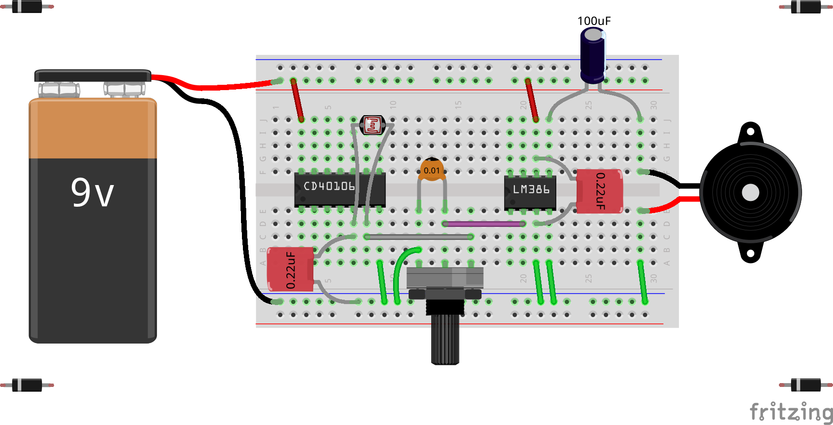

Schematic diagram of the circuit:
