TCP Packet Analysis
Jordan Bell
jxb466
ID: 1354708

Part 1 (4k)
Note: TPC connection starts at #14 on the packet trace.
I will refer to us as the Initiator, requesting the data.
I will refer to the server as the Receiver, receiving our request

SYN
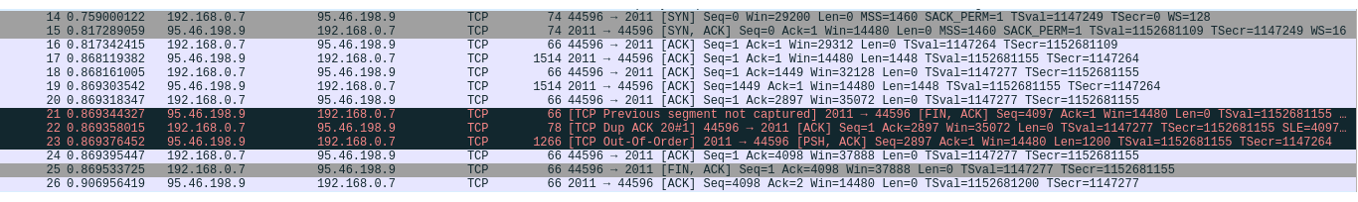
14: SYN flag set in initial packet sent to receiver at port 2011. Len = 0 as no data is included, just an intention to connect
15: Receiver at port 2011 sends a SYN & ACK-flagged packet. This acknowledges #14 packet and accepts the connection.

Data transfer
16: We send an acknowledgment for the last SYN packet sent by 2011 (#15)
17: Receiver at 2011 sends first block of data. 1448 bytes of data in the packet (66 bytes wrap around it for various protocols (Ethernet II, IPv4 and TCP) wrap around it).
18: Initiator’s ACK for #17. ACK number is 1449, indicating received amount (+1)
19: Receiver at 2011 sends second block of data. 1448 more bytes of data. Now sent 2896/4096 bytes
20: Initiator’s ACK for #19. ACK number is 2897, indicating received amount (+1)

Out-of-order communication
21: FIN flag for closing the connection. Indicates 4096 bytes sent, even though we have only received 2896/4096.
22: Initiator’s Duplicate ACK of #20 (acknowledging #19)
23: Out-of-order packet received for the final 1200 bytes. Should have been received before #21

FIN
24: Initiator’s ACK for #23, indicating 4096/4096 bytes received.
25: Initiator’s ACK for #21, agreeing that the connection will be closed.
26: Receiver’s final ACK (for #25).

Part 2 (64k)
Note: TPC connection starts at #9 on the packet trace.
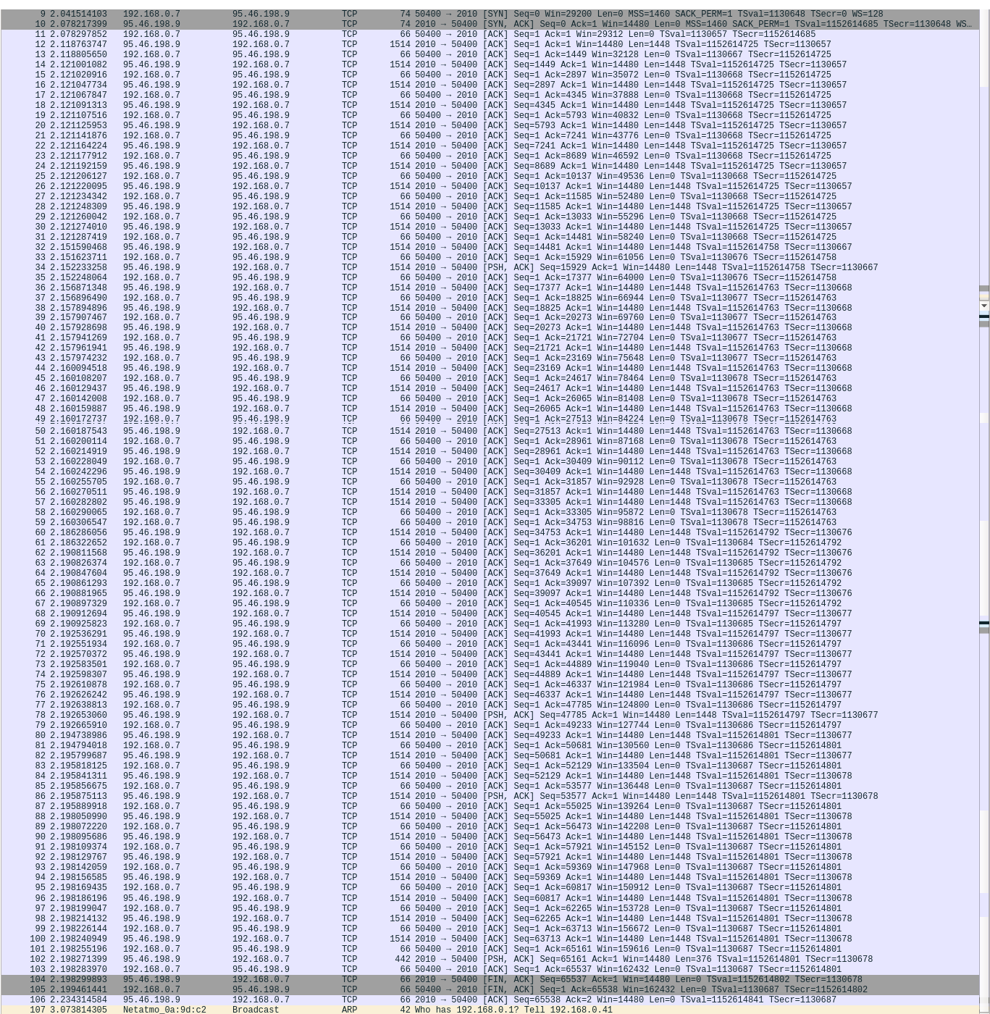
9: SYN flag set in initial packet sent to receiver at port 2010. Len = 0 as no data is included, just an intention to connect
10: Receiver at port 2010 sends a SYN & ACK-flagged packet. This acknowledges #9 packet and accepts the connection.
11: Initiator ACKs #10
12: Receiver sends first 1448 bytes
13: Initiator ACKs previous packet (#12)
[Repeat #12 and #13 up to #55]
56 & 57: Receiver sends two packets before receiving ACK. The receiver does not wait for ACKs before sending new packets. As a result, multiple are sent and the Data/ACK pattern is momentarily desynchronised.
58 & 59: ACKs for #56 and #57 respectively
[Continue Data/ACK pattern up to #101]
102: Receiver sends final 376 bytes for a total of 65536 bytes
103: ACK #102
104: Receiver's FIN/ACK for closing the connection
105: Initiator's FIN/ACK for closing the connection
106: Final ACK from receiver

Part 3 (10-second interruption)

Part 4 (2-minute interruption)

