Source: <http://www.easyrgb.com/?X=MATH>

RGB -> XYZ

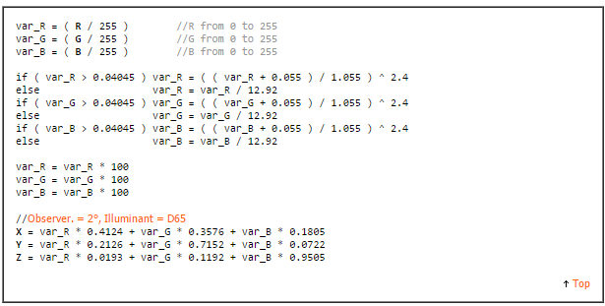

XYZ -> CIE-L\*AB

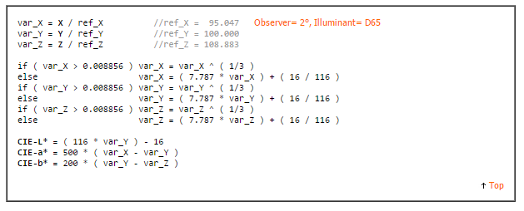

XYZ -> Hunter-LAB

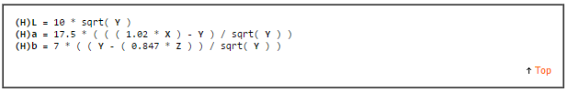

Difference = Delta E1994

