

Rollout Search Tool
Documentation

Prepared by: Jordan Brobyn
Client Computing Infrastructure – Software Packaging
Date: 30/08/2012

Document Information

Prepared by: | Client Computing Infrastructure – Software Packaging
Prepared for: | Rollout, ECCI
Author(s): | Jordan Brobyn
Document creation date: | 30/08/2012

Revision History

Revision number | Revision date | Revised by | Reviewed date and by | Revision description
1.0 | 30/08/2012 | Jordan Brobyn |  | Give a thorough understanding and documentation of the Rollout Search Tool

Table of Contents

Document Information 2

Revision History 2

Table of Contents 3

Rollout Search Tool Overview 4

Introduction 4

Prerequisites 4

Functionality 4
Importing ACF2s From A File 5
Manual Input Search 8
Exporting 9

Selection Method 10
Selection Steps 11

Code Overview 12
Primary Objects 12
Primary Objects 13

Potential Problems 15

Potential Upgrades 15

Rollout Search Tool Overview

Introduction

This document provides an overview of the Rollout Search Tool. Items included are: Requirements, Functionality, Selection methods, Code Overview, Current Bugs or Issues and Potential Upgrades

Rollout Search Tool is located on \\*****\JordanB\RolloutTool

Pre-requisites

The following sequence needs to be followed for the tool to function:

Microsoft .Net Framework 4 must be installed

To verify, launch: Start > Control Panel > Programs and Features. The program entry is:



Functionality

Main Window View

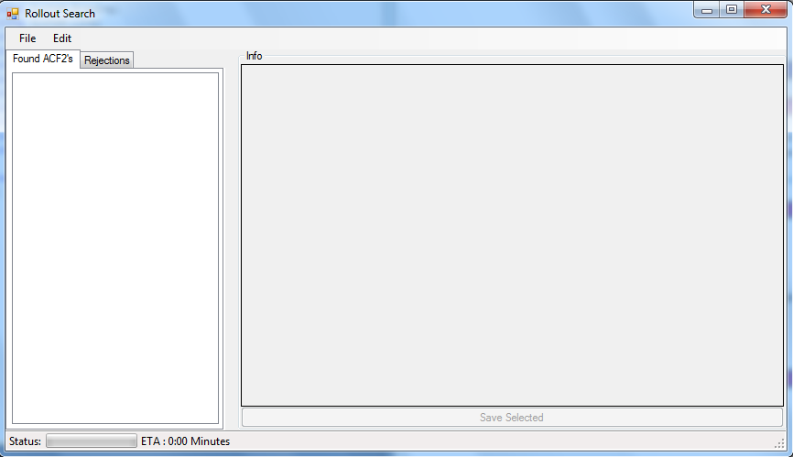

The tool is equipped with 3 Primary features

- Importing ACF2’s
- Manual Input Search
- Exporting (Selection Logs, Node list with ACF2, Detailed node list, Rejection List)

Importing ACF2’s

- Importing ACF2’s can be done through the menu under “File”

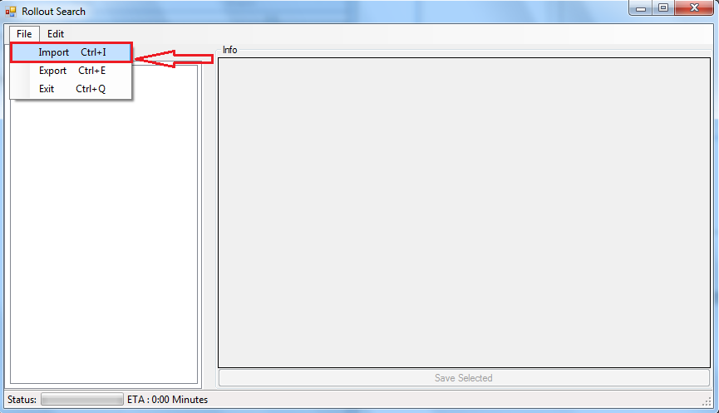

- Selecting this menu option will prompt the user to navigate to the file location containing the list of ACF2’s. It is recommended to import only .csv files or .txt files containing only ACF2 ids.
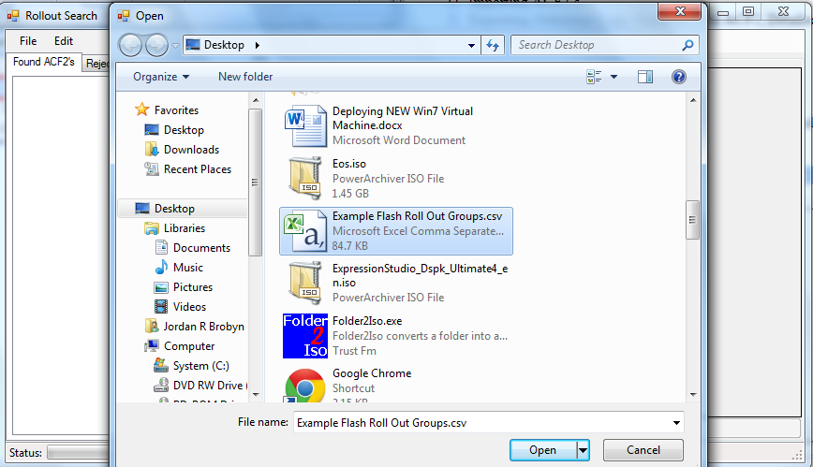

- The tool will automatically begin making its selections for primary nodes. A progress bar is included as well as an estimated time of completion. If you wish to minimize the application, you can view its progress on the taskbar.
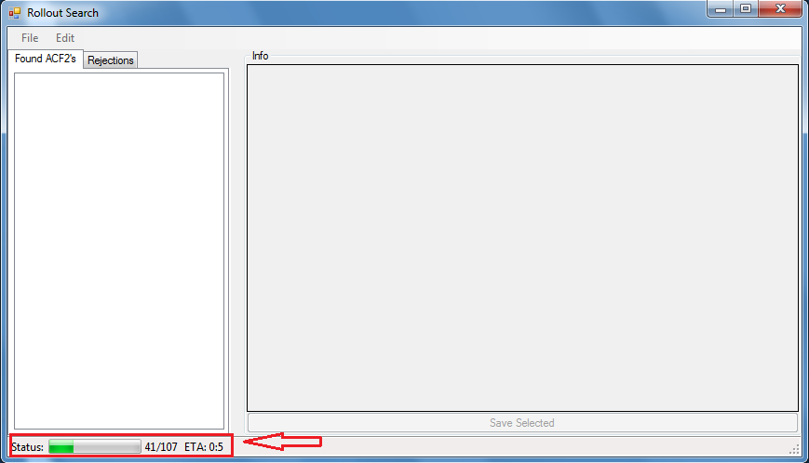

- The end result should produce a list of selectable ACF2’s sorted by the largest nodes found. Selecting an ACF2 will display its nodes as well as the selected nodes chosen by the program.
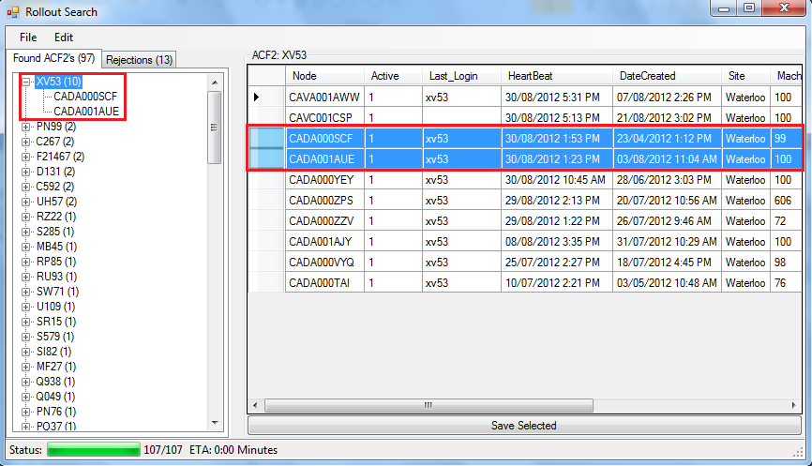

- If when searching through the selections you notice one you wish to change or add, holding ‘ctrl + left mouse click’ will select other nodes in the list. To save them just hit the save button below.
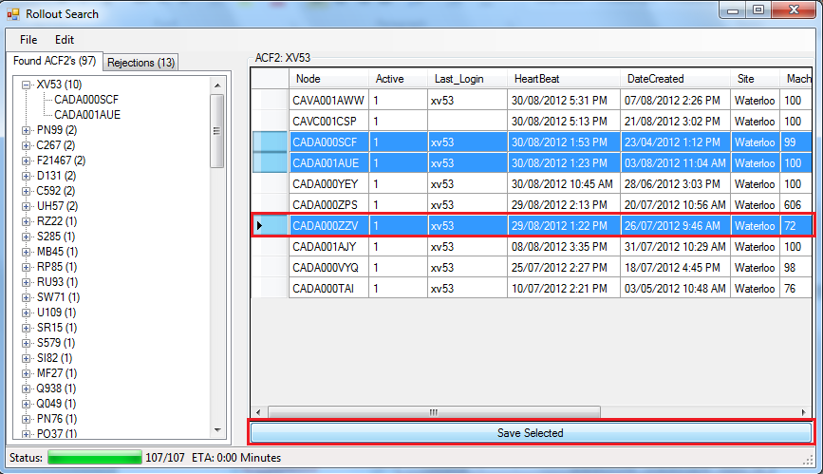

- Settings can be done before a search to increase potential finds as well as change the server if SCCM is ever updated in the future.
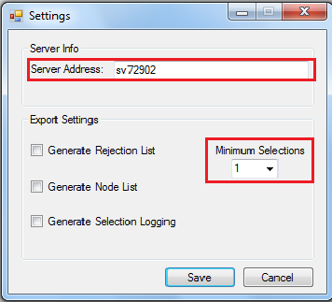

Manual Input Search

- Manual input is much like the import method but uses the ‘Edit’ menu to insert ACF2’s
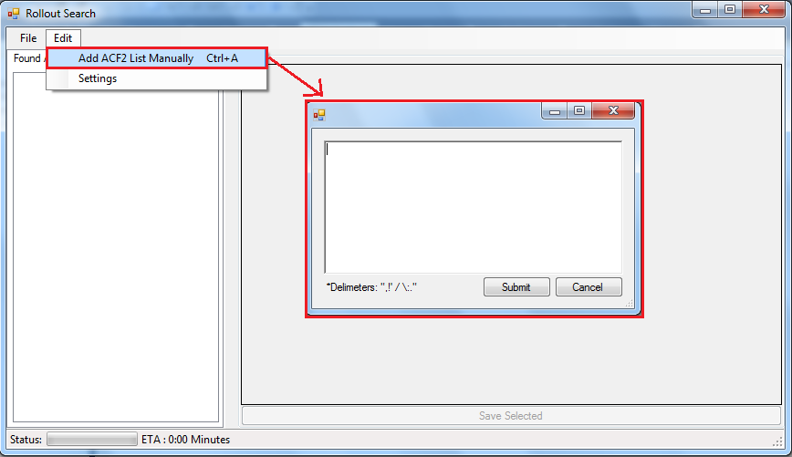

*The steps and results will be identical to importing from a file. See the steps above.

Exporting

- Exporting has a few options in when saving important information and can be done under File-> Export
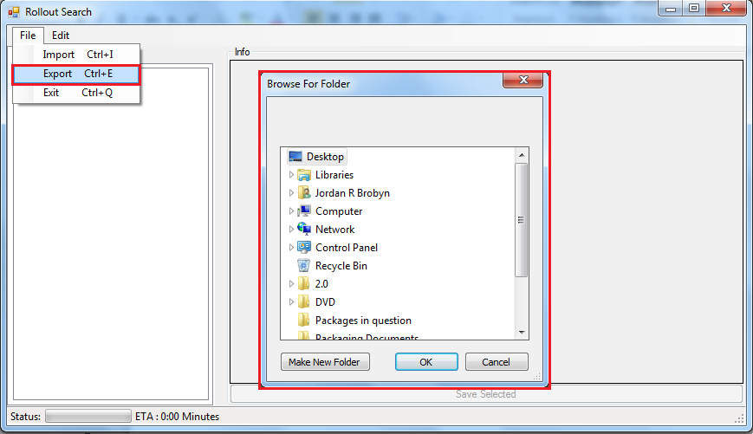
- A file will be created called “rollout- (CURRENT DATE).csv”
- Some settings may be enabled to produce more information during an export. These settings are found under Edit-> Settings.
These extra files will be output to the directory chosen during an export and will follow the pattern:
selectionLog-(CURRENTDATE).txt ,
nodeList-(CURRENTDATE).csv,
rejectionList-(CURRENTDATE).csv
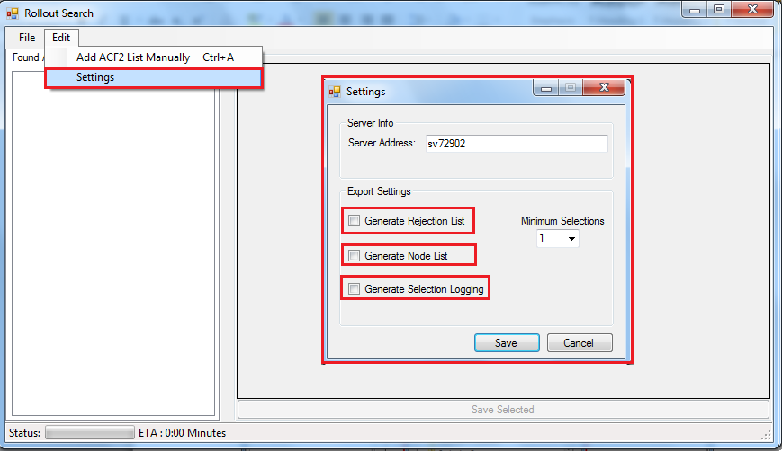

Selection Method

The selection method is performed after collecting as much relative information from an ACF2 as possible. The first query search attempts to find nodes that have the ACF2 chosen with a relatively high usage rate ( < 66%) as well, they must be the owner or recently logged on that machine.

What I have found is that XP machines tend to not have this usage information, so a second broader search is performed simply on machines that may be at all related to this ACF2 chosen.

Query 1:
Select distinct
SMS_R_SYSTEM.NetbiosName,
SMS_R_SYSTEM.OperatingSystemNameandVersion,
SMS_R_SYSTEM.CreationDate,
SMS_SITE.SiteName,
SMS_R_SYSTEM.Active,
SMS_R_SYSTEM.LastLogonUserName,
SMS_R_SYSTEM.employeeId,
SMS_R_SYSTEM.AgentTime,
SMS_R_SYSTEM.AgentName,
SMS_G_SYSTEM_COMPUTER_SYSTEM.Model,
SMS_G_SYSTEM_SYSTEM_CONSOLE_USER.NumberOfConsoleLogons,
SMS_G_SYSTEM_SYSTEM_CONSOLE_USER.TotalUserConsoleMinutes,
SMS_G_SYSTEM_SYSTEM_CONSOLE_USAGE.TotalConsoleTime,
SMS_G_SYSTEM_SYSTEM_CONSOLE_USER.LastConsoleUse
from SMS_G_SYSTEM_SYSTEM_CONSOLE_USER
INNER JOIN SMS_R_SYSTEM on SMS_R_SYSTEM.ResourceID = SMS_G_SYSTEM_SYSTEM_CONSOLE_USER.ResourceID
LEFT JOIN SMS_G_SYSTEM_SYSTEM_CONSOLE_USAGE on SMS_G_SYSTEM_SYSTEM_CONSOLE_USAGE.ResourceID = SMS_G_SYSTEM_SYSTEM_CONSOLE_USER.ResourceID
LEFT JOIN SMS_G_SYSTEM_SYSTEM_ENCLOSURE on SMS_G_SYSTEM_SYSTEM_ENCLOSURE.ResourceID = SMS_R_SYSTEM.ResourceID
INNER JOIN SMS_G_SYSTEM_COMPUTER_SYSTEM on SMS_G_SYSTEM_COMPUTER_SYSTEM.ResourceID = SMS_R_SYSTEM.ResourceID
left join SMS_Site on SMS_Site.SiteCode=SMS_R_SYSTEM.SMSAssignedSites
Where SMS_R_SYSTEM.employeeId = '" + id + @"'
Or SMS_R_SYSTEM.LastLogonUserName = '" + id + @"'
AND SMS_G_SYSTEM_SYSTEM_CONSOLE_USAGE.TotalConsoleTime != 0"

*NOTE* id is the ACF2

Query 2 (If primary search failed to find anything)

Select * From SMS_R_SYSTEM left join SMS_Site on SMS_Site.SiteCode=SMS_R_SYSTEM.SMSAssignedSites where NetbiosName = '" + id + "' OR LastLogonUserName = '" + id + "'"

A typical query will return the following information for each found node:

- Node Name: The name the machine is known by SCCM
- Active: Either a 1 or 0 where 1 is active according to SCCM
- Last Login: The last known logged on user, typically this is unreliable for virtual machines
- Agents: The agents collected are a list of record takers from SCCM to keep track of recent checkup events
- Heartbeat: The last time the machine checked in with SCCM
- Date Created: The date the machine became known to SCCM
- Site: The site code at which the node is connected to (ex. Waterloo, Toronto, Hong Kong)
- Machine Use: The percentage the ACF2 has used this machine. Typically XP machines provide inaccurate results.
- Owner: The determined owner of the machine. For windows 7 this is determined during imaging with the ABC Tool.
- OS: The current running operation system, determined by either 5.1 or 6.1

More information can be found at:
http://msdn.microsoft.com/en-us/library/cc145392.aspx

Selection Steps

The following steps are performed in order to remove potential non-primary machines from the whole list of known nodes for a particular ACF2.

*NOTE* logging is performed throughout the selection process, so the user can determine why a specific node was not selected. The log file can be found after a export.

- At each pass the safety variable set in settings will be checked to determine if the found number matches the safety amount.
- First find the most recent heartbeats of either a notebook or desktop.
  - A heartbeat is done daily as long as the machine is on and connected to the network
  - If there are no notebooks or desktops, then the user is typically only using virtual machines.
- Determine a cutoff heartbeat date by finding machines that are atleast 5 days older than the most recent heartbeat of a desktop or notebook.
  - Remove each node below this cutoff
- Remove any nodes that the heartbeats are before the most recent creation date
  - If a node was created very recently, it is likely that that machine is replacing any older machines.
- If a win7 machine exists, remove any XP machines
  - Since we are in the migration to windows 7 any xp machine are likely being replaced
- Remove non-owners
  - A owner is determined by the setting used during the ABC Tool imaging process
- Remove any test machines if they still exist
  - This can be determined by the 3rd value in a node name, either (B,C,V)
- Remove any nodes after the oldest creation date
  - Any nodes that are still kept and have one of the most recent heartbeats are likely their primary machine at this point. If a laptop and desktop are found, both will be kept.

*NOTE* This rejection process is not 100 percent accurate and there will be some cases that did not match this search criteria. It is recommended to still take a look through high node count ACF2’s

Code Overview

Primary Objects

Found in Main.cs

The ACF2 object will store the selected notes, owner (aka ACF2) as well as the selected nodes. Log information for each particular ACF2 will only be used during export

public class ACF2
{
public String ID { get; set; }
public List<NodeItem> Nodes { get; set; }
public List<NodeItem> SelectedNodes { get; set; }
public String log { get; set; }
}

The Rejection object simply holds all values that did not return any valid information. This would likely mean these people do not work at Sunlife anymore, or their SCCM has been broken on their machine for a very long time.

public class Rejections
{
public String ID { get; set; }
}

The NodeItem Object keeps track of the node found and all its important information for use during the selection process.

public class NodeItem
{
public string Node { get; set; }
public string Active { get; set; }
public string Last_Login { get; set; }
public String[] Agents { get; set; }
public String[] dateString { get; set; }
public String HeartBeat { get; set; }
public String DateCreated { get; set; }
public String Site { get; set; }
public String MachineUse { get; set; }
public String Owner { get; set; }
public String OS { get; set; }
}

Function Overview

Main.cs

- public WqlConnectionManager Connect(string serverName)
  - Used to connect to a valid server address. In our case currently (2012) that would be \\sv72902
- public NodeItem populateItemWin7(Dictionary<String, String> ID)
  - Used to create a node item with relative information regarding a win7 node found from the querys
- public NodeItem populateItemWinXP(Dictionary<String, String> ID)
  - Used to create a node item with relative information regarding a winXP node found from the querys
  - There is a winXP and win7 populate function due to some variations in information returned depending on this difference

- public void displayACF2(String id)
  - Displays information about a ACF2 selected by the user in a Data-grid format
- public void QueryACF2s(WqlConnectionManager connection,String[] ACF2s,int subThread)
  - Used to query the list of ACF2’s provided by the user.
Depending on the worker thread, a different portion of the list will be worked on asynchronously.
- public void populate_Tree(List<ACF2> users)
  - Populated the list view tree with ACF2’s found
- public void update_Tree(ACF2 user)
  - Updated the list view tree with changes made by the user based on a change in selected nodes
- private void addACF2ListToolStripMenuItem_Click(object sender, EventArgs e)
  - Event signal to begin searching for ACF2’s
- private void LoadList()
  - Dispatches worker threads to begin public void QueryACF2s
- private void ACF2_Tree_AfterSelect(object sender, EventArgs e)
  - Ensures only parent nodes in the list view are selected and then dispatches public void displayACF2
- private void get_Selected()
  - Displays selected nodes in blue in the data grid view
- private void set_Selected(String id)
  - Sets selected nodes in blue in the data grid view
- private void save_Selected_Click(object sender, EventArgs e)
  - Save button event to save the newly selected nodes if the user chose to change them
- private void backgroundWorker_ProgressChanged(object sender, ProgressChangedEventArgs e)
  - Updates the UI to show the current progress and estimate completion time for the remaining ACF2’s being worked on
- private void exportToolStripMenuItem_Click(object sender, EventArgs e)
  - Exports the lists and other information depending on Settings enabled before the export operation
- private void importToolStripMenuItem_Click(object sender, EventArgs e)
  - Import file operation
- public void divideACF2_Work(List<String> acf2s)
  - Splits the current ACF2 list in two to be given to two worker threads.
- private void settingsToolStripMenuItem_Click(object sender, EventArgs e)
  - Displays the settings menu and watches for changes when the user saves the changes. This will affect how the export feature works as well as the safety limit or server connection

Sorter.cs

- public KeyValuePair< List<Main.NodeItem>,String> selectBest(List<Main.NodeItem> list,String owner,int safety, string logs)
  - Primary function of the sorter. This function determines the logic of when to remove a node from the selection list.

*NOTE* The sorter class contains many more functions but they are very straight forward and do as the name entails.

Potential Problems

Some problems during execution may arise. Most should be caught and any critical errors will prompt the user pertaining to server access or file access.

The selection logic is still not 100 percent perfect. In some cases an inactive node is selected or even a virtual machine can be selected instead of a desktop or notebook. I have only seen this happen once or twice during an execution of every known ACF2 (around 14k users).

If the results begin to become inaccurate, adjusting the selection algorithm in Sorter.cs is recommended.

If the servers address changes, a global variable “server” can be altered to quickly change it permanently.

Potential Upgrades

- Take a deeper look into a more accurate selection algorithm to produce better results and reduce the end interaction from the user. The program typically takes 6 second to calculate 100 ACF2s with only two threads. Making the worker threads more dynamic could potentially speed up the program as well.
- Update the query sent to the database. Currently the query does a single user at a time due to the complication of values returned. If more time was taken to provide the entire list in one query the results could be found MUCH quicker.
- Provide more features like deploying directly from the application or features similar.
- Allowing particular information to be exported alone. For example, only exporting the rejections or log file.
- Currently selections and server information are not saved anywhere. If a user changed the server address and re-opened the program, the server would revert to sv72902.
- Enable more hotkeys or advanced usage. For example using strictly the keyboard to navigate
- Query Active Directory as well to not only search from ACF2s but real names or emails as well.

