Phase A

Team JORDAN

Joint Operations Rescue and Disaster Assistance Network

Generated using mixtral-8x22b-instruct-v0.1

Generated using Microsoft Designer powered by DALL.E 3

Phase B

2700 Sloat Boulevard is closest to tsunami (west) shore

5 cell phone tower pings

Caller stated they are in building above 30 floors

100 Van Ness Avenue (in orange) only has 29 floors

Most likely location is therefore 2700 Sloat Boulevard (in green)

Phase C

With the provided SAR resources, NVIDIA’s AI Workbench tool was utilized to create a model that can synthesize and respond based on Retrieval Augmented Generation technology.

The provided resources for search and rescue documentation, guidance, and strategy have been added to the vector database for augmentation of an endpoint LLM.

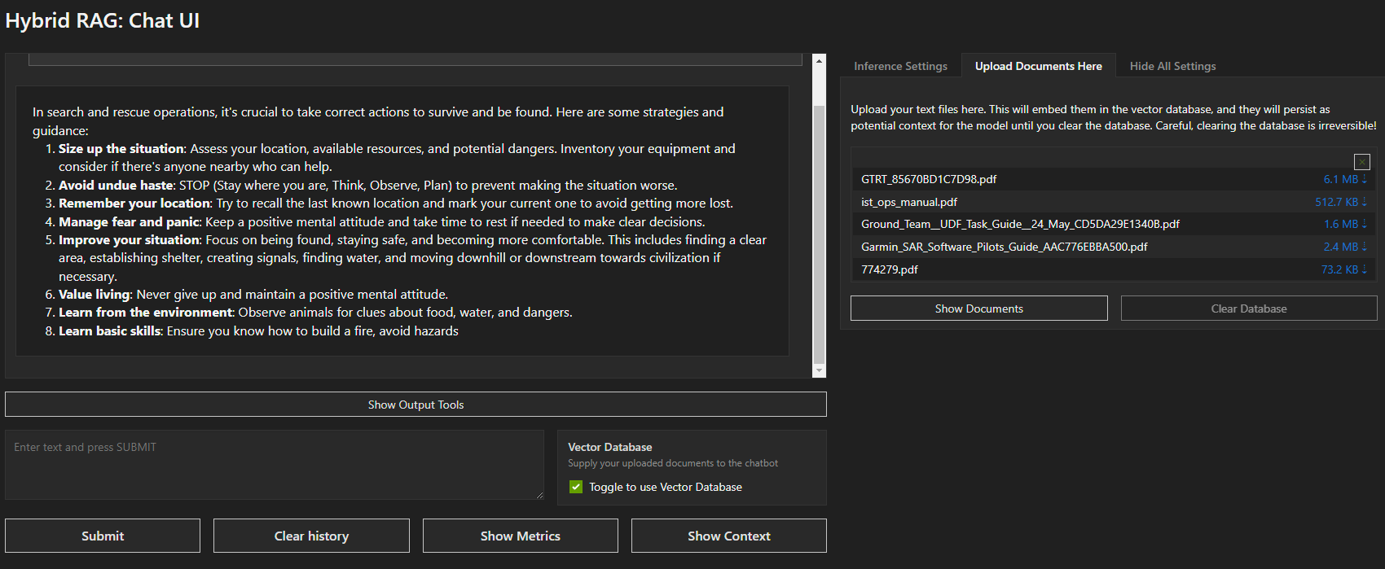

This model can be used in parallel with NVIDIA’s parakeet-ctc-0.6b speech to text model for questions to be answered via radio comms.

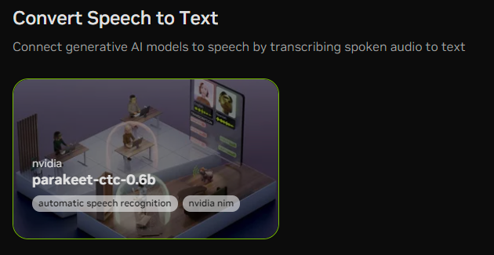

Phase D

The Walabot kit was setup to view through the brick wall. Successful activation was demonstrated using the WalabotSDK software.

A representative image showing a person identified behind the wall was saved for later use.

The website server with the SAR interactive was then used to find victims. This was either by listening for sounds or looking out for the red mark.

The previous image identifying whether a person is present behind an obstruction was uploaded as a reference.

After the search action gave back an updated image, a Python script was developed with the help of generative AI to determine if there was a person by identifying the darker red (highest response) color.

Then was then fed back into the interactive page to rescue the victims.