**EAD2 CA2 Ticket Vendor App**

**Jordan Carr + Lee Farrell**

**GitHub Repository:**

[https://github.com/JordanCarr96/EADCA2](https://github.com/JordanCarr96/EADCA2?fbclid=IwAR3WkXvolC4n-QVJMATTd2eCrCZ7UA_IDlRGDPBaeJYe6qtoScTPIzvbb5E)

**URI Scheme:**

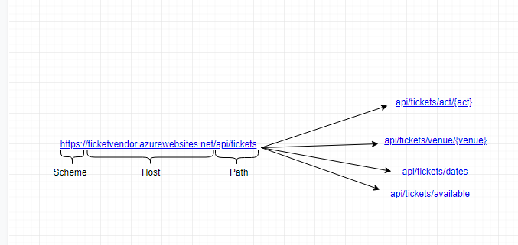

**Screen Shots of App:**

Main Page

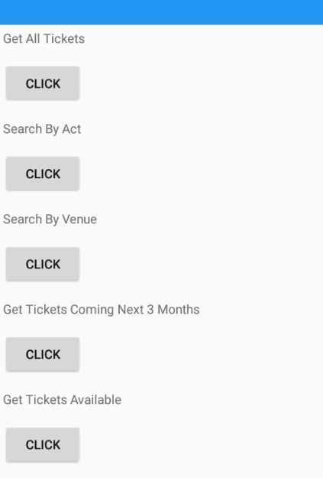

Get All

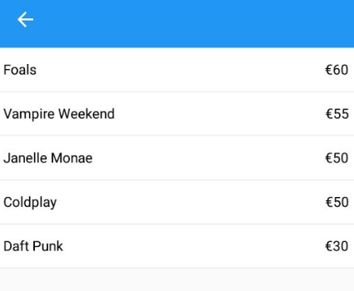

Get By Act

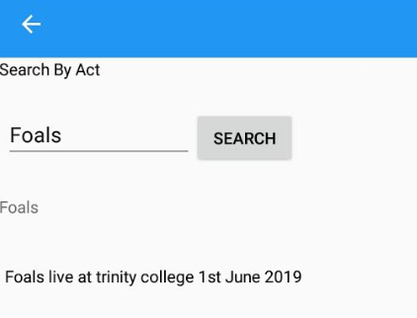

Get By Venue

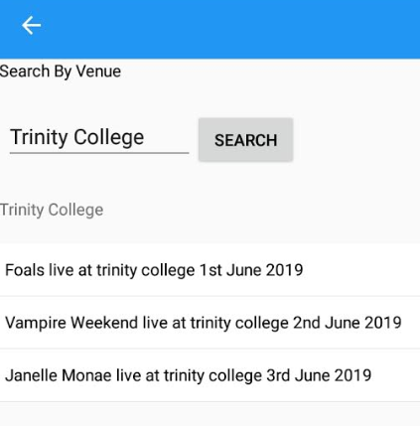

Get Coming Soon

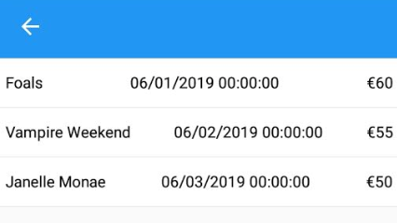

Get Tickets Available

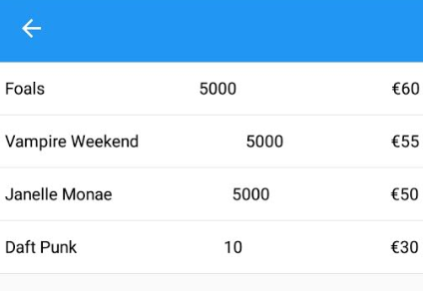

App Internationalised Spanish

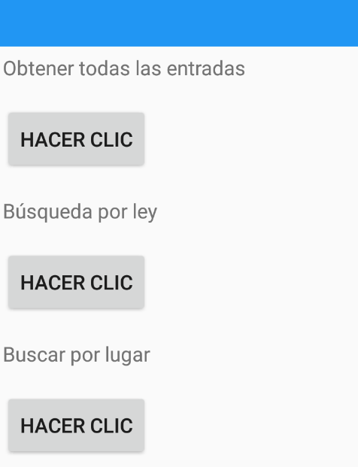

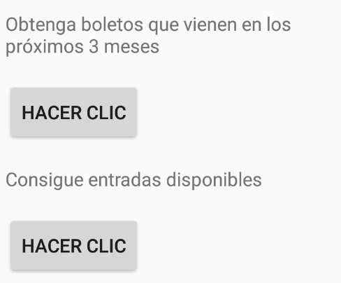

**Azure Deployment Settings:**

Published using app service

App Name: TicketVendor20190328105427

Resource Group: TicketVendorCA2

Hosting Plan: TicketVendor20190328105427Plan

Application Insights: West Europe

Database Name: TicketVendor_db

Database Tables: dbo.Tickets

Server Name: ticketvendordbserver

Base URL: <https://ticketvendor.azurewebsites.net/api/tickets>

**Testing Report:**

