User Stories

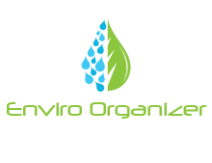

5 is the highest Difficulty it would take to implement each feature

As an environmental Scientist, I would like a way to organize my photos on a per site bases

Priority: High Difficulty: 2/5

As a very unorganized person I need a way to Organize my work while on my Trip

Priority: High Difficulty: 3/5

As a geologist, I need a way to save my photos with captions such as “This is a x rock”

Priority: medium Difficulty: 1/5

As a geography Student, I want organize my Trip work on a per module bases.

Priority: High Difficulty: 2/5

As an Environmental Scientist, I want to caption each photo along with a google maps location mapped to where I took that photo

Priority: High Difficulty: 4/5

As Geologist who work in a team a lot, I would like to share my work with other people who are on my project

Priority: low Difficulty: 4/5