**Plans and Progress**

Concept

Rule of Atonement is a multi- platformed gaming experience centered around a seamless transition between compatible devices. Rule of Atonement or ROA was conceived and began development under The Holy Pirates group in early 2019. The Holy Pirates saw a gap in the market where cross compatibility was lacking across devices and platforms, leading to lower user engagement and an inconsistent and broken gaming experience. To fill this gap in the market Holy Pirate’s look to create a virtual world platform that is part MMO and part social shared space.

**Early Stages**

RoA began development in March 2019 between the members of The Holy Pirates as they undertook Introduction to Information Technology at R.M.I.T. The group collectively decided to pursue the development of an MMORPG that operated with a “Seasons” concept. By operating with this concept, we can accept user feedback and analytics and adjust future seasons themes and genres as the market demands while providing fresh content to keep users actively engaged. By including a shared social space within the game as well as file sharing capabilities we hope to better engage our users and enforce longer and more active retention of gamers.

After the initial concept was conceived and agreed upon Holy Pirates began assigning roles and responsibilities for the team. We took some time to talk about our strengths and weaknesses and examined our areas of interest in order to better assign positions and tasks. In the end we decided to undertake the following roles.

* Aidan: Music Lead
* John: Lead Writer
* Ervine: Lead Network Engineer
* Ned: CEO
* Jordan: Lead Platform Engineer

As we are a small and tight knit team there is and will continue to be a large crossover of responsibilities as we develop our game design, layout, structure and rules.

In development meetings that were held on the Discord app in the beginning of the project the team spoke at length of what needs and holes we saw in today's gaming landscape. As a group we determined that our point of difference should be to deliver a multi layered and dynamic MMO that is equipped with multi-platform compatibility. Furthermore we would develop an ever-changing seasons concept that could reflect real life inputs in order to deliver a unique experience for all users and drive user engagement and retention.

Figure 1. Turret Gunner

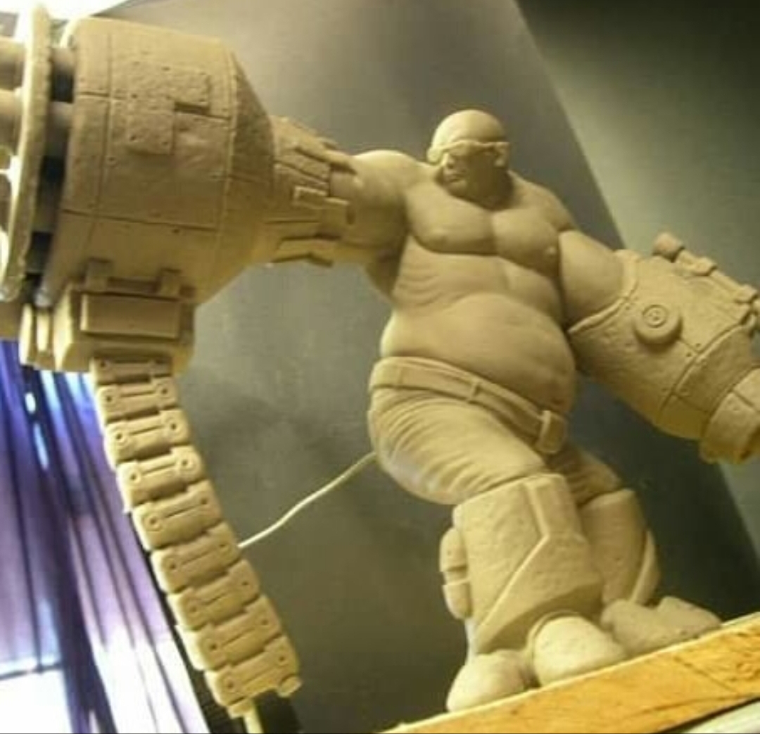

**Predicted Issues**

Some issues we identified early on in the planning stage were both data and network constraints. It quickly became apparent to us that in order to achieve our goal of multi-platform compatibility and on the go gaming RoA would need to be able to operate with reduced graphical, sound and network capabilities in order to ensure smooth gaming without consuming excess data and battery life. If we were unable to achieve this, we could almost certainly expect an uphill battle in order to develop and maintain a loyal consumer base. In order to combat these issues, we looked to Jordan and Ervine as our platform and network engineers for solutions. We also discussed the need to hire level designers, programmers, storyboard artists, testers and an internal producer to complement our team should a RoA pitch be successful in securing funding for further development. Finally, we also spoke of current MMOs being tired. Many users experience repetitive and unoriginal gameplay as well as a lack of continuity due to not being able to take their game with them. To fix this issue we are proposing a game that through the use of “AI” inhabitants will evolve and change with every interaction so that no two experiences can be the same. RoA’s planned multi-platform functionality will ensure users stay engaged by giving them the convenience to play anywhere and at any time.

Concept Development

The basis of the idea for RoA was based on the development team’s writer, John’s idea for an MMO. As such, we saw it fitting that he took the lead in writing and artistic direction as well as character and world development. We did this in order to stay true to his original idea, allowing him to set forth the game design concept that we could work towards as a team.

At this point we decided to develop some musical concepts as well as potential character art to help guide our direction and give some inspiration as we developed the concept. Aidan composed musical pieces to set the mood and tone of the game and Ned commissioned initial character drawings and busts of some initial character designs.

Fig 2. Northern Patrolman and his steed

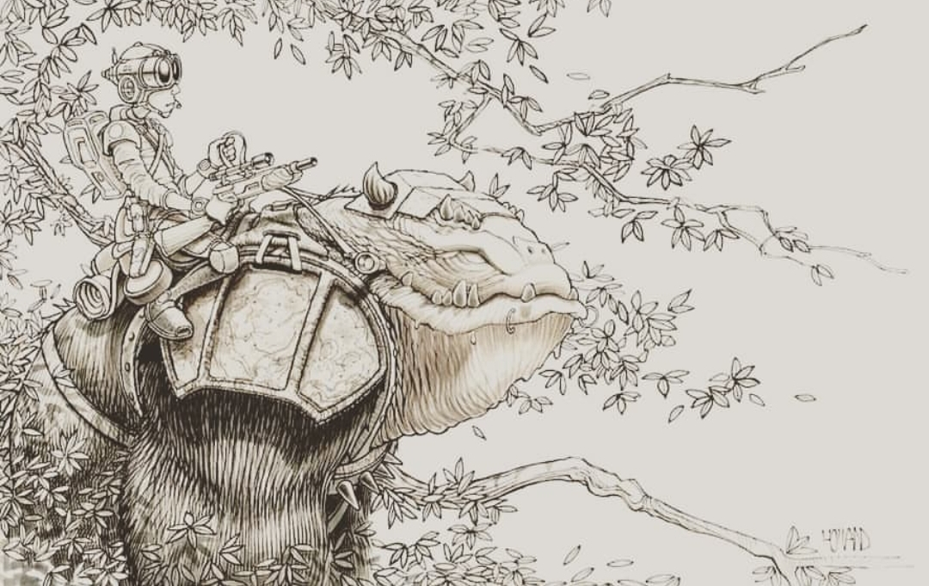

**Current State Of Development**

At Present, the team at Holy Pirates is currently working on a video pitch in order to secure further funding for development of Rule of Atonement. We are developing concept art, musical scores and will present our research that we have done into our games potential capabilities, audience and progress.

Figure 3. Roaming Executioner Bust

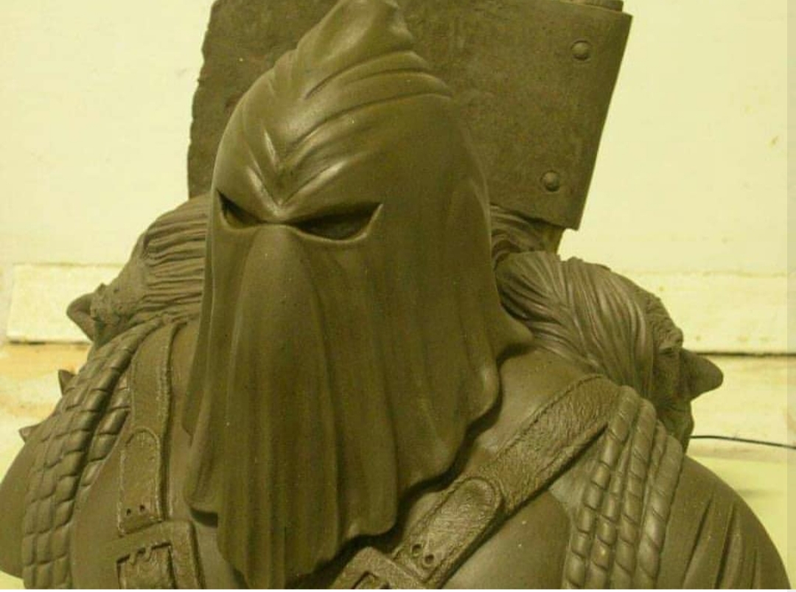

Figure 4. Project Planning Timeline

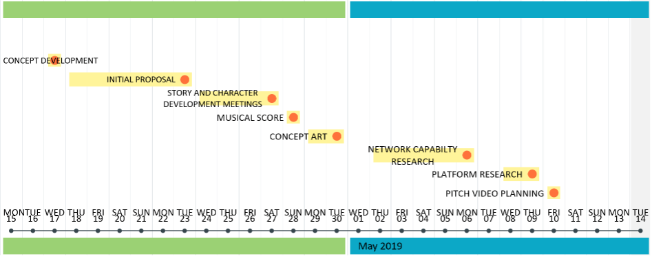

Our aim in the video is to demonstrate our game concept as well as our inspiration and motivation for developing Rule of atonement. We want our viewers to embrace the idea of RoA as we have and help us take this game to the next stage. Our pitch will be aimed at potential investors and collaborators who can help us to advance the project while bringing onboard new skills and financial backing that we do not have access to at present. We want to showcase our concept of a multi-platform, multi layered MMO that embraces the concept of anyone, anywhere, anytime.