## Lab 5 Dimensional Models

1. ACCOUNT (aCode, OpeningDate, Balance,BrenchID (FK), AccountType, cCode (FK)) CUSTOMER (cCode, Name, Address, Phone, BDay, Gender, Salary) TRANSACTION (Tcode, Date, Type, amount, aCode (FK) )   
   BRANCH (BrenchID, Name, Address, RegionID (FK), BankID (FK) )   
   REGION (RegionID, RegionName, Country)   
   BANK (BankID, Name,)

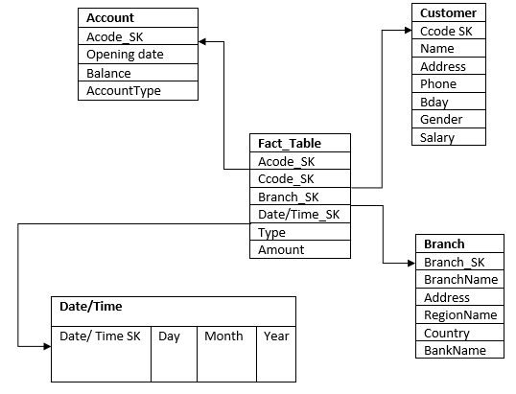

Select sum (Fact_Table. Amount), Branch.BranchName From Fact_Table  
Join Account on Fact_Table.Acode SK = Acode_SK  
Join Branch on Fact_Table.Branch_SK = Branch_SK  
Join Date/Time on Fact_Table.Date/Time_SK = Date/Time_SK

Where Account. AccountType = ‘Student’ and  
Date/Time.Day between 1 and 31 and

Date/Time.Month ‘Jan’ and ‘Dec’ and

Date/Time.Year = 2009  
Group by Branch_SK

1. User (Username, Password, Name, Email)  
   Forum (Fid, ForumName, Topic)  
   Thread (Tid, Tname, CreatedDate, Fid(FK))  
   Topic (TopicID, TopicDescription)  
   Posts (Pid, Tid, Username, Content, Timestamp)

One Topic many Forums  
One Forum Many Threads

One Threads Many Posts

One User Many Posts

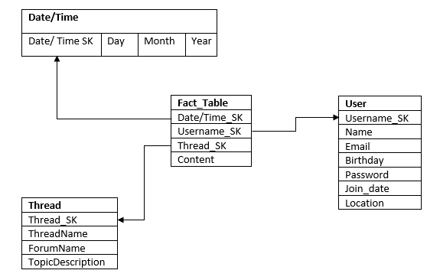

Query 1: Total number of posts on the on a thread by a user.  
Select count (*) From Fact_Table  
Join Thread on Fact_Table.Thread_SK = Thread.Thread_SK

Join User on Fact_Table.Username_SK = User.Username_SK  
Where User.Username_SK = ‘Jordan’ and Thread.Thread_SK = 123

Query 2: Shows the content a user has posted over a period of time  
Select content From Fact_Table  
Join Date/Time on Fact_Table.Date/Time_SK = Date/Time.Date/Time_SK  
Join User on Fact_Table.Username_SK = User.Username_SK  
Join Thread on Fact_Table.Thread_SK = Thread.Thread_SK  
Where User.Username = ‘Jordan’ and Thred.Thread_SK = 123

And Date/Time.Day Between 1 and 31 and Date/Time.Month = ‘April’

And Date/Time.Year = 2016

I done my dimensional model on Boards.ie. Boards.ie is a large Irish Forum on the internet. This allows Users can post questions or opinions on certain topics of interest. Other people can then see what this person has posted and then reply to it. There is a huge verity of topics to post and comment on.