Lab 2: Normalization
Exercise 1:
1NF:
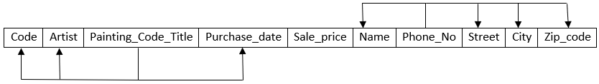
2NF:
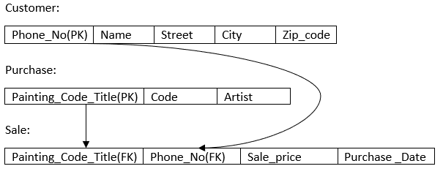
Customer(Phone_No(PK), Name, Street, City, Zip_code)
Purchase(Painting_Code_Title(PK), Code, Artist)
Sale(Painting_Code_Title(PK), Phone_No(PK), Sale_price, Purchase_date)
3NF:
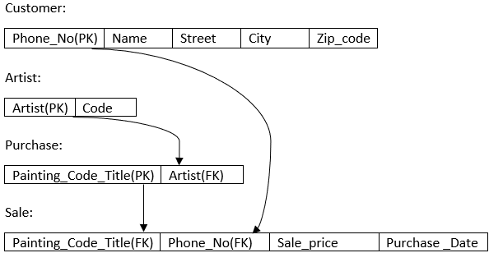
Customer(Phone_No(PK), Name, Street, City, Zip_code)
Artist(Artist(PK), Code)
Purchase(Painting_Code_Title(PK), Artist(FK))
Sale(Painting_Code_Title(PK), Phone_No(PK), Sale_price, Purchase_date)
Exercise2:
1NF
App_no, Student_id, Student_name, Street, State, ZipCode, App_year, Ref_Name, RefInstitution, Ref_statement, PriorSchoolID, PriorSchoolAddr, GPA
Apps_NOT_Normalized
App_No integer,
StudentID integer,
StudentName varchar(50),
Street varchar(100),
State varchar(30),
ZipCode varchar(7),
App_Year integer,
ReferenceName varchar(100),
RefInstitution varchar(100),
ReferenceStatement varchar(500),
PriorSchoolId integer,
PriorSchoolAddr varchar(100),
GPA number(2)

2NF:
Apps_NOT_Normalized
App_No integer, (PK)

Student details
StudentID integer (PK)
Student Name varchar(50)
Street varchar(50)
State varchar(50)
ZipCode varchar(50)

Reference
Ref_Name_Ins varchar(100)
App_Year integer, (PK)
ReferenceName varchar(100),
RefInstitution varchar(100),
ReferenceStatement varchar(500),

School history
PriorSchoolId integer, (PK)
PriorSchoolAddr varchar(100),
GPA number(2)

Student (App_no, StudentID, StudentName, Street, State, Zipcode)
Reference (Ref_Name_Ins , App_year, ReferenceName, RefInstitution, ReferenceStatement)
School (PriorSchoolId, PriorSchoolAddr, GPA)
3NF:
Student_details
StudentID integar (PK)
Student_ name varchar(50)

Student_address
StudentID integar (PK)
Street varchar(50)
State varchar(50)
ZipCode varchar(50)

School
PriorSchoolId integer, (PK)
PriorSchoolAddr varchar(100),

School_history
StudentID integer, (PK)
PriorSchoolId integer,
GPA number(2)

Application
App_No integer, (PK)
App_Year integer,
StudentID integer

Reference
App_year integar (PK)
App_no integar
ReferenceName varchar(100),
RefInstitution varchar(100),
ReferenceStatement varchar(500),

Student_Details( StudentID, Student_name)
Student_address(StudentID, Street, State, ZipCode)
School(PriorSchoolID, PriorSchoolAddress)
School_history(StudentID, PriorSchoolID,GPA,)
Application(App_No, App_year, StudentID)
Reference(App_year, App_no, RefferenceName, RefInstitution, ReferenceStatement)
4:
Unnormalized
insert into Apps_NOT_Normalized values(1,1,'Mark','Grafton Street','New York','NY234',2003,'Dr. Jones','Trinity College','Good guy',1,'Castleknock',65);
Apps_NOT_Normalized
App_No integer, | 4
StudentID integer, | 4
StudentName varchar(50), | 50
Street varchar(100), | 100
State varchar(30), | 30
ZipCode varchar(7), | 7
App_Year integer, | 4
ReferenceName varchar(100), | 100
RefInstitution varchar(100), | 100
ReferenceStatement varchar(500), | 500
PriorSchoolId integer, | 4
PriorSchoolAddr varchar(100), | 100
GPA number(2) | 2

Total = 1005 * 36(entry’s) = 36180

Noramlized
Student_details
StudentID integar (PK)
Student_ name
4 + 50 = 54
54 x 6 = 324
Student_address
StudentID integar (PK)
Street varchar(50)
State varchar(50)
ZipCodevarchar(50)
50 + 50 + 50 + 4 = 154
154 x 9 = 1386
School
PriorSchoolId integer, (PK)
PriorSchoolAddr varchar (100),
4 + 100 = 104
104 x 5 = 520
School_history
StudentID integer (PK)
PriorSchoolId integer,
GPA number(2)
4 + 4 + 2 = 10
10 x 21 = 210
Application
App_No integer, (PK)
App_Year integer,
StudentID integer
4 + 4 + 4 = 12
12 x 13 = 156
Reference
App_year integar (PK)
App_no integar
ReferenceName varchar(100),
RefInstitution varchar(100),
ReferenceStatement varchar(500)
4 + 4 + 100 + 100 + 500 = 708
708 x 13 = 9204
Total = 324 + 1386 + 520 + 210 + 156 + 9204 = 11800
Gain performance = 11800 / 36180 = 0.326 (0.326 x 100 = 32.6 )
100-32.6 = 67.4
There is a gain performance of 67.4%

