Distributed Systems

Name: Jordan Forde  
Student Number: C14403588  
Assignment Title: On-line auction system  
Date: 17th of November 2017

I declare that this work, which is submitted as part of my coursework, is entirely my own, except where clearly and explicitly stated.

How to run:  
Start the server with the command java Server 4032. Enter in at least 5 times and prices into the auction. Connect the clients to the server by running java Client Localhost 4032. In the server now type “EXIT” in capital letters. Now enter in client’s names and start bidding.

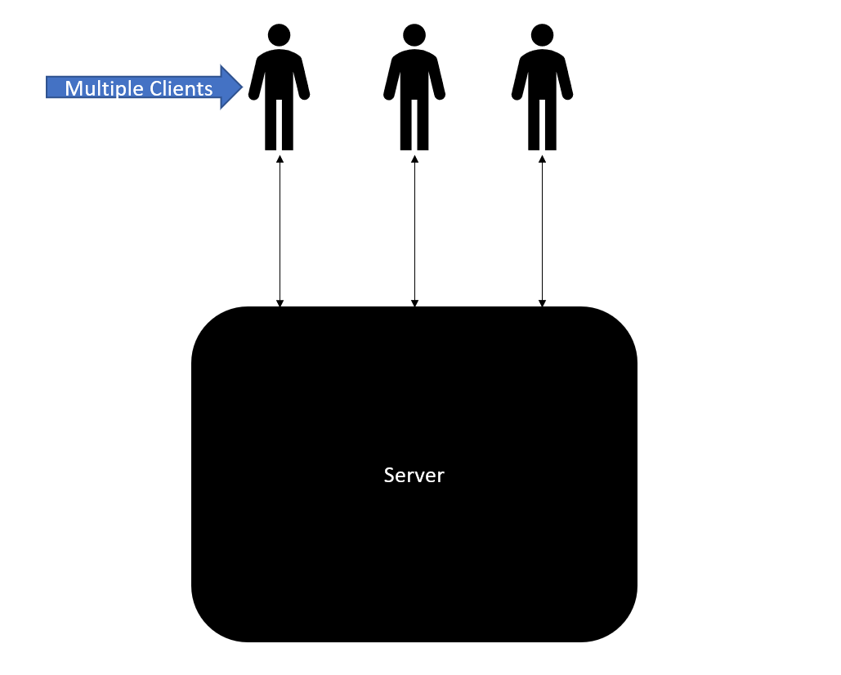

We have our server which allows us to enter in our items for auction and price them. If it cannot connect it will tell us. The server allows clients to connect it. The server will tell us if a client has connected. When the clients are connected they enter their name and are allowed to bid. The server has a sixty second timer in it and it is reset after every bid. We must display to the clients the starting price of the item and then when some has entered a bid it must displayed to all the clients. The clients bid must be greater than the starting price or the highest bid. The client handler handles the clients. It informs other clients when someone has joined and allows them to exit. If no one bids for an item, the item will go up for auction again. The server will inform the clients when all the items are sold.