Software Requirements and Design Document

For

Group 6

Version 1.0

Authors:
Jordan F
Isabella B
Fiana F
Anthony A
Abby H

Overview (5 points)
For this project, we’re calling Tomodachi Life: Remade. This game will try and remake many of the features and aspects from the original Nintendo game, such as creating and living with Mii characters, playing with them and seeing how their life unfolds. As the player, you can dress up each character and decorate their rooms, as well as feed them and take care of them. It’s a life-simulator game. For the scope of this project, however, we will be mainly focused on creating characters, games to play with them, and potentially implementing an event system.

Functional Requirements (10 points)

- The game should be able to save the current version. This is a high priority requirement.
- The game should be able to load a previous version of the game, saved from the last time the game was opened. This is a high priority requirement.
- Map Design
  - The player should be able to move around the map, allowing them to see every location available to them. This is a high-level priority.
  - The map should allow a player to tap a location to enter it. This is a high level priority.
- Character creation
  - The characters should be able to customize what eyes, nose, eyebrows, and hair they would like to have out of available presets. This is a high level priority.
  - The player should be allowed to change the color of their skin and hair based on their choice. This is a medium level priority.
- Mini-Games
  - Must allow interactive elements / progress or points
- Grocery Store
  - The player should be able to buy food items and store them. This is a low level priority.
- Apartments
  - The apartments should house all of the characters a play makes, each in their own section. This is a medium level priority.
- Town Hall
  - A player must be able to create new characters within the Town Hall location. This is a medium level priority.

Non-functional Requirements (10 points)
- Performance
- Reliability
Minimal bugs or lag is important for gameplay purposes. Enjoyment is the top priority. Certain features like different personality types or many character customization options are soft requirements that would add to quality of life, but are not required nor functional.

Use Case Diagram (10 points)
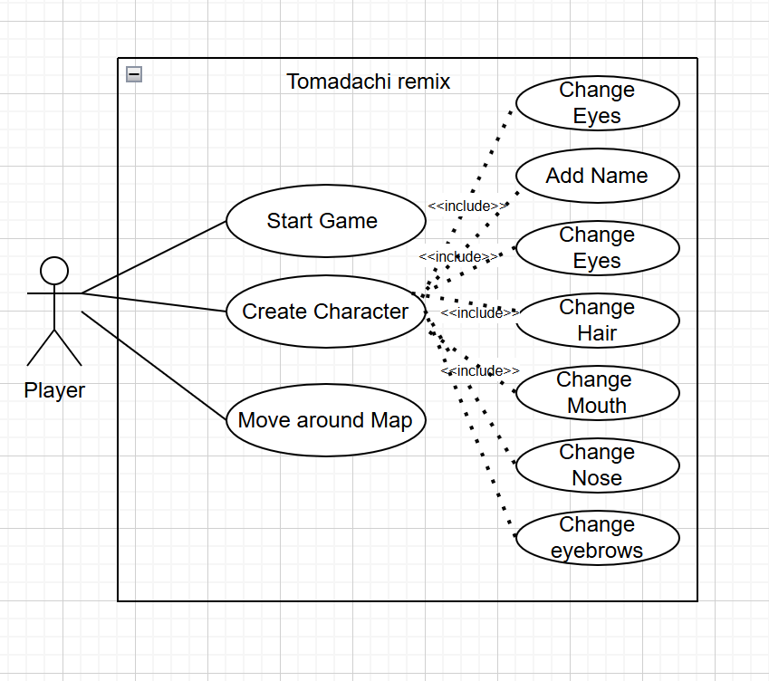

Class Diagram and/or Sequence Diagrams (15 points)
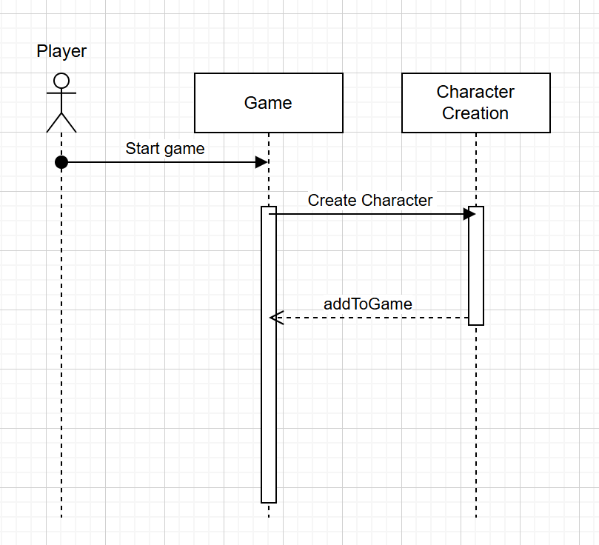
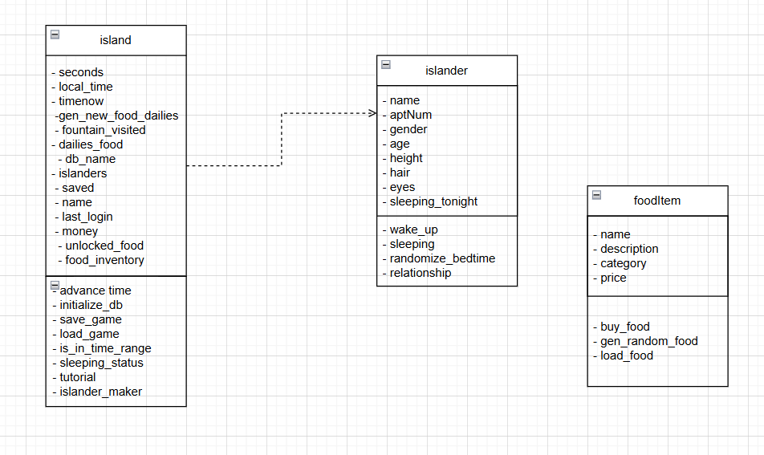

Operating Environment (5 points)
The environment that the software will operate on will be a laptop similar to most games found on Steam. Since we’re using Godot, the game will be playable on MacOS systems as well as WindowsOS systems, both on the current version of the operating systems.

Assumptions and Dependencies (5 points)
The game has been moved to Godot from an original python script so we are reliant on the saving mechanism from the original to be implemented into GDScript, as well as other features like food items and loading states. We also need to implement a Python backend into Godot in order for those save and load states to work but we are unsure of how to do this. The database used in the Python script is supported by SQLite3.

