# PyCharm Professional Installation Guideline

## Apply for a license

Please follow this link: <https://www.jetbrains.com/community/education/#students> and select the **"Apply now"** button.

* Fill in the form that opens, and in the field "**Email address**", specify the student email received by SoftUni.
  + Registration will be successful after confirming your student email. You can do that by logging with your student email at [office.com](https://office.com/)
  + You can **find your student email address** in the **email that was sent to you** a couple of days after the beginning of the **Fundamentals course**. This email contains all the licenses that Softuni provides.
* After successful registration, you can follow the email from the JetBrains link, redirecting you to the confirming page and starting your Pycharm Professional download.

***Note: The email from JetBrains will be sent to your student email.***

## Installing the IDE

After opening the installation file, the following installation window is displayed**:**

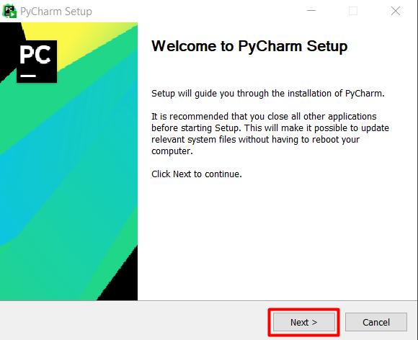

By pressing the **"Next"** button, it goes to the directory selected for the installation of our development environment:

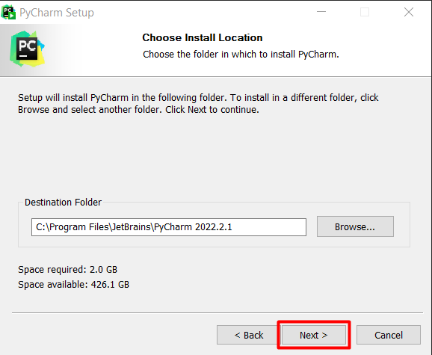

By pressing the **"Next"** button again, you go to a panel in which the following checkboxes must be marked:

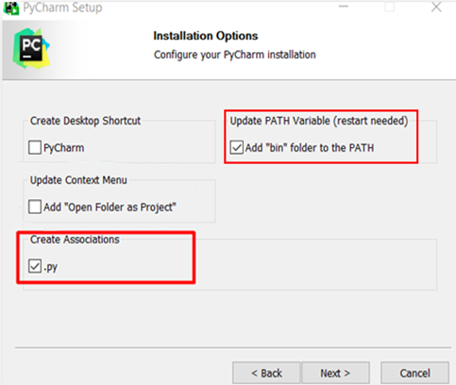

Continue until installation starts.

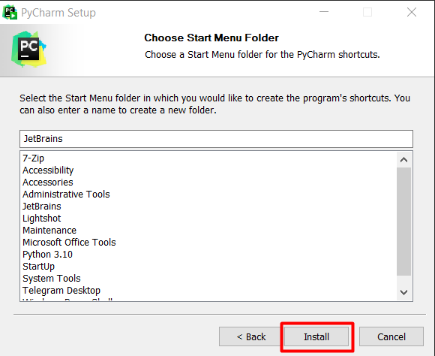

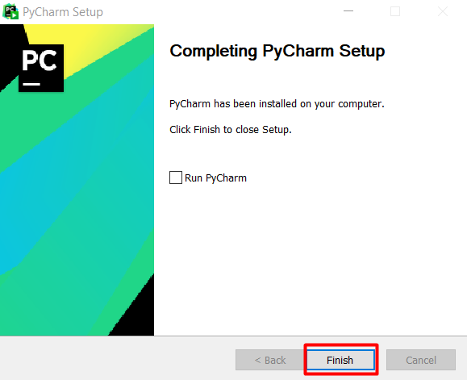

After everything is finished, **run PyCharm**.

## Open Pycharm

