Guardians of the Arena

The Team: Group H

Joey Shepard - designer, producer, and programmer.

Daniel Tenorio - designer, and programmer

Steven Kawafuchi - designer and programmer

Jordan Hua - designer and programmer

LS:JDGOSHOH - sound artist

We plan on using a spreadsheet to divvy up the programming work and communicate who is working on what. Spreadsheet can be found [here](https://docs.google.com/a/uci.edu/spreadsheets/d/1W4T-KTIXXPl_zBg936XmlJFUYLgrR0PrILJ1LyPd0l4/edit?usp=drive_web).

Overview

* **Pitch**
  + “Guardians of the Arena” is a 1-on-1 turn-based board game with an arena flare and is based in 2D. The board is tile-based, much like chess, and the players battle to eliminate the enemy forces to win. The players can customize their starting lineup, determining which units to use and where they are placed initially on the board. Each turn, the player can move and attack with as many units as his/her resources allow. There will be environmental obstacles, and a unit composition of around 10 distinct units. It would include ranged spellcasters, tanky melee units, and some immobile structures with spells/auras (totems). It would be preferred if the artist could provide visual effects for to accompany the units that need it.
* **Description of game play, key features, win conditions**
  + Player’s must kill the enemy Guardian (robust warrior unit) and then kill the Soulstone in order to win.
  + Players have 1 minute per turn
  + Players have a resource system that allows unit movement and attacks
  + There are two factions to pick units from
* **Genre and important influences**
  + Turn based multiplayer strategy
  + Strongly influenced by Tactics Arena Online, Hearthstone, and Final Fantasy Tactics
* **Art design**
  + TBD
* **Technical platform**
  + Unity 4.3 with C#, Visual Studio 2012 with C# for PC, and Git

How the Game Works

Outline:

The server will connect two players with similar MMR and randomly give one of the two players the first move. The server will then place each of the player’s units based on their preset board setups. At the start of each turn the players resource, “mana” will increase. Mana is used to move, and attack with all units in the game.

Gameplay:

Each player will start with a certain amount of a resource, mana, at the start of the game which allows a player to move and attack with their units. A player’s mana increases every turn up to a certain maximum and their turn is limited to 1 minute each (similar system to Hearthstone). Player’s units will attack each other, level up, and gain new abilities. The objective of the game is to kill the enemies Guardian, a very robust unit, which protects the enemy Soulstone (equivalent to the king in chess).

Mechanics and Player Design:

Start Steps-

1. 1 square grid is chosen.  (1 of 3 randomly picked grid shapes possibly in future)
2. 10 squares on the grid will be randomly chosen as “shrub” objects.
   1. Shrub- a square that indicates that neither player can set their pieces on.
3. Player 1 and Player 2 set their pieces on the grid.
   1. Both players are given the same number of in-game currency called “unit points”.  Unit points are used to purchase the players’ pieces in which they will use with them in the game until they are destroyed.
   2. Neither player can or will gain unit points for the rest of the game
   3. Given the selected grid and the 10 randomly chosen squares as shrubs, here is how the player will set their pieces before the game starts:
      1. Player 1 can set their pieces anywhere on the 3 lower-rows of squares, and Player 2 can set their pieces anywhere on the 3 upper-rows of squares.
4. Player Pieces Setup-
   1. Both the game board is set and before the players select their pieces using the unit points, Player 1 and Player 2 have the choice of picking between 2 factions (Faction A and Faction B).  Both players can use the same faction if they want.
   2. Faction A Units:
   3. Faction B Units:
      1. Dragon
      2. Tether
      3. Behemoth
   4. Neutral Units (Provided to both factions):
   5. How to read the Unit Design Spreadsheet (Spreadsheet link: ???)
      1. Unit Design Spreadsheet Purpose-

This spreadsheet describes the rules regarding how each unit in the faction the player chose can be used.  The design of each unit type (aka piece type), provides the core foundation to the mechanics of how the player will interact with their selected faction.  The following describes each attribute of each unit type in regards to how the piece of that type is used.  The attributes of both players’ pieces are in effect ONLY during each player’s turn as described in the Game State Diagram (Link:   ????).  Each attribute has a dedicated column of its own in the Unit Design Spreadsheet.

* + 1. Unit Name-

Text that labels what the players should refer that particular piece type in the game as.

* + 1. Faction-

Describes which faction that includes that particular piece type for the player to use if they selected that faction.

* + 1. Unit Cost-

How much unit points the player must spend in order to include 1 of that piece into their collection of pieces at the beginning of the game

* + 1. Health-
    2. Armor-
    3. Movement Range-
    4. Movement Cost-
    5. Attack Range-
    6. Attack Cost-
    7. Unique Abilities 1-
    8. Unique Abilities 2-

Game State/Infinite Loop-

Rules:

Balance:

Mechanics:

Focus: The focus spell casted will persist until the unit that casted the focus spell takes damage

Paralyze: Paralyzed units are incapable or moving and attacking.

User Interface and Diagrams

[Game Start Diagram](https://docs.google.com/a/uci.edu/drawings/d/1BS_y8t53bQjxKTfzLf1pB5ZAbRmwK5PIttz2OKrcxWE/edit)

[Game State Diagram](https://docs.google.com/a/uci.edu/drawings/d/15N_akAUxOn5koKBvuuSA_Nv6oAKXxvX8gSA3uXCSSPk/edit)

[General Game Box Diagram](https://docs.google.com/a/uci.edu/drawings/d/1dfJ3_3uUNkRogtdqaBHfxeZ-h5NJxoNp1PNGvRy95zI/edit)

[Interface State Diagram](https://docs.google.com/a/uci.edu/drawings/d/1K1Q7MvWy6ufZufYcjcz05QzBsDeJMKwx-F4h8OrbyV4/edit?usp=drive_web)

[Server to Client Statechart](https://docs.google.com/a/uci.edu/drawings/d/11AHn8NWQhfQDqSrbzfZntLxU1YscVPACi9hsXPi9eiw/edit?usp=drive_web)

Artwork

Concept Art:

Tactics Arena Online

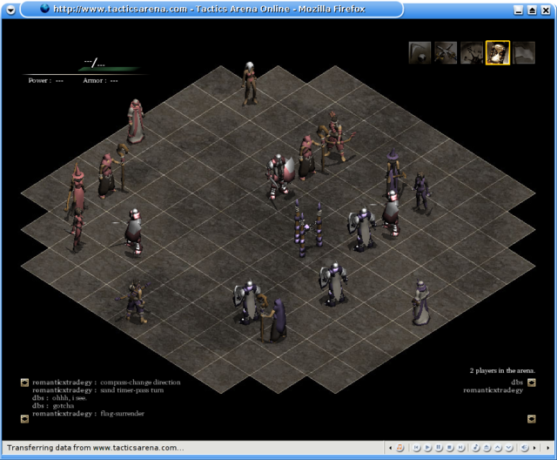  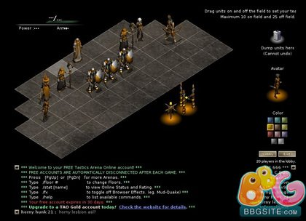

Final Fantasy Tactics

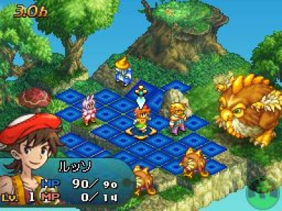  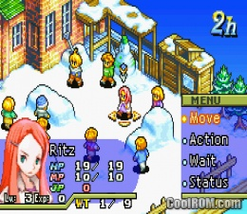

Music and Sound

We are planning on getting a sound artist to create individual sounds for animations, effects, buttons, and background music.

Story

No plans for a story at the moment

Characters (Units/Pieces)

[Unit Spreadsheet](https://docs.google.com/a/uci.edu/spreadsheets/d/1aTu4rTUQYx6VsWrD9ubFAJOJuLUy1NCjey2VQVlH4gE/edit#gid=0)

Levels

No plans for different levels (maps) at the moment.

Artificial Intelligence

Planning to make a simple AI vs a player if time allows.