UOFG Design System UI Kit Documentation
Overview
The aim of the API software is to allow developers to make calls to it to get the most up-to-date design styles from the UOFG figma library. It makes use of webhooks to get pinged when a new named version of the library is saved and updates the jsons that are stored in the figmafiles/ directory.
Features:
- API with endpoints that end-users can make calls to get the design styles of components they need, and an updates endpoint that allows webhooks to alert it of a new library version. (app/app.ts)
- File to create webhooks (fileUpdateWebhook.js)
- File to clear webhooks (clearWebhooks.js)
- File to pull the latest version of the library (figmaApi/initialisation/figmaTest.js)
- Generator functions for each implemented component (inside figmaApi/initialisation directory)
- Storybook directory that contains prototype website used for demonstration of API.
Current Status: Prototype
- The API can be ran, and updates when a new library version is saved
- Not all components are implemented
- Webhooks are very inconsistent and can take 1+ hours to ping the API with an update

Architecture Diagram
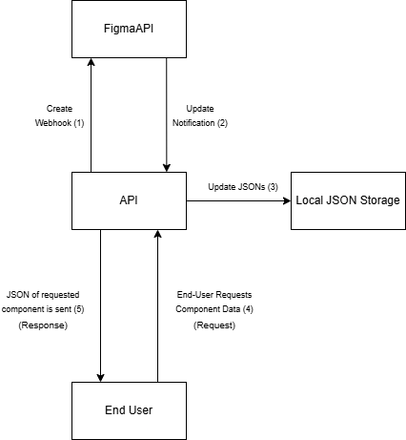
The API integrates with the Figma API by creating a webhook that will notify it when a new version of the library is saved. When an update occurs and a notification is sent, the API updates the current JSON files to be up-to-date with the newest data in the Figma library. End-Users can make requests to the API to retrieve the most recent component data.

Tech Stack
- Node.js: Provides the runtime environment for executing the server-side application
- Typescript: Used to improve readability and maintainability of API
- Express.js: Used to build API and handles requests
- cors: Allows cross-origin requests, used to test on the same machines as API is running on
- Json: JSON format used to store components based on retrieved figma data
- Fs/promises: used for asynchronous reading and writing of JSONs
- FigmaAPI: Figma’s API that sends our API notification when updates happen.
- Storybook: workshop for creating components and pages in isolation. It was used to demonstrate the updates working on a prototype webpage.
- ESLint: Linting utility. Helps find and fix problems with code. Part of the Continuous Integration pipeline
- NGROK: Allowed testing without needing to port-forward

Installation & Setup
Dependencies
- Dependencies can be installed using “npm install” in a command prompt window inside the project directory.
How To Run
- Environment Variables needed:
  - FILE_ID: id of the file/library on Figma
  - FIGMA_TOKEN: Figma personal access token
  - TEAM_ID: The id of the team on Figma which has access to the file
  - NGROK_URL: An ngrok URL
- The main file can be found inside the ./app/ directory
- The app.ts file contains the code
- It can be ran using “tsc app.ts”, then the compiled app.js file can be ran using “node app.js”
- Inside the root directory “node fileUpdateWebhook.js” can be ran to create a webhook, and “node clearWebhooks.js” can be used to clear webhooks

How To Use
End-Users
- Users can make requests to endpoints in the API
- Example of a request for a primary button component:
- The user then receives the following response:
- 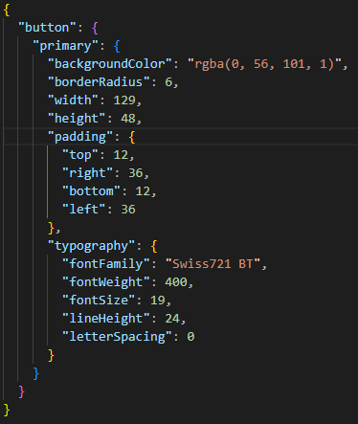

Structure
/app -> contains the main API code, with the endpoints
/design-lib -> library structure for functions that would make calls to the API for the users *Not Implemented*
/figmaApi -> Generator functions for updating the component JSON files
/figmafiles -> Stored component JSON files
/storybook -> Storybook files used for demonstration
/test, /tests -> contains files for testing the code
root -> contains the files for creating/clearing webhooks

Issues
- Webhooks are very inconsistent and can take over an hour to notify the API when an update happens
- Currently uses ngrok to allow out of network connections
- Only certain components implemented

Source Code Location: https://github.com/JordanMajer55/UOFG-Design-UI-Kit-SH27

