Comparison and Implementation of Data Compression Methods for SoC-based Radar Systems  Jordan Mohindra · Supervisor: A/Prof Beena Ahmed · School of Electrical Engineering and Telecommunications, UNSW Sydney
  [UNSW logo]

1 Motivation  Table 1: What this thesis adds  2 Method  Figure 1: Processing chain  Table 2: Test data | 3 Stage 1: screen all  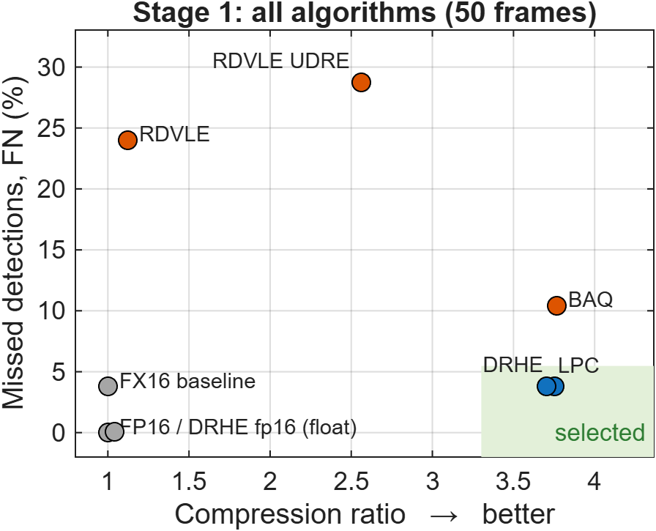  Figure 2: Compression vs missed detections (MATLAB, 50 frames)  FN/FP vs float reference; 3.77 % comes from 16-bit quantisation, not compression  Table 3: MATLAB benchmark, 50 ColoRadar frames (highlighted = taken to Stage 2) | 4 Stage 2: DRHE vs LPC  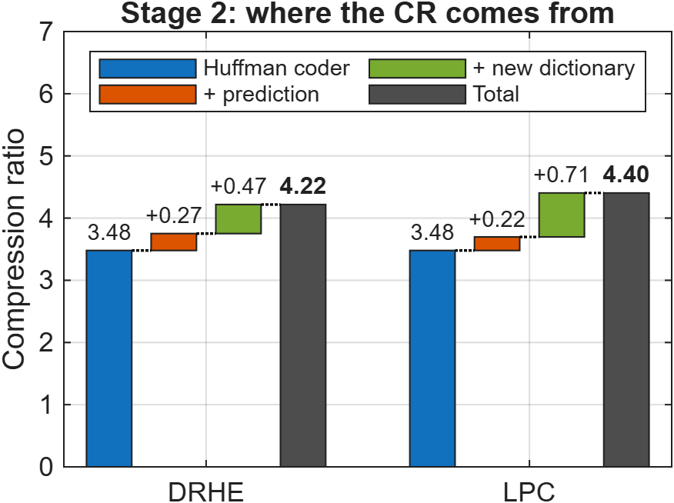  Figure 3: CR built up from Huffman coding, prediction and the new dictionary (50 frames)  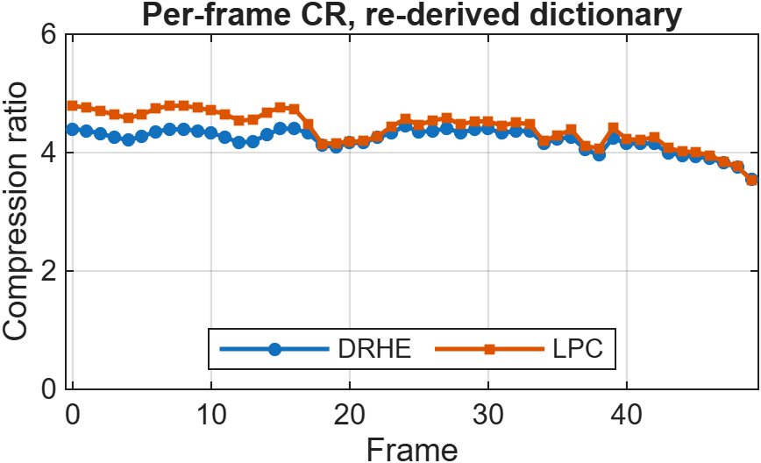  Figure 4: Per-frame CR, re-derived dictionary (MATLAB)
   | Kiem [1] | This thesis
  Data | Simulated noise | Real (ColoRadar [2])
  Algorithms | DRHE | 8 configurations
  Radar | Single TX | 12-TX TDM-MIMO
  HW = simulation | No | Yes, byte-exact
  Raw ADC frames (ColoRadar)
  ↓
  Range FFT (MATLAB)
  ↓
  Predict: DRHE or LPC
  ↓
  Huffman-code residual
  ↓
  Compress on FPGA (HLS C++)
  ↓
  Decompress + bit-exact check
  Parameter | Value
  Sensor | TI AWR2243 ×4 cascade
  Transmitters | 12 (TDM)
  Range bins × ramps | 128 × 192
  RX channels | 4
  Frames tested | 50
  Algorithm | CR | FN % | FP % | Lossless
  FP16 (float, reference) | 1.00 | 0.00 | 0.00 | –
  FX16 (fixed-point baseline) | 1.00 | 3.77 | 1.11 | –
  DRHE fp16 | 1.04 | 0.05 | 0.01 | yes
  DRHE | 3.75 | 3.77 | 1.11 | yes
  LPC Huffman | 3.70 | 3.77 | 1.11 | yes
  BAQ | 3.76 | 10.44 | 9.69 | no
  RDVLE | 1.12 | 24.01 | 4.62 | no
  RDVLE UDRE | 2.56 | 28.73 | 4.44 | no
5 FPGA system  Figure 5: System on the XCKU5P  Figure 6: Hardware setup | 6 Hardware results  * simulation, board run pending † theoretical ‡ incl. FFT  Table 4: Measured at 100 MHz on the KCU116  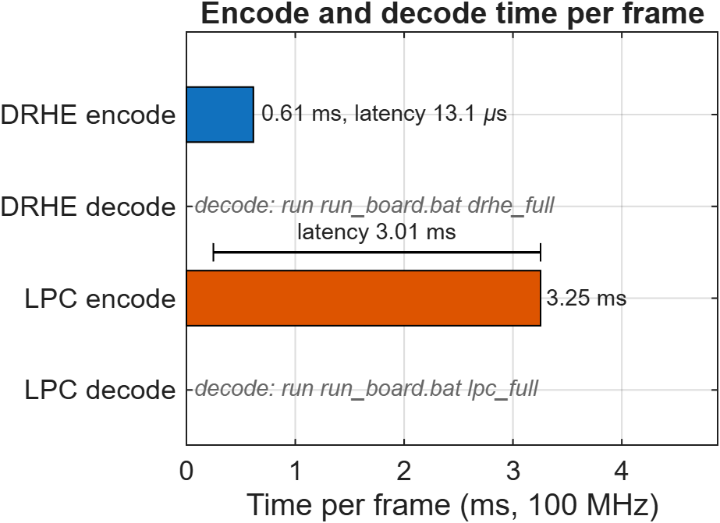  Figure 7: Encode and decode time per frame (decode: board run pending) | 7 Resources  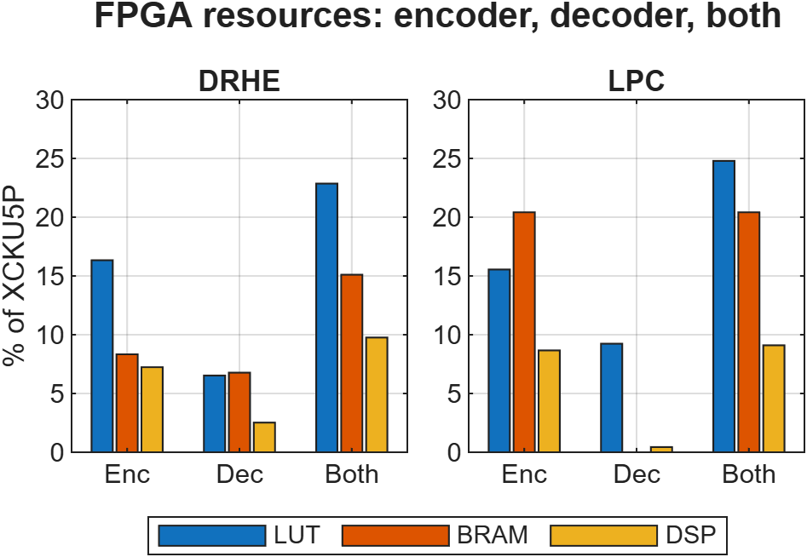  Figure 8: Encoder, decoder and both (cores only)  Key numbers
  [Insert: Vivado block design, reports/block_design_drhe.pdf]
  [Photo: KCU116 board running the test]
  Metric | DRHE | LPC | Kiem [1]
  CR on board | 3.751 | 3.697 | 3.17
  CR, new dictionary* | 4.218 | 4.404 | –
  Throughput (Gibit/s) | 4.77 | 0.90 | 11.92 †
  Encode latency (µs) | 13.1 | 3,006 | 79.4 ‡
  Core LUTs | 35,433 | 33,704 | 45,892
  Bit-exact vs sim | 50/50 | 50/50 | No
  4.40×  best lossless CR (LPC*) | 0 bits  lost, 50/50 frames
  13.1 µs  DRHE encode latency | 23 %  of LUTs, DRHE enc + dec
8 Conclusion  Stage 1: only DRHE and LPC are lossless with a useful CR.  Stage 2: LPC compresses most (4.40×), but DRHE is 5× faster with 230× lower latency → DRHE at the sensor. | 9 Next steps  Streaming LPC · fixed-point DRHE · stress tests · energy per frame.
[1] L. Kiem, Design and Implementation of Data Compression Methods for SoC-based Radar Systems. [2] A. Kramer et al., ColoRadar: The direct 3D millimeter wave radar dataset, IJRR, 2022.

