Irish Dance Database

Final Project

Jordan Murray

Donald Schwartz

CMPT 308N-113

November 29, 2018

Table of Contents

Database Description………………………………………………………………...……………2

ER Diagram………….…………………………………………………………………………....4

Create Table Statements & Normal Form Justification:

ShoeCompanies…………....………………………………………………………………………5

DressCompanies………………...………………………………………………………………...6

WigCompanies………………………..…………………………………………………………...7

Wig…………………………………………………………………………………………….…..8

Awards…………………………………………………………………………………………….9

Major…………………………………...………………………………………………………...10

Competitions……………………………………………………………………………………..11

Adjudicated………………………………………………………………………………………12

Judges……………………………………………………………………………….……………13

DanceTeachers………………………..………………………………………………………….14

DanceSchools…………………………………………………………………..………………...15

Dancers…………………………………………………………………………………………..16

Queries:

Universal Quantifier……………………………………………………………………………...18

Only……………………………………………………………………………………………....19

None……………………………………………………………………………………………...20

Right Join………………………………………………………………………………………...21

Left Join……………………………………………………………………………………….....23

Full Join………………………………………………………………………………………….25

6 Tables...………………………………………………………………………………………...27

Query1..………………………………………………………………………………………….29

Query2…………………………………………………………………………………………...30

Query3…………………………………………………………………………………………...31

Database Description

The world of Irish dance has many different aspects that need to be organized. The database being modeled is a way to organize many aspects of this sport throughout the United States. Some main entities that are involved are Dancers, Dance Schools, Dance Teachers, Wig Companies, Shoe Companies, Dress Companies, Majors, and Judges.

A dancer has an ID that uniquely identifies it, a name, an age, and a level. There are many aspects that contribute to a dancer’s look. Some parts of a dancer’s costume are shoes, a dress, and a wig. Dancers acquire these things from shoe companies, dress companies, and wig companies. A dancer can only get their dress from one dress company. This is the same for their shoes and their wig. However, a shoe company, a dress company, and a wig company can provide their services to multiple dancers.

A shoe company has an ID number that uniquely identifies it, a company name, a phone number, a city and state. A dress company has an ID number to uniquely identify it, a company name, a designer name, a phone number, a city and state. A wig Company has the same attributes as a shoe company. There are many different kinds of wigs that a dancer has to choose from. A wig has a unique ID number, a name, a type, and the company it belongs to. A wig company can offer many different kinds of wigs, but a specific wig can only be offered by one company.

A dancer dances at one dance school. A dance school consists of many dancers and has a unique ID number, a name, a city, a state, a phone number, and a price per month. Similarly, a dance teacher teaches at a dance school which can have many different teachers. A dance teacher has an original ID number to identify them, a name, and a certification.

A dancer can win many awards, but an award can only be given to one dancer. An award has a unique ID and a name. Dancers can only compete at one major competitions(regionals) to win awards. So, a major gives many awards, but a specific award can only be given at one major. A major has a special ID number, a region name, a city, and a state. At a major competition, there are many different categories of competitions, but any individual competition can only be at one major. An individual competition has a unique ID, an age group, a room number, a competition type and the number of competitors. Competitions can be adjudicated by many judges and a judge can adjudicate many different competitions. A judge has a unique ID, a name, a hometown, and the number of years they have been judging.

These are some of aspects of the Irish dance that need to be organized. This description gives a brief overview of the database being modeled to show the relationships between these entities and their individual attributes.

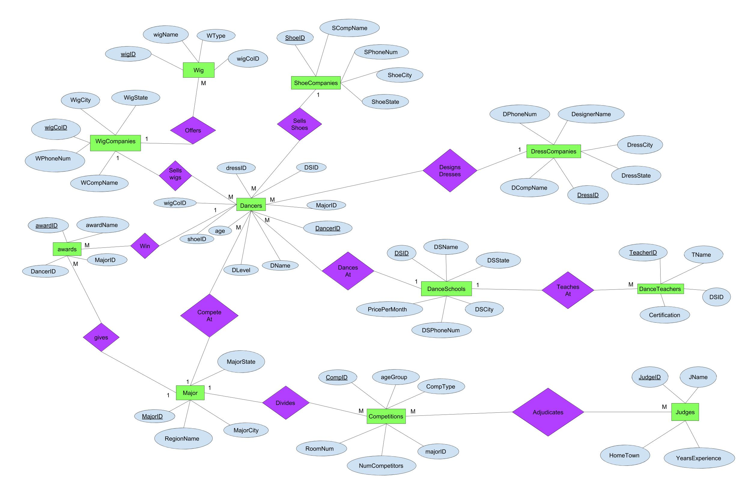ER Diagram

ShoeCompanies Table

CREATE TABLE Shoe Companies(

ShoeID INT NOT NULL,

SCompName NVARCHAR2(20) NOT NULL,

SPhoneNum NVARCHAR(12) NOT NULL,

ShoeCity NVARCHAR2(15) NOT NULL,

ShoeState NVARCHAR2(2) NOT NULL,

PRIMARY KEY (ShoeID));

This table lists all information regarding the different kinds of shoe companies that are available to a dancer. It gives a Unique ShoeID to every company. This unique ID determines the SCompName, the SPhoneNum, ShoeCity, and ShoeState. This table is left in second normal form because although ShoeCity does determine ShoeState (transitive dependency), making a separate table for this would slow down the efficiency of the database considering each city and state is unique to each company. 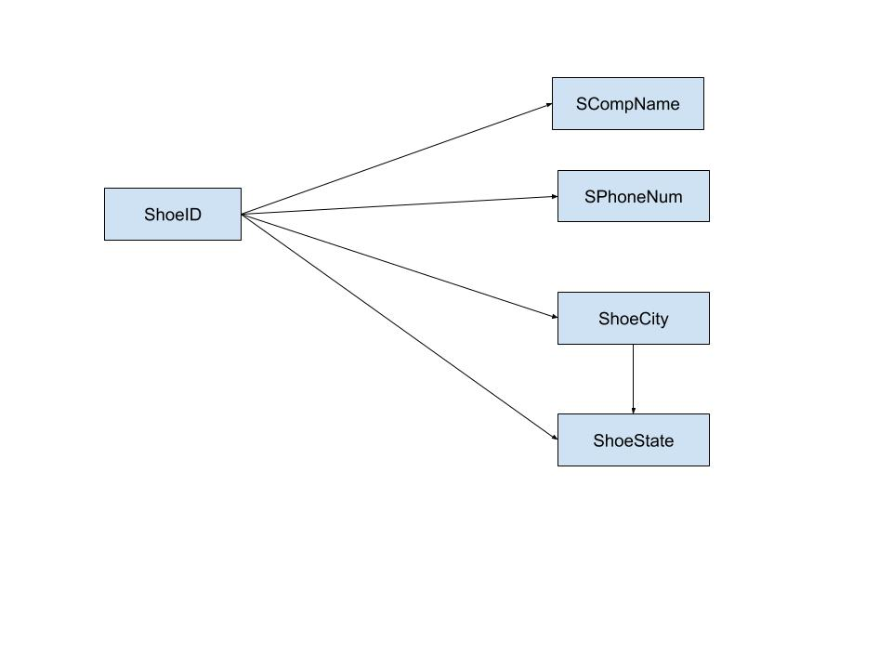

DressCompanies Table

CREATE TABLE DressCompanies(

DressID INT NOT NULL,

DCompName NVARCHAR2(20) NOT NULL,

DesignerName NVARCHAR2(20) NOT NULL,

DPhoneNum NVARCHAR(12) NOT NULL,

DressCity NVARCHAR2(15) NOT NULL,

DressState NVARCHAR2(2) NOT NULL,

PRIMARY KEY (DressID));

This table lists all information regarding the different kinds of Dress companies that are available to a dancer. It gives a Unique Dress to every company. This unique ID determines the DCompName, the DesigerName the DPhoneNum, DressCity, and Dress State. This table is left in second normal form because although DressCity does determine DressState (transitive dependency), making a separate table for this would slow down the efficiency of the database considering each city and state is unique to each company.

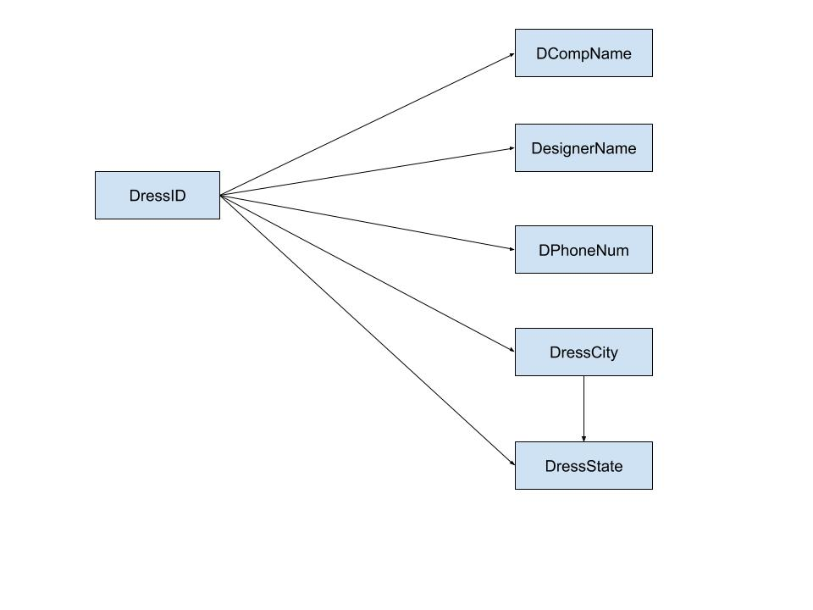

WigCompanies Table

CREATE TABLE WigCompanies(

WigCoID INT NOT NULL,

WCompName NVARCHAR2(20) NOT NULL,

WPhoneNum NVARCHAR(12) NOT NULL,

WigCity NVARCHAR2(15) NOT NULL,

WigState NVARCHAR2(2) NOT NULL,

PRIMARY KEY (WigCoID));

This table lists all information regarding the different kinds of Wig companies that are available to a dancer. It gives a Unique WigCoID to every company. This unique ID determines the WCompName, the WPhoneNum, WigCity, and WigState. This table is left in second normal form because although WigCity does determine WigState (transitive dependency), making a separate table for this would slow down the efficiency of the database considering each city and state is unique to each company.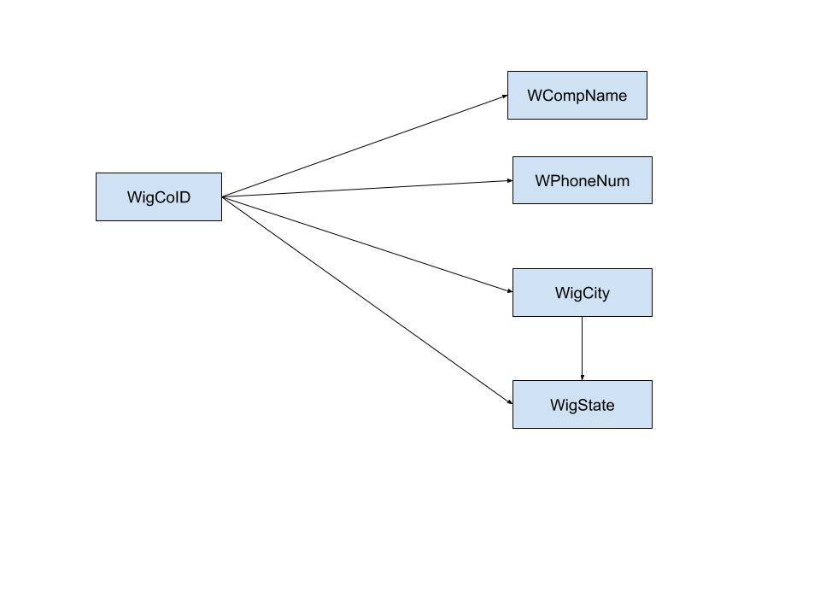

Wig Table

CREATE TABLE Wig(

WigID INT NOT NULL,

WigName NVARCHAR2(20) NOT NULL,

WType NVARCHAR2(10) NOT NULL,

WigCoID INT,

PRIMARY KEY (WigID),

FOREIGN KEY (WigCoID) REFERENCES WigCompanies(WigCoID));

This table gives all details about the different kinds of wigs that a different dance company offers. There is a wigID which determines the WigName, WType, and the WigCoID. WigCoID is a foreign key that references wigCompanies. This table is in third normal form. 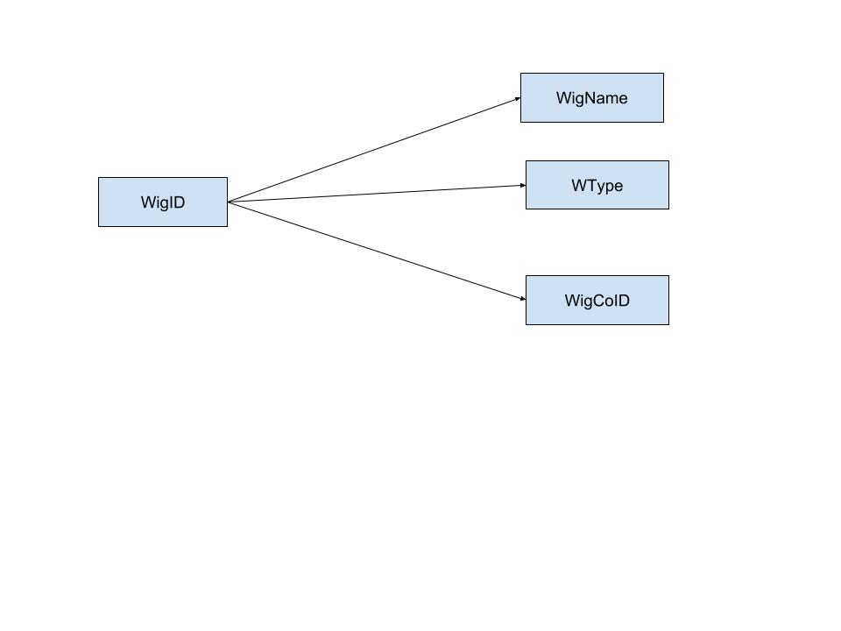

Awards Table

CREATE TABLE Awards(

AwardID INT NOT NULL,

AwardName NVARCHAR2(20) NOT NULL,

DancerID INT,

MajorID INT,

PRIMARY KEY (AwardID),

FOREIGN KEY (DancerID) REFERENCES Dancers(DancerID),

FOREIGN KEY (MajorID) REFERENCES Major(MajorID));

The content of this table describes the different kinds of awards that dancers can win. The AwardID determines the AwardName, the DancerID, and the MajorID. DancerID and MajorID are foreign keys that have been left in this table. DancerID references the Dancers table and MajorID references the Major table. Hence, this table is in third normal form.

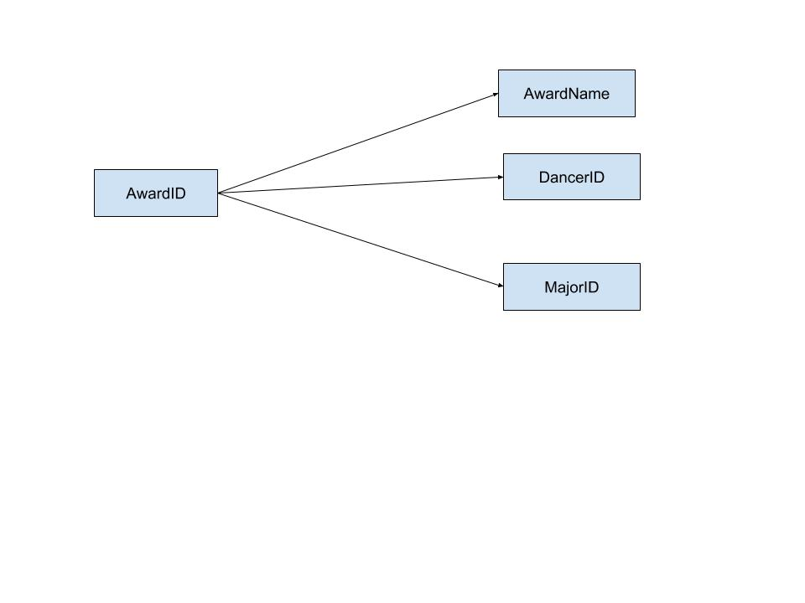

Major Table

CREATE TABLE Major(

MajorID INT NOT NULL,

RegionName NVARCHAR2(20) NOT NULL,

MajorCity NVARCHAR2(15) NOT NULL,

MajorState NVARCHAR2(2) NOT NULL,

PRIMARY KEY (MajorID));

This table gives the different regional competitions that a dancer can dance at. The majorID determines the RegionName, the MajorCity, and the MajorState. This table is left in second normal form because although MajorCity does determine MajorState (transitive dependency), making a separate table for this would slow down the efficiency of the database considering each MajorCity and MajorState is unique to each Major.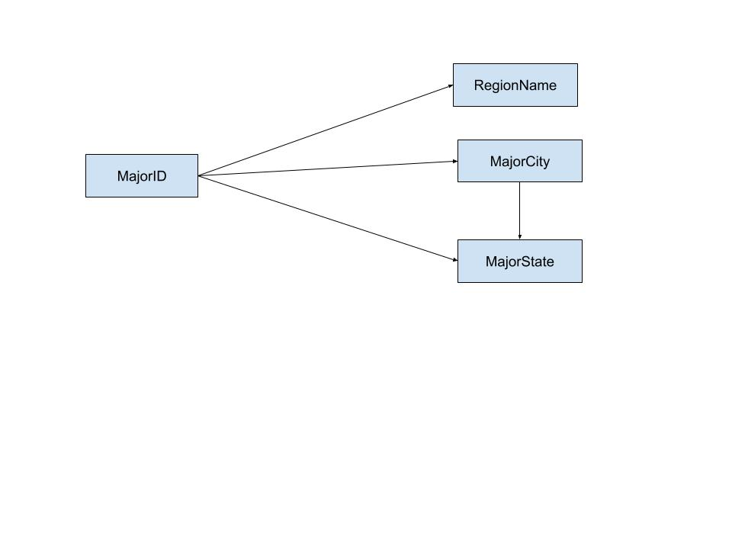

Competitions Table

CREATE TABLE Competitions(

CompID INT NOT NULL,

ageGroup NVARCHAR2(3) NOT NULL,

CompType NVARCHAR2(15) NOT NULL,

RoomNum INT NOT NULL,

NumCompetitors INT NOT NULL,

MajorID INT,

PRIMARY KEY (CompID),

FOREIGN KEY (MajorID) REFERENCES Major(MajorID));

The Competitions table explains the different categories of competitions that are at each major. The CompID determines the ageGroup, CompType, RoomNum, NumCompetitors, and MajorID. This table is in third normal form. It has one foreign key MajorID which references the Major table.

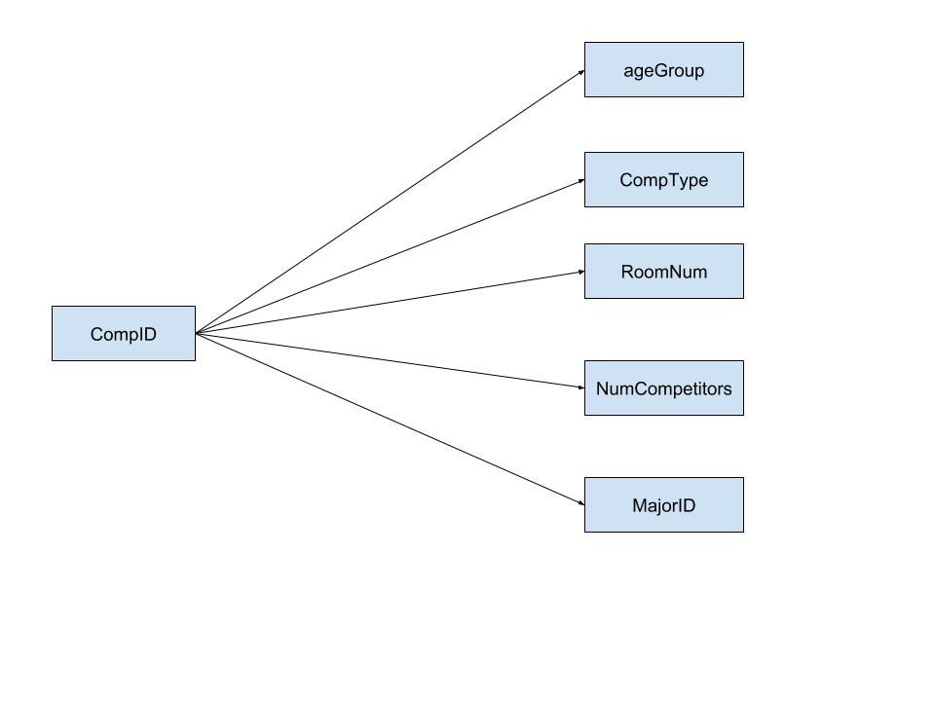

Adjudicated Table

CREATE TABLE Adjudicated(

JudgeID INT NOT NULL,

CompID INT NOT NULL,

PRIMARY KEY (JudgeID, CompID),

FOREIGN KEY (JudgeID) REFERENCES Judges (JudgeID),

FOREIGN KEY (CompID) REFERENCES Competitions (CompID));

This table represents the relationship between a competition and a judge. A competition can be adjudicated by many different judges and a judge can adjudicate multiple competitions. This table is automatically in third normal form because it does not have any determinants. Together the JudgeID and the CompID make up the primary key. Each ID separately is a foreign key that references its corresponding table.

Judges Table

CREATE TABLE Judges(

JudgeID INT NOT NULL,

JName NVARCHAR2(20) NOT NULL,

Hometown NVARCHAR2(15) NOT NULL,

YearsExperience INT NOT NULL,

PRIMARY KEY (JudgeID));

This table describes information about the judges who adjudicate the competitions. The unique JudgeID determines the JName, their Hometown, and their yearsExperience. Therefore this table is in third normal form.

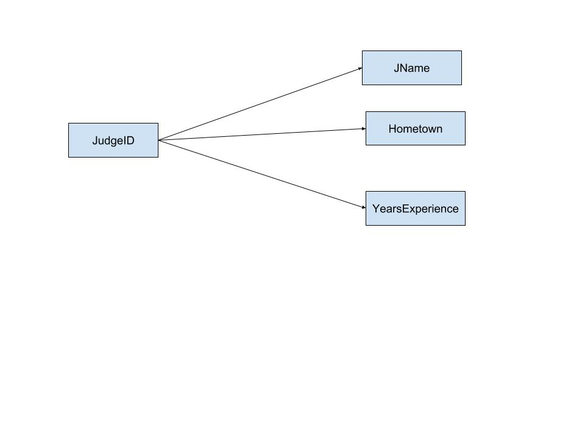

DanceTeachers Table

CREATE TABLE DanceTeachers(

TeacherID INT NOT NULL,

TName NVARCHAR2(30) NOT NULL,

Certification NVARCHAR2(6) NOT NULL,

DSID INT,

PRIMARY KEY (TeacherID),

FOREIGN KEY (DSID) REFERENCES DanceSchools(DSID));

This table gives information about dance teachers. The TeacherID determines the TName, certification, and DSID. DSID is a foreign key that references the DanceSchools table. Hence, this table is in third normal form.

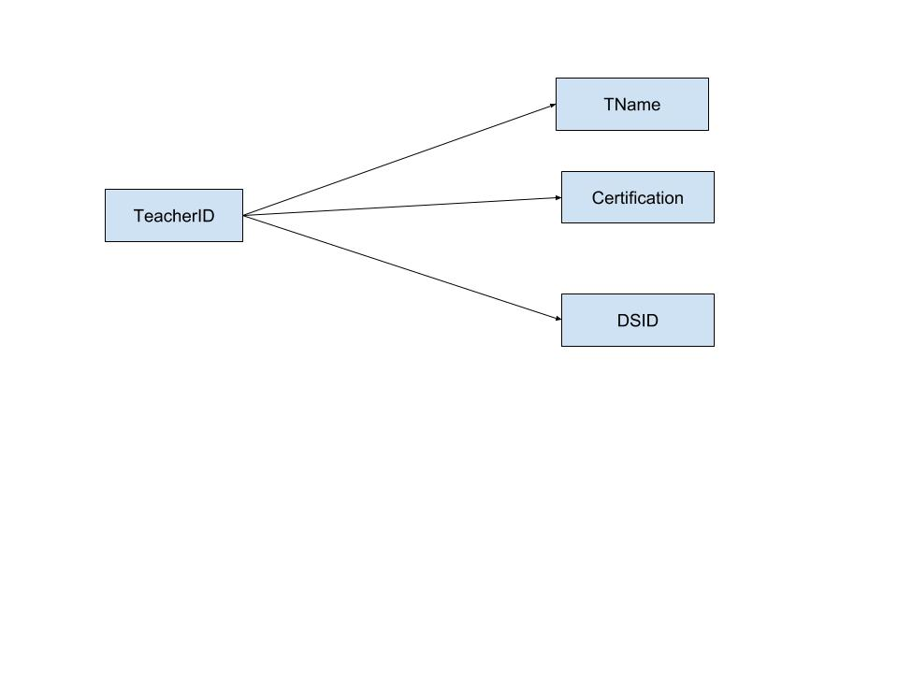

DanceSchools Table

CREATE TABLE DanceSchools(

DSID INT NOT NULL,

DSName NVARCHAR2(20) NOT NULL,

PricePerMonth INT NOT NULL,

DSCity NVARCHAR2(15) NOT NULL,

DSState NVARCHAR2(2) NOT NULL,

DSPhoneNum NVARCHAR2(12) NOT NULL,

PRIMARY KEY (DSID)); This table lists dance schools around the country and all of the information associated with it. The DSID determines the DSName, PricePerMonth, DSCity, DSState, and DSPhoneNum. This table is left in second normal form because although DSCity does determine DSState (transitive dependency), making a separate table for this would slow down the efficiency of the database considering each DSCity and DSState is unique to each Dance School.

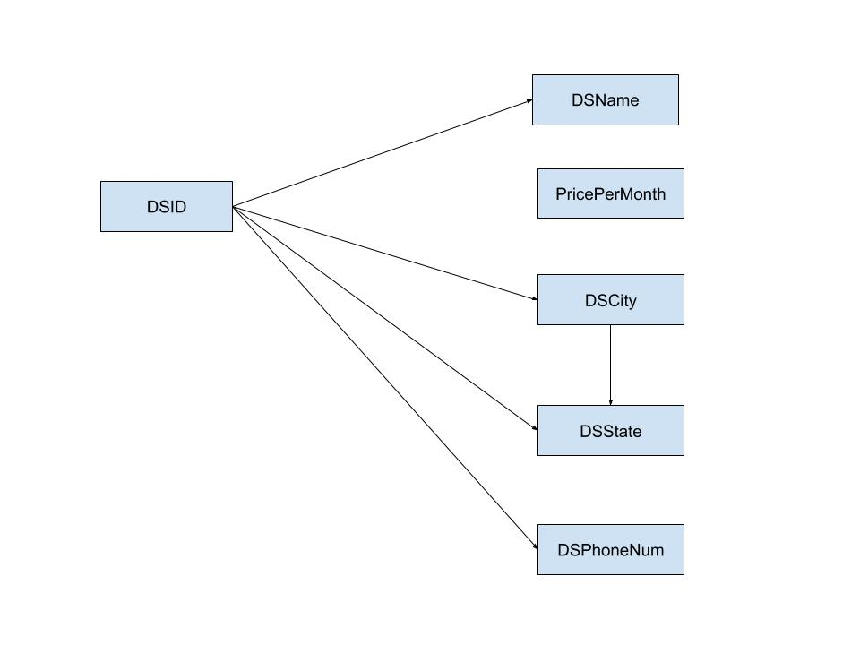

Dancers Table

CREATE TABLE Dancers(

DancerID INT NOT NULL,

DName NVARCHAR2(30) NOT NULL,

Age INT NOT NULL,

DLevel NVARCHAR2(20) NOT NULL,

ShoeID INT,

WigCoID INT,

DressID INT,

DSID INT,

MajorID INT,

PRIMARY KEY (DancerID),

FOREIGN KEY (ShoeID) REFERENCES ShoeCompanies(ShoeID),

FOREIGN KEY (WigCoID) REFERENCES WigCompanies(WigCoID),

FOREIGN KEY (DressID) REFERENCES DressCompanies(DressID),

FOREIGN KEY (DSID) REFERENCES DanceSchools(DSID),

FOREIGN KEY (MajorID) REFERENCES Major(MajorID));

This table gives all information about a dancer. The dancerID determines the DName, Age, Level, ShoeID, wigCoID, DressID, DSID, and MajorID. This table has five foreign keys: ShoeID, wigCoID, DressID, DSID, and MajorID. ShoeID references the ShoeCompanies table, wigCoID references the wigCompanies table, DressID references the DressCompanies table, DSID references the DanceSchools table, and MajorID references the MajorID table. These foreign keys have been left in this table and the transitive and partial dependencies have been removed. Hence, this table is in third normal form.

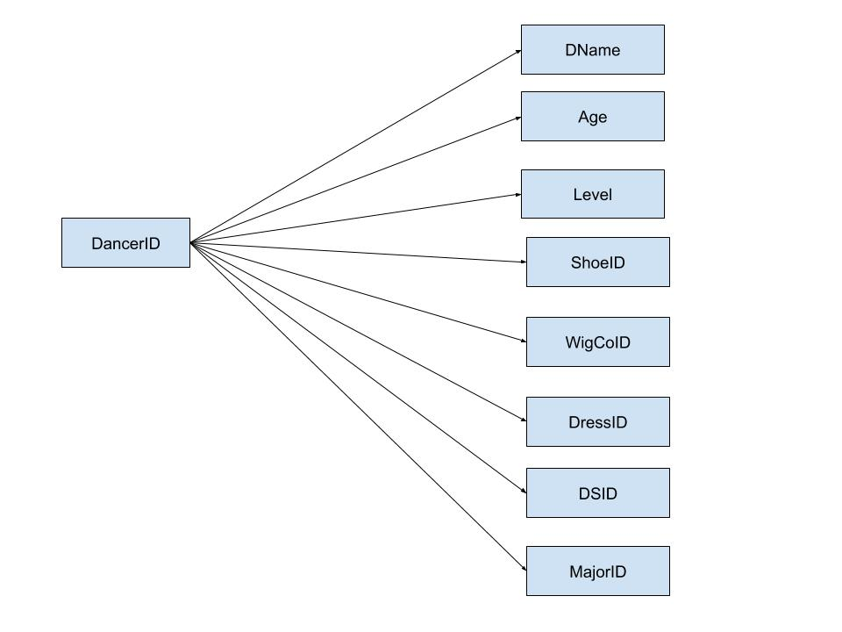

Universal Quantifier

Name the judges who judge all of the competitions

SELECT Judges.JName

FROM Judges

WHERE NOT EXISTS

(SELECT *

FROM Competitions

WHERE NOT EXISTS

(SELECT *

FROM Adjudicated

WHERE Judges.JudgeID = Adjudicated.JudgeID

AND Competitions.CompID = Adjudicated.CompID));

|  |
| --- |
| JNAME |
| John O'Keefe |

Cardinality: 1

Only

Name dancers, their age and their level who are only taught by Michael Farrell.

SELECT Dancers.DName, Dancers.Age, Dancers.DLevel

FROM Dancers

WHERE Dancers.DSID NOT IN

(SELECT DanceSchools.DSID

FROM DanceSchools

WHERE DanceSchools.DSID NOT IN

(SELECT DanceTeachers.DSID

FROM DanceTeachers

WHERE DanceTeachers.TName = 'Michael Farrell'));

|  |  |  |
| --- | --- | --- |
| DNAME | AGE | DLEVEL |
| Dale Kane | 18 | Prelim Champion |
| Maura Sabini | 12 | Prizewinner |
| Jenna Murray | 15 | Prizewinner |

Cardinality: 3

None

Name the dress companies that designed a dress for a dancer who has won no awards.

SELECT DressCompanies.DCompName

FROM DressCompanies

WHERE DressCompanies.DressID NOT IN

(SELECT Dancers.DressID

FROM Dancers

WHERE Dancers.DancerID NOT IN

(SELECT awards.DancerID

FROM awards));

|  |
| --- |
| DCOMPNAME |
| Eire Designs |

Cardinality: 1

Right Join:

Name all dancers and their awards if they won any

SELECT Dancers.DName, awards.awardName

FROM awards RIGHT JOIN Dancers ON Dancers.DancerID = awards.DancerID;

|  |  |
| --- | --- |
| DNAME | AWARDNAME |
| Julia O'Rourke | 1st |
| Owen Lubers | 1st |
| Owen Lubers | 3rd |
| Simone Adele | 2nd |
| Jenna Murray |  |
| Grace Duncan |  |
| Melanie Valdez | 2nd |
| Meaghan Houlihan | 1st |
| Ashley Harten |  |
| Samantha Brewster |  |
| Curtis Long | 2nd |
| Olivia Murray | 2nd |
| Gianna Cheeseman |  |
| Maura Sabini |  |
| Dale Kane | 3rd |
| Fiona Dargan | 1st |
| Fiona Dargan | 3rd |
| Mitchell Hodges | 1st |
| Mitchell Hodges | 2nd |
| Mitchell Hodges | 3rd |
| Julia Marino |  |
| Brogan McCay | 3rd |
| Cyra Taylor |  |
| Jess Hindley |  |

Cardinality: 24

Left Join

Name all dance teachers, the school they teach at and their certification if they have one

SELECT DanceTeachers.Certification, DanceTeachers.TName, DanceSchools.DSName

FROM DanceTeachers LEFT JOIN DanceSchools ON DanceSchools.DSID = DanceTeachers.DSID;

|  |  |  |
| --- | --- | --- |
| CERTIFICATION | TNAME | DSNAME |
|  | Ashley Gilnack | Farrell School |
| TCRG | Michael Farrell | Farrell School |
| TCRG | Karen Petri | Doherty-Petri |
| TCRG | Lisa Petri | Doherty-Petri |
|  | Caitrin O'Meara | Broesler |
|  | Eileen Paulson | Broesler |
| TCRG | Kevin Broesler | Broesler |
|  | Erin Collins | Lenihan |
| TCRG | Meghan Lenihan | Lenihan |
| TCRG | Patty Lenihan | Lenihan |
| TCRG | Geraldine Murray | Murray Academy |
| TCRG | Patrick Campbell | Brady Campbell |
| TCRG | Rebecca Brady-Campbell | Brady Campbell |
|  | Natalie Findling | Burke Connolly |
|  | Molly Gareau | Burke Connolly |
| TCRG | Emma Burke | Burke Connolly |
| TCRG | Erin Connelly | Burke Connolly |
|  | Briley Mastis | Clark Academy |
|  | Olivia Smugala | Clark Academy |
| ADCRG | Mar Jo Clark Cange | Clark Academy |
| ADCRG | Alisa Dosch | Clan Rince |
| ADCRG | Jeannie Thornton | Clan Rince |
| ADCRG | Deirdre O'Sullivan-Toolan | O'sullivan Academy |
| TCRG | Karen Petri | O'sullivan Academy |
| TCRG | Theresa O'Sullivan-Randall | O'sullivan Academy |

Cardinality: 25

Full Join

Name all dancers, the major they competed at if they did and the award they won if they won an award.

SELECT Dancers.DName, Major.RegionName, awards.awardName

FROM Dancers FULL JOIN awards ON Dancers.DancerID = awards.DancerID

FULL JOIN Major ON Major.MajorID = Dancers.MajorID;

|  |  |  |
| --- | --- | --- |
| DNAME | REGIONNAME | AWARDNAME |
| Julia O'Rourke | Mid-Atlantic | 1st |
| Owen Lubers | New England | 3rd |
| Owen Lubers | New England | 1st |
| Simone Adele | New England | 2nd |
| Jenna Murray | Mid-Atlantic |  |
| Grace Duncan |  |  |
| Melanie Valdez | Mid-Atlantic | 2nd |
| Meaghan Houlihan | Western | 1st |
| Ashley Harten |  |  |
| Samantha Brewster |  |  |
| Curtis Long | Southern | 2nd |
| Olivia Murray | Western | 2nd |
| Gianna Cheeseman | Mid-Atlantic |  |
| Maura Sabini | Mid-Atlantic |  |
| Dale Kane | Mid-Atlantic | 3rd |
| Fiona Dargan | Southern | 3rd |
| Fiona Dargan | Southern | 1st |
| Mitchell Hodges | Mid-America | 3rd |
| Mitchell Hodges | Mid-America | 2nd |
| Mitchell Hodges | Mid-America | 1st |
| Julia Marino | Western |  |
| Brogan McCay | Western | 3rd |
| Cyra Taylor |  |  |
| Jess Hindley |  |  |

Cardinality: 24

6 Tables

Name dancers if they have the following: the name of their shoe Company, dress company, wig company, dance school, the awards they have won, and the region they dance at for majors.

SELECT Dancers.DName, SC.SCompName, DC.DCompName, WC.WCompName, DS.DSName, awards.awardName, Major.RegionName

FROM Dancers, ShoeCompanies SC, DressCompanies DC, WigCompanies WC, DanceSchools DS, awards, Major

WHERE Dancers.ShoeID = SC.ShoeID

AND Dancers.DressID = DC.DressID

AND Dancers.WigCoID = WC.WigCoID

AND Dancers.DSID = DS.DSID

AND Dancers.DancerID = awards.DancerID

AND Dancers.MajorID = Major.MajorID;

|  |  |  |  |  |  |  |
| --- | --- | --- | --- | --- | --- | --- |
| DNAME | SCOMPNAME | DCOMPNAME | WCOMPNAME | DSNAME | AWARDNAME | REGIONNAME |
| Julia O'Rourke | Fays | PrimeDress Designs | Celtic Curls | Doherty-Petri | 1st | Mid-Atlantic |
| Melanie Valdez | Feis Fayre | Elevation | Camelia Rose | Doherty-Petri | 2nd | Mid-Atlantic |
| Dale Kane | Fays | Eire Designs | Celtic Curls | Farrell School | 3rd | Mid-Atlantic |
| Simone Adele | Ryan & O'Donnell | Lewis | Camelia Rose | Broesler | 2nd | New England |
| Meaghan Houlihan | Fays | Eire Designs | Emerald Key | Murray Academy | 1st | Western |
| Olivia Murray | Fays | Rising Star | Celtic Curls | Clan Rince | 2nd | Western |
| Brogan McCay | Fays | Rising Star | Celtic Curls | Clan Rince | 3rd | Western |
| Fiona Dargan | Feis Fayre | PrimeDress Designs | Camelia Rose | Burke Connolly | 1st | Southern |
| Fiona Dargan | Feis Fayre | PrimeDress Designs | Camelia Rose | Burke Connolly | 3rd | Southern |

Cardinality: 9

Query1

Get the judge ID numbers of judges who have a lower number years of experience than Ryan Carroll

SELECT Judges2.JudgeID

FROM Judges Judges1, Judges Judges2

WHERE Judges1.JName = 'Ryan Carroll'

AND Judges1.YearsExperience > Judges2.YearsExperience;

|  |
| --- |
| JUDGEID |
| 901 |
| 902 |
| 904 |
| 906 |
| 907 |
| 908 |

Cardinality: 6

Query2

Select the dancer ID number for dancers who danced at a major that had a competition judged by a judge from Dublin

SELECT DISTINCT Dancers.DancerID

FROM Dancers, Major, Competitions, Judges, Adjudicated

WHERE Dancers.MajorID = Major.MajorID

AND Competitions.MajorID = Major.MajorID

AND Competitions.CompID = Adjudicated.CompID

AND Adjudicated.JudgeID = Judges.JudgeID

AND Judges.Hometown = 'Dublin';

|  |
| --- |
| DANCERID |
| 110 |
| 114 |
| 115 |
| 113 |
| 104 |
| 117 |
| 118 |
| 112 |
| 101 |
| 106 |
| 107 |
| 111 |

Cardinality: 1

Query3

Get the Dancers Name, the Wig Name about a wig that belongs to Camelia Rose company that offers a bun wig to dancers who are the level Open Champion

SELECT Dancers.DName, Wig.WigName, Wig.Wtype, WigCompanies.WCompName

FROM Wig, WigCompanies, Dancers

WHERE WigCompanies.WigCoID = Wig.WigCoID

AND WigCompanies.WigCoID = Dancers.WigCoID

AND Dancers.DLevel = 'Open Champion'

AND Wig.WType = 'Bun'

AND WigCompanies.WCompName = 'Camelia Rose'

ORDER BY(Dancers.DName);

|  |  |  |  |
| --- | --- | --- | --- |
| DNAME | WIGNAME | WTYPE | WCOMPNAME |
| Fiona Dargan | Double Lucy | Bun | Camelia Rose |
| Fiona Dargan | Alliyah | Bun | Camelia Rose |
| Gianna Cheeseman | Double Lucy | Bun | Camelia Rose |
| Gianna Cheeseman | Alliyah | Bun | Camelia Rose |
| Melanie Valdez | Alliyah | Bun | Camelia Rose |
| Melanie Valdez | Double Lucy | Bun | Camelia Rose |

Cardinality: 6