GITHUB REPOSITORY LINK:
https://github.com/JordanNaidoo870/SEN381-CivicConnect.git
EXACT FINAL PROJECT COMMIT/TAG:
Commit: [FINAL M4 SHA PENDING]
Tag/Release Candidate: [FINAL M4 TAG PENDING]
Final RTM Location:
Date Submitted: 2026/10/16
SOFTWARE ENGINEERING 381 — SEN381
CIVICCONNECT
Project Engineering Document (PED)
Version 4.0 — Finalize, Consolidate and Conclude; Closing PED (v4.0)

Jordan Naidoo (602463), Darrin Everette Mokuena (601172), Tshepo Koithen (603233)
CivicConnect Project Engineering Document (PED) v4.0 Final - Engineering Closure
2026
Contents
Document Control and Version History 4
Problem and Business Need 5
Stakeholder Analysis 6
Scope Baseline 9
Project Constraints 12
Initial Risk Register 13
Functional Requirements 18
Non-Functional Requirements 18
Acceptance Criteria 19
Initial RTM 19
Engineering Decision Log 20
Forward Engineering Considerations 21
PED v1.0 Baseline Review and Sign-Off 22
Milestone 2 — Architecture, Technology & Initial Design Baseline 23
M1 Baseline Review and Controlled Evolution 23
Updated Assumptions and Dependencies 24
Architecturally Significant Requirements and Quality Drivers 25
Architecture Decision and Baseline 26
Data and Persistence Baseline 28
Technology Stack Selection 30
Information Architecture and User-Interface / Interaction Design 33
Initial Design Decisions Informed by Assignment 2 35
Initial Interface and Integration Decisions 37
Deployment Compatibility and Environment Direction 38
M2 Risk Register Review and New Risks 39
Forward Engineering Considerations — M2 Update 41
Evolved Requirements Traceability Matrix (M2) 42
Engineering Decision Log — M2 Evolution and ADR Index 44
GitHub, Collaborative Engineering and Initial CI Controls 45
Application / Technical Documentation Baseline 46
Architecture, Technology & Initial Design Baseline — M2 Scope 47
PED v2.0 Baseline Review and Sign-Off 47
Milestone 3 — Controlled Construction, Integration, Quality & Release Readiness 49
M3 Submission Baseline and Evidence Locator 49
M2 Baseline Conformance and Significant Deviations 50
Collaborative Engineering, GitHub Control and CI Quality Gate 52
Applied Unit / Black-Box / Integration / System Verification 53
Performance, Reliability and Evidence of Correction 55
Evolved Requirements Traceability Matrix — M3 Extension 57
Release Evidence Summary and Final Readiness Judgment 59
M3 Evidence Annex — Screenshots Supplied by the Team 61
Milestone 4 - Final Project Engineering Closure (PED v4.0) 69
M3 Reference Additions 84
References 84

Document Control and Version History
Item | Current Control
Project | CivicConnect
Document | Project Engineering Document (PED)
Current version | PED v4.0 Final (closure baseline; release identifiers pending publication)
Current baseline | Milestone 4 - Finalise, Consolidate & Conclude
Governing document | SEN381 CivicConnect Master Project Brief
Current team | Jordan Naidoo (602463); Darrin Everette Mokuena (601172); Tshepo Koithen (603233)
Document status | Final engineering closure prepared 16 October 2026; pending final GitHub release, acceptance-baseline reconciliation and three-member sign-off.

Version History
Version | Date | Baseline / Change | Contributors | Status
v1.0 | 2026/09/09 | Engineering Foundation & Requirements Baseline | Jordan Naidoo; Darrin Everette Mokuena | Accepted
v2.0 | 2026/09/30 | Architecture, Technology & Initial Design Baseline; resolves major M1 deferred design decisions and adds M2 architecture/data/technology/design evidence | Jordan Naidoo; Darrin Everette Mokuena; Tshepo Koithen | Accepted
v3.0 | 2026/10/14 | Controlled Construction, Integration, Quality & Release Readiness; extends v2.0 with observed construction, tests, CI, risks, defects, debt, RTM, evidence and release assessment | Jordan Naidoo; Darrin Everette Mokuena; Tshepo Koithen | Accepted
v4.0 | 2026/10/16 | Final integrated product, M1 scope-to-delivery evaluation, acceptance/evidence closure, M3 issue final status, deployment/no-go and engineering conclusion. | Jordan Naidoo; Darrin Everette Mokuena; Tshepo Koithen | Prepared - final release and sign-off pending

Problem and Business Need

Problem Statement
The organization currently manages community service requests through disparate communication channels, including email, telephone, WhatsApp messages, spreadsheets and paper-based records. This approach makes it difficult to keep a consistent record of each request during its lifecycle. As a result, requests may be duplicated, missed, misplaced or wrongly handled, and requesters have limited insight into whether their requests have been received, assigned, delayed, resolved or closed.
The central problem is therefore not the lack of software, but the lack of a controlled, traceable and consistent process for managing service requests. Staff need clearer ownership and prioritization of their work, requesters need greater visibility and feedback, and management needs reliable information about outstanding, overdue and completed requests. The current fragmented process also creates accountability challenges because status changes and actions are not consistently captured in a controlled environment.
CivicConnect will solve this problem by providing a controlled digital platform through which service requests can be submitted, managed, monitored and reported. The goal is to improve visibility and accountability without imposing an excessive technical, operational or financial burden on the organization.

Business Need
The organization needs a single system that will embrace the entire service request lifecycle and replace the reliance on disparate manual methods of communication and record keeping. The system to be selected must enable requesters to track their requests, allow authorized staff to manage and update requests in a controlled way and provide management with the information they need to monitor service activity and accountability.
The intended business value of CivicConnect is:
Business need | Intended value
Centralized request management | Creates one controlled source of service-request information.
Improved requester visibility | Allows requesters to see the current status and history of their requests.
Clear staff responsibility | Makes it easier to identify who is responsible for a request.
Controlled status management | Reduces inconsistent or untraceable status changes.
Improved accountability | Maintains information about actions, comments and resolution activity.
Better management oversight | Provides information on open, overdue, resolved and closed requests.
More reliable reporting | Reduces dependence on manually assembled and inconsistent reports.

These value areas are directly related to the weaknesses identified in the existing process and to the minimum requester, staff and management capabilities required for CivicConnect.

Project Business Objective
The business goal of CivicConnect is to design a controlled and traceable service request management platform through which requests are made, assigned, monitored, updated and closed whilst providing appropriate visibility to requesters, staff and management.
The project can only be considered as valuable, if it meets the needs of the stakeholders within the agreed confines of scope, schedule, cost/resource, quality, security and operational constraints. The Master Project Brief explicitly refers to the fact that project success is not merely defined as whether the final application runs or appears visually complete.

Stakeholder Analysis
Stakeholder analysis is required in M1 because the requirements baseline must derive from the actual needs of the stakeholders instead of basing it simply on assumptions made by the development team. The Milestone 1 brief specifically requires stakeholders, their needs, influence/interest and meaningful conflicting expectations to be identified.
The Systems Engineering Body of Knowledge explains that stakeholder needs include: stakeholder expectations, wants, perceived constraints and desired system behavior. These needs should subsequently be transformed into more structured and formal requirements (SEBoK, 2025; ISO/IEC/IEEE, 2018).

Stakeholder Register
ID | Stakeholder | Interest | Influence | Key Needs / Expectations
STK-01 | Requester | High | Medium | Simple request submission, appropriate categorization, request status visibility, history and meaningful feedback.
STK-02 | Service Staff | High | High | Access relevant requests, locate requests efficiently, view details, accept/assign responsibility, update statuses and record work performed.
STK-03 | Management / Oversight | High | High | Reliable information about service activity, outstanding and overdue work, completed requests and organizational accountability.
STK-04 | System / Operational Administrator | Medium | High | Controlled access, maintainability, configuration control, reliable operation, logging and eventual recovery capability.

STK-01 — Requesters
Requesters are the people who report matters concerning the provision of services to the organisation. The primary interest of requesters is having a reliable and understandable method of submitting a request and understanding what happens after the request is submitted.
The requester should be able to:
- submit an appropriate service request;
- categorise the request;
- view its current status;
- view previously submitted requests; and
- receive meaningful feedback when a request is accepted, rejected, updated or completed.
These expectations are directly established by the Master Project Brief
Main need:
Visibility and confidence that the request has entered a controlled process.
Requirement implications:
The requirements should therefore include functions for request submission, categorisation, status viewing, request history and appropriate feedback.

STK-02 — Service Staff
Service staff require access to requests relevant to their areas of responsibility and sufficient information to understand and perform on each request.
The Master Project Brief requires staff to be able to search, filter or sort requests, view full details of requests, take ownership, update requests by making controlled status changes, log actions or comments and resolve or close requests if authorized
Main need:
An efficient but controlled way of managing assigned service work.
Requirement implications
Requirements should cover:
- authorised request access;
- request searching/filtering/sorting;
- responsibility or assignment;
- controlled status transitions;
- comments/actions;
- resolution information; and
- authorised closure.

STK-03 — Management / Oversight
Management needs reliable information on service activity, rather than having to create reports manually from a number of different sources.
The required management capabilities are identifying open, overdue, resolved and closed requests, viewing service activity by useful dimensions such as category and status, and getting sufficient information to enable accountability and service-performance analysis
Main need:
Reliable oversight and accountability information.
Requirement implications:
Later requirements should provide management with appropriate summary and reporting capabilities without automatically granting unrestricted access to every piece of service-request information.

STK-04 — System / Operational Administrator
The system will eventually require operations such as maintaining configuration, controlling access and supporting deployment and operation.
Security practice also requires that the access privileges of a user or process are restricted to what they need to perform their task. The OWASP principle of least privilege recommends that permissions are restricted to those necessary to perform the required task, rather than providing excessive access (OWASP Foundation, n.d.).
Main need:
Maintainability and controlled operation of CivicConnect.
Requirement implications:
The M1 requirements should recognise the need for controlled authentication/authorisation and secure information handling. However, the exact authentication mechanism, access control implementation and technology should be decided in a later milestone.

Stakeholder Conflicts and Competing Expectations
Stakeholders do not necessarily want exactly the same things. Requirements engineering must therefore identify areas where satisfying one expectation could negatively affect another.
Conflict | Competing Expectations | Engineering Effect
Visibility vs confidentiality | Requesters and management want useful information, while some request information may be sensitive. | Later access rules must balance useful visibility with restricted access.
Ease of use vs accountability | Staff need fast status updates, but management needs traceable changes. | Updating requests should remain convenient while retaining meaningful history.
More functionality vs project capacity | Stakeholders may benefit from extra features, while the project has limited time and resources. | Minimum business capabilities should be prioritized and non-essential features controlled or deferred.
Fast resolution vs realistic workload | Requesters may want immediate outcomes, while staff may need to priorities multiple requests. | CivicConnect should provide meaningful status visibility without making unrealistic service promises.
Detailed oversight vs information exposure | Management requires oversight, but access to sensitive details should be appropriately limited. | Reporting and access requirements should distinguish necessary management information from unnecessary sensitive detail.

Identifying these conflicts now is important because stakeholder needs become inputs to later requirements and design decisions rather than being treated as independent wish lists (SEBoK, 2025).

Scope Baseline

Purpose of the Scope Baseline
The scope baseline defines what we are currently delivering and what is being specifically excluded or deferred. A clear scope statement is also important in professional practice for new requirements to provide the basis for assessment of whether they are within the scope of the project. Without clear project boundaries, teams may struggle to assess whether newly identified functionality within the project falls inside or outside the approved effort, increasing the possibility of uncontrolled scope expansion (Burek, 2008).

In-Scope Business Capabilities
The following functionality forms the proposed committed scope
Requester Scope
SC-IN-01 — Submit a service request with the required information.
SC-IN-02 — Categorise a service request using a controlled category mechanism.
SC-IN-03 — View the current status of submitted requests.
SC-IN-04 — View a history/list of previously submitted requests.
SC-IN-05 — Receive meaningful feedback when a request is accepted, rejected, updated or completed.
Staff Scope
SC-IN-06 — View service requests relevant to authorised staff.
SC-IN-07 — Search, filter and/or sort requests using useful criteria.
SC-IN-08 — View complete request details.
SC-IN-09 — Assign or accept responsibility for requests.
SC-IN-10 — Update requests through controlled status transitions.
SC-IN-11 — Record relevant actions, comments and resolution information.
SC-IN-12 — Resolve or close requests where authorised.
Management / Oversight Scope
SC-IN-13 — View useful service-activity information.
SC-IN-14 — Identify open, overdue, resolved and closed requests.
SC-IN-15 — View information according to useful dimensions such as request category and status.
SC-IN-16 — Access sufficient information to support accountability and service-performance analysis.
These sixteen capabilities reflect the minimum CivicConnect business capabilities established in the Master Project Brief.

Supporting Scope
Certain supporting capabilities will also be required to provide controlled and usable versions of the above functionality.
SC-IN-17 — Authorised users must be distinguishable according to their permitted responsibilities.
SC-IN-18 — Service-request information and relevant lifecycle history must persist reliably.
SC-IN-19 — Significant request status and responsibility changes must be traceable.
SC-IN-20 — Required request information must be appropriately validated.
SC-IN-21 — Sensitive information and credentials must be handled through appropriate security controls.
These supporting items are consistent with the Master Brief's requirements for traceability, security and lifecycle accountability.
They do not specify the final architecture, programming language, database, technology to authenticate or deploy. ISO/IEC/IEEE requirements-engineering guidance differentiates between defining and managing requirements and prematurely fixing a particular implementation solution (ISO/IEC/IEEE, 2018).

Out-of-Scope
The following items are proposed deliberate exclusions from the initial CivicConnect baseline:
SC-OUT-01 — Native Android application.
SC-OUT-02 — Native iOS application.
SC-OUT-03 — Automatic request creation directly from WhatsApp.
SC-OUT-04 — Automatic service-request creation from social-media platforms.
SC-OUT-05 — SMS-based request submission and management.
SC-OUT-06 — IoT/sensor-generated service requests.
SC-OUT-07 — Full procurement and financial-management functionality.
SC-OUT-08 — Full stock/inventory-management functionality.
SC-OUT-09 — Multi-organisation commercial SaaS functionality.
SC-OUT-10 — Replacement of unrelated organisational systems.
Every additional feature raises additional requirements, design, security, implementation, testing, documentation, deployment and maintenance obligations. The Master Brief specifically points out that a smaller controlled solution can have more Software Engineering than an unfinished solution that has too much functionality.

Deferred / Future Scope
The following capabilities have potential stakeholder value but are not part of the current committed baseline:
SC-FUT-01 — Native mobile applications.
SC-FUT-02 — WhatsApp or external communication-channel integration.
SC-FUT-03 — SMS notifications.
SC-FUT-04 — Geographic/map-based request visualisation.
SC-FUT-05 — Advanced analytical dashboards.
SC-FUT-06 — More advanced escalation and workflow automation.
SC-FUT-07 — Integration with external asset-management or maintenance systems.
SC-FUT-08 — Advanced media/attachment functionality.

Deliberate Scope Exclusion — Direct WhatsApp Integration
One deliberate proposed exclusion is direct integration between CivicConnect and WhatsApp.
Whilst it is one of the current contributing factors to the fragmented request-management environment, the business problem does not dictate that CivicConnect must integrate with every available communication channel. The priority task is instead to establish a controlled, traceable central request-management process.
Direct integration with an external platform would add interface dependencies, testing requirements, security considerations, operational dependencies and potential cost or vendor constraints. Adding functionality without control over its impact on project scope exposes schedule and other objectives to risk (Abramovici, 2000).
Direct WhatsApp integration is therefore proposed as future scope, making it possible to prioritise the establishment of a core service request lifecycle before introducing changes that impact it. The decision can be revisited through controlled change if sufficient stakeholder value justifies impact.

Project Constraints

Purpose of Constraint Analysis
Constraints define conditions within which the system must be engineered. This specifically requires scope, schedule, cost/resources, quality and security constraints to be recorded along with their implications for engineering. Constraints are significant because they affect future architecture, technology, implementation, testing and deployment decisions.

Constraint Register
ID | Constraint | CivicConnect Constraint | Engineering Implication
CON-01 | Scope | Approved functionality must remain within the baselined project boundaries. | New functionality must not be added informally after baseline.
CON-02 | Schedule | CivicConnect must progress through the four formal SEN381 milestones within the academic delivery period. | Work must be prioritized and uncontrolled expansion avoided.
CON-03 | Cost | Free or low-cost development/deployment options should be preferred where practical. | Later technology decisions must investigate limits and likely operational cost.
CON-04 | Quality | Quality attributes must eventually be demonstrated using measurable evidence. | NFRs and acceptance criteria must be measurable and later linked to tests.
CON-05 | Security | Security must be considered throughout the lifecycle rather than added immediately before deployment. | Access, sensitive information, secrets, dependencies and security verification need consideration from early requirements onward.
CON-06 | Technology | No final stack or architecture is prescribed. | Technology must be selected later using requirements, evidence and trade-off analysis.
CON-07 | Institutional Environment | The institution does not guarantee support or compatibility for every technology or external platform selected by a team. | Compatibility must be investigated before final technology commitment.
CON-08 | Configuration Management | Controlled project changes must be represented progressively through repository evidence. | Documentation and later implementation should use authentic issues, commits, branches and Pull Requests.

Constraint Interactions and Trade-Offs
Scope vs Schedule:
An increase in scope brings additional requirements, implementation, testing, security and documentation work. Therefore, because the academic delivery period is fixed, uncontrolled scope growth could reduce the time available for verification and refinement.
This is why a scope statement is established prior to lower-level requirements and implementation decisions. PMI guidance points out that the definition of scope boundaries helps the team assess what requirements belong to the project and avoid uncontrolled expansion (Burek, 2008).
Engineering response:
Optional functionality should be deferred where it would jeopardize delivery of the core CivicConnect capabilities.
Resources vs Scope:
The amount of functionality that can be delivered depends on the development time, software tools, computing resources and external services available to the project. Adding unnecessary functionality may increase development, testing, documentation and deployment effort while also creating additional resource requirements.
Engineering response:
CivicConnect will prioritise its required business capabilities and favour technologies and services that are accessible, maintainable and appropriate for the available project resources.
Cost vs Deployment:
A free or low-cost hosting platform may reduce operational cost but may also impose restrictions relating to storage, performance, runtime support, availability or service usage.
Engineering response:
No deployment platform should be selected solely because it has a free tier. Deployment options should be compared and then selected based what is most suitable.
Security vs Usability:
Users need convenient services, but convenience is insufficient grounds for providing access to unnecessary information or functions.
Engineering response:
Following the principle of least privilege is the solution that helps to minimize privileges and provide only those necessary for the current task (OWASP Foundation, n.d.).

Initial Risk Register

Risk Management Approach
The CivicConnect Risk Register will be kept up-to-date and reviewed as the project progresses in accordance with the Master Project Brief to ensure that the risks to the project are sufficiently detailed to manage, and will consider areas such as requirements, people/skills, technology, security, integration, deployment, cost, schedule, quality and dependencies.
This approach is consistent with ISO 31000, which treats risk management as a continuing process involving risk identification, analysis, evaluation, treatment, monitoring and communication rather than a once-off exercise (ISO, 2018).
A project risk register commonly records information such as the risk, owner, cause, status, probability, impact and mitigation actions so that risks can be actively managed rather than merely listed (Project Management Institute, n.d.).

Risk Rating Method
Each identified risk will be given:
- a Probability (P) score from 1 to 5; and
- an Impact (I) score from 1 to 5.
The initial project risk exposure will be calculated as:
Risk Exposure = Probability × Impact
We will then use that score to determine the priority based on this scale that the team decided:
Score | Priority
1–4 | Low
5–9 | Medium
10–15 | High
16–25 | Critical

Initial CivicConnect Risk Register

Risk ID | Risk Event and Cause | P | I | Score | Priority | Mitigation | Contingency | Owner | Status
RSK-001 | Uncontrolled additional features may enter the project after baseline because stakeholder requests are accepted without formal impact analysis. | 4 | 4 | 16 | Critical | Maintain clear in/out/future scope and use formal change control after baseline. | Defer non-essential functionality or formally revise approved scope after impact analysis. | Jordan | Open
RSK-002 | Sensitive service-request information may be disclosed to unauthorized users because access requirements are incomplete or implemented incorrectly. | 3 | 5 | 15 | High | Define access/security requirements early and apply least-privilege principles during later design. | Restrict affected functionality or information until the access weakness is corrected and verified. | Darrin | Open
RSK-003 | A later technology or deployment choice may be incompatible with the team's environment, capabilities or available services. | 3 | 4 | 12 | High | Defer final selection to M2 and evaluate alternatives using compatibility, team capability, cost, security and deployment evidence. | Replace the unsuitable option before major implementation dependency develops. | Darrin | Open
RSK-004 | Requirements may become inconsistent or lose traceability as the project evolves. | 3 | 4 | 12 | High | Use stable requirement IDs, clear acceptance criteria and an evolving RTM. | Conduct traceability review and correct all affected artefacts before approving the change. | Jordan | Open
RSK-005 | Quality evidence may be weak later because M1 requirements or NFRs are vague and cannot be objectively tested. | 3 | 4 | 12 | High | Define measurable NFRs and testable acceptance criteria during M1. | Revise inadequately testable requirements through controlled change before verification. | Darrin | Open
RSK-006 | Service-request data may be lost or corrupted if data integrity, backup and recovery are considered too late. | 2 | 5 | 10 | High | Record data integrity/recovery as a lifecycle concern before persistence decisions are made. | Use the approved recovery process and investigate the underlying cause if loss occurs. | Darrin | Open
RSK-007 | A free or low-cost platform may introduce unexpected operational limits or costs. | 3 | 3 | 9 | Medium | Investigate service limits and likely operational costs before committing to deployment technology. | Select an approved alternative or adjust deployment/resource usage if necessary. | Jordan | Open
RSK-008 | Incorrect, incomplete or duplicate service-request data may be recorded because input validation and duplicate-handling rules are insufficient. | 3 | 4 | 12 | High | Define clear validation requirements and acceptance criteria; identify mandatory fields and duplicate-handling rules during requirements/design. | Correct affected records, strengthen validation rules and add regression tests for the failure cases. | Jordan | Open
RSK-009 | Deployment may fail or behave differently from development because configuration, dependencies or environment settings are inconsistent between development, testing, staging and production. | 3 | 4 | 12 | High | Define environment requirements early, document configuration/dependencies and validate releases in a production-like staging environment. | Roll back to the last stable release, correct the configuration mismatch and redeploy after verification. | Darrin | Open
RSK-010 | System failures or degraded performance may not be detected quickly because logging, monitoring or health-check mechanisms are inadequate. | 2 | 4 | 8 | Medium | Include observability requirements and plan appropriate logging, monitoring and health checks before deployment. | Investigate using available logs, restore service where possible and improve monitoring for the identified failure condition. | Jordan | Open

Highest-Priority Risk Analysis
At the initial baseline, RSK-001 — Scope Creep and RSK-002 Sensitive service-request —have the highest calculated exposure of 16/25 and 15/25.
RSK-001 — Scope Creep:
This risk is critical as each added feature introduces a range of additional activities beyond coding. Scope creep has an impact on requirements, design, UI, data, security, testing, documentation, schedule, and deployment/maintenance.
PMI literature flags uncontrolled scope growth as a risk and suggests a need to establish agreed mechanisms to control additions rather than tolerate them (Abramovici, 2000).
Risk response:
The team will:
- maintain a controlled scope baseline;
- clearly separate committed and future scope;
- evaluate proposed changes after baseline;
- consider their schedule/resource effect; and
- defer functionality where its cost outweighs the value achievable within the project constraints.

RSK-002 Sensitive service-request
RSK-004 has been given a high priority, since CivicConnect may contain information about service requests that should only be accessible by authorized users. If the requirements for access are incomplete or the access controls are implemented incorrectly, users might be able to view or change information that they are not allowed to see.
OWASP recommends applying the principle of least privilege, meaning that users should only be given the minimum permissions required to perform their responsibilities. OWASP also recommends designing authorisation controls early, denying access by default where appropriate, and verifying permissions on requests rather than relying only on what is displayed in the user interface (OWASP Foundation, n.d.).
Risk response:
- defining clear security and authorisation requirements during requirements engineering;
- identifying which user types should be permitted to perform specific actions;
- applying least-privilege principles when access-control rules are designed;
- considering sensitive information when defining data and interface requirements;
- ensuring later access-control implementation is tested through appropriate unit, integration and security tests; and
- recording any remaining security weaknesses as residual risks rather than claiming that the system is completely secure.

Functional Requirements
These describe the specific features the system must perform.
ID | Priority | Description | Source
FR-01 | Must-have | The system shall allow citizens to create a new account using an email address and password. | Citizen Stakeholder
FR-02 | Must-have | The system shall allow citizens to submit a new service request, including title, description, issue category (e.g., Roads, Water, Garbage), and location. | Citizen Stakeholder
FR-03 | Should-have | The system shall allow citizens to attach photos or videos to their service request as supporting evidence. | Citizen Stakeholder
FR-04 | Must-have | The system shall allow citizens to view the current status of their submitted requests. | Citizen Stakeholder
FR-05 | Must-have | The system shall allow municipal staff (admins) to view a complete list of all submitted requests. | Municipal Authority Stakeholder
FR-06 | Must-have | The system shall allow admins to filter and search requests by category, status, and date. | Municipal Authority Stakeholder
FR-07 | Must-have | The system shall allow admins to update the status of a request (e.g., from "Pending" to "In Progress" to "Resolved"). | Municipal Authority Stakeholder
FR-08 | Should-have | The system shall allow admins to add official replies to a citizen's request thread. | Municipal Authority Stakeholder
FR-09 | Could-have | The system shall allow citizens to upvote other citizens' issues to highlight community priorities. | Community Engagement Goal
FR-10 | Won't-have (Future) | The system shall be integrated with an external payment gateway for permit applications. | Deferred Scope

Non-Functional Requirements
These define the qualities and constraints of the system.
ID | Category | Description | Source
NFR-PERF-01 | Quality/Performance | The citizen dashboard page shall load in under 2 seconds for 95% of requests. | Quality Constraint
NFR-SEC-01 | Security | All user passwords shall be hashed and salted before storage. | Security Constraint
NFR-SEC-02 | Security | All data transmitted between the client and server shall be encrypted using TLS 1.2 or higher. | Security Constraint
NFR-REL-01 | Quality/Reliability | The system shall maintain an uptime of 99.5% during business hours. | Quality Constraint
NFR-COST-01 | Cost/Resource | The development and operational costs must remain within the allocated budget of R500/month. | Cost Constraint
NFR-SCALE-01 | Quality/Scalability | The system shall support up to 5,000 concurrent users without significant degradation in performance. | Quality Constraint
NFR-COMP-01 | Compliance | The system shall comply with the POPIA regulations for data privacy and protection. | Scope/Quality Constraint
NFR-OBS-01 | Observability | The system shall log all CRUD operations on requests for auditing purposes. | Quality Constraint

Acceptance Criteria
Clear, testable conditions for a requirement to be considered "done." (Cucumber, 2026)
For FR-02: Submit a Service Request
- Given that a citizen is logged into the system
- When they navigate to the "Submit Request" form, fill in a valid title, description, and category, and click "Submit"
- Then the system shall create a new service request with a unique ID, status "Pending," and display a confirmation message to the user. (Cucumber, 2026)
For FR-07: Admin Updates Request Status
- Given that an admin is logged into the system
- When they select a pending request from the list, change its status to "In Progress," and save the change
- Then the system should update the request's status and timestamp in the database, and the change shall be immediately reflected in the citizen's view. (Cucumber, 2026)
For NFR-PERF-01: Performance
- Given a simulated load of 1,000 concurrent users
- When they request the citizen dashboard
- Then the page load time for 95% of requests must be under 2 seconds. (ISO/IEC, 2023)
For NFR-SEC-01: Security
- Given a new user registration or a password change
- When the user submits their password
- Then the system must store it as a hashed value using a strong algorithm (e.g., bcrypt) and not as plain text. (OWASP Foundation, 2026)

Initial RTM
Requirement ID | Requirement Description | Source | Priority | Acceptance Criteria ID
FR-01 | User account creation | Citizen Stakeholder | Must-have | AC-FR-01
FR-02 | Submit service request | Citizen Stakeholder | Must-have | AC-FR-02
FR-07 | Admin updates request status | Municipal Authority | Must-have | AC-FR-07
NFR-PERF-01 | Dashboard load under 2 seconds | Quality Constraint | Should-have | AC-NFR-PERF-01
NFR-SEC-01 | Passwords hashed | Security Constraint | Must-have | AC-NFR-SEC-01
NFR-COMP-01 | POPIA compliance | Scope/Quality Constraint | Could-have | AC-NFR-COMP-01

Engineering Decision Log
The Engineering Decision Log is used to capture the rationale behind key decisions made during the development of CivicConnect. It will serve as a living document that explains the reasoning behind major decisions and ensures that important decisions are justified based on the information and limitations available at the time the decision was made.

Decision Status
The following statuses will be used:
Status: Meaning:
Accepted The decision has been agreed and currently applies to the project.
Deferred A decision is required later, but there is currently insufficient evidence to make it responsibly.
Superseded A later approved decision has replaced the original decision.
Rejected An alternative was considered but deliberately not selected.

Initial Engineering Decision Register
Decision ID | Decision | Status
DEC-001 | Priorities the mandatory CivicConnect business capabilities as the initial committed scope. | Accepted
DEC-002 | Defer direct WhatsApp integration from the initial project scope. | Accepted
DEC-003 | Use a 5 × 5 probability-impact method to priorities initial project risks. | Accepted
DEC-004 | Defer final application delivery approach until M2. | Deferred
DEC-005 | Defer final technology stack and software architecture until M2. | Deferred
DEC-006 | Establish the need for controlled role-based access now, but defer the exact authentication and authorization mechanism. | Deferred
DEC-007 | Defer the final deployment/hosting platform until appropriate alternatives have been evaluated. | Deferred

Forward Engineering Considerations
1. Security (OWASP Top 10)
- Why it matters now: Security requirements (NFR-SEC-01, NFR-SEC-02) must be defined now to guide M2 architecture and implementation. (OWASP Foundation, 2021)
- Risk of ignoring: Introduction of vulnerabilities (e.g., SQL injection, broken authentication), leading to data breaches and non-compliance with POPIA. (OWASP Foundation, 2021)
2. Scalability and Performance
- Why it matters now: NFR-PERF-01 and NFR-SCALE-01 define performance expectations. These influence database schema design and architectural choices (e.g., caching, load balancing). (ISO/IEC, 2023)
- Risk of ignoring: System becomes slow during peak usage, failing NFRs and leading to user dissatisfaction. (ISO/IEC, 2023)
3. Testability (Testing Strategy)
- Why it matters now: Requirements must be testable. Acceptance criteria are the first step. M2 architecture must support unit, integration, and performance testing.
- Risk of ignoring: Late defect discovery, making fixes expensive and causing unreliable releases.
4. Observability (Logging & Monitoring)
- Why it matters now: NFR-OBS-01 requires logging. This must be considered in architecture to ensure all CRUD operations are auditable.
- Risk of ignoring: Inability to debug issues in production, identify security breaches, or measure system performance against SLAs. (OWASP Foundation, 2021)
5. Deployment Environment
- Why it matters now: The target environment (cloud vs. on premise) impacts cost, security, and technology choices.
Risk of ignoring: Choosing a technology stack or architecture that is not cost-effective or is difficult to deploy in the target environment.
6. Maintainability
- Why it matters now: The decision to use a 3-tier architecture (D-01) was made to ensure maintainability. (Microsoft, 2021).
- Risk of ignoring: High technical debt making the system hard to modify in the future, increasing operational costs.
7. Responsible Use of AI (as per Assignment 1)
- Why it matters now: Generative AI tools could be used to help draft requirements, code, or tests.
- Risk of ignoring: Introducing insecure or incorrect code that appears correct, or creating hidden technical debt. Aligns with OWASP Top 10 for LLM applications. (OWASP Foundation, 2026).

PED v1.0 Baseline Review and Sign-Off

Item | Details
Project | CivicConnect
Baseline Type | Milestone 1 — Engineering Foundation & Requirements Baseline
Version | PED v1.0
Date | 2026/09/09
Scope reviewed | YES
Requirements and traceability checked | YES
Risk review completed | YES
Repository/governance controls checked | YES
Outcome | ACCEPTED

Team Approval
Team Member | Review Confirmation | Date
Jordan Naidoo | Approved | 2026/09/09
Darrin Everette Mokuena | Approved | 2026/09/09

AI Verification:
Team Member: Jordan Naidoo
AI tool / use: Co Pilot
Purpose: Risk register structure and calculation assistance, risk analysis format
Output used: Calculations for risk register
What was changed/rejected: parts of risk analysis format
Team Member: Darrin Everette Mokuena
AI tool / use: Co Pilot
Purpose: what is needed in an Acceptance criterion
Output used: general format
What was changed/rejected: parts of format were changed

Milestone 2 — Architecture, Technology & Initial Design Baseline
Milestone 2 evolves the accepted M1 requirements baseline into project-specific architecture, data, technology and initial design commitments
M2 engineering position
CivicConnect will be engineered as a responsive web application using a modular monolith with clear presentation, application/domain and infrastructure boundaries. The selected implementation stack is .NET 10 LTS / ASP.NET Core MVC, EF Core 10 with PostgreSQL 18, ASP.NET Core Identity, Bootstrap 5.3.x and GitHub-based collaborative engineering. External SMS/email/WhatsApp notification integration remains outside the current committed scope; the architecture preserves a controlled future integration seam without introducing a message broker now.

M1 Baseline Review and Controlled Evolution
The M1 baseline was reviewed before making M2 decisions. No committed scope item is removed and no deferred external-channel integration is brought into scope. The review resolves decisions that M1 intentionally deferred and adds measurable acceptance evidence where the existing wording needed an engineering interpretation. The original M1 baseline and sign-off remain preserved above.
M1 area reviewed | M2 outcome | Controlled evolution
Problem / business need | No change | Still valid; the architecture must support a controlled, traceable request lifecycle.
Stakeholders | No change | Role design now maps Requester, Service Staff, Management and System Administrator to application permissions.
Scope baseline | No material change | Core request lifecycle remains committed. WhatsApp, SMS request management, payment integration and other advanced integrations remain deferred/future.
Functional requirements | No wording change | FR-01 to FR-10 retained. FR-09 remains optional/deferred for M2; FR-10 remains future.
NFRs | Clarified acceptance evidence | Performance, scalability, reliability, audit and TLS expectations are linked to ASRs and planned verification.
Constraints | No baseline change | Cost, schedule, security, quality, technology and configuration-management constraints drive M2 decisions.
Risk Register | Updated | Risk exposure is re-reviewed after architecture/technology selection and M2-specific risks are added.
Decision Log | Evolved | DEC-004, DEC-005 and DEC-006 are resolved through M2 ADRs. DEC-007 is refined to a deployment direction while the final hosting provider remains deliberately deferred.
Forward Engineering Considerations | Updated | Security, testability, observability, deployment, maintainability and performance now have selected architectural responses and defined M3 follow-up evidence.

M2 Clarification Record
ID | Affected baseline item | Clarification
CLAR-001 | NFR-SCALE-01 | “Without significant degradation” will be interpreted for later verification as a controlled workload of up to 5,000 concurrent sessions.
CLAR-002 | NFR-OBS-01 | A request CRUD audit record must at minimum identify actor (where known), action, request/entity identifier and UTC timestamp. Correlation ID is added where available.
CLAR-003 | FR-03 / SC-FUT-08 | FR-03 permits basic evidence attachment. SC-FUT-08 is interpreted as advanced media functionality such as complex media processing, rich galleries or external media workflows. No scope contradiction is introduced.
CLAR-004 | FR-05 / stakeholder access | “Admins” in FR-05 means authorised staff with the appropriate permission. Broader access does not override least-privilege and resource-access policies.
CLAR-005 | M1 maintainability note | The earlier reference to “3-tier architecture” is formalised in M2 as logical separation of presentation, application/domain and infrastructure/persistence responsibilities inside a modular monolith; it does not mean three separately deployed services.

Updated Assumptions and Dependencies
These assumptions and dependencies make the M2 decisions explicit and give later milestones concrete items to verify. If an assumption becomes false and materially affects scope, architecture or requirements, controlled change is required.
ID | Assumption | Engineering consequence | Status
ASM-01 | CivicConnect will be delivered primarily through modern desktop/mobile web browsers. | Supports responsive web delivery; native mobile apps remain future scope. | Open — verify during usability testing
ASM-02 | Users have unique email addresses suitable for account identification. | Supports ASP.NET Core Identity email-based accounts. | Open — verify with stakeholder/client
ASM-03 | Initial request location can be captured as controlled text without map/GIS integration. | Avoids adding map provider cost and external dependency in M2. | Accepted for current scope
ASM-04 | External SMS/WhatsApp/payment integrations are not required for the committed M2 build. | Avoids message broker/external provider dependency now. | Accepted from M1 scope
ASM-05 | A relational database is appropriate because request, user, category, assignment, history and audit records have strong relationships and integrity requirements. | Supports PostgreSQL selection. | Accepted in M2
ASM-06 | The eventual host can run a Linux-compatible .NET 10 application or Docker container and connect securely to PostgreSQL. | Creates a portable deployment direction. | Must be verified before final host selection
ASM-07 | Final performance/scalability claims require load testing; architecture alone is not proof of meeting 2-second/5,000-user targets. | Keeps NFR evidence honest. | Verification deferred to M3
ASM-08 | The repository remains the controlled source for code, technical documentation, ADR references and progressive evidence. | Supports traceability and review. | Ongoing

ID | Dependency | Purpose / implication
DEP-01 | .NET 10 LTS / ASP.NET Core 10 | Core runtime and web framework; supported LTS release through November 2028 (Microsoft, 2026a).
DEP-02 | Entity Framework Core 10 + Npgsql provider | ORM and PostgreSQL integration. Exact package patch versions must be pinned in the project file and kept compatible.
DEP-03 | PostgreSQL 18 | Relational persistence and transaction/concurrency support (PostgreSQL Global Development Group, 2025).
DEP-04 | ASP.NET Core Identity | User, password, role/claim and token management (Microsoft, 2026c).
DEP-05 | Bootstrap 5.3.x | Responsive UI toolkit; project-specific accessibility still requires design and testing.
DEP-06 | GitHub / GitHub Actions | Repository governance, Pull Requests, reviews and repeatable automated checks.
DEP-07 | Future hosting / managed PostgreSQL provider | Must support TLS, secrets/configuration, database backup/recovery and the project cost constraint. Provider selection remains open until pricing/operational evidence is reviewed.

Architecturally Significant Requirements and Quality Drivers
The following drivers are selected because they materially change architecture, data, technology or design. They are not a generic list of quality attributes. Each driver is tied to an existing CivicConnect requirement, constraint, risk or stakeholder need.
ASR | Driver | Evidence | Architecture consequence
ASR-01 | Security, privacy and controlled access | NFR-SEC-01, NFR-SEC-02, NFR-COMP-01; SC-IN-17/21; RSK-002 | Authentication must be centralised; server-side authorisation, least privilege, protected secrets, TLS and ownership checks are architectural responsibilities.
ASR-02 | Performance | NFR-PERF-01; requester/staff usability | Use server-side paging/filtering, efficient queries/indexes, async I/O and avoid unnecessary distributed calls. Performance testing remains required.
ASR-03 | Scalability | NFR-SCALE-01; CON-03 cost | Keep the web application stateless for user requests, avoid critical in-memory state, support horizontal application scaling and efficient database access.
ASR-04 | Reliability and data integrity | NFR-REL-01; SC-IN-18/19; FR-07; RSK-006/008 | Use relational transactions, controlled status transitions, history/audit records, optimistic concurrency and backup/recovery-capable hosting.
ASR-05 | Auditability and observability | NFR-OBS-01; management accountability; RSK-010 | Audit request CRUD/status activity and use structured logging/correlation so later monitoring and incident analysis are possible.
ASR-06 | Maintainability, testability and controlled change | CON-02/04/08; Forward Engineering Considerations | Use modular boundaries, dependency injection, small focused services, explicit interfaces and selective patterns; avoid unnecessary microservices/abstractions.
ASR-07 | Cost and deployment compatibility | NFR-COST-01; CON-03/06/07; RSK-003/007/009 | Prefer open-source/low-licensing-cost components, one deployable application, portable container-capable hosting and a managed relational database; final provider must fit the R500/month constraint.

Architecture Decision and Baseline
Three realistic alternatives were considered. The decision favours proportionate control over architectural novelty, consistent with the Master Brief requirement that complexity must be justified by project evidence (Belgium Campus ITversity, 2026a; 2026c).
Alternative | Benefits | Costs / limitations | M2 judgement
Simple layered monolith without explicit modules | Lowest initial setup complexity; one deployable application. | Request, reporting, identity and audit concerns can become tightly coupled as the codebase grows; module ownership and change impact become less clear. | Rejected as too weak for maintainability/traceability needs.
Modular monolith with layered internal boundaries | One deployable application while keeping explicit modules and presentation/application/domain/infrastructure separation. Supports transactions, simple deployment and future extraction if evidence later justifies it. | Requires discipline to preserve boundaries; not independently deployable per module. | SELECTED.
Microservices / distributed event-driven architecture | Strong independent deployment/scaling boundaries and natural asynchronous integration. | Higher operational cost, network failure modes, distributed transactions, monitoring and deployment complexity. External notification integration is future scope. | Rejected for current baseline as disproportionate.

Selected architecture: CivicConnect will use a modular monolith. The application is deployed as one ASP.NET Core web application, internally divided into cohesive modules and layers. PostgreSQL is a separate persistence service. Logical layers do not imply separate network services. This resolves DEC-004 and DEC-005 while preserving a future ability to extract integrations only if later requirements justify that cost.
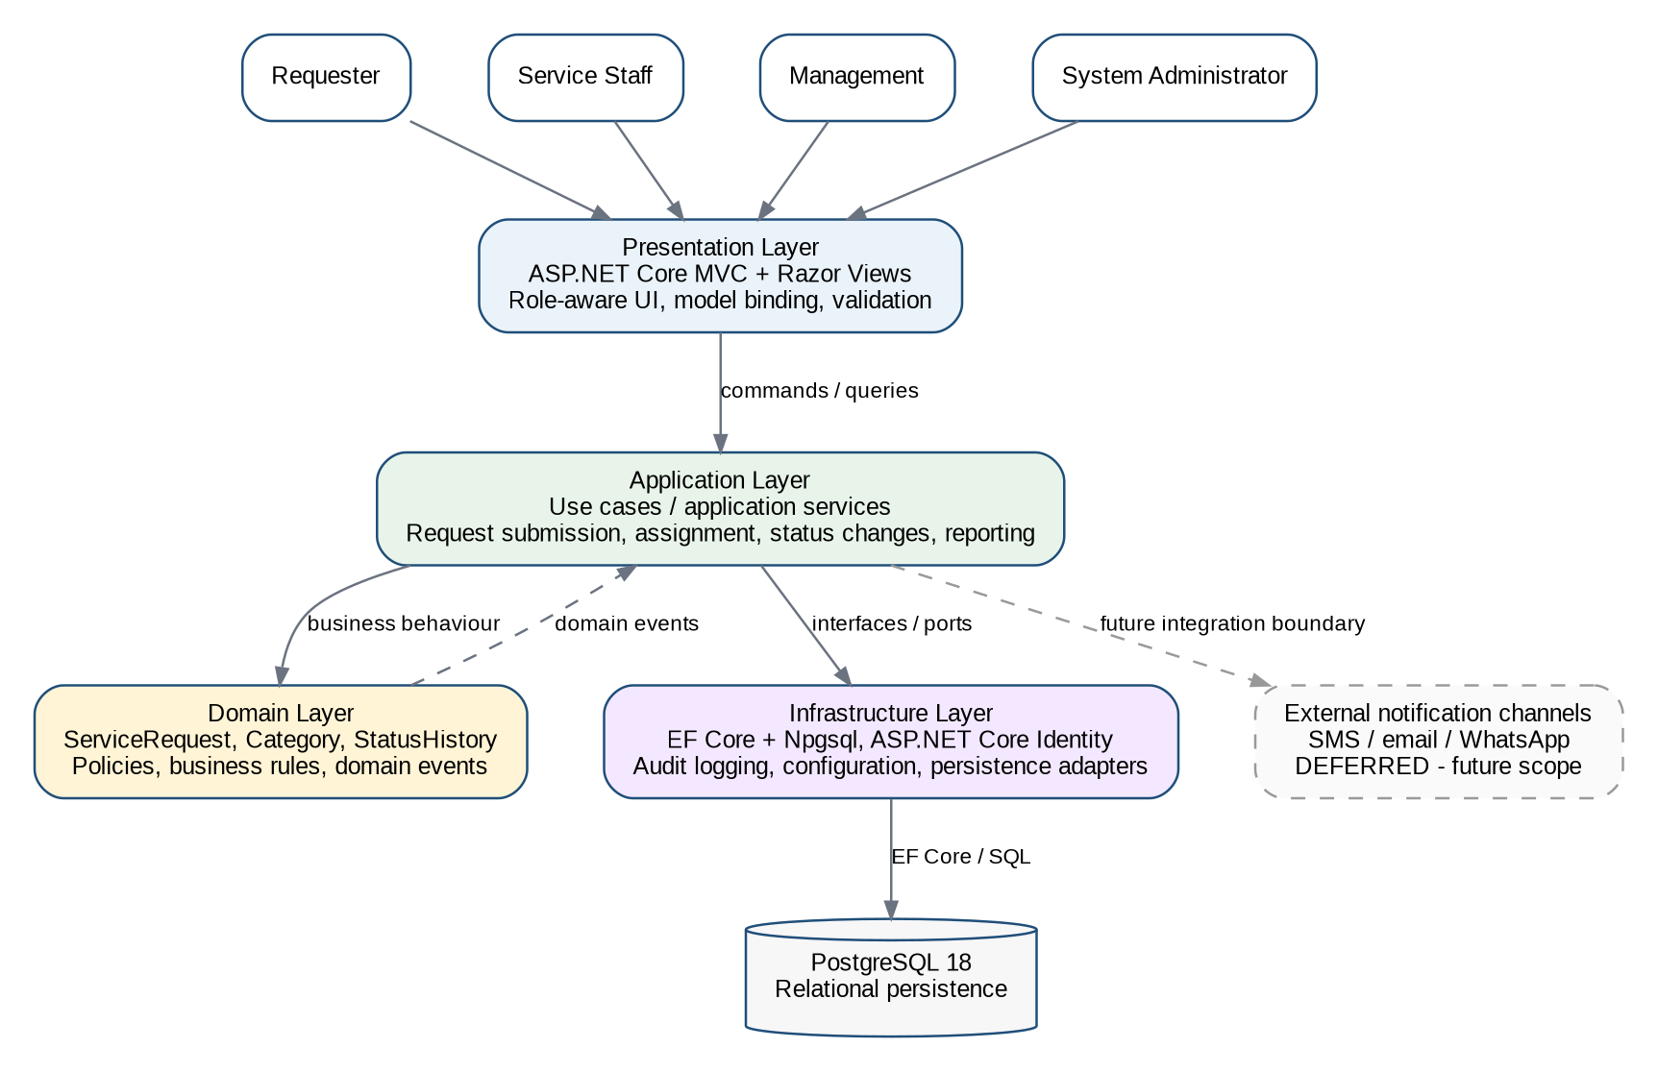
Figure M2-1. CivicConnect logical architecture baseline.
Module | Responsibility | Primary drivers
Identity & Access | Account registration/login, role/claim policies, resource ownership checks. | FR-01; NFR-SEC-01/02; ASR-01
Request Management | Submit/view requests, categories, validation, request details. | FR-02/03/04; SC-IN-01–05; ASR-02/04
Work Management | Search/filter, assignment, controlled status changes, comments/resolution. | FR-05/06/07/08; SC-IN-06–12; ASR-04/05
Reporting / Oversight | Summary views and service-activity queries; no unrestricted sensitive-detail access by default. | SC-IN-13–16; ASR-02/05
Audit & Observability | Audit records, structured application logging and correlation. | NFR-OBS-01; ASR-05
Infrastructure / Persistence | EF Core, PostgreSQL, migrations, transaction boundary, repository/query adapters, configuration. | SC-IN-18–21; ASR-04/07

ADR-001 — Use a modular monolith with layered internal architecture
Field | Record
Status | Accepted
Context | M1 deferred the final delivery approach and architecture. CivicConnect needs controlled request lifecycle behaviour, strong relational consistency, maintainability and low operational complexity.
Constraints | Fixed academic schedule; R500/month operating-cost constraint; security and audit needs; external integrations are mostly future scope.
Alternatives considered | Simple unstructured/layered monolith; modular monolith; microservices/event-driven distributed architecture.
Decision | Use one ASP.NET Core web application organised as explicit modules with presentation, application/domain and infrastructure/persistence boundaries; PostgreSQL is the separate database service.
Rationale | This provides enough separation for maintainability/testability while keeping deployment, transactions, configuration and operations proportionate.
Trade-offs | Module boundaries rely on engineering discipline; individual modules cannot be deployed independently. Future extraction would require an ADR and migration work.
Risks | Architecture erosion/tight coupling; single application instance may be an availability SPOF until scaled.
Evidence | M1 ASRs/constraints; Master Brief proportional-architecture guidance; Assignment 2 coupling/cohesion research; .NET/ASP.NET Core framework capabilities.
Later consequence | Repository structure, RTM module allocation, design decisions and later deployment all follow this architecture. Material change requires controlled ADR/change analysis.

Data and Persistence Baseline
A relational persistence model is selected because CivicConnect has strongly related users, requests, categories, assignments, status history, comments and audit records that require referential integrity and transactional correctness. Assignment 2 specifically identified status updates as a business operation where the request state and its history must not diverge (CivicConnect Project Team, 2026, Task 2).
Entity | Role | Key data | Ownership / lifecycle
ApplicationUser | Identity aggregate | UserId, Email, role/claims, account metadata | Owns submitted requests/comments; can be assigned staff; Identity-managed credential data is not exposed to application code.
RequestCategory | Reference data | CategoryId, Name, IsActive | Controls valid categories and supports filtering/reporting.
ServiceRequest | Primary aggregate root | RequestId, RequesterId, AssignedStaffId?, CategoryId, Title, Description, Location, Status, timestamps, Version | Owns the request lifecycle and controls valid state changes.
RequestStatusHistory | Lifecycle evidence | HistoryId, RequestId, OldStatus, NewStatus, ChangedByUserId, ChangedAtUtc, Comment? | Append-only history for traceability/accountability.
RequestComment | Communication record | CommentId, RequestId, AuthorUserId, Body, IsOfficial, CreatedAtUtc | Supports official staff replies and request conversation.
RequestAttachment | Supporting evidence | AttachmentId, RequestId, FileName, ContentType, StorageReference, UploadedAtUtc | Basic evidence attachment only; advanced media management remains future scope.
RequestUpvote | Optional engagement | RequestId + UserId, CreatedAtUtc | Retained as optional/could-have; not part of the initial M2 implementation priority.
AuditLog | Audit evidence | AuditId, UserId?, Action, EntityType, EntityId, TimestampUtc, CorrelationId | Supports NFR-OBS-01 and later investigation.

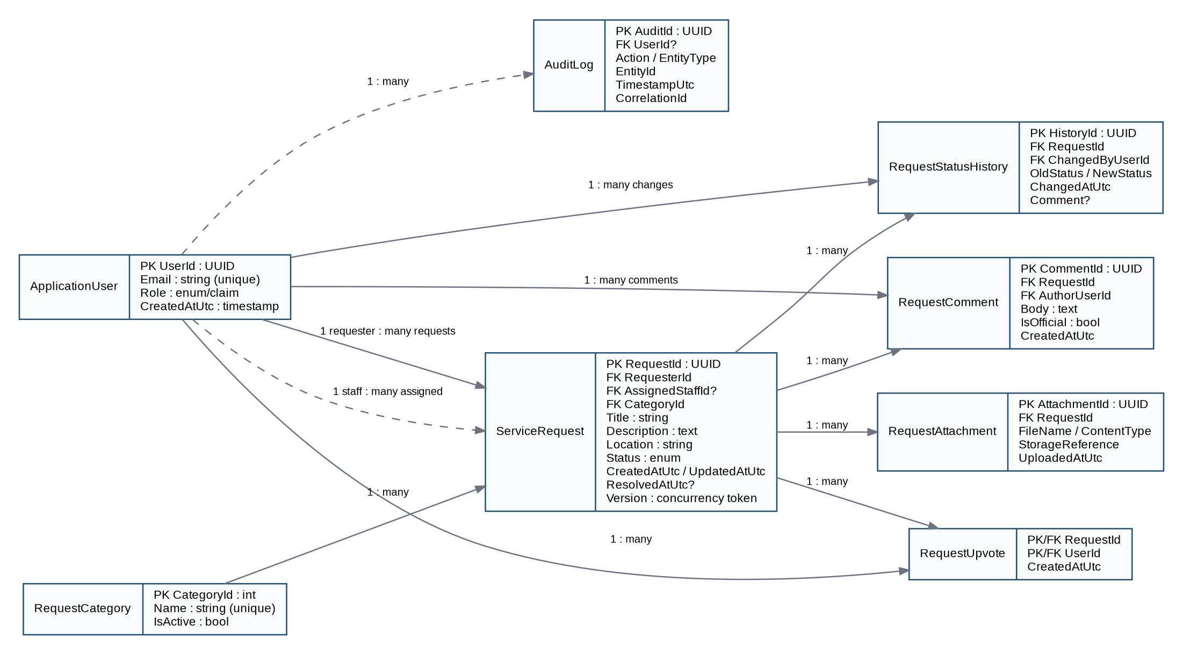
Figure M2-2. Initial CivicConnect logical data model (Identity tables simplified).

Data Integrity, Transactions and Concurrency
• Status change is a transactional business operation: validate authorisation and transition, update ServiceRequest, append RequestStatusHistory and write required audit evidence within one persistence transaction. If any critical write fails, the transaction rolls back.
• Optimistic concurrency is selected for request updates because simultaneous edits are possible but expected to be less common than reads. A concurrency token is checked during update; a conflict returns a controlled message instead of silently overwriting a newer change. EF Core provides optimistic concurrency support (Microsoft, 2026d).
• Validation is layered: browser/UI validation improves feedback, application/service validation enforces business rules and authorisation, and PostgreSQL constraints enforce required fields, uniqueness and referential integrity.
• The database schema will use foreign keys and unique constraints for relationships and account/category integrity. Requests, history and audit timestamps are stored in UTC.
• Indexes are required on common access paths: requester, assigned staff, status, category, created/updated date and combinations used for queue/report filtering. Pagination is required for request lists to avoid unbounded queries.
• No critical workflow state is stored only in application memory. This supports restart recovery and later horizontal scaling.

Availability, Bottleneck and Recovery Implications
• PostgreSQL is a critical dependency and potential single point of failure. Final hosting must provide managed backups and a recovery capability; higher-availability database options are evaluated against cost before production.
• The web application is designed stateless so additional instances can be introduced later without redesigning session-critical data storage.
• The initial database is a shared relational store rather than database-per-module because cross-module request transactions and the project scale do not justify distributed consistency complexity.
• RPO/RTO targets and tested restore evidence are intentionally deferred to M3 production-readiness work; the M2 architecture only requires that the selected hosting direction can support backup/recovery.

ADR-002 — Use PostgreSQL relational persistence with EF Core and transactional request lifecycle updates
Field | Record
Status | Accepted
Context | CivicConnect data is relational and correctness of request status/history/assignment is more important than introducing multiple stores.
Constraints | Data integrity, auditability, performance targets, maintainability, cost and future deployment portability.
Alternatives considered | Relational PostgreSQL; document database; mixed/polyglot persistence.
Decision | Use PostgreSQL 18 as the primary store, accessed through EF Core 10/Npgsql. Use transactions for multi-record business operations and optimistic concurrency for conflicting request updates.
Rationale | Strong relational integrity, mature transaction semantics, open-source licensing and direct alignment with Assignment 2 persistence research.
Trade-offs | The relational database can become a throughput/SPOF bottleneck; schema migrations must be controlled; EF abstractions do not remove the need for SQL/query understanding.
Risks | See related M2 Risk Register entries and the trade-offs recorded above; implementation evidence must confirm that the selected controls are effective.
Evidence | FR-07; SC-IN-18/19; NFR-REL-01; RSK-006/008; Assignment 2 Task 2; PostgreSQL and EF Core documentation.
Later consequence | Data model, migrations, transaction services, RTM data-impact links and later backup/recovery testing follow this decision.

Technology Stack Selection
The stack is selected as an engineering decision rather than a familiarity choice. Comparison considers requirement/architecture fit, support lifecycle, integrated security/data tooling, maintainability, deployment portability and cost as required by the Master Brief (Belgium Campus ITversity, 2026a).
Alternative | Evidence / benefits | Trade-offs | M2 judgement
.NET 10 LTS + ASP.NET Core MVC + EF Core + PostgreSQL | Integrated MVC, dependency injection, Identity, configuration/logging and EF Core; .NET 10 is an active LTS release through November 2028 (Microsoft, 2026a). | Requires C#/.NET toolchain; some hosting platforms use Docker rather than native runtime. | SELECTED — strongest fit for a single cohesive web stack with built-in identity/data support.
Node.js 24 LTS + TypeScript + web framework + PostgreSQL | Large ecosystem, strong web tooling, Node 24 is LTS (OpenJS Foundation, 2026). | More framework/package choices and dependency surface; security/auth/data stack is less unified by default. | Viable alternative; rejected to reduce dependency/stack fragmentation.
Java 25 + Spring Boot 4 + PostgreSQL | Mature enterprise ecosystem, Java 25 current LTS family and Spring Boot supports modern Java versions (Oracle, 2026; VMware, 2026). | More configuration/tooling overhead for this project; no project-specific benefit large enough to offset complexity. | Viable alternative; rejected for current baseline.

Area | Selected technology | M2 rationale / version control
Runtime / language | .NET 10 LTS / C# 14 | Current LTS line; exact patch level kept current in development environment.
Web framework | ASP.NET Core 10 MVC + Razor Views | Server-rendered responsive web app; MVC separation, model binding/validation, dependency injection and testability (Microsoft, 2026b).
UI toolkit | Bootstrap 5.3.x + project CSS | Responsive layout without introducing SPA build/runtime complexity.
Authentication / authorisation | ASP.NET Core Identity + roles/policies + resource ownership checks | Identity manages users/passwords/roles/claims/tokens; application policies enforce least privilege (Microsoft, 2026c; OWASP Foundation, n.d.).
ORM | Entity Framework Core 10 | Migrations, LINQ data access, transactions and concurrency integration; EF Core 10 is LTS with .NET 10.
PostgreSQL provider | Npgsql EF Core provider compatible with EF Core 10 | Official PostgreSQL provider for EF Core; exact patch pinned in project file (Npgsql, n.d.).
Database | PostgreSQL 18.x | Open-source relational store with current supported release line and strong integrity/transaction capabilities (PostgreSQL Global Development Group, 2025).
Testing | xUnit + ASP.NET Core integration test facilities | Initial unit/integration verification; exact package versions pinned in the repository.
Build / CI | dotnet CLI + GitHub Actions | Repeatable restore/build/test checks on Pull Requests; mature CD is deferred.
Packaging / deployment compatibility | Docker-compatible Linux container | Provider portability and consistent runtime; final hosting provider is deferred to the deployment decision.
Source control | Git + GitHub | Protected main, Issues, branches, Pull Requests, two independent approvals and traceable review per Master Brief.

ADR-003 — Select .NET 10 / ASP.NET Core MVC / EF Core / PostgreSQL as the CivicConnect application stack
Field | Record
Status | Accepted
Context | M1 deferred stack selection. M2 now requires a coherent frontend/backend/persistence/tooling decision compatible with architecture and deployment.
Constraints | Security, maintainability, schedule, cost, dependency maturity, testability, deployment portability and NFRs.
Alternatives considered | .NET 10 stack; Node.js 24/TypeScript stack; Java 25/Spring Boot stack.
Decision | Use .NET 10 LTS with ASP.NET Core MVC/Razor, EF Core 10/Npgsql and PostgreSQL 18. Bootstrap 5.3.x supports responsive UI.
Rationale | The selected stack provides a cohesive built-in web/security/configuration/data toolchain and long-term support while remaining cross-platform and open-source at the core.
Trade-offs | Commits the project to C#/.NET and EF Core conventions. Hosting platforms without native .NET require Docker. Package/version maintenance remains necessary.
Risks | Dependency vulnerabilities/compatibility; provider support; learning curve; performance target not yet proven.
Evidence | Official Microsoft .NET/ASP.NET/EF documentation; PostgreSQL documentation; Npgsql documentation; Master Brief technology-selection criteria.
Later consequence | Repository/project structure, implementation, test tooling, Docker compatibility and future deployment all depend on this stack.

Authentication and Authorisation Decision
DEC-006 is now resolved. CivicConnect will use ASP.NET Core Identity for account management and authentication, combined with application-defined roles/policies and resource-level checks. Identity supports user/password/role/claim management and integrates with ASP.NET Core applications (Microsoft, 2026c).
Role | Permitted responsibility | Key restriction
Requester | Submit requests; view own requests/history; add permitted requester content. | Cannot view or modify another requester’s private request data.
Service Staff | View authorised queues/details; accept/assign responsibility as permitted; update status; add official comments/resolution. | Access is limited to staff functions and authorised request scope.
Management | View oversight/reporting information and permitted details. | No unrestricted access to sensitive request content solely because of reporting responsibility.
System Administrator | Manage application access/configuration functions required for operation. | Administrative privilege is separated from ordinary service-work permissions; least privilege applies.

• Authentication is required for protected request and staff functions. Anonymous access is limited to explicitly public pages such as login/registration and general information.
• Authorisation is enforced server-side using policies/role checks and resource ownership; hiding a link in the UI is not considered access control.
• Passwords are handled by ASP.NET Core Identity and are never stored or logged as plaintext. Password-policy and lockout configuration will be documented in implementation evidence.
• Application secrets are not stored in source control. Local development uses Secret Manager or local environment configuration; CI/deployed environments use controlled secret variables/providers (Microsoft, 2026e; GitHub, 2026).

ADR-004 — Use ASP.NET Core Identity with role/policy and resource-based authorisation
Field | Record
Status | Accepted
Context | CivicConnect needs email/password accounts and differentiated Requester, Staff, Management and Administrator access.
Constraints | NFR-SEC-01/02, POPIA-related privacy, least privilege, M1 RSK-002, schedule and maintainability.
Alternatives considered | Custom authentication implementation; external identity provider; ASP.NET Core Identity.
Decision | Use ASP.NET Core Identity for authentication/user management. Define application roles/policies and enforce ownership/permission checks for protected resources.
Rationale | Avoids custom credential handling, integrates with the selected framework and directly supports roles/claims/tokens.
Trade-offs | Identity configuration can still be insecure if policies are incorrect; resource-level authorisation requires explicit tests. External SSO is not provided by this decision.
Risks | See related M2 Risk Register entries and the trade-offs recorded above; implementation evidence must confirm that the selected controls are effective.
Evidence | FR-01; NFR-SEC-01/02; RSK-002; Microsoft Identity documentation; OWASP authorisation guidance.
Later consequence | Controller/action policies, user model, RTM security links and M3 authorisation tests follow this decision.

Information Architecture and User-Interface / Interaction Design
The Master Brief requires M2 to include information architecture, interaction design and wireframe/prototype evidence. The UI baseline uses role-aware navigation, progressive disclosure and clear status information. The wireframes below are low-fidelity design evidence rather than claims that the final UI is implemented.
Role / area | Primary navigation | Interaction objective
Public | Home; Register; Login | Understand CivicConnect and enter the protected system.
Requester | Dashboard; Submit Request; My Requests; Request Details; Profile | Submit and track requests with clear feedback and history.
Service Staff | Request Queue; Assigned to Me; Request Details; Status/Comment/Resolution actions | Find work quickly and perform controlled updates.
Management | Overview; Service Activity; Overdue/Open/Resolved/Closed views; filtered reporting | Support accountability and performance oversight.
System Administrator | Access/configuration administration appropriate to implemented controls | Operate the system without mixing ordinary service-work privileges.

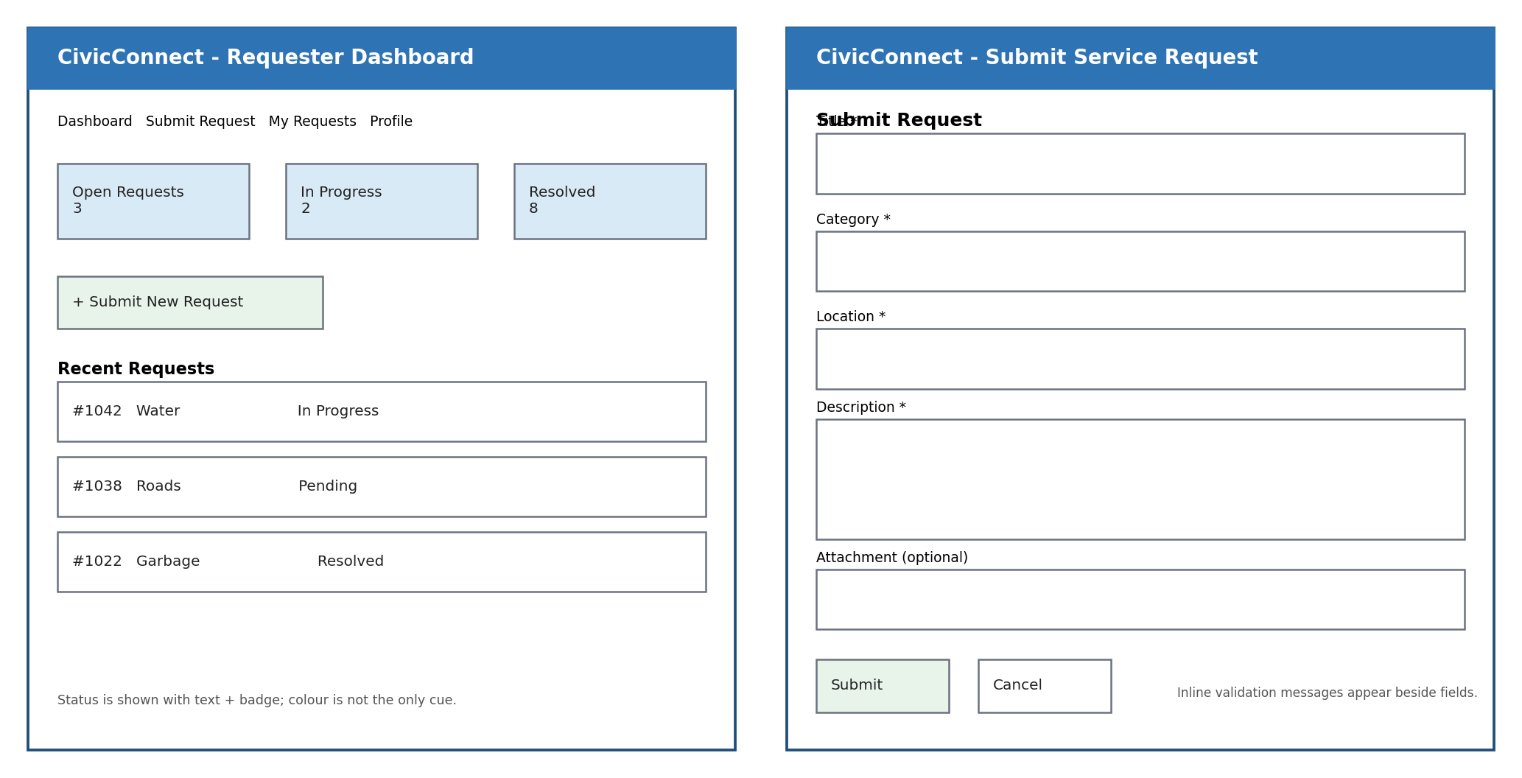
Figure M2-3. Requester dashboard and submit-request wireframes.
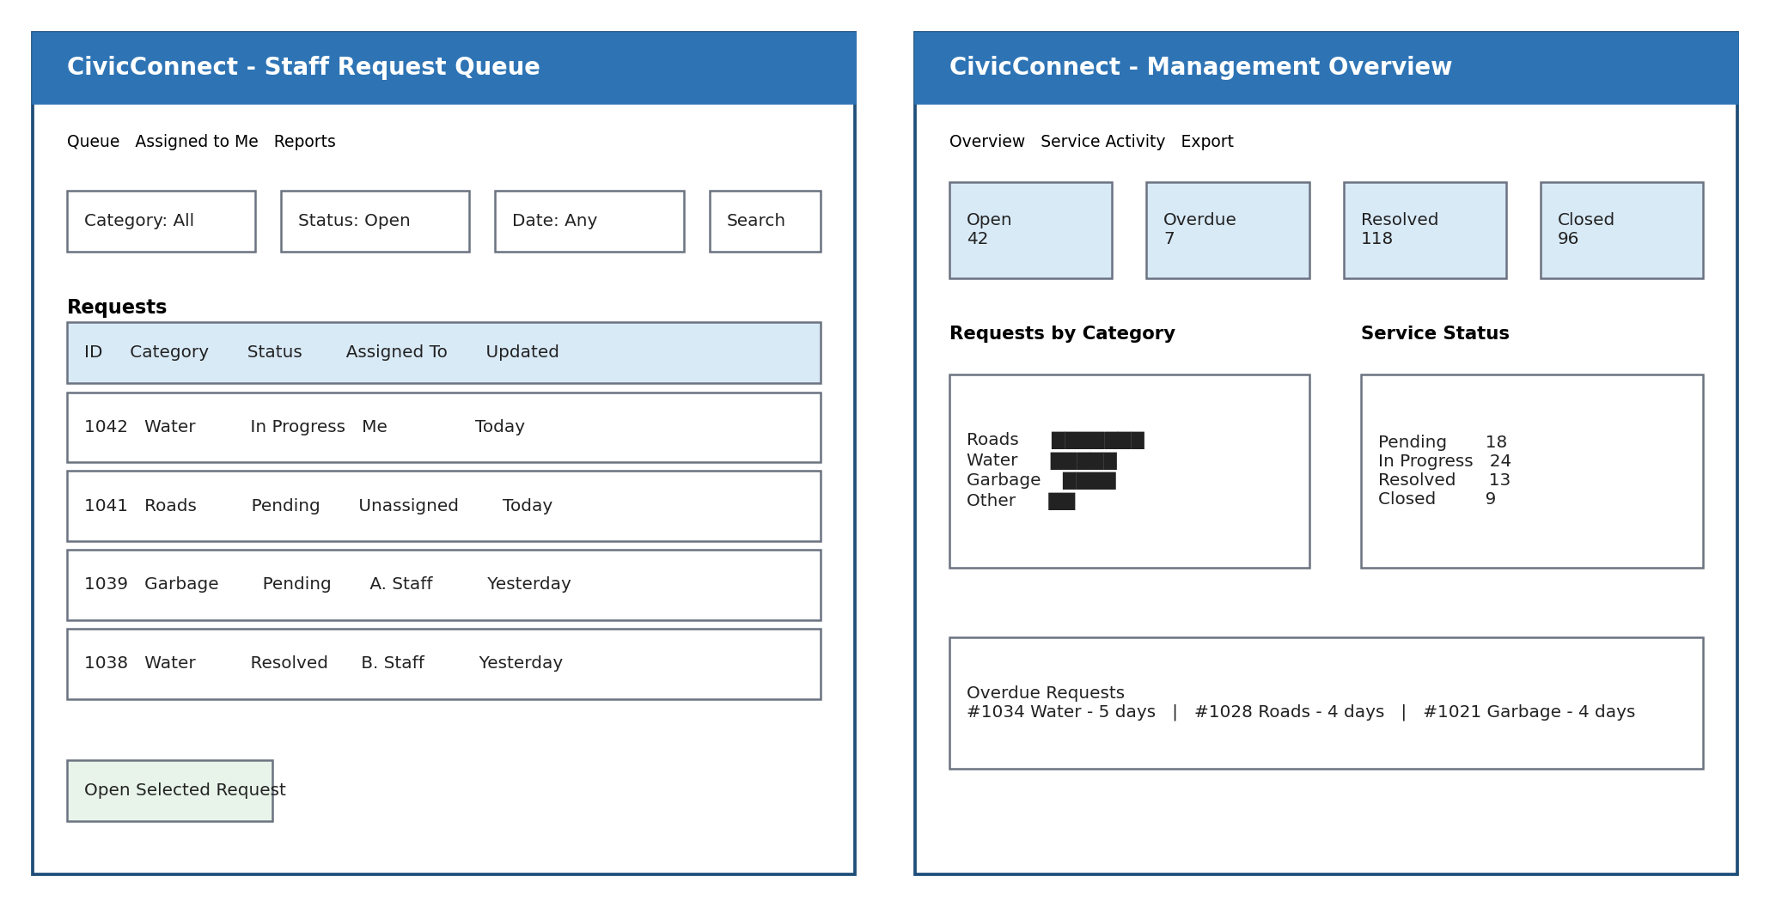
Figure M2-4. Staff queue and management overview wireframes.

Usability and Accessibility Rationale
• Responsive layout is required so core requester and staff workflows remain usable on common desktop and mobile browser widths.
• Forms use explicit visible labels, required-field indicators, inline validation messages and a logical keyboard order. Error messages identify the field and correction required.
• Status is communicated using text as well as colour so meaning does not depend on colour perception alone.
• Keyboard-visible focus, semantic headings, adequate target sizes and sufficient contrast are design requirements. WCAG 2.2 AA is adopted as the accessibility design target; formal conformance evidence is deferred to later testing (W3C, 2024).
• Request lists use pagination, filtering and consistent column/status terminology to reduce cognitive load and support performance.
• Dangerous or irreversible operations require confirmation where appropriate, while routine status changes should remain efficient for staff.

ADR-005 — Use a responsive server-rendered, role-aware MVC user interface with WCAG 2.2 AA as the design target
Field | Record
Status | Accepted
Context | CivicConnect must serve requesters, staff and management without requiring a native application or SPA architecture.
Constraints | Responsive access, maintainability, performance, accessibility, scope and schedule.
Alternatives considered | Server-rendered MVC/Razor; SPA frontend; native mobile application.
Decision | Use ASP.NET Core MVC/Razor Views with Bootstrap and role-aware navigation. Design to WCAG 2.2 AA criteria and verify later.
Rationale | Keeps one web stack, reduces client build complexity and supports progressive server-side validation while meeting responsive browser scope.
Trade-offs | Less rich client-side interaction than a SPA; accessibility still requires implementation/testing rather than toolkit defaults.
Risks | See related M2 Risk Register entries and the trade-offs recorded above; implementation evidence must confirm that the selected controls are effective.
Evidence | M1 requester/staff/management needs; Master Brief UI/wireframe requirement; W3C WCAG 2.2.
Later consequence | UI structure, Razor views, navigation, acceptance tests and later usability/accessibility evidence follow this decision.

Initial Design Decisions Informed by Assignment 2
Assignment 2 researched alternatives before implementation. M2 now makes the project-specific decision. We did not automatically adopt the research recommendation when the current CivicConnect evidence does not justify the complexity (Belgium Campus ITversity, 2026c).

Design Problem 1 — Category-Specific Request Rules
Problem: categories such as Roads, Water and Garbage may eventually require different rules, but the current baselined requirements only require a controlled category and common request fields. Assignment 2 compared Strategy and Template Method and explicitly noted that Strategy becomes unnecessary complexity if categories currently use the same rules (CivicConnect Project Team, 2026, Task 1).
Final M2 decision: do not implement multiple Strategy classes yet. Use one cohesive RequestValidator plus controlled RequestCategory data. Introduce category strategies only through a later ADR/change when real category-specific rules are baselined. This is a deliberate simpler approach, not an absence of design.
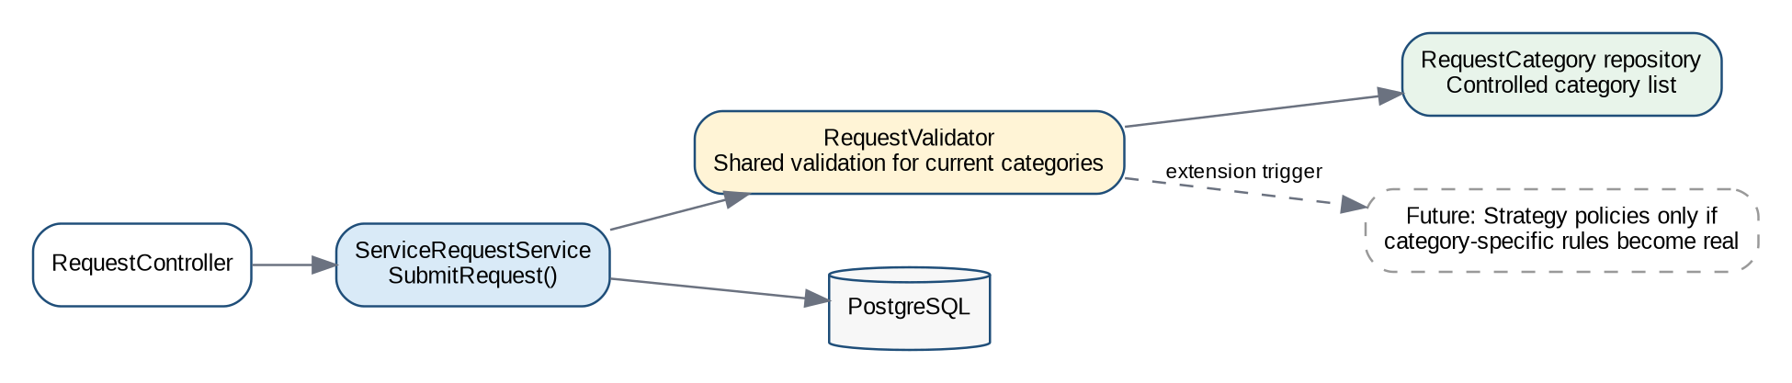
Figure M2-5. Current category-validation approach with a deliberate future Strategy extension point.
Affected element | M2 responsibility
ServiceRequestService | Coordinates request creation and invokes shared validation.
RequestValidator | Validates common title/description/location/category rules.
RequestCategory | Provides controlled active categories from persistence.
Future category policy/Strategy | Not created until a real category-specific rule justifies the abstraction.

ADR-006 — Use shared request validation now; defer Strategy until category rules genuinely diverge
Field | Record
Status | Accepted
Context | A2 identified a possible future variation point, but current M1 requirements do not define different validation/processing rules per category.
Constraints | Avoid over-engineering; maintainability; testability; schedule; current scope.
Alternatives considered | Strategy pattern; Template Method; simple shared validator with controlled category data.
Decision | Use a shared RequestValidator and category reference data. Do not create category-specific Strategy classes in M2.
Rationale | Lowest current complexity while preserving a clear trigger for later refactoring if category-specific rules become real requirements.
Trade-offs | A future category-specific rule may require refactoring. The team must not let conditionals grow uncontrolled; threshold for change is documented.
Risks | See related M2 Risk Register entries and the trade-offs recorded above; implementation evidence must confirm that the selected controls are effective.
Evidence | Assignment 2 Task 1 comparison; M1 FR-02 and controlled-category scope; Master Brief requirement to avoid unnecessary complexity.
Later consequence | Current request submission design stays simple. A later category-rule change would require ADR review, new tests and RTM updates.

Design Problem 2 — Multiple Reactions to a Request Status Change
Problem: a successful status change affects more than one concern. The request and history/audit evidence must remain correct, while non-critical secondary reactions such as requester feedback, telemetry or future notifications should not force the core service to depend directly on every consumer. Assignment 2 compared Observer/event handling with direct service calls and found the Observer approach more extensible when multiple independent reactions exist (CivicConnect Project Team, 2026, Task 1).
Final M2 decision: critical data correctness remains inside the application transaction. After a successful commit, an in-process RequestStatusChanged domain event is published to decouple non-critical secondary reactions. This applies Observer/event principles without introducing a network broker or microservice.
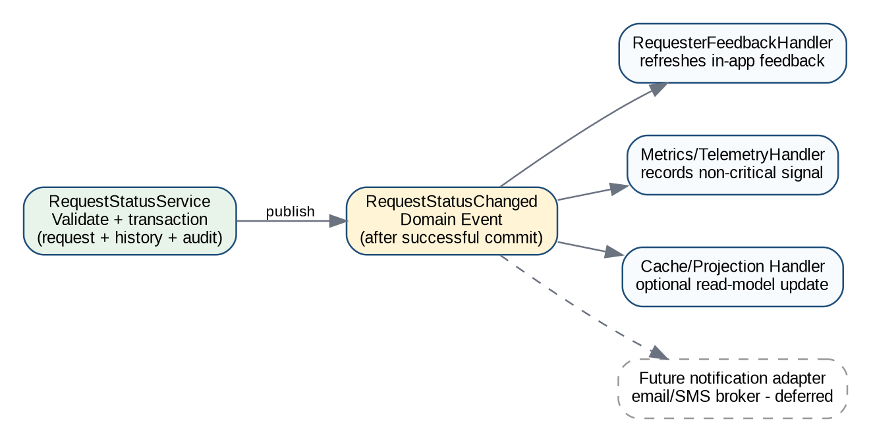
Figure M2-6. In-process domain-event/Observer decision for secondary status-change reactions.

ADR-007 — Use in-process domain events / Observer for secondary status-change reactions
Field | Record
Status | Accepted
Context | Status changes have multiple downstream reactions, but request/history/audit correctness must remain strongly consistent and external messaging is not current scope.
Constraints | Data integrity, maintainability, testability, current scope, deployment simplicity.
Alternatives considered | Direct calls from status service; in-process Observer/domain events; external asynchronous broker.
Decision | Keep request/history/audit changes in one transaction, then publish an in-process RequestStatusChanged event for non-critical secondary handlers. External broker integration remains deferred.
Rationale | Reduces coupling without distributed-system overhead and leaves a controlled future integration seam.
Trade-offs | Introduces event indirection and handler ordering/error considerations. Handlers require tests. In-process events do not provide durable external delivery.
Risks | See related M2 Risk Register entries and the trade-offs recorded above; implementation evidence must confirm that the selected controls are effective.
Evidence | FR-07; NFR-OBS-01; Assignment 2 Task 1/3; M1 future notification scope.
Later consequence | Application services publish a domain event after successful commit. Future external notification integration must use a new integration ADR and may translate the domain event to a versioned integration event.

Initial Interface and Integration Decisions
M2 deliberately avoids creating network boundaries inside the modular monolith merely because APIs/microservices were studied. Current internal communication uses typed application/service interfaces and in-process events. Browser-to-application HTTP remains the main external boundary. Assignment 2’s asynchronous broker recommendation is retained as research evidence for a future external-notification integration, but SMS/WhatsApp notification capability is outside the current committed scope.
Boundary | Mechanism | Information exchanged | Validation / failure / security behaviour
Browser → MVC presentation | HTTPS form/GET/POST requests | View models / validated form data | Model validation; anti-forgery for state-changing forms; authenticated/authorised routes; user-friendly validation errors.
Presentation → Application services | Typed in-process method calls / commands | CreateServiceRequest, ChangeRequestStatus, search/filter criteria | Application validates business rules/authorisation; domain errors become controlled UI responses.
Application → Persistence | EF Core DbContext / repository-query abstractions where useful | Entities/query specifications | Transaction rollback on critical failure; concurrency conflict returned for user retry/refresh.
Status change → secondary handlers | In-process RequestStatusChanged domain event | RequestId, OldStatus, NewStatus, ChangedAtUtc, ChangedByUserId | Handlers isolated from core transaction where non-critical; errors logged and do not corrupt committed request state.
Future notification adapter | DEFERRED: asynchronous integration boundary if external email/SMS enters scope | Versioned notification event derived from status event | Broker/provider failure, retry/idempotency, schema versioning and security must be decided later.

ADR-008 — Keep internal module communication in-process; defer durable external messaging until an in-scope integration requires it
Field | Record
Status | Accepted
Context | A2 researched asynchronous event-driven notification integration, but M1 explicitly defers SMS/WhatsApp/external-channel capabilities.
Constraints | Scope baseline, cost, operational complexity, reliability, maintainability and future extensibility.
Alternatives considered | Internal REST/microservices; message broker now; in-process interfaces/events with future adapter seam.
Decision | Use in-process application interfaces and domain events. Do not deploy a broker or notification microservice in M2. Reassess if external notifications are approved later.
Rationale | Avoids unnecessary infrastructure and failure modes while retaining a clear event contract for future adaptation.
Trade-offs | Future extraction will require additional work and durable-delivery semantics; in-process events do not survive process failure after commit.
Risks | See related M2 Risk Register entries and the trade-offs recorded above; implementation evidence must confirm that the selected controls are effective.
Evidence | M1 SC-FUT-02/03; Assignment 2 Task 3; Master Brief proportional integration guidance.
Later consequence | No broker is part of the M2 baseline. Any future external notification feature triggers interface/security/versioning and operational ADR review.

Deployment Compatibility and Environment Direction
M2 selects a deployment direction, not a production-readiness claim. The architecture must remain plausible for staging/production and the final provider must be evaluated against cost, availability, backup/recovery and operational evidence. Production deployment and full observability remain M3/later concerns.
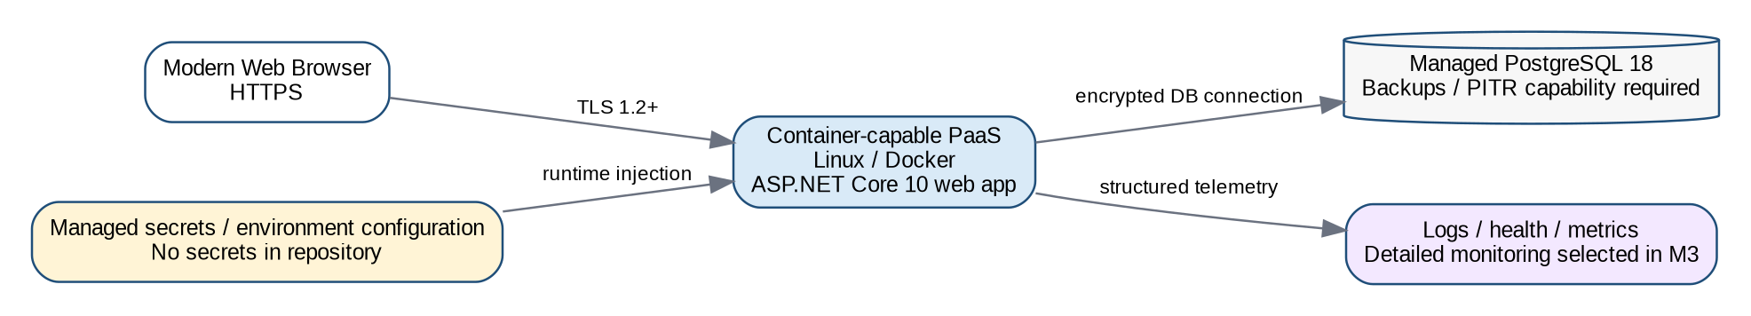
Figure M2-7. Provider-neutral deployment direction.
Environment | Direction | Key controls / differences
Development | Local developer machine; ASP.NET Core app; local/container PostgreSQL; sample/dev data. | .NET User Secrets or local environment values; rapid iteration; no production credentials.
Test | Repeatable automated/unit/integration test environment; disposable test data/database where practical. | Controlled fixtures; CI-generated logs/results; no production data.
Staging | Production-like container/runtime and PostgreSQL configuration before release. | Environment-specific secrets, TLS, migration rehearsal and deployment checks. Detailed implementation in M3.
Production | Container-capable PaaS + managed PostgreSQL. | Real availability/cost/security/backup responsibility. Final provider selection and production evidence deferred.

• Application configuration is environment-specific. Non-sensitive defaults may be version-controlled; secrets and credentials are injected at runtime and never committed.
• The web application is container-compatible and stateless for critical user/session state, reducing provider lock-in and preserving a future horizontal-scaling option.
• The final provider must support HTTPS/TLS, controlled secrets, PostgreSQL connectivity, logs/health information and a backup/recovery capability while remaining within the cost constraint.
• The R500/month NFR is a hard selection constraint. Free tiers are not accepted as sufficient evidence of production suitability; current provider pricing and limits must be checked immediately before final selection.
• Final host/provider selection remains deliberately deferred because pricing, regional availability, free-tier limitations and production-readiness requirements are time-sensitive. This is the only major deployment choice still open after M2.

ADR-009 — Adopt a portable Linux-container/PaaS deployment direction with managed PostgreSQL; defer final hosting provider
Field | Record
Status | Accepted
Context | M1 deferred hosting. M2 must ensure architecture/technology choices are deployable without prematurely claiming production readiness.
Constraints | R500/month cost target; TLS/secrets; backup/recovery; .NET/PostgreSQL compatibility; operational simplicity and lock-in risk.
Alternatives considered | Windows/IIS-specific hosting; provider-native .NET hosting; Linux Docker/container-capable PaaS with managed PostgreSQL.
Decision | Target a Linux container-capable PaaS for the ASP.NET Core application and managed PostgreSQL. Keep provider selection open until current cost/region/backup/availability evidence is reviewed.
Rationale | Portable runtime, simpler environment parity and reduced lock-in. Keeps the stack deployable across several providers.
Trade-offs | Container packaging adds build configuration; managed database pricing may exceed the budget at production scale; final availability objectives may require paid HA options.
Risks | See related M2 Risk Register entries and the trade-offs recorded above; implementation evidence must confirm that the selected controls are effective.
Evidence | CON-03/07; NFR-COST-01; RSK-003/007/009; Master Brief environment/technology-selection standard.
Later consequence | Docker/runtime configuration and environment-variable conventions follow this direction. Final provider decision must be recorded before staging/production release.

M2 Risk Register Review and New Risks
The M1 risk register remains the historical baseline. M2 re-rates risks only where new evidence changes exposure and adds architecture/data/technology/design risks. Scores use the existing 5×5 probability-impact method.
ID | Risk | M1 | M2 | Status | M2 evidence / response
RSK-001 | Scope creep | 16 Critical | 16 Critical | Open | No scope change; formal change control remains essential.
RSK-002 | Unauthorised access to sensitive request information | 15 High | 15 High | Open | Identity/authorisation approach selected, but implementation/security verification does not yet exist.
RSK-003 | Technology/deployment incompatibility | 12 High | 6 Medium | Mitigated / Open | Core stack is selected and cross-platform; final host compatibility still requires confirmation.
RSK-004 | Requirements lose traceability | 12 High | 8 Medium | Mitigated / Open | RTM structure now includes ASR/architecture/data/design/technology/status/ADR fields; repository evidence still must be maintained.
RSK-005 | Weak quality evidence from vague NFRs | 12 High | 8 Medium | Mitigated / Open | M2 adds measurable interpretations/ASR links; real verification remains for M3.
RSK-006 | Data loss/corruption | 10 High | 10 High | Open | Persistence design improved, but backup/restore evidence is not yet available.
RSK-007 | Unexpected platform limits/cost | 9 Medium | 9 Medium | Open | Final provider is deliberately deferred until current pricing/limits are evaluated.
RSK-008 | Incorrect/incomplete/duplicate request data | 12 High | 9 Medium | Mitigated / Open | Layered validation/relational constraints selected; implementation evidence pending.
RSK-009 | Environment/configuration mismatch | 12 High | 12 High | Open | Environment direction defined; staging parity evidence belongs to M3.
RSK-010 | Failures/performance not detected quickly | 8 Medium | 8 Medium | Open | Audit/logging architecture defined; monitoring/alerts not yet implemented.

ID | Risk event / cause | P | I | Score | Priority | Mitigation | Contingency | Owner | Status
RSK-011 | Concurrent staff updates may overwrite a newer request state if concurrency is not implemented correctly. | 3 | 4 | 12 | High | Use optimistic concurrency token; return conflict and require refresh/retry; test competing updates. | Disable conflicting update path until corrected; review affected data/history. | Darrin | Open
RSK-012 | Framework/package dependency vulnerability or incompatible upgrade may affect security/build/deployment. | 3 | 4 | 12 | High | Pin compatible versions; use supported LTS runtime; dependency review/scanning in CI. | Rollback package upgrade; patch/replace dependency through reviewed PR. | Tshepo | Open
RSK-013 | Module boundaries may erode and create tight coupling as development accelerates. | 3 | 3 | 9 | Medium | Repository structure, code review and ADRs enforce module/layer responsibilities. | Refactor through controlled change; add architectural tests/rules if needed. | Jordan | Open
RSK-014 | Secrets may be accidentally committed or exposed through configuration. | 2 | 5 | 10 | High | User Secrets locally; GitHub/deployment secrets; gitignore; PR review and secret scanning where available. | Rotate exposed secret immediately, remove/revoke credential and investigate repository history. | Tshepo | Open
RSK-015 | Performance/scalability targets may not be achievable within the R500/month operational-cost constraint. | 4 | 4 | 16 | Critical | Stateless app, pagination/indexes and efficient queries; measure before adding infrastructure; treat performance/cost together. | Rework queries/architecture, revise capacity plan or formally negotiate requirement/cost trade-off through change control. | Jordan | Open
RSK-016 | Single application/database service may cause downtime if an instance or database fails. | 3 | 4 | 12 | High | Choose provider with health checks, restart/redeploy and backup/recovery capability; keep app stateless for later scale-out. | Restore/redeploy service/database; use provider recovery process; record residual availability risk. | Darrin | Open

Highest M2 attention: RSK-001 and RSK-015 both have Critical exposure (16/25). RSK-001 remains a governance risk; RSK-015 is the most important new technical/economic risk because the 5,000-user scalability objective and 2-second performance target may require resources that conflict with the R500/month operating-cost constraint. M2 therefore chooses an architecture that can scale but does not claim the NFRs are met until measured.

Forward Engineering Considerations — M2 Update
ID / concern | M2 status | Current decision/evidence | Later evidence needed
FEC-01 Security/access control | Partially resolved in M2 | Identity + role/policy/resource authorisation selected. | M3 must threat-model actual implementation, run security-relevant tests/checks and record residual risk.
FEC-02 Testability/automated verification | Partially resolved in M2 | Layered architecture, DI, xUnit and CI direction selected. | M3 must expand unit/integration/regression evidence and quality gates.
FEC-03 Deployment environment/cost | Direction resolved; provider open | Linux container/PaaS + managed PostgreSQL direction. | Final provider, current cost, staging parity and release/rollback evidence required later.
FEC-04 Data integrity/backup/recovery | Integrity design resolved; recovery evidence open | Transactions, relational constraints and optimistic concurrency selected. | M3 must configure/rehearse backup/restore and define release migration/rollback controls.
FEC-05 Logging/monitoring/observability | Partially resolved | AuditLog + structured logging/correlation designed. | M3 selects actionable monitoring/alerts and demonstrates operational evidence.
FEC-06 Maintainability/changeability | Architecture response selected | Modular monolith, layers and selective design approaches. | Review architecture erosion/technical debt as implementation grows.
FEC-07 Performance/scalability | Architecture response selected; proof open | Stateless app, pagination/indexing, async I/O direction. | M3 performance/load testing must determine whether NFRs and cost can coexist.
FEC-08 Accessibility/usability | New M2 consideration | Role-based wireframes and WCAG 2.2 AA design target. | Later implementation requires keyboard/contrast/form/usability verification.
FEC-09 External notifications | Deliberately deferred | No broker/external notification service in M2; event seam preserved. | Only revisit if external email/SMS/WhatsApp becomes approved scope.

Evolved Requirements Traceability Matrix (M2)
The RTM now traces requirements into architecture/data/design/technology decisions.
Req | Source/Priority | AC | ASR | Architecture/Data | Design/Technology | Implementation evidence | Verification | ADR/Risk
FR-01 | Citizen / Must | AC-FR-01 | ASR-01 | Identity & Access; ApplicationUser | ADR-004; ASP.NET Core Identity | Planned: registration/login UI + Identity configuration | Not Yet Implemented | ADR-004 / RSK-002
FR-02 | Citizen / Must | AC-FR-02 | ASR-02/04 | Request Management; ServiceRequest + Category | ADR-006; .NET MVC/EF Core | Planned: Create request controller/service/view + migration | Planned unit/integration tests | ADR-001/002/003/006
FR-03 | Citizen / Should | AC-FR-03 planned | ASR-04/07 | RequestAttachment | Basic attachment only; advanced media deferred | Planned after core flow | Planned validation/security tests | CLAR-003 / RSK-007
FR-04 | Citizen / Must | AC-FR-04 planned | ASR-01/02 | Request Management query; ServiceRequest/History | Role/resource authorisation; MVC | Planned requester dashboard/details | Planned authorisation/query tests | ADR-004/005
FR-05 | Municipal Authority / Must | AC-FR-05 planned | ASR-01/02 | Work Management queue | Server-side permission + pagination | Planned staff queue | Planned role/query tests | CLAR-004 / ADR-004
FR-06 | Municipal Authority / Must | AC-FR-06 planned | ASR-02/03 | Work Management; indexed request query | EF Core query/paging/filtering | Planned search/filter queue | Planned integration/performance tests | ADR-002/003
FR-07 | Municipal Authority / Must | AC-FR-07 | ASR-04/05 | Work Management; Request + History + Audit | Transaction + optimistic concurrency + ADR-007 event | Planned status service/UI | Planned transaction/concurrency tests | ADR-002/007 / RSK-011
FR-08 | Municipal Authority / Should | AC-FR-08 planned | ASR-04/05 | RequestComment | MVC/service + audit | Planned official comment path | Planned auth/integration tests | ADR-001/004
FR-09 | Community goal / Could | AC-FR-09 planned | ASR-03/07 | RequestUpvote | Relational optional module | Deferred for M2 | Planned if activated | Scope priority / RSK-001
FR-10 | Deferred scope | N/A | ASR-07 | External payment boundary | No M2 implementation decision | Deferred | Deferred | DEC-001/002 principles
NFR-PERF-01 | Quality / Must | AC-NFR-PERF-01 | ASR-02 | All read paths; indexes/pagination | ASP.NET Core + PostgreSQL | Architecture selected; implementation pending | Planned load test | ADR-001/002/003 / RSK-015
NFR-SEC-01 | Security / Must | AC-NFR-SEC-01 | ASR-01 | Identity credential store | ASP.NET Core Identity | Identity configuration planned | Planned password-storage/config review | ADR-004 / RSK-002
NFR-SEC-02 | Security / Must | AC-NFR-SEC-02 planned | ASR-01/07 | Deployment boundary | HTTPS/TLS 1.2+ required | Deployment configuration pending | Planned TLS verification | ADR-009 / RSK-009
NFR-REL-01 | Quality / Must | AC-NFR-REL-01 planned | ASR-04/07 | App + DB runtime | Stateless app; managed DB direction | Provider not yet selected | Planned availability/recovery evidence | ADR-009 / RSK-016
NFR-COST-01 | Cost / Must | AC-NFR-COST-01 planned | ASR-07 | Deployment topology | Single app + managed DB; provider deferred | Cost model pending provider selection | Pre-release cost check planned | ADR-009 / RSK-007/015
NFR-SCALE-01 | Quality / Must | AC-NFR-SCALE-01 via CLAR-001 | ASR-03/07 | Stateless app + scalable DB access | Pagination/indexes/horizontal-ready app | Implementation pending | Planned 5,000-session load test | ADR-001/002/009 / RSK-015
NFR-COMP-01 | Compliance / Must | AC-NFR-COMP-01 planned | ASR-01 | Identity/data/audit modules | Least privilege, data minimisation, auditability | Implementation pending | Planned privacy/security review | ADR-004 / RSK-002
NFR-OBS-01 | Quality / Must | AC-NFR-OBS-01 via CLAR-002 | ASR-05 | Audit & Observability | AuditLog + structured logging/correlation | Implementation pending | Planned audit/log verification | ADR-001/007 / RSK-010

Engineering Decision Log — M2 Evolution and ADR Index
M1 Decision | Original decision | M2 status | M2 consequence
DEC-001 | Prioritise mandatory CivicConnect capabilities | Accepted | Still applies; optional features remain subordinate to the core lifecycle.
DEC-002 | Defer direct WhatsApp integration | Accepted | Still applies; no external-channel integration is brought into M2 scope.
DEC-003 | Use 5×5 risk method | Accepted | Still used for M2 risk review.
DEC-004 | Defer final application delivery approach until M2 | Superseded / Resolved | ADR-001/005 select a responsive web application and modular monolith.
DEC-005 | Defer technology stack/software architecture until M2 | Superseded / Resolved | ADR-001/003 select architecture and stack.
DEC-006 | Need controlled role access; defer exact mechanism | Superseded / Resolved | ADR-004 selects ASP.NET Core Identity + role/policy/resource authorisation.
DEC-007 | Defer final deployment/hosting platform | Deferred — refined | ADR-009 selects the deployment direction but deliberately keeps the final provider open pending cost/operational evidence.

ADR | Decision | Status
ADR-001 | Modular monolith + layered architecture | Accepted
ADR-002 | PostgreSQL/EF Core persistence + transactions/concurrency | Accepted
ADR-003 | .NET 10 / ASP.NET Core / EF Core / PostgreSQL stack | Accepted
ADR-004 | ASP.NET Core Identity + role/policy/resource authorisation | Accepted
ADR-005 | Responsive MVC/Razor UI + WCAG 2.2 AA target | Accepted
ADR-006 | Shared request validation; Strategy deferred until justified | Accepted
ADR-007 | In-process domain events/Observer for secondary status reactions | Accepted
ADR-008 | In-process internal integration; external durable messaging deferred | Accepted
ADR-009 | Container/PaaS + managed PostgreSQL direction; provider deferred | Accepted with provider open
ADR-010 | GitHub PR workflow and initial CI quality checks | Accepted

GitHub, Collaborative Engineering and Initial CI Controls
The M2 repository process adopts the proportionate parts of Assignment 2 SCM/CI research and the mandatory Master Brief governance.
Control | M2 rule | Reason
Protected main | No substantive direct development on main. | Prevents uncontrolled baseline changes.
Issue / task | Meaningful work starts from an Issue/task linked to requirement/artefact where practical. | Creates traceability and planning evidence.
Branch | Short-lived feature/fix/docs branch, e.g. feature/FR-02-submit-request. | Isolates work and reduces integration risk.
Pull Request | PR references Issue, requirement/ADR where relevant and describes verification. | Creates review and decision evidence.
Independent review | Two approvals from team members other than the author for substantive PRs. | Mandatory project control and meaningful peer review.
Automated restore/build | Run dotnet restore/build on PRs. Build failure blocks merge. | Basic repeatable integration evidence.
Automated tests | Run available unit/integration tests on PRs; failing required tests block merge. | Prevents known regressions.
Static/style checks | Start as warning where necessary; increase to blocking once rules are stable. | Avoids turning setup noise into false quality confidence.
Dependency/security check | Review vulnerable dependencies; high-severity unresolved findings block merge unless formally risk-accepted. | Supports supply-chain/security control.
Secrets | No credentials in repository. Use User Secrets/local env for development and GitHub/deployment secrets for controlled environments. | Reduces secret exposure.
Documentation review | PED/ADR/README/RTM changes also use PR review. | Documentation is controlled engineering evidence, not an afterthought.

ADR-010 — Adopt feature-branch/PR governance with initial GitHub Actions restore-build-test checks
Field | Record
Status | Accepted
Context | M2 requires controlled collaborative development and progressive adoption of suitable A2 SCM/CI research.
Constraints | Protected main, two independent approvals, authentic progressive evidence, no mature CI/CD requirement yet.
Alternatives considered | Manual-only checks; full CI/CD now; proportionate CI on PRs.
Decision | Use Issues → short-lived branch → commits → PR → two independent approvals → merge. Run repeatable restore/build/test and selected dependency/static checks through GitHub Actions as they become available.
Rationale | Provides early integration evidence without turning M2 into a deployment-pipeline project.
Trade-offs | A green build does not prove quality; checks need maintenance; flaky tests can reduce trust.
Risks | See related M2 Risk Register entries and the trade-offs recorded above; implementation evidence must confirm that the selected controls are effective.
Evidence | Master Brief GitHub governance; Assignment 2 Task 4 SCM/CI research.
Later consequence | M3 expands automated unit/integration/regression/security checks and formal quality gates.

Application / Technical Documentation Baseline
The PED records engineering reasoning; the repository README must describe the software that actually exists. The following structure is the M2 documentation baseline.
CivicConnect/
├── src/
│ ├── CivicConnect.Web/ # MVC/Razor presentation
│ ├── CivicConnect.Application/ # use cases/application services
│ ├── CivicConnect.Domain/ # entities, rules, domain events
│ └── CivicConnect.Infrastructure/ # EF Core, Identity, persistence/logging adapters
├── tests/
│ ├── CivicConnect.UnitTests/
│ └── CivicConnect.IntegrationTests/
├── docs/
│ └── PED/ # controlled PED/ADR references
├── .github/workflows/ # initial CI checks
├── README.md
└── CivicConnect.sln
README section | Required M2 content
Purpose / scope | Short CivicConnect purpose and current milestone/status.
Prerequisites | .NET 10 SDK, PostgreSQL 18 or compatible local container, Git, optional Docker.
Setup | Clone repository; restore packages; provide local development secrets/configuration; create/apply database migrations.
Run | Run the web project using the documented dotnet command or IDE profile; identify local URL.
Configuration | Document required keys without values/secrets; explain User Secrets/environment variables.
Database | Describe PostgreSQL setup, migrations and test/dev data expectations.
Architecture / modules | Map repository projects/folders to PED architecture responsibilities.
Interfaces | List established controller routes/interfaces/domain events as they are implemented.
Testing | Document unit/integration test commands and current limitations.
Known limitations / TODO | Explicitly identify incomplete M2 features, deferred integrations and unverified NFRs.

Architecture, Technology & Initial Design Baseline — M2 Scope
Baseline item | M2 position
Included in baseline | Responsive web delivery; modular monolith/layered architecture; module responsibilities; ASRs; relational PostgreSQL data model; .NET/ASP.NET Core/EF Core stack; Identity access approach; UI information architecture/wireframes; shared validation approach; in-process domain event approach; internal integration boundaries; deployment direction; M2 risks/RTM/ADRs/GitHub controls.
Deliberately open / deferred | Final hosting provider and production sizing; production backup/RPO/RTO evidence; full monitoring/alerts; external SMS/email/WhatsApp integration and broker technology; final performance/security test results; complete class/API design for undeveloped features; production release/rollback procedure.
Post-baseline rule | Any material change to architecture, persistence, stack, authentication, external integration or deployment direction requires ADR/change impact analysis and updates to the RTM, risks, technical documentation and affected tests.
Baseline readiness condition | Engineering decisions are sufficiently stable for controlled development

PED v2.0 Baseline Review and Sign-Off
Item | Details
Project | CivicConnect
Baseline Type | Milestone 2 — Architecture, Technology & Initial Design Baseline
Version | PED v2.0
Prepared date | 2026/09/30
M1 baseline reviewed | YES
ASRs / architecture reviewed | YES
Data / persistence reviewed | YES
Technology / design decisions reviewed | YES
RTM / Risk / ADR structures updated | YES
Outcome | ACCEPTED

Team Approval
Team Member | Review Confirmation | Date
Jordan Naidoo | M2 Reviewed and accepted | 2026/09/30
Darrin Everette Mokuena | M2 Reviewed and accepted | 2026/09/30
Tshepo Koithen | M2 Reviewed and accepted | 2026/09/30

AI verification Milestone 2
Team Member: Jordan Naidoo
AI tool / use: Co Pilot
Purpose: To verify and suggest Technology stacks and to see if a chosen architecture is compatible with the technology stack and vice versa
Output used: None decisions were changed for certain technology stacks and research began for alternatives
What was changed/rejected: None

Team Member: Tshepo Koithen
AI tool / use: Co Pilot
Purpose: To verify if the design problems were sufficiently addressed
Output used: None
What was changed/rejected: As the problem was none actually solved we came together to research and come up with an appropriate solution.

Milestone 3 — Controlled Construction, Integration, Quality & Release Readiness
PED v3.0 is an evidence-backed continuation of PED v2.0. All accepted v1.0 and v2.0 historical sections above remain part of the same controlled project record. This M3 section reports the working integrated increment and the verification actually observed by 14 October 2026; (Belgium Campus ITversity, 2026a; 2026d).

M3 Submission Baseline and Evidence Locator
Required field | Current M3 record
Project / team | CivicConnect — SEN381; Jordan Naidoo (602463), Darrin Everette Mokuena (601172), Tshepo Koithen (603233)
PED version | v3.0 — evidence consolidation dated 2026/10/14; formal team sign-off Accepted
GitHub repository | https://github.com/JordanNaidoo870/SEN381-CivicConnect.git
Exact release candidate commit/tag | Commit: 47175df1739e7c60593a9fa659da941c9d6e5a3c  Tag/Release: v3.0.0-m3-rc1
CI/run proof | GitHub Actions → CivicConnect build and verification → build-test. Latest CI run link:  https://github.com/JordanNaidoo870/SEN381-CivicConnect/actions/runs/38545688632
Living RTM and registers | Existing PED M1/M2 RTM continued in this M3 update; intended controlled repository location: docs/PED/PEDv3.0
Test execution evidence | Appended screenshots EV-01 to EV-14, GitHub Actions run logs; repository evidence
Submission date | 2026/10/14

M3 Overview, Implemented Product Scope and Status
The release-candidate candidate currently operates locally as a responsive ASP.NET Core MVC web application against PostgreSQL 18. Requesters register, sign in, submit categorized/location-based requests, view their own request lists and histories, and may upload basic attachments. Service staff inspect/filter work, accept/assign it, make controlled status changes and issue replies. Management can view activity summaries; administrators provision staff/management accounts. EF Core transactions, request history and audit records support accountability. These behaviours are evidenced by the actual code and test runs; browser screenshots in the evidence appendix support selected journeys rather than proving every screen.
Status | Evidence and interpretation
Implemented / locally demonstrated | ASP.NET Core MVC app, EF Core migrations to PostgreSQL, Identity roles, requester and staff workflows, corrected management query, 27 automated test executions, local authorized request list, k6 dashboard load run.
Verified with stated limits | Unit 13; black-box 5; integration 4; HTTP-based E2E 2; security 3. Tests use SQLite test doubles/ASP.NET test host, not a live browser plus PostgreSQL for all tests.
Deferred by M2 scope | FR-09 community upvotes; FR-10 payment gateway; WhatsApp/SMS/external messaging; mobile apps and advanced analytics/automation.

M2 Baseline Conformance and Significant Deviations
The accepted M2 modular-monolith architecture remains the controlling decision. The engineering comparison below reflects source files provided with CivicConnect and the observed local testing, not an assumption that all paths have been production-validated (CivicConnect Project Team, 2026; Belgium Campus ITversity, 2026d).
M2 baseline decision | M3 implementation/evidence | Disposition
Modular monolith: Web / Application / Domain / Infrastructure | src/CivicConnect.Web, Application, Domain and Infrastructure; CivicConnect.sln; successful Release build | Conforms
ASP.NET Core MVC + Razor + Bootstrap | MVC controllers/views, requester/staff/management/admin interface, browser screenshots | Conforms
PostgreSQL 18 + EF Core/Npgsql, transactions, optimistic concurrency | DbContext, migration files from local setup, request repository, INT01–INT04. Some tests run against SQLite and require PostgreSQL parity verification. | Implemented; parity gap
ASP.NET Core Identity + role restrictions | Identity roles/hashed credentials, SEC01–03, BB01–03, manual SEC-04 denied access | Conforms for tested cases
Shared request validation rather than Strategy proliferation | RequestValidator and RequestService, UNIT01–07, BB04–05 | Conforms
In-process status-change observer/events; authoritative history atomic | RequestWorkflow, service/repository transaction and history/audit, INT02–03; event logger/publisher | Conforms in test scope
GitHub PR governance + GitHub Actions CI | Workflow build, analyzer and xUnit results; | Conforms

Controlled Change, Impact Analysis and Decision Continuity
Implementation fixes are recorded as corrective work; they are not retroactively treated as approved M2 architecture changes. Any material change from the M2 baseline requires an ADR/change request with rationale, trade-offs, impacted requirements, test updates and reviewer approval. The Master Brief additionally expects a formal lecturer/client change request and impact analysis; no authentic lecturer/client request record has been supplied, so this is an evidence gap rather than an invented approval (Belgium Campus ITversity, 2026a).
Control ID / event | Trigger and engineering impact | Status / evidence
CHG-M3-01 — EF migration API correction | GetMigrationsAsync unavailable; replaced with GetMigrations. Restored compilation, no scope/schema change. | Implemented; subsequent successful build and migration screen (local history).
CHG-M3-02 — xUnit namespace correction | Missing Xunit import in HTTP test helper prevented integration-tests compilation. | Implemented; 27 CI tests and separate test runs subsequently passed.
CHG-M3-03 — Management category-count LINQ | EF Core provider could not translate projection/order expression; grouped with translatable anonymous projection before materializing result. | Fix reported; original error captured EV-13. Post-fix dedicated management regression screenshot/test not provided.
CHG-M3-04 — NuGet security servicing | High/moderate Cryptography.Xml/Pkcs dependency advisories in CI/local scan; upgraded dependency declarations. | Local rescan clean EV-09; user reports latest GitHub rescan clean, latest CI URL/SHA pending.
CHG-M3-05 — Performance test harness | Original k6 script repeatedly logged in and failed functional checks/locked user; corrected to authenticate once and reuse synthetic session. | Original failure EV-11; corrected retest EV-12; test harness improvement, not proven application defect.

Construction, Data Integrity and Configuration Management

Implemented layers and responsibilities
CivicConnect.Web owns HTTP controllers, Razor views, request binding and role-aware navigation; CivicConnect.Application owns request services, contracts and input rules; CivicConnect.Domain owns entities, request statuses and transitions; CivicConnect.Infrastructure owns EF Core persistence, ASP.NET Identity data, audit/status history and event publishing. This keeps business rules independently testable while preserving a single deployable unit.
Layer or concern | Representative controlled source path | Evidence
Presentation / role controls | src/CivicConnect.Web/Controllers/{Requests,Staff,Management,Admin,Account}Controller.cs; Views/ | BB01–05, SEC02–03, E2E01–02
Application / shared validation | src/CivicConnect.Application/Services/RequestService.cs; Validation/RequestValidator.cs | UNIT01–07, INT01
Domain / workflow | src/CivicConnect.Domain/Events/RequestWorkflow.cs; Entities/Models.cs | UNIT08–11
Data / transactions / audit | src/CivicConnect.Infrastructure/Data/CivicConnectDbContext.cs; Repositories/EfRequestRepository.cs; Data/Migrations/ | INT01–04; PostgreSQL EF migration output
Release configuration / CI | src/CivicConnect.Web/Properties/launchSettings.json; .github/workflows/ci.yml | EV-07 and local build evidence; exact CI revision must match frozen SHA

Construction and persistent information
Principal persistent concepts are Identity users and roles, request categories, service requests, status history, comments, attachments and audit entries. A request has a category, requester, status, timestamps and version; assignment and transition rules restrict operations. Transactional updates are verified by INT02 (status/history/audit) and INT03 (stale-version rejection without extra history). INT01 confirms request creation with audit, and INT04 confirms authorization and assignment auditing in the isolated test database.
Local development uses PostgreSQL 18 with an EF-generated InitialCreate migration, and screenshots earlier in the work show the schema migration applied. ASP.NET Core User Secrets hold development database/admin secrets outside project files; secrets must not be committed. The CI uses .NET 10 on an Ubuntu runner. Windows 10 Pro local execution is demonstrated, but Windows 10 Pro is not claimed as a fully supported long-term hosting/development OS.

External and internal interfaces
Web-to-application service operations and EF Core/Npgsql-to-PostgreSQL are the exercised integration boundaries. Controllers expose HTTP routes used by the HTTP-based tests;

Collaborative Engineering, GitHub Control and CI Quality Gate
Repository: https://github.com/JordanNaidoo870/SEN381-CivicConnect. Source screenshots demonstrate a GitHub Actions workflow called “CivicConnect build and verification” with green build-test runs on PR and main. The observed job restores packages, builds with .NET analyzers, runs xUnit and uploads test evidence. Build/test failures block that CI job. A green job alone is not a guarantee of zero security findings or an approved merge.
Repository control | Observed evidence
Branch + PR workflow | Visible web/CI integration test etc folders and follow-up housekeeping.
Two independent approvals | Master requires author-excluded reviewers;
Protected main / status checks | M3 and Master require protected main and required check; green workflow logs exist.
CI build and tests | Observed build-test succeeded, 13 unit +14 integration-project tests (27/27); EV-07.
Analyzer and dependency checks | Observed analyst/build step; clean local Release analyzer EV-10; clean local dependency EV-09. Earlier CI inventory exposed vulnerabilities.
TRX evidence retention | CI uploaded m3-test-results.zip; combined job uses same m3-tests.

Quality Strategy Applied — Risk-Based Verification
Following Assignment 3 quality research, testing is prioritized by business impact and failure likelihood rather than raw test quantity. The highest consequence scenarios are unauthorized data access (RSK-002), validation/data errors (RSK-008), inconsistent status/history (RSK-006), traceability gaps (RSK-004), and insecure dependencies (security constraint). QA is the process discipline (review, scope, CI); QC is the observed test/static/security evidence; verification checks implementation against specified rules; validation asks whether the integrated citizen/staff workflow meets the intended business need (Belgium Campus ITversity, 2026e; ISO/IEC, 2023).
Quality/risk driver | Verification selected | Why selected / what it does NOT prove
Unauthorized citizen/staff/admin access — RSK-002 | BB01–03, SEC03, manual SEC-04 | Detects selected authorization bypasses; not comprehensive penetration testing.
Bad input or inconsistent requests — RSK-008 | UNIT01–07, BB04–05 | EP/BVA probes meaningful input classes/limits; not exhaustive fuzz testing.
Incorrect status/change-history/data — RSK-006 | UNIT08–11, INT01–04, E2E02 | Exposes invalid transitions and transaction problems in SQLite test environment; PostgreSQL parity not fully proved.
User-journey breakage — FR-02/04/07 | E2E01–02, manual requester dashboard, CI | Checks HTTP workflows; not visual browser compatibility or accessibility.
Insecure dependencies and unsafe code — RSK-002/CON-05 | SEC01–03, NuGet vulnerability audit, Release .NET analyzers | Known CVE and configured analyzer findings; not a zero-vulnerability guarantee.
Slow requester dashboard — NFR-PERF-01 | PERF-01 k6 5 users ×30s, 150 dashboard requests | Low-load p95 <2s for this setup only; no evidence at 1,000/5,000 users or enterprise scale.

Applied Unit / Black-Box / Integration / System Verification
On 14 October 2026, our team executed tests in separate xUnit groups. The local evidence is reproducible through the cited project/filter commands and saved TRX reports. Actual screenshot results are reproduced in the M3 Evidence Annex (EV-01–EV-06). The earlier CI job also ran 27/27 tests on GitHub;
Level | Automated method and basis | Executed / result | Evidence ID
Unit/component | UNIT01–12; 12 named methods, UNIT02 2 data inputs; validation and status rules | 13 pass, 0 fail, 0 skip | EV-01; TestResults/unit-tests.trx
Black-box functional | BB01–05; unauthenticated, ownership, staff-role and invalid form/category outcomes | 5 pass, 0 fail, 0 skip | EV-02; black-box-tests.trx
API/integration | INT01–04; service/database interactions, audit, concurrency/assignment | 4 pass, 0 fail, 0 skip | EV-03; integration-tests.trx
HTTP E2E/system | E2E01–02; requester submits/views; staff updates/requester sees history | 2 pass, 0 fail, 0 skip | EV-04; e2e-tests.trx
Automated security | SEC01–03; hashed passwords, CSRF block, staff-role denial | 3 pass, 0 fail, 0 skip | EV-05; security-tests.trx
Manual authorization | SEC-04 requester attempted /Admin/CreateUser and was denied | Pass observed, separate from 27 automated executions | EV-06

Unit test catalogue — purpose, selected data and expected results
Test ID | Precondition/input | Expected behaviour | Requirement
UNIT01 | Valid title/description/location/category | No validation errors | FR-02 / RSK-008
UNIT02 ×2 | Title: "Abcd" (4 chars), empty string | Title validation error | FR-02 / RSK-008
UNIT03 | Title exactly 5 chars | Accepted minimum boundary | FR-02
UNIT04 | Title length 121 chars | Maximum boundary breach rejected | FR-02
UNIT05 | Description "tiny" | Description rule rejects too-short text | FR-02
UNIT06 | CategoryId = 0 | Invalid category rejected | FR-02
UNIT07 | Location whitespace | Location validation error | FR-02
UNIT08 | Pending → InProgress | Transition allowed | FR-07
UNIT09 | Pending → Closed | Invalid transition rejected | FR-07
UNIT10 | Closed → any state | All modification transitions rejected | FR-07
UNIT11 | Resolved → InProgress | Correction/reopen allowed | FR-07
UNIT12 | Comment length 1501 | Overlong comment rejected | FR-08

Actual: screenshot EV-01 lists every named method as Passed, “Total tests: 13; Passed: 13; Failed: 0; Skipped: 0”; unit-tests.trx was generated. UNIT02 uses a parameterized theory with two inputs; the executed case count is 13 rather than 12.

Black-box techniques, test cases and negative/high-priority mapping
Test ID / technique | Precondition and operation | Expected result / risk | Actual / source
BB01 — decision/authorization | Unauthenticated GET /Requests/Create | Redirect to login; FR-01/security | PASS; EV-02
BB02 — decision/authorization | Requester GET /Staff/Queue | Denied; SC-IN-17 / RSK-002 | PASS; EV-02
BB03 — ownership/negative | Requester B GET details owned by A | Denied; SC-IN-21 / RSK-002 | PASS; EV-02
BB04 — EP / invalid class | Requester submits invalid title (e.g. abc) | No request created; FR-02 / RSK-008 | PASS; EV-02
BB05 — EP / invalid class | Requester submits invalid category | Reject without data changes; FR-02 | PASS; EV-02
Supporting BVA — UNIT03/04 | Title 5 vs 121 chars | Boundary accepted/rejected | PASS; EV-01
Supporting state transition — UNIT08–11 | Pending/Resolved/Closed transition combinations | Valid transitions only | PASS; EV-01

Technique application: Equivalence Partitioning groups valid vs invalid title/category values; Boundary Value Analysis covers title minimum (5) and maximum-overrun (121); State Transition applies lifecycle rules; decision/role-based scenarios exercise changing authorization conditions. At least two appropriate techniques are explicitly demonstrated. Negative cases include UNIT02/04/05/06/07/09/10/12, BB01–05 and SEC02/03. High-priority coverage includes FR-02 (UNIT01/BB04/BB05), FR-07 (UNIT08–11/INT02–03), NFR-SEC-01 (SEC01), sensitive-access RSK-002 (BB02/BB03/SEC03), and data integrity RSK-006 (INT01/02/03).

Integration and critical journeys
Test ID | Test basis and deliberate starting state | Expected result | Actual
INT01 | Valid request created for requester with active category | Request record persisted + audit CREATE | PASS; EV-03
INT02 | Staff status update at matching version | Request, status history and audit all committed | PASS; EV-03
INT03 | Stale version reused for second update | Conflict rejected, no extra history | PASS; EV-03
INT04 | Requester attempts assignment; then staff assignment | Citizen denied, staff accepted, audit recorded | PASS; EV-03
E2E01 | Requester logs in, submits valid request | Pending request and details visible | PASS; EV-04
E2E02 | Staff changes status with note; requester reads details | Updated status and comment/history visible | PASS; EV-04

Static, Security, Dependency and Configuration Verification
Security/control evidence | Observed result | Meaning and remaining limitation
SEC01 Identity storage | PASS; password hash stored, plaintext absent, password verification succeeds. | Supports NFR-SEC-01 for tested Identity path; not external password audit.
SEC02 CSRF negative POST | PASS; missing antiforgery token returns HTTP 400. | Supports protection for selected state-changing form.
SEC03 staff-only action | PASS; requester denied status change and request unchanged. | Demonstrates least privilege for one action.
SEC-04 manual denied admin access | PASS; browser redirected to /Account/Denied for /Admin/CreateUser as requester. | Actual local-browser role test (EV-06).
NU1902/NU1903 remediation | Initial vulnerable Crypto.Pkcs/Xml versions and advisories in earlier CI screenshot; packages updated; fresh local scan reports no vulnerable projects. | EV-08 historical findings; EV-09 clean local. Latest GitHub result reported clean by user but exact post-fix run link/SHA missing.
Release .NET analyzer build | All six projects build in Release with RunAnalyzers/EnableNETAnalyzers/AnalysisLevel=latest; no warnings/errors shown. | EV-10; not a substitute for specialist security review.
Basic repository secrets guard | CI shows step completed; source includes a basic grep-type guard. | Not comprehensive secret-scanning or proof no secrets ever entered history.

Security interpretation: the verified tests mitigate known threats in login storage, CSRF and authorization, while the clean NuGet report shows no advisories under the configured sources at scan time. No DAST, full SAST/CodeQL security review, POPIA compliance audit, independent penetration test or robust secrets-history scan is evidenced. Sensitive real municipal data must not be used in this student test environment (OWASP Foundation, 2021; Republic of South Africa, 2013).

Performance, Reliability and Evidence of Correction

PERF-01 — authenticated requester dashboard
Selected operation: GET /Requests after requestor authentication. This route directly supports requester status visibility and NFR-PERF-01. The test was executed on a Windows 10 Pro development PC against the locally running ASP.NET Core/EF Core/PostgreSQL application, using Grafana k6 2.2.0. Five looping virtual users used one synthetic account/session for 30 seconds; no real users, WAN latency or multi-account concurrency were simulated.
Metric / configured criterion | Observed corrected run | Interpretation
Virtual users × duration | 5 × 30 seconds | Small controllable local workload
Completed dashboard iterations | 150; 0 interrupted | 150 authenticated dashboard retrievals
HTTP requests (total) | 152 | Includes authentication setup traffic
Dashboard functional checks | 300/300 passed (100%) | Two assertions per dashboard GET: HTTP 200 and page heading
Dashboard average response time | 4.19 ms | Mean during this low-load environment
Dashboard p95 response time | 3.59 ms | Below configured 2,000 ms (2s) threshold
Dashboard HTTP failure rate | 0/150 = 0% | Below configured <1% threshold
Configured k6 thresholds | p95<2000 ms; failed<1%; checks>99% | All passed for this run

The first performance run completed 150 iterations but had 0/150 successful login checks and 0/150 successful dashboard-content checks. HTTP 200 responses were therefore not a reliable authenticated-dashboard performance measure. The original script repeated login each iteration and caused an account lockout or invalid-credential feedback during diagnosis. Correction: authenticate once in setup, assert authentication success, reuse a synthetic authenticated session for GET /Requests. The corrected retest returned 300/300 successful functional assertions. Figure EV-11 preserves the failed initial run; EV-12 documents the corrected measured result.
Limitations: local loopback HTTP, a single account shared across five VUs, small data volume and 30-second duration do not validate the full NFR-SCALE-01 goal (5,000 concurrent users), NFR-REL-01 (99.5% business-hour uptime), or the original M1 1,000-concurrent-user acceptance scenario. The 3.59 ms p95 is only a low-load indicative observation; it cannot be extrapolated to production municipal usage or compared with real end-user browser page-load time.

Defect Register — Observed Findings and Regression Status
Defects distinguish actual software errors from security findings and test-harness weaknesses; fixes are not labelled closed without the relevant verification. Earlier M1/M2 risk history remains unchanged. The M3 register uses DFT-prefixed identifiers to avoid confusion with the existing RSK and DEC IDs.
ID / severity | Finding and effect | Correction | Verification / status
DFT-001 / Medium | DbInitializer used unavailable GetMigrationsAsync; first full build failed. | Changed to supported GetMigrations. | Subsequent build succeeded, EF migration applied; Closed (observed).
DFT-002 / Medium | HttpTestHelpers Assert unresolved due to missing using Xunit; integration tests failed compilation. | Added Xunit namespace. | All 27 subsequent local/CI tests ran; Closed.
DFT-003 / High | Management dashboard EF LINQ category-count expression failed SQL translation (screen exception). | Rewrite grouping/projection and materialize result before mapping. | Source fix described; dedicated management dashboard regression screenshot not supplied; verification OPEN (EV-13).
DFT-004 / Test harness / Medium | Original k6 login every iteration: 300/450 functional checks failed; risk of locking test account. | One-time login + shared synthetic session; assert dashboard response/content. | PERF-01 retest 300/300 passed; Closed as test harness issue (EV-11,12).
DFT-005 / Security High | NuGet advisories in Crypto.Xml/Pkcs dependency graph. | Package upgrades/patched versions. | Local six-project scan clean EV-09; GitHub final SHA linkage still pending.

M3 Technical Debt and Deferred Verification Register
TD ID | Debt/compromise | Consequence | Recommended resolution / priority
TD-001 | SQLite used for automated integration tests, PostgreSQL deployed locally. | Provider-specific queries, migrations and concurrency can differ. | Add PostgreSQL-backed integration suite/CI service — High.
TD-002 | Combined CI TRX logger overwrites one test report. | Artifact does not preserve both project-level reports. | Unique TRX filenames/paths; attach both to CI run — Medium.
TD-003 | E2E automation tests HTTP flows, not a real browser. | Rendering, accessibility and browser regression gaps. | Add 1–2 Playwright smoke journeys — Medium.
TD-005 | Small load test cannot validate 1,000/5,000 concurrent user scale. | NFR scale and reliability claims unverified. | Representative load/soak plus monitoring after environment readiness — Medium.
TD-006 | Attachment, comment and management reporting manual regression incomplete. | Potential untested FR-03/06/08/management defects. | Risk-prioritized post-fix regression, add automated assertions — Medium.
TD-007 | No proven advanced secrets-history scan, DAST or accessibility audit. | Security/privacy/usability residual exposure. | Appropriate scans and review with recorded limitations — Medium.

M3 Risk Register Review — Preserving M1/M2 Risk IDs
The initial and M2 risk registers above are preserved as their historical baseline. Below are M3 review judgments, not silently changed M1 numbers. Ratings apply the existing P×I 1–5 scale (1–4 Low; 5–9 Medium; 10–15 High; 16–25 Critical). M3 scores are proposed team-review values reflecting observed controls and gaps and must be approved by risk owners.
Existing risk | M3 risk / observed control | Proposed P×I | Action / owner
RSK-001 | Scope creep; FR-09/upvotes and FR-10/payments remain deferred. | 2×4 = 8 Medium | Maintain M3 core freeze/change review; Jordan.
RSK-002 | Sensitive data access; BB/SEC/manual denied access and clean local dependency scan mitigate selected paths. | 2×5 = 10 High | Add security regression, secrets audit; Darrin.
RSK-003 | Technology/deployment mismatch; local Windows 10 and Linux CI tested, no staging evidence. | 3×4 = 12 High | Verify deployment parity and OS support; Darrin.
RSK-004 | Traceability loss; RTM extended here, controlled repository revision remains to be published. | 2×4 = 8 Medium | Commit reviewed RTM in repository; Jordan.
RSK-005 | Weak quality evidence; 27 tests and performance/scan evidence now available. | 2×4 = 8 Medium | Close gaps in attachment/management and staged journeys; Darrin.
RSK-006 | Data loss/integrity; transaction/history tests pass using SQLite; PostgreSQL recovery untested. | 3×5 = 15 High | Add backup/restore validation and PostgreSQL tests; Darrin.
RSK-007 | Cost limits; local development only, no selected host/cost benchmark. | 3×3 = 9 Medium | Compare credible providers vs R500/month; Jordan.
RSK-008 | Invalid request data; validation/BB tests pass. | 2×4 = 8 Medium | Add attachments/duplicates edge cases; Jordan.
RSK-010 | Observability gaps; audit logs + health endpoint planned but long-running alerts not evidenced. | 3×4 = 12 High | Verify alerting, diagnostics and recovery; Jordan.
.

Evolved Requirements Traceability Matrix — M3 Extension
This table extends the existing M1 RTM and M2 evolved RTM by adding the implementation, verification, actual result and defect/gap columns. It is not a replacement for the previous baseline. IDs, source and priorities continue from M1. Acceptance IDs use the established AC- prefix; for rows without expanded original wording, the concise M3 measurable condition is labelled as a working verification criterion requiring baseline review. Evidence links refer to the annex and test artefacts.
Requirement / source | M3 acceptance focus | Code/component | Test(s) | Observed evidence | Defect / status gap
FR-01 / Must | Citizen registration; account with email/password | AccountController; Identity | E2E01, SEC01 | Pass in test scope; EV-04/05 | No email verification evidence
FR-02 / Must | Valid fields/category create Pending request with ID | RequestsController; RequestService; Validator | UNIT01–07, BB04–05, INT01, E2E01 | Pass; EV-01/02/03/04 | Functional tested
FR-03 / Should | Authenticated owner can upload/retrieve allowed evidence safely | RequestsController; attachment model | Manual code/UI evidence; no numbered automated test | Unverified by supplied test set | Attachment regression
FR-04 / Must | Requester sees own current status and history | RequestsController; repository | BB03, E2E01–02 | Pass in test host; EV-02/04 | Manual own-dashboard EV-14
FR-05 / Must | Authorised staff lists all relevant requests | StaffController; Request list | BB02; E2E02 | Authorisation pass; staff queue present in system test | Full list data/filter coverage partial
FR-06 / Must | Staff filters/searches by status/category/date | StaffController; repository filtering | No targeted numbered automated test | Implementation identified, not independently evidenced | Test debt TD-006
FR-07 / Must | Staff status change valid/versioned, atomic history | RequestWorkflow; service/repository | UNIT08–11, INT02–03, SEC03, E2E02 | Pass; EV-01/03/04/05 | PostgreSQL concurrency parity open
FR-08 / Should | Authorised staff official reply appears to requester | Comment service/view | UNIT12; E2E02 status note | Partial: length + history text only | Dedicated official reply
NFR-PERF-01 | Citizen dashboard p95 <2s at stated load | GET /Requests; k6 | PERF-01 | Pass at 5 VUs; EV-12 | Formal 1,000 concurrent acceptance not met
NFR-SEC-01 | Passwords hashed & salted (Identity) | Identity store | SEC01 | Pass; EV-05 | Full security audit open
NFR-SEC-02 | TLS 1.2+ between browser and server | ASP.NET HTTPS development profile | Local HTTPS browser | HTTPS observed only | Protocol-version/production TLS audit
NFR-COST-01 | Operating cost ≤R500/month | Host direction deferred | No deployed cost data | Not verified | Host quote/budget required
NFR-SCALE-01 | 5,000 concurrent users target | Layered app/db | PERF-01 only 5 VUs | Not verified at scale | Capacity/load test remains
NFR-COMP-01 | POPIA protection/compliance | Identity/authorization/minimal data | BB/SEC role tests | Partial controls only | Formal POPIA compliance audit not claimed
NFR-OBS-01 | Audit request create/update/delete with actor/id/time | AuditLog, history and correlation | INT01/02/04 | Pass for tested create/status/assign | All CRUD and operational alert proof pending

Architecture Decisions, ADR Continuity and AI Accountability
M2 ADR-001–ADR-010 remains the controlling design history above. No evidence requires superseding the modular-monolith, ASP.NET Identity, PostgreSQL, validation or status-change architecture. The M3 adjustments below are operational/verification decisions; only material changes approved by the team should receive a new formal ADR.
M3 decision/reference | Context → option → decision → consequence | Status
M3-DEC-011 / test database | Fast isolated SQLite test-host integration selected to keep reliable CI; alternative PostgreSQL test service would improve fidelity at setup cost. Consequence: provider-specific parity gap TD-001. | Proposed / implementation observed
M3-DEC-012 / k6 authentication | Per-iteration login locked user and invalidated metric; changed harness to login once and reuse session. Consequence: 5 VUs share session, so not 5 distinct citizens. | Accepted as test-harness correction; EV-11/12

Release Evidence Summary and Final Readiness Judgment
The release review evaluates multiple independent evidence sources and distinguishes small integrated development success from the stronger claims required for a frozen M3 submission. Assessment as of 14 October 2026, against the currently available evidence, is NOT READY for formal M3 release baseline because one mandatory staging/test deployment is absent and the exact final SHA/approvals are not yet corroborated. This is an evidence classification, not an assertion that the core application cannot run (Belgium Campus ITversity, 2026d).
Release gate | Observed M3 state | Interpretation / required action
Application construction | Local ASP.NET MVC/PostgreSQL running; main user journeys exercised; code/tests present. | Credible integrated increment; selected paths have defects/gaps.
CI build and automated regression | GitHub job succeeded 27/27: 13 unit +14 other; local groups separately confirm 27/27. | Functional regression evidence strong
Black-box/negative and integration | BB01–05 and INT01–04 passed, plus E2E01–02 and SEC01–03. | Meets numerical minimum, with test-host/SQLite limitations.
Static and security | Release analyzer build clean; local six-project dependency report clean. | Known local advisory findings resolved;
Performance | PERF-01 5 VUs, 30s, 150 requests, p95 3.59 ms, 0% dashboard HTTP failures, 100% functional checks. | Pass under small local workload,
Defect and debt transparency | M3 Defect Register and Technical Debt Register continued; | Do not overstate unverified fixes.
Exact assessed revision | Latest full commit hash / tag and post-fix CI URL unavailable. | Mandatory baseline identity NOT MET; freeze final revision.
Formal sign-off and team demo | Team reviewed and signed off | Team has individually and collectively reviewed and signed off

Final M3 release classification and conditions
CLASSIFICATION: Conditionally READY. Working core implementation and regression quality are promising and to scope.

Rollback, recovery and operational direction
Proposed release rollback: freeze the assessed Git SHA or immutable tag; deploy that version with recorded environment settings. If a later deployment fails, restore the last verified application build and corresponding configuration. EF schema changes must be evaluated before database rollback; do not assume code rollback reverses data migrations. Maintain tested backups, verify restore integrity, and avoid overwriting new live requests.

Residual risks and next actions
Residual risk | Reason still present / current mitigation | Next action and proposed owner
Limited performance/reliability proof | 5VUs/30s local and shared session cannot validate 1,000/5,000 scale or 99.5% uptime. | Scale/soak and monitoring in representative environment; Jordan.
Database parity and recoverability | Most automated tests run with SQLite; PostgreSQL backup/restore unverified. | PostgreSQL integration tests; backup and restore dry run; Tshepo.
Management dashboard regression | Previously observed EF translation failure; fix not independently screened here. | Reproduce and capture successful management dashboard; Darrin/Tshepo.
Security/privacy completeness | NuGet audit clean, but secret-history/DAST/POPIA review not evidenced. | Extend scanners and least-privilege review; Darrin.
Release identity/governance | Release Tag: v3.0.0-m3-rc1 | Protect main, link reviewed PRs, freeze RC commit; whole team.

M3 Baseline Review and Approval
Each team member has reviewed this document, the exact code revision, the test reports, the risk/debt/defect states and have therefore signed off. The M1 approval (9 Sep) and M2 approval (30 Sep) above remain valid historical records, not substitutes for M3 acceptance.
Team member / student no. | Review focus | Decision and date
Jordan Naidoo / 602463 | Requirement trace, requester/service features, risk and baseline | REVIEWED AND SIGNED OFF ON 2026/10/14
Tshepo Koithen / 603233 | Persistence, integration, data controls and regression | REVIEWED AND SIGNED OFF ON 2026/10/14
Darrin Everette Mokuena / 601172 | CI/security/static/performance/release review | REVIEWED AND SIGNED OFF ON 2026/10/14

M3 Evidence Annex — Screenshots Supplied by the Team
These are authentic screenshots supplied during the M3 test sequence. Each figure provides a compact evidence claim and a limitation. Full local TRX files, test source methods and the controlled GitHub Actions log should remain available for assessor inspection; screenshot photographs alone are not a substitute for reproducible evidence. Screenshots were cropped only for reading clarity without altering the reported outcomes.

EV-01 — Unit/component suite, 13 passed
Command: dotnet test tests/CivicConnect.UnitTests/CivicConnect.UnitTests.csproj with normal console and TRX output. All UNIT01–UNIT12 pass, UNIT02 runs twice. This shows outcome; exact assertions are in RequestValidationTests.cs.
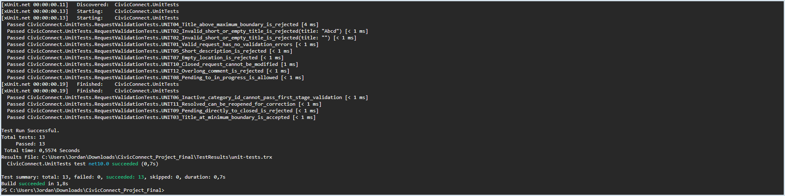
EV-01. Unit testing — 13 executed, 13 passed, 0 failed, 0 skipped; unit-tests.trx saved.

EV-02 — Black-box suite, 5 passed
BB01–BB05 cover login redirect, staff-only screen, request ownership, invalid titles and inactive/invalid categories. The screenshot shows all five test names and a 5/5 pass summary.
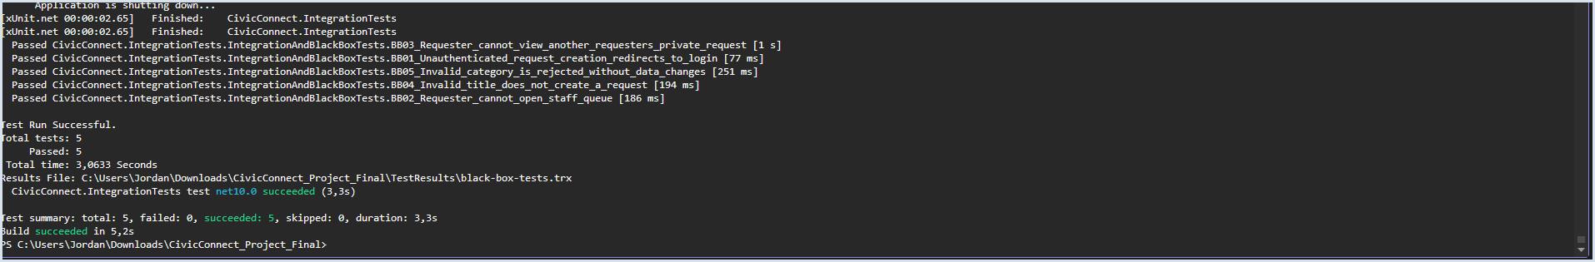
EV-02. Black-box test execution — Five passing tests; source test methods provide input, preconditions and assertions.

EV-03 — Integration suite, 4 passed
INT01–INT04 cover persistence/audit, atomic status-history/audit, stale concurrency and authorized assignment. Uses the isolated test host/SQLite, not live PostgreSQL.
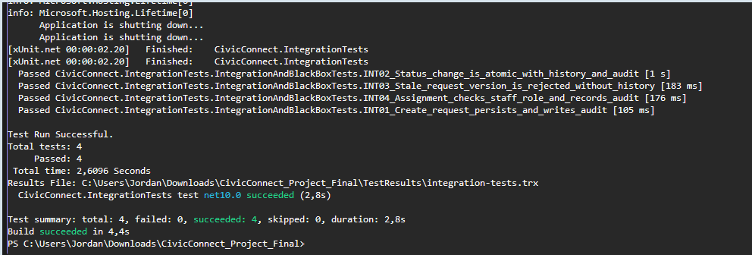
EV-03. Integration test results — Four passing tests, 0 failed, TRX report saved.

EV-04 — E2E HTTP system journeys, 2 passed
E2E01 requester login/submission/detail and E2E02 staff change/requester history, using the ASP.NET Core in-memory test host (not Playwright/browser).
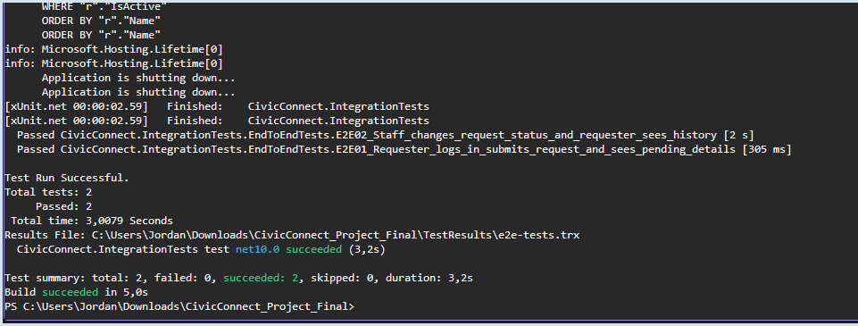
EV-04. HTTP E2E results — Two passed, no failures/skips; e2e-tests.trx saved.

EV-05 — Automated security suite, 3 passed
SEC01 hashed password, SEC02 missing ant forgery token rejected, SEC03 requester blocked from staff-only status update.
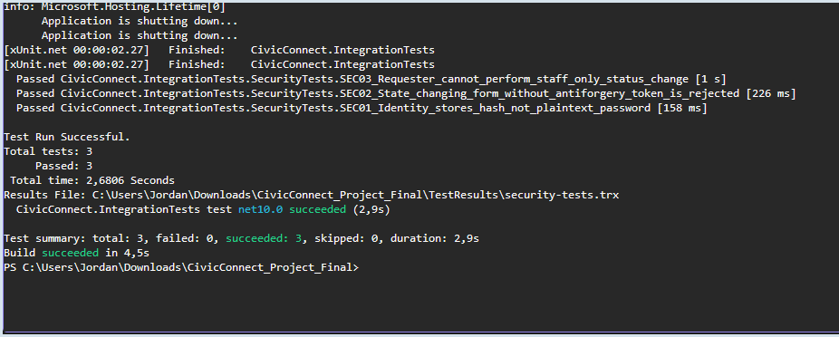
EV-05. Automated security results — Three tests passed with security-tests.trx.

EV-06 — Manual unauthorized administrator access
CivicConnect redirected to /Account/Denied.
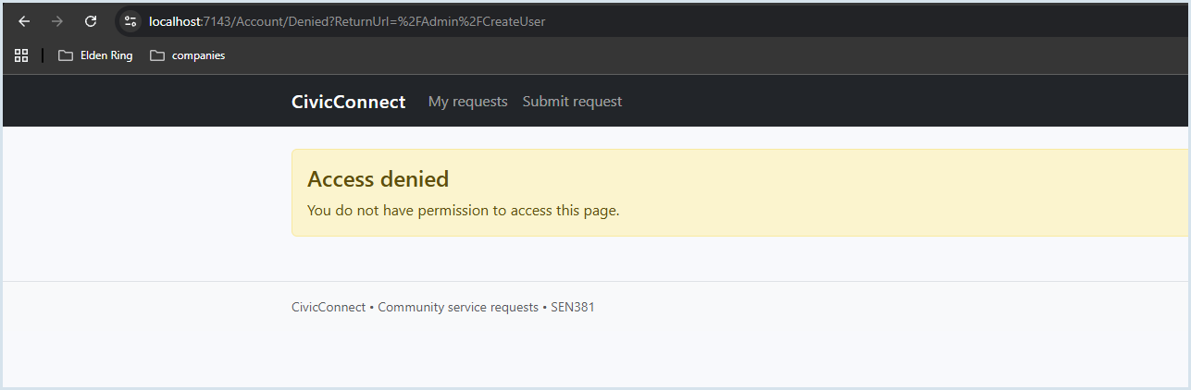
EV-06. Manual role-based access control — Access Denied response visible while signed in as requester.

EV-07 — GitHub Actions build-test successful
Job “CivicConnect build and verification” shows restore, build/.NET analyzers, automated blocking tests, dependency inventory, basic credentials guard and test evidence upload. 13 unit + 14 integration-project tests = 27/27 pass. Historical run shown;
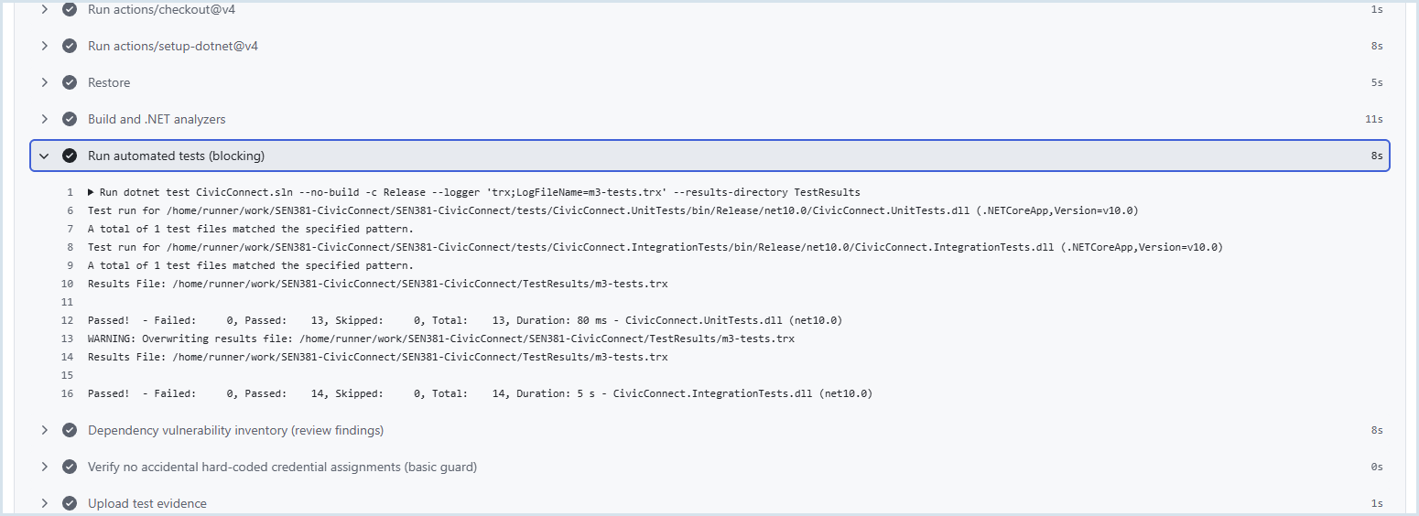
EV-07. GitHub CI execution — 13 unit and 14 integration-project pass; includes warning about TRX file overwrite.

EV-08 — Initial CI security findings
Earlier dependency inventory reported high/moderate advisory findings in Cryptography.Xml/Pkcs. A green step meant inventory executed, not that packages were vulnerability-free. Findings led to package servicing.
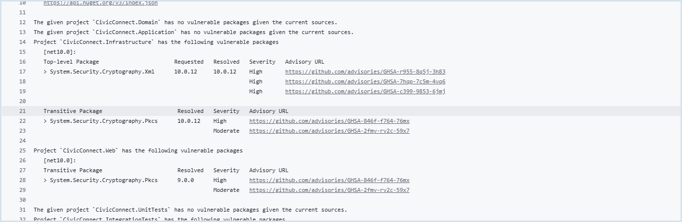
EV-08. Initial vulnerable dependency inventory — Historic advisory findings across Infrastructure/Web/IntegrationTests.

EV-09 — Local post-fix dependency audit clean
dotnet package list --project CivicConnect.sln --vulnerable --include-transitive reported zero vulnerable packages across all six projects using configured NuGet sources. It is time- and source-dependent.
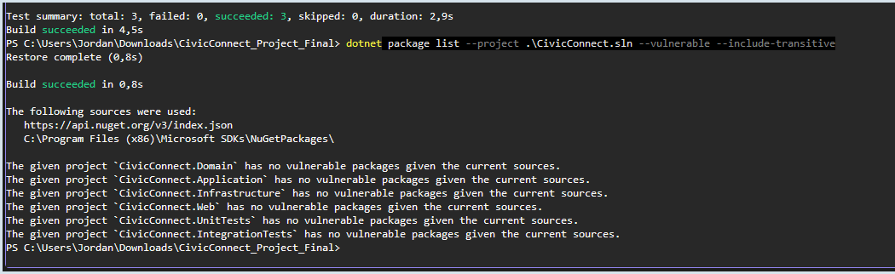
EV-09. Clean dependency audit — All six projects reported no vulnerable packages.

EV-10 — Release analyzer build successful
dotnet build CivicConnect.sln -c Release -p:RunAnalyzers=true -p:EnableNETAnalyzers=true -p:AnalysisLevel=latest completed for all six projects; no warnings or errors appear in supplied output.
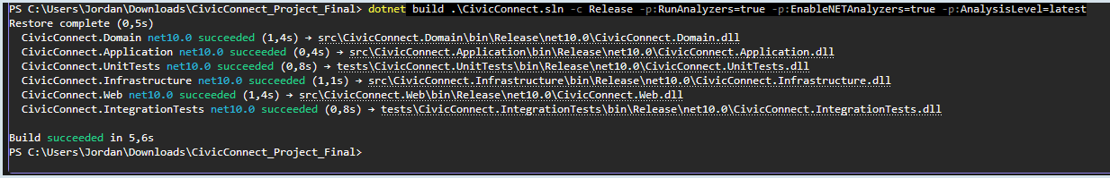
EV-10. Release .NET analyzer outcome — Build succeeded in 5.6 seconds.

EV-11 — Initial performance test failed functional checks
Original 5-VU/30s load test made 600 HTTP requests and reported p95 of 2.19 ms, but only 150/450 functional checks passed; login acceptance and authenticated page-content checks failed. The timing could not support an authenticated dashboard claim.
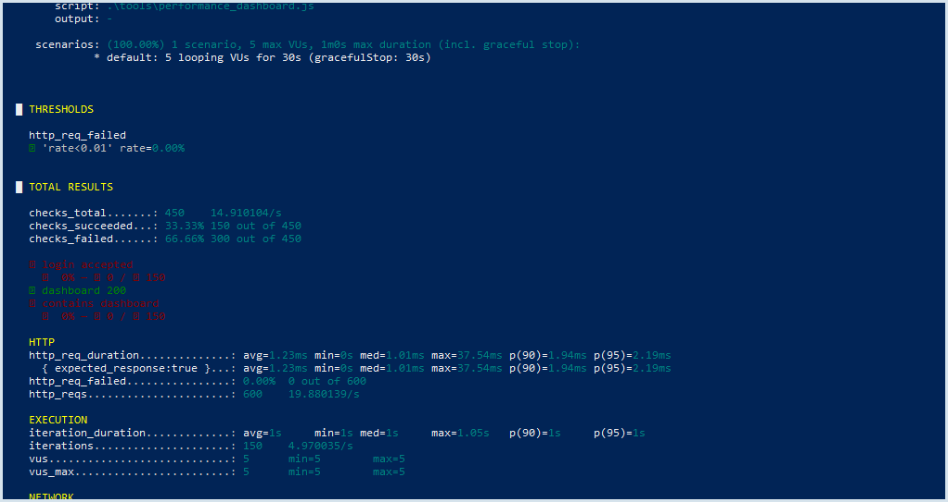
EV-11. Initial failed k6 test — HTTP failure rate 0% but login/content assertions failed; preserved as failure diagnosis.

EV-12 — Corrected k6 performance test passed
After one-time login/session reuse, 5 VUs ran 30s; 150 dashboard iterations, 300/300 functional checks, dashboard p95 3.59ms, failure rate 0%. Only proves this low-load/local configuration.
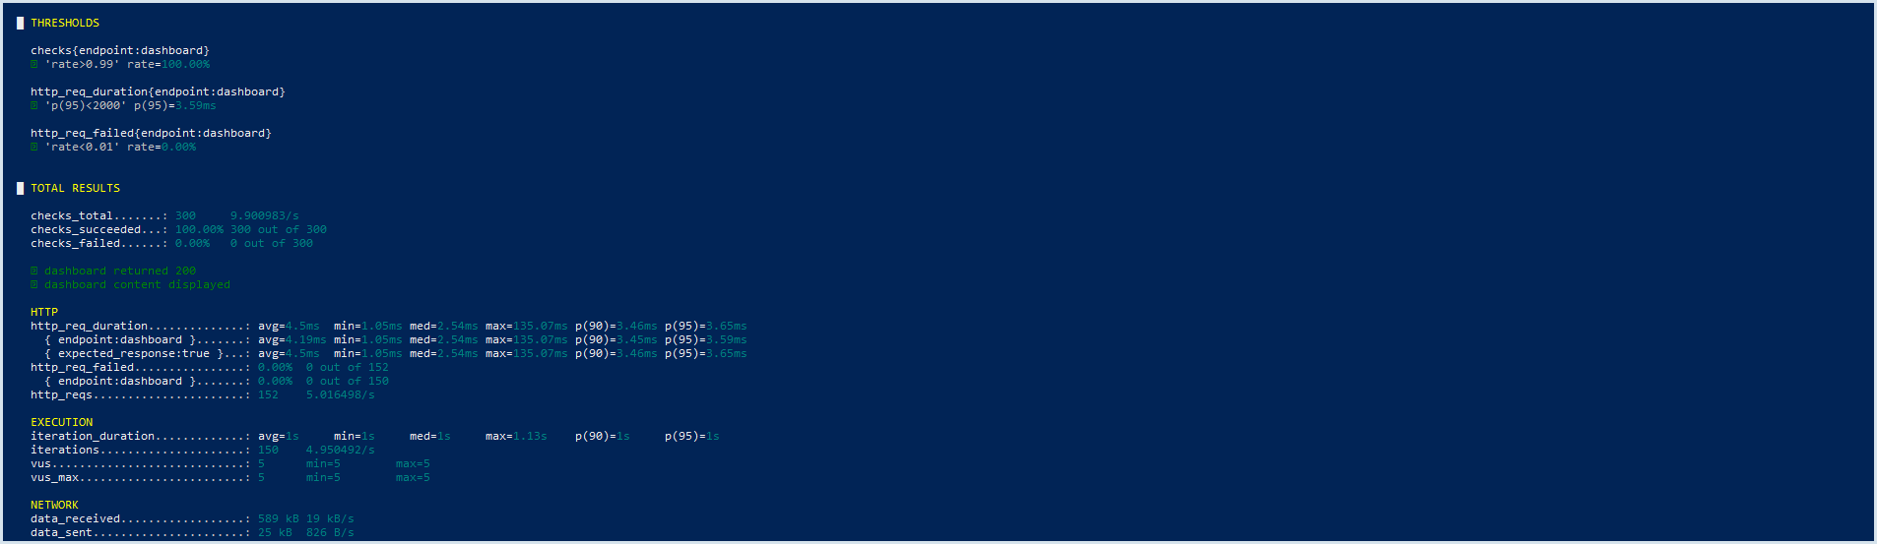
EV-12. Corrected authenticated dashboard load — All configured k6 thresholds passed.

EV-13 — Management dashboard LINQ failure evidence
Original runtime error demonstrates an EF Core query-translation defect when management summary grouped category counts. A corrective source edit was proposed/applied; no supplied successful post-fix management regression is available here.
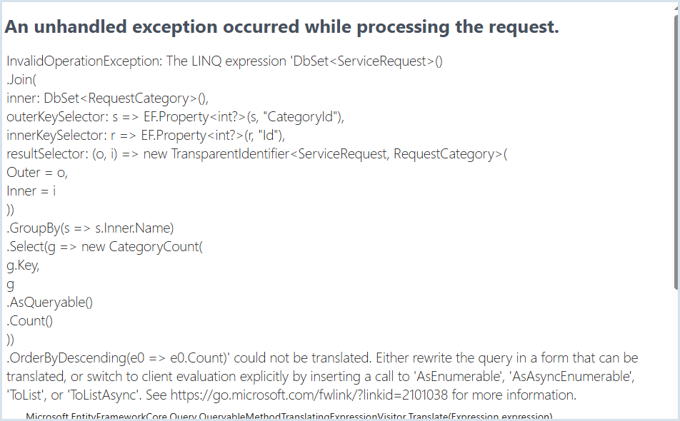
EV-13. Management dashboard original defect — InvalidOperationException: GroupBy projection/order expression could not be translated.

EV-14 — Manual requester dashboard working
Browser view shows signed-in requester seeing “My service requests” after login. The account was newly created following initial performance-script lockout diagnosis. This is a manual sanity check, not a multi-user load test.
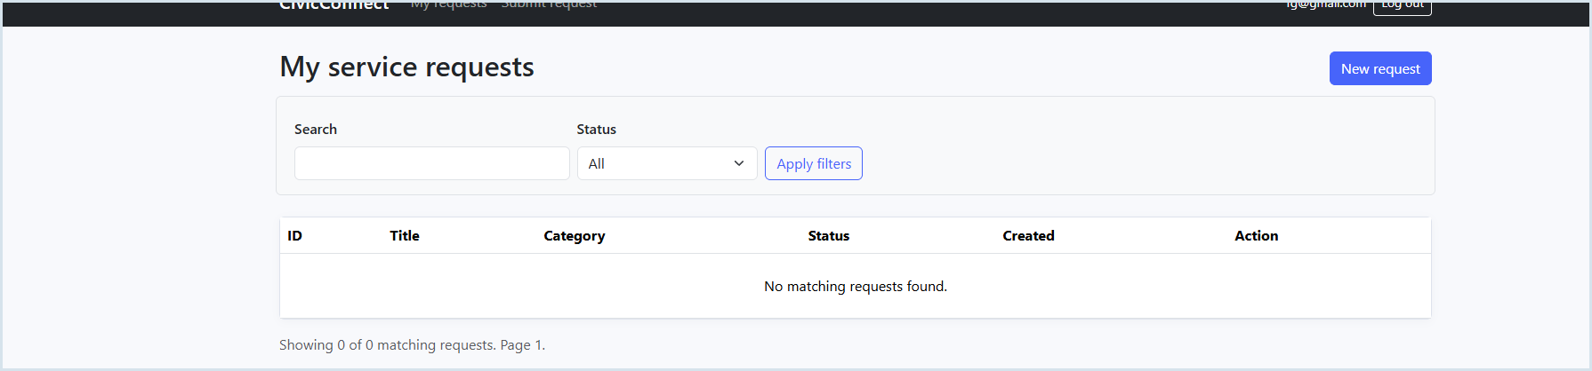
EV-14. Requester dashboard — Authenticated requester page rendered successfully.

Evidence Publication Map — Proposed Controlled Repository Paths
Evidence group | Proposed GitHub controlled location | Verified status in this document
Screenshot annex | docs/m3/evidence/EV-01.png through EV-14.png | Embedded in this PED;
Unit/black-box/integration/E2E/security reports | docs/m3/evidence/test-results/ or CI artifact URL; never upload passwords. | Local TRX file creation shown; exact remote artifacts must be verified.
Test cases and source | tests/CivicConnect.UnitTests and tests/CivicConnect.IntegrationTests | Methods named in source archive; GitHub baseline verified
Performance script/result | tools/performance_dashboard_fixed.js; docs/m3/evidence/EV-11/EV-12 | Corrected local run evidenced; script must be committed for future reproducibility.
RTM, risks, defects, technical debt, AI record | Existing controlled docs/engineering location + updated PED v3; avoid disconnected duplicates. | Updates incorporated in this continuous PED;
CI checks, PR approvals, release tag | github.com/JordanNaidoo870/SEN381-CivicConnect/actions and /pulls plus exact Git  Commit: 47175df1739e7c60593a9fa659da941c9d6e5a3c  Tag/Release: v3.0.0-m3-rc1 | Existing green CI observed.

AI verification Milestone 3
Team Member: Jordan Naidoo
AI tool / use: Co Pilot
Purpose: Postegre test data generation
Output used: Test data was generated and inserted into the database
What was changed/rejected: None

AI verification Milestone 3
Team Member: Tshepo Koithen
AI tool / use: Co Pilot
Purpose: To neaten up the code for web pages infrastructure
Output used: None just the structure was optimized.
What was changed/rejected: None

Milestone 4 - Final Project Engineering Closure (PED v4.0)
FINALISE | CONSOLIDATE | CONCLUDE. This Milestone 4 section is an in-place continuation of the accepted M1, M2 and M3 portions of this same PED. Previous baselines, requirement IDs, architecture decisions and the EV-01–EV-14 M3 screenshots above are preserved. New judgments are based on the Final Project brief, source/CI evidence documented in PED v3.0 and additional local staging screenshots dated 16 October 2026 (Belgium Campus ITversity, 2026f; CivicConnect Project Team, 2026).

M4.1 Final submission and evidence controls
Control item | M4 closing position
Project / team | CivicConnect, SEN381; Jordan Naidoo (602463); Darrin Everette Mokuena (601172); Tshepo Koithen (603233).
Final repository | https://github.com/JordanNaidoo870/SEN381-CivicConnect.git
Final branch / GitHub history | main; retain the existing issues, branch history, PRs, checks and historical PED files.
FINAL RELEASE TAG | [INSERT FINAL M4 RELEASE TAG HERE] (planned name: v4.0.0-m4-final; do not claim published yet)
FULL FINAL COMMIT SHA | [INSERT FULL 40-CHARACTER FINAL MAIN/TAG COMMIT SHA HERE]
FINAL RELEASE URL | [INSERT ACTUAL GITHUB RELEASE PAGE URL HERE]
LATEST CI RUN FOR THE FROZEN FINAL SHA | [INSERT EXACT SUCCESSFUL GITHUB ACTIONS RUN URL FOR FINAL SHA HERE]
Final product demonstration | Windows local staged Release build + isolated PostgreSQL database; http browser screenshots DEPLOY-01–06; additional final acceptance checks specified below.
Acceptance and team baseline sign-off | Final PED accepted and team baseline signed off

M4.2 Executive outcome and final release judgment
CivicConnect is a coherent modular-monolith ASP.NET Core MVC application supporting requester submission/tracking, authorised staff assignment/status/history and an administrative/management surface. Its implementation follows the M2 architecture (ADR-001–ADR-010), with C#/.NET 10, EF Core/PostgreSQL and ASP.NET Core Identity. M3 delivered a 27-pass automated verification suite, local clean NuGet advisory inventory, analyzer build and a passing, corrected 5-VU dashboard test. M4 adds local published-build and PostgreSQL staging proof. These controls support a stable academic integrated increment, not unrestricted public production readiness.
Control item | M4 closing position
Working final-product evidence | M3 EV-01–EV-14; local staged Release DLL and PostgreSQL initialization DEPLOY-01–06.
Deployment state chosen by the team | LOCAL STAGING / SIMULATED-PRODUCTION DEMONSTRATION: Release output on the same developer computer, environment "Staging", isolated civicconnect_simprod database.
Formal go-live decision | NO-GO for actual public/municipal production use at the M4 decision point. No claim is made for real-world availability, privacy certification, recoverability or scale.
Main rationale | Unverified full staging requester-to-staff lifecycle, no real production certificate/host isolation, no tested backup/restore, no 99.5% availability or 5,000-concurrent demonstration, and incomplete POPIA/privacy review.
Final M4 readiness classification | ACADEMIC FINAL BASELINE: CONDITIONAL READY , PUBLIC GO-LIVE: NOT READY (NO-GO).

M4.3 Final integrated product - baseline conformance
The following reflects the M1 stakeholder promise, M2 architectural direction and M3 exercised components. All references to implementation must ultimately be validated against the frozen final commit.
Part of final product | Observed engineering result | Final delivery interpretation
Requester lifecycle | AccountController + Identity; RequestsController; create/list/details, category and location; service/history data. M3 E2E01 and BB/UNIT tests passed. | Core requester journey evidenced in automated test host; re-demonstrate in final staged build.
Staff workflow | StaffController, status validation/assignment, history, audit. INT02/03/04, E2E02 and SEC03 passed. | Core staff transaction/authorization credible. Stage browser currently shows empty queue, not final request cycle.
Management and administration | ManagementController and administrative role account tools present. Staged administrator logged in and saw Staff queue; M3 management LINQ exception reported. | Account and staff UI evidenced; management-dashboard post-fix regression not separately proved. Keep DFT-003 open.
Persistence | PostgreSQL 18; EF InitialCreate; Identity, Requests, Categories, Comments, Attachments, Audit Logs tables. | Schema and administrator row verified on isolated staging DB; PostgreSQL-specific functional parity not fully covered by SQLite-based integration tests.
Quality and engineering controls | M3 xUnit 27, CI, static analyzer, clean local dependency audit and k6 5 virtual users for 30s. | Strong selective verification; not enterprise-grade release certification.

M4.4 Mandatory M1 scope-to-final-delivery closure
The approved M1 baseline contains SC-IN-01–SC-IN-21 (16 stakeholder-facing and 5 supporting capabilities). The matrix below continues that exact numbering. "Met" means an implemented path and relevant existing positive evidence are available; "Partial" means function or control exists but coverage/acceptance is incomplete. This is a capability-level engineering checkpoint.
M1 ID | Committed capability | Priority | M4 status | Best evidence | Final conclusion / variance
SC-IN-01 | Submit request | In scope | MET | E2E01; INT01; EV-03/04 | Valid submit creates persisted Pending request
SC-IN-02 | Controlled categories | In scope | MET | UNIT06; BB05; E2E01 | Category selection/invalid category rejection
SC-IN-03 | See current status | In scope | MET | BB03; E2E01/02 | Own status displayed in tested journeys
SC-IN-04 | Own request history/list | In scope | MET | BB03; E2E02; EV-14 | Owner-restricted list/history evidenced
SC-IN-05 | Meaningful feedback | In scope | PARTIAL | E2E02; UI status/history | Feedback occurs in views; exhaustive reject/update/completion behavior not tested
SC-IN-06 | Authorised staff request view | In scope | MET | E2E02; DEPLOY-05 | Role-aware queue is accessible; staged database currently has no sample requests
SC-IN-07 | Search, filter and sort | In scope | PARTIAL | StaffController/UI; DEPLOY-05 | Controls visible; targeted filtering outcome not evidenced
SC-IN-08 | Full request details | In scope | MET | E2E02; Requests/Staff views | Core detail information used in workflow
SC-IN-09 | Assignment/responsibility | In scope | MET | INT04; EV-03 | Staff assignment and audit pass; requester denied
SC-IN-10 | Controlled status transition | In scope | MET | UNIT08-11; INT02/03 | Allowed transitions/optimistic concurrency validated
SC-IN-11 | Actions, replies, resolution information | In scope | PARTIAL | UNIT12; E2E02 note | Status notes present; official reply lifecycle unverified
SC-IN-12 | Authorised resolve/close | In scope | PARTIAL | UNIT09-11; workflow | Closed-state guard tested; complete resolve-to-close journey not separately shown
SC-IN-13 | Management activity overview | In scope | PARTIAL | ManagementController; DFT-003 | Dashboard implementation; known SQL LINQ exception lacked regression proof
SC-IN-14 | Open/overdue/resolved/closed metrics | In scope | PARTIAL | Management queries; DFT-003 | Query aggregate/results and overdue accuracy unverified
SC-IN-15 | Category/status oversight | In scope | PARTIAL | Management interface; DFT-003 | Grouped category output was LINQ failure site; regression open
SC-IN-16 | Accountability insights | In scope | MET | INT01/02/04; AuditLog | Audit provenance and history selected paths verified
SC-IN-17 | Authorised roles | In scope | MET | BB02/03; SEC03; DEPLOY-05 | Role-gated routes and admin access evidenced
SC-IN-18 | Persistence and lifecycle history | In scope | MET | INT01/02; DEPLOY-02/06 | Data persisted in test database; PostgreSQL schema present
SC-IN-19 | Traceable status/assignment | In scope | MET | INT02/04 | History and audit written with transitions
SC-IN-20 | Validate request inputs | In scope | MET | UNIT01-07; BB04/05 | Boundary, equivalence and invalid fields rejected
SC-IN-21 | Sensitive information/security | In scope | PARTIAL | SEC01-03; EV-09; DEPLOY-01 | Select controls verified; full privacy, TLS and secret-history review outstanding

M4.5 Quantified scope completion - calculation and baseline qualification
PROVISIONAL CAPABILITY CHECK: 13 MET + 8 PARTIAL + 0 NOT MET among 21 original M1 SC-IN capability items. Value = (13 × 1.0 + 8 × 0.5 + 0 × 0) / 21 × 100 = 80.95%. This narrowly exceeds the Final Brief 80% target at capability-check granularity.
MANDATORY QUALIFICATION: Original M1 wrote explicit Given/When/Then acceptance conditions for FR-02, FR-07, NFR-PERF-01 (at 1,000 concurrent users) and NFR-SEC-01; the initial RTM lists only six AC links. It does not provide a separately approved, complete acceptance-criterion inventory corresponding one-to-one with all 21 SC-IN items. The official Final Brief formula must use the approved M1 AC denominator, not a reconstructed denominator chosen to pass. Team/assessor must reconcile and formally ratify that checklist and the outcome before entering an official figure.
Control item | M4 closing position
M1 capability proxy (not official AC percentage) | 13 full + 8 half + 0 zero over 21 = 80.95% (working checklist).
Explicit M1 subset | FR-02 met in test scope; FR-07 met in test scope; NFR-SEC-01 verified for tested Identity storage; NFR-PERF-01 1,000-user acceptance NOT VERIFIED by 5-user k6.
OFFICIAL SCOPE COMPLETION PERCENTAGE - FINAL VALIDATION | 80.95% COMPLETION OF SCOPE
Must-have qualification | SC-IN-05/07/11/12/13/14/15/21 remain partial as verified above.

M1 functional and non-functional closeout exceptions
Original req. | Final evidence/status
FR-03 - photos/videos (Should) | PARTIAL: attachment model/controller present; uploaded-file type/size/ownership regression not demonstrated.
FR-08 - official replies (Should) | PARTIAL: comment length and E2E staff note tested; dedicated official reply experience not fully demonstrated.
FR-09 - upvotes (Could) | NOT DEMONSTRATED; not in SC-IN-01–21 business-capability list; M2/M3 states optional/deferred.
FR-10 - external payment (Won't/Future) | DEFERRED as originally listed.
NFR-PERF-01 | PARTIAL: 5 VU local test passes 2s p95; original M1 Gherkin demands 1,000 users.
NFR-SEC-02 / COMP-01 | PARTIAL: local HTTPS and select RBAC/CSRF/Identity controls.
NFR-REL-01 / SCALE-01 | NOT VERIFIED: 99.5% business-hours uptime and 5,000 concurrent users not tested.
NFR-COST-01 | NOT VERIFIED for operated public service; local cost is not representative hosting cost.
NFR-OBS-01 | PARTIAL: tested CREATE/status/assign audit; not all request CRUD or alerting verified.

Deferred baseline preserved: SC-OUT-01–10 (native mobile, WhatsApp/social/SMS creation, IoT, full finance/inventory, commercial multi-tenant, unrelated systems) remain out-of-scope. SC-FUT-01–08 remain future scope. No unsupported M4 feature expansion or retroactive change approval is asserted.

M4.6 Critical final acceptance and verification continuity
Existing M3 automated tests are carried forward, not recreated; M4 introduces no new numerical testing quota (Final Brief, section 6). This table identifies the observed baseline as opposed to unverified post-M4 reruns.
Level / source | Executed M3 result | Acceptance meaning / release limitation
UNIT01-12 (xUnit) | 13 passed / 0 failed / 0 skipped; EV-01 | Validation and transition logic; 2 UNIT02 data cases.
BB01-05 | 5 passed; EV-02 | Negative authorization, ownership, invalid request fields.
INT01-04 | 4 passed; EV-03 | Persistence, atomic history/audit, concurrency and assignment (SQLite test provider).
E2E01-02 | 2 passed; EV-04 | HTTP test-host requester/staff status journeys; not full browser/staging E2E.
SEC01-03 | 3 passed; EV-05 | Hash storage, CSRF and role denial.
TOTAL xUnit suites | 27 passed / 0 failed in M3; CI screenshot EV-07 | Do not count as re-executed on final M4 release until final CI SHA is confirmed.
Dependency/static | Local six-project no-advisory scan EV-09; Release analyzers clean EV-10 | Clean at observed scan time; full security audit not shown.
PERF-01 k6 | 150 dashboard iterations; 300/300 checks; p95 3.59ms; 0% dashboard HTTP failures; EV-12 | 5 synthetic virtual users for 30sec; does not prove 1,000/5,000 scale.
Local staging | DEPLOY-01–06 16 Oct; PostgreSQL migration; HTTPS startup; homepage, admin login/queue. | Dedicated DB and staged DLL verified; do final requester-to-staff scenario and link final SHA.

Selected final requirement-to-evidence traces
Stakeholder need / req. | Acceptance / engineering choice | Final evidence | M4 disposition
Requester creates request - FR-02 | Valid title, description, category and location -> unique Pending request; ADR-001/002/006. | UNIT01–07; BB04–05; INT01; E2E01; EV-01–04. | MET in test host;.
Staff status updates - FR-07 | Authorised actor; valid version/transition; audit/history; ADR-002/007. | UNIT08–11; INT02/03; SEC03; E2E02. | MET in tested scope; PostgreSQL concurrency parity open.
Sensitive-data protection - NFR-SEC-01, SC-IN-17/21 | Identity credential hash, restricted staff/user resources; ADR-004. | SEC01/03; BB02/03; DEPLOY-05. | Identity hashes and selected access routes MET; full POPIA partial.
Dashboard performance - NFR-PERF-01 | p95 <2s at original M1 1,000-user scenario. | PERF-01 EV-12: 5 virtual users. | PARTIAL; cannot certify original 1,000-user acceptance.
Management service reporting - SC-IN-13/15 | Summaries by status/category and accountability. | ManagementController and historic LINQ exception DFT-003. | PARTIAL;

M4.7 Final defect, risk and technical-debt closure

Defect register continuation (M3 identifiers retained)
Existing ID | M3 issue | M4 outcome | Closure evidence / remaining step
DFT-001 | Unsupported EF GetMigrationsAsync prevented build | CLOSED | Corrected migration API; build and DB migration later succeeded.
DFT-002 | Integration test missing xUnit namespace | CLOSED | Updated helper; 27 xUnit tests passed in recorded M3 run.
DFT-003 | Management category LINQ could not translate | OPEN / REGRESSION UNVERIFIED | Fix reported but no successful management-dashboard regression screenshot;
DFT-004 | k6 repeated failed login / lockout during load | CLOSED AS TEST-HARNESS ISSUE | Corrected to one authenticated setup; 300/300 post-fix checks (EV-11/12).
DFT-005 | High/moderate cryptography dependency advisories | CLOSED FOR LOCAL SCAN; FINAL-SHA RECHECK | Local clean scan EV-09; repeat in final CI and link scan output for frozen SHA.

Final risk status and ownership - M1/M3 IDs continued
Risk ID | M4 position | Residual risk / mitigation owner
RSK-001 | Medium / controlled | M4 freezes scope; optional upvotes/payment future, no new feature promises. Jordan.
RSK-002 | High / open | Selected authorisation passes but complete POPIA/DAST/secret-history work not done. Darrin.
RSK-003 | Medium / partly mitigated | Local Windows and Linux CI; local staging works but true production parity remains unverified. Darrin.
RSK-004 | Medium / open pending final release | RTM evolved, exact final tagged commit and final acceptance denominator pending. Jordan.
RSK-005 | Medium / mitigated with gaps | 27 xUnit tests plus perf/scan; missing management and attachment browser regression. Darrin.
RSK-006 | High / open | SQLite/PG parity and PostgreSQL recovery/backup restore not demonstrated. Tshepo.
RSK-007 | Medium / open | R500/month hosting and true operating-cost proof unavailable. Jordan.
RSK-008 | Medium / mitigated | Negative and boundary validations tested; attachment/duplicate paths still limited. Jordan.
RSK-010 | High / open | Audit tests exist; operational alerting, availability and restore are unverified. Jordan.

Technical Debt Register - M3 IDs retained
Existing ID | Status at finalisation | Consequence / forward action
TD-001 | CARRIED | SQLite integration tests differ from PostgreSQL production provider; add PostgreSQL-backed tests.
TD-002 | CARRIED | Combined CI TRX report overwritten; emit distinct per-suite artifacts.
TD-005 | CARRIED | Small load test inadequate for 1,000/5,000 users and availability claims.
TD-006 | CARRIED | Attachments, official replies and management regression coverage
TD-007 | CARRIED | Secrets-history/DAST/accessibility

M4.8 Final deployment assessment and evidence-backed no-go
Environment demonstrated 16 October 2026: dotnet publish -c Release to Deployment/CivicConnect-SimulatedProduction; local Windows PowerShell launched the published CivicConnect.Web.dll under ASPNETCORE_ENVIRONMENT=Staging and HTTPS localhost:7243. The separately named civicconnect_simprod PostgreSQL database was migrated using EF Core, and a seeded administrative account was persisted. The staged home page and staff queue were shown in the browser. The database screenshot shows the 15-table public schema and a saved AspNetUsers administrator row. Environment variables held credentials within that PowerShell process; this is safer than a committed password but not a complete production secrets-management solution.
Evidence ID | What the supplied image genuinely proves | Limit
DEPLOY-01 | PowerShell prompts/env-variable staging setup; no plaintext secret printed. | Command text is not itself proof of valid creds or isolated host.
DEPLOY-02 | EF InitialCreate migration, initial admin seeded, Staging started and listening on port 7243. | Initial missing migration-history query logged a failure but migration/startup subsequently completed.
DEPLOY-03 | Published staging homepage loads in Chrome at localhost:7243. | Not evidence of full business lifecycle.
DEPLOY-05 | Authenticated admin can access Staff request queue; role-aware navigation visible. | Fresh staging DB has no submitted requests.
DEPLOY-06 | pgAdmin shows civicconnect_simprod schema and persisted seeded AspNetUsers record. | Schema/seed proof, not proof of recovery or complete domain CRUD.

Environment boundaries and final go-live gate
Readiness gate | Observed status / why
Separate database / configuration | civicconnect_simprod created and initialised, distinct from civicconnect_dev; same local PostgreSQL service/user used.
TLS and secrets | https://localhost:7243 demonstrates local HTTPS; user-supplied environment variables, development certificate and role shared with dev.
Critical user journey | M3 E2E test-host paths pass; staging administrator login/queue works; no staged end-to-end request/status screens supplied.
Availability / scale / recovery | No 99.5% uptime, 5,000 users, PostgreSQL backup/restore or alerting evidence.
Privacy/access and security | Identity/CSRF/RBAC/scan evidence; no complete POPIA or production security/penetration review.
Cost and operating procedures | No provider/production quotation, support/monitoring/runbook/rollback rehearsal.

DECISION M4-GOLIVE-01 (final): NO-GO for public production deployment. Permit a controlled, synthetic-data local demonstration of the staging/simulated-production environment for assessment. This is not an assertion that production deployment is impossible; it is a risk-based judgment that release before privacy, integrity, recoverability, and operational assurances would expose citizen information and service records without sufficient safeguards. Release authority: three-student team recommendation, pending institutional acceptance.
Conditions to reconsider go-live: (1) freeze tagged final SHA and demonstrate final CI; (2) staged browser requester -> staff -> requester acceptance with separate synthetic accounts; (3) prove repeatable PostgreSQL backup/restore and rollback; (4) implement accepted public TLS secrets/least-privilege and privacy review; (5) benchmark uptime/load and operational monitoring of up to 1000 concurrent users; (6) cost and runbook review; (7) complete high-severity management regression and approvals.

M4.9 Final RTM extension - same requirement IDs, final outcome
The original M1 initial RTM, M2 nine-column trace and M3 evidence extension remain above. The following M4 status columns close the same chain and must be linked to the final GitHub tag when published. "MET" is confined to test-evidenced scope, not inferred production acceptance.
Req ID | Original expectation | Implementation / test / proof | M4 outcome | Gap / future / disposition
FR-01 | Requester registration | AccountController / Identity; E2E01, SEC01 | MET in test host; staged requester unshown | Release-sha link pending
FR-02 | Request submission | RequestsController, validator; UNIT01-07, BB04-05, INT01, E2E01 | MET in automated scope | Staged acceptance check pending
FR-03 | Basic attachment | Attachment model and request UI | PARTIAL | Type/size/access validation not evidenced
FR-04 | Requester status and history | RequestsController; BB03, E2E01/02 | MET in automated scope | Staged owner check pending
FR-05 | Staff queue | StaffController; E2E02; DEPLOY-05 | MET basic staff access | Fresh staging queue empty
FR-06 | Staff filtering/search | StaffController; filter controls DEPLOY-05 | PARTIAL | No tested filter result set
FR-07 | Authorised controlled update | Workflow/status/history; UNIT08-11, INT02/03, E2E02 | MET in test host | PG concurrency parity open
FR-08 | Official replies | Comment view; UNIT12; E2E02 note | PARTIAL | Dedicated reply regression open
FR-09 | Optional upvote | Could-have; no demonstrated module | NOT DELIVERED / optional | Clarify disposition with approved scope record
FR-10 | Payment gateway | Won't-have/future | DEFERRED | Outside committed final scope
NFR-PERF-01 | p95 <2s / M1 1,000-users | PERF-01 at 5 VUs EV-12 | PARTIAL | Original 1,000 load not verified
NFR-SEC-01 | Password hash | Identity + SEC01 EV-05 | MET on tested path | Full credential security audit not claimed
NFR-SEC-02 | TLS ≥1.2 | HTTPS development/staging URL | PARTIAL | No protocol/certificate verification
NFR-REL-01 | 99.5% uptime | No soak or uptime observation | NOT VERIFIED | Release blocker
NFR-COST-01 | R500/month | Local hosting; no provider costs | NOT VERIFIED | Operational quote required
NFR-SCALE-01 | 5,000 concurrent | 5-VU local k6 only | NOT VERIFIED | Capacity benchmark required
NFR-COMP-01 | POPIA | RBAC, Identity selected routes | PARTIAL | Privacy governance audit required
NFR-OBS-01 | Request audit CRUD | INT01/02/04 selected events | PARTIAL | Full CRUD and runtime monitoring gap

Evidence locator: EV-01–EV-14 (preceding M3 annex), DEPLOY-01–06 (following M4 annex), existing source paths and GitHub Actions run referenced in M3 table 51. Final link fields M4.1 must be completed after tagging; reviewers should compare these with the assessed revision.

M4.10 Decision, change, assumptions and AI accountability closure

Consequences of selected M2 decisions
Existing ADR / decision | Original rationale | Consequence now visible | Retain or change?
ADR-001 modular monolith | Avoid microservice complexity with 3-student team. | One publishable web DLL, separated layers, easy local integration; no high-availability failover. | RETAIN for current scale; plan operational boundaries before public use.
ADR-002 PostgreSQL + EF Core | Relational consistency and auditable transactions. | Audit/history transaction INT02; migrations/schema observed in staging. SQLite provider parity and backup remain debt. | RETAIN; add PG integration/recovery tests.
ADR-004 Identity / roles | Reuse audited framework controls, limit access. | SEC01, SEC03 and denied staff/owner access passed; staging admin login worked. Full POPIA/privacy not proven. | RETAIN; tighten production deployment controls.
ADR-006 shared validation not Strategy | Category rules similar; simpler common validation. | UNIT/BB validation passes and remains understandable; no proof category policy requires separate strategies. | RETAIN until category rules diverge.
ADR-007 Observer-style status reactions | Decouple secondary effects without weakening transaction. | Status + history/audit INT02 proven atomic; external messaging was not added to scope. | RETAIN; introduce durable outbox only for approved integrations.
ADR-009 deployment portability | Portable build; provider decision deferred. | Local staged DLL and DB work, but no production provider/managed hosting/cost evidence. | RETAIN direction; mark provider undecided and no-go.
ADR-010 branch/PR CI | Review and test gates for controlled engineering. | Historical GitHub CI green; reviewer/branch-protection and frozen final SHA must be independently evidenced. | RETAIN; require independent PR approvals and green final build.

Change and assumptions status
M3 corrective changes CHG-M3-01–05 remain recorded unchanged. M4 does not introduce a new material architecture change or authorize new scope. If the final source upload, package updates or management regression changed behaviour, link the relevant authentic PR/change request and rerun tests. No lecturer/client approved scope change or completed final review record was provided for insertion; therefore none is invented.

M4.11 Final project success, resources and engineering conclusion
Master success dimension | Evidence-backed conclusion | Limit / consequence
Stakeholder value | Requester and staff lifecycle has positive integrated automated results and traceable status/audit evidence. | No municipal end-user acceptance/UAT recorded; management reporting regression open.
Scope | Original 21 SC-IN capabilities mapped; derived working checkpoint is 80.95%. | Final accepted M1 AC percentage has been signed off
Cost/resources | Three-student team and local free toolchain; no paid hosting currently evidenced. | R500/month production operating cost not verified or budget audited.
Quality | 27 passing M3 tests, local clean dependency scan/analyzers and corrected PERF-01. | Test-host provider mismatch, limited load and staging E2E gaps.
Security/privacy | Identity hashing, selected CSRF/RBAC and access restrictions are observed. | POPIA, secret-history, public TLS and security assessment remain open.
Risk | Risks RSK-001 onward assessed and residuals carried honestly. | Data recovery, operational monitoring and privacy risks remain material.
Deployment/operations | Published build, PostgreSQL schema, startup, admin sign-in shown in local staged setup. | No independent production service/recovery test; formal public no-go.
Maintainability | Layer separation, ADRs, RTM and documented technical debt provide handover. | CI artifacts, browser regression and PostgreSQL parity debt carried.

FINAL PROJECT CONCLUSION: The team delivered an integrated academic CivicConnect increment that addresses the original fragmented request-tracking problem through a coherent requester/staff application and auditable data model. The most convincing evidence is the actual application and database, 27 targeted automated tests, controlled CI and a corrected load-test procedure. At the same time, some M1 management, feedback, NFR and operations commitments are only partially demonstrated. The professionally justified end-state is a frozen academic final baseline and an explicit NO-GO for public municipal production use until the listed acceptance, privacy, reliability and recovery gaps are closed. This follows the Final Brief rule to finalise rather than invent new feature work (Belgium Campus ITversity, 2026f).

M4.13 Final baseline checklist and approvals
Final acceptance item | Status at draft date
One integrated final source and staged runnable application | SUPPORTED in prior project files
Critical staged requester -> staff -> requester walk-through | SHOWN IN M3 PRESENTATION
M1 21 SC-IN capabilities and Must-haves accounted for | PROVISIONAL MATRIX DONE
M3 issues, risk, debt and ADR closure | DOCUMENTED WITH OPEN ITEMS
Final frozen code + PED v4.0 + CI on exact tag | PENDING
Deployment/go-live assessment | NO-GO PUBLIC; LOCAL STAGING DEMO
Team approval | TEAM HAS APPROVED AND SIGNED OFF

Team member / student ID | Final closure review statement | Signature / date
Jordan Naidoo / 602463 | I reviewed scoped-delivery result, stakeholder/RTM links, M4 no-go and final commit. | 2026/10/16
Tshepo Koithen / 603233 | I reviewed data/persistence, integration, recovery debt, scope evidence and final commit. | 2026/10/16
Darrin Everette Mokuena / 601172 | I reviewed security/CI/performance, unresolved risks and final release decision. | 2026/10/16

M4.14 Staging / simulated-production screenshot annex
These figures are the actual team screenshots supplied on 16 October 2026. They show locally executed staging evidence. Screen captures are point-in-time evidence, not a substitute for final tagged-commit verification or automated/live acceptance results. Real passwords are not printed; screenshots are of synthetic/local accounts.
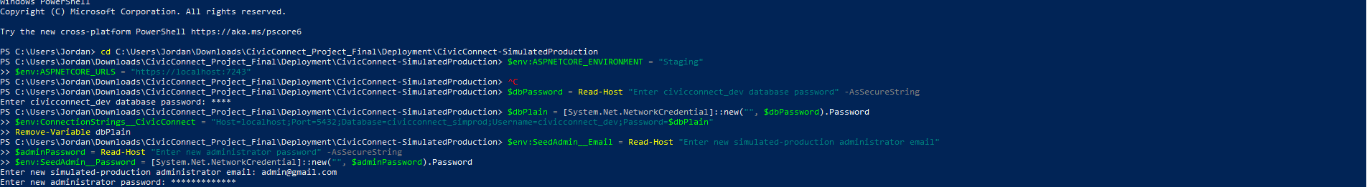
DEPLOY-01 - Separate deployment folder; Staging environment and credential-prompt configuration (masked password).
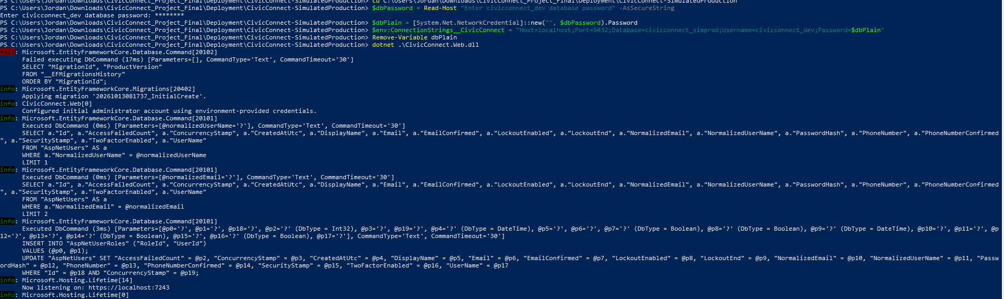
DEPLOY-02 - EF initial migration, seeded administrator and HTTPS Staging startup on 7243.
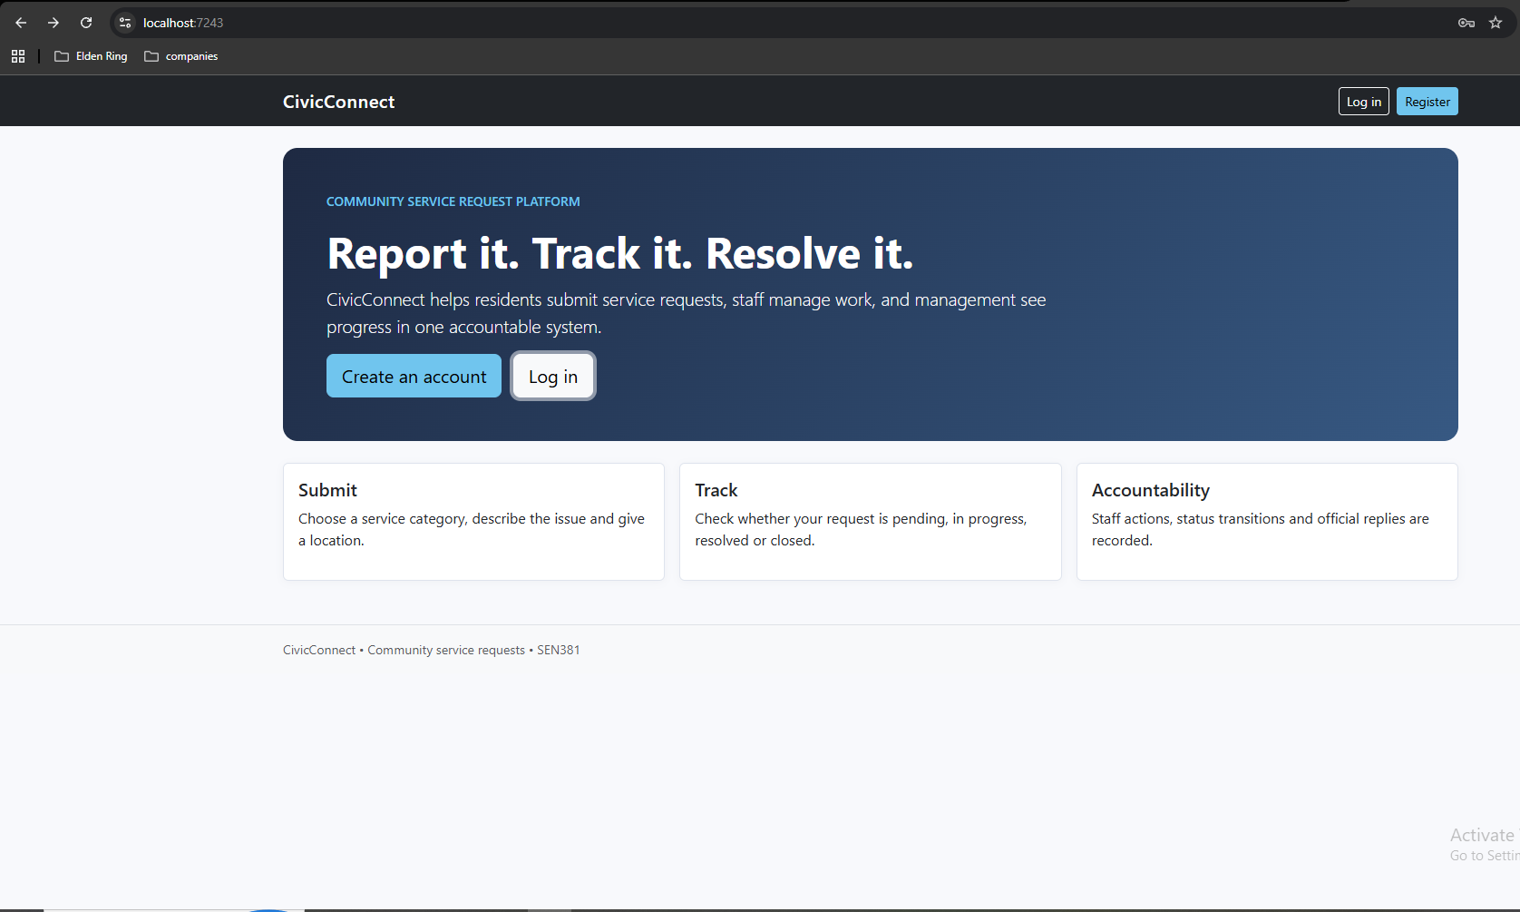
DEPLOY-03 - CivicConnect homepage served by the published staging application at localhost:7243.
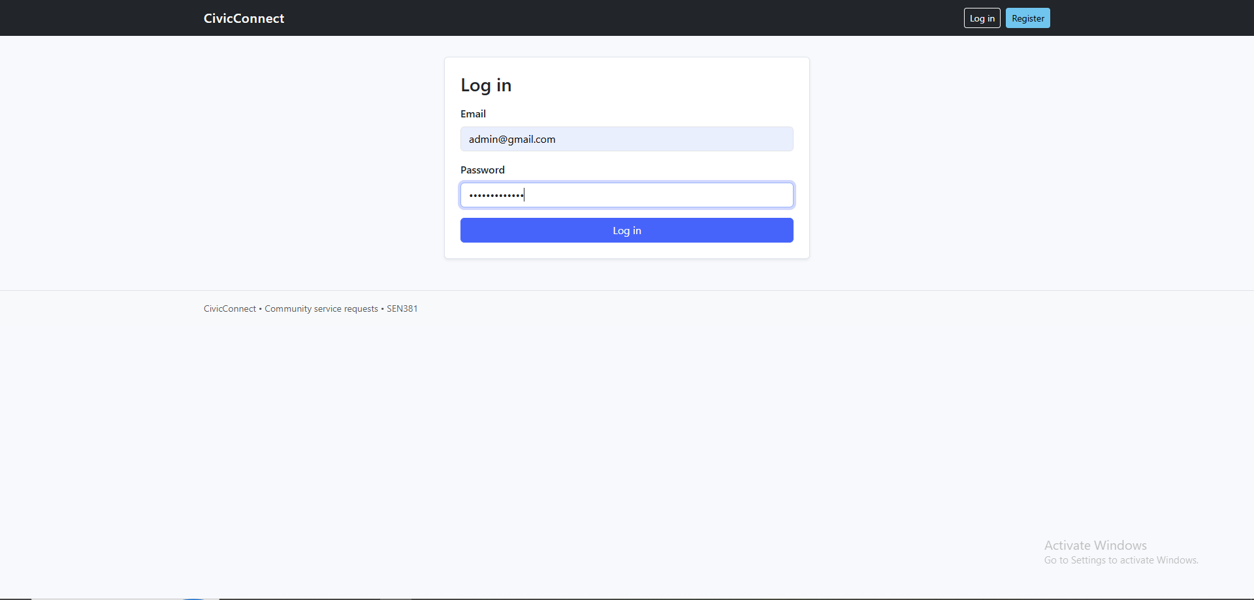
DEPLOY-04 - Staged administrator login interface before successful authentication; password remains masked.
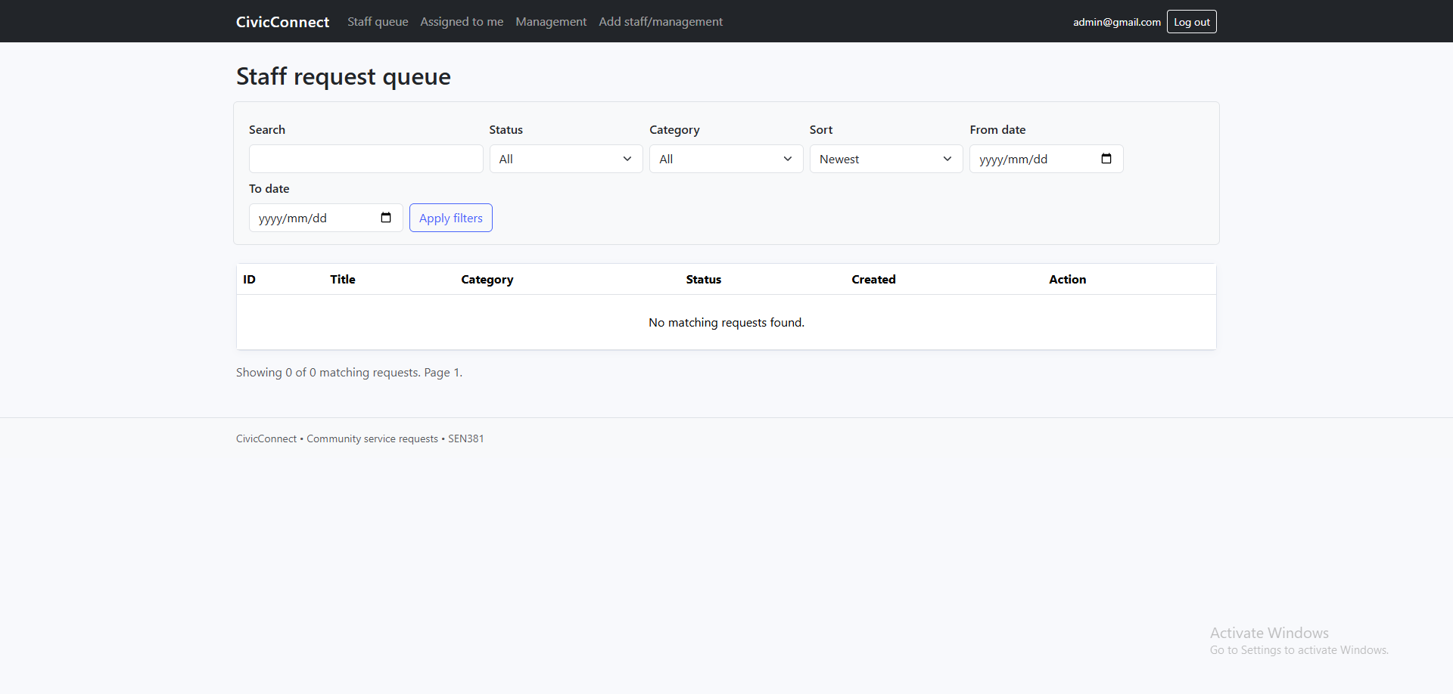
DEPLOY-05 - Authenticated staged administrator sees Staff request queue and authorised navigation; empty DB is visible.
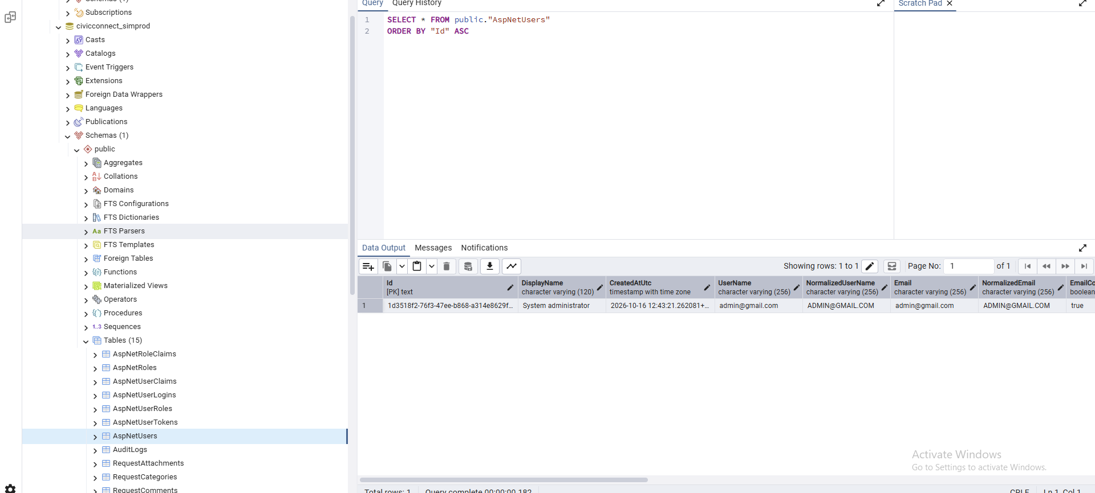
DEPLOY-06 - PostgreSQL civicconnect_simprod, 15 tables and a persisted administrative AspNetUsers record.

M4.15 Evidence publication map and reference addition
ID / artefact | Recommended controlled GitHub path | Status
PED v4.0 Final - same evolving document | docs/PED/CivicConnect_PED_v4.0_Final_Engineering_Closure.pdf and .docx | Draft authored; upload on reviewed branch, then tag.
M3 EV-01–14 | Existing PED v3 annex; docs/evidence/m3/ if retained | Already included in inherited PED; source logs run in M3.
M4 DEPLOY-01–06 | docs/evidence/m4/deployment/DEPLOY-01...06.png | Observed in this PED; repository publication pending.
Final CI link | docs/evidence/m4/ci/ or GitHub Actions final tagged run URL | [INSERT AFTER FINAL SHA VERIFIED].
RTM, Risk/Defect/Debt/ADR/AI registers | Original PED sections + M4 closure; linked controlled source if separate | Continue same IDs; no newly fabricated approval.
GitHub release / SHA | https://github.com/JordanNaidoo870/SEN381-CivicConnect/releases | [INSERT FINAL URL/TAG/SHA AFTER PUBLICATION].

M4 reference addition (Harvard): Belgium Campus ITversity. 2026f. SEN381 Software Engineering 381: CivicConnect - Final Project / Milestone 4, Finalise, Consolidate & Conclude. Pretoria: Belgium Campus ITversity. Source: team-uploaded SEN381 FINAL.pdf, 13 pp.
Supporting original source continuity: Belgium Campus ITversity (2026a) Master Project Brief; (2026b) M1; (2026c) M2; (2026d) M3; (2026e) Assignment 3; CivicConnect Project Team (2026) M1–M3 PED/test/evidence. The complete original M1–M3 reference list is preserved after this annex.

AI verification Milestone 4
Team Member: Jordan Naidoo
AI tool / use: Co Pilot
Purpose: Scope coverage calculation
Output used: Scope calculation coverage was conducted manually then verified by AI
What was changed/rejected: Incorrect calculations where changed

M3 Reference Additions
The original M1/M2 References section is preserved below. The sources introduced for M3 are cited in the new text as Belgium Campus ITversity (2026d, 2026e) and are appended to the retained bibliography; the numbering/status of previous decisions is unchanged.
Belgium Campus ITversity. 2026d. SEN381 Software Engineering 381: CivicConnect Project — Milestone 3, Controlled Construction, Integration, Quality & Release Readiness. Pretoria: Belgium Campus ITversity.
Belgium Campus ITversity. 2026e. SEN381 Assignment 3: Research for Quality, Security & Production Readiness Decisions. Pretoria: Belgium Campus ITversity.
CivicConnect Project Team. 2026. Local and GitHub CI evidence for Milestone 3: xUnit UNIT/BB/INT/E2E/SEC executions; NuGet vulnerability inventory; .NET analyzer build; Grafana k6 PERF-01 outputs. Evidence screenshots EV-01–EV-14 in this PED; source code and CI workflow in repository.

References
Abramovici, A. 2000. Controlling Scope Creep. PM Network, 14(1), pp. 44–48. Project Management Institute.
Belgium Campus ITversity. 2026a. SEN381 Software Engineering 381: Integrated Team Software Engineering Project — CivicConnect Master Project Brief. Academic Year 2026.
Belgium Campus ITversity. 2026b. SEN381 Software Engineering 381: CivicConnect Project — Milestone 1: Engineering Foundation & Requirements Baseline. Academic Year 2026.
Belgium Campus ITversity. 2026c. SEN381 Software Engineering 381: CivicConnect Project — Milestone 2: Architecture, Technology & Initial Design Baseline. Academic Year 2026.
Burek, P. 2008. Creating Clear Project Requirements: Differentiating “What” from “How”. PMI Global Congress 2008 — North America. Project Management Institute.
CivicConnect Project Team. 2026. SEN381 Assignment 2: Research for Engineering Decisions. Jordan Naidoo, Darrin Everette Mokuena and Tshepo Koithen.
Cucumber. n.d. Gherkin Reference. Cucumber Documentation. Accessed 9 September 2026.
Faris, R.K. and Patterson, D. 2007. Managing Risk in the Project Portfolio. PMI Global Congress 2007 — North America. Project Management Institute.
GitHub. 2026. Secrets — GitHub Actions Documentation. Available at: https://docs.github.com/en/actions/concepts/security/secrets [Accessed 30 September 2026].
International Organization for Standardization (ISO). 2018. ISO 31000:2018 Risk Management — Guidelines. Geneva: ISO.
ISO/IEC. 2023. ISO/IEC 25010:2023 Systems and Software Engineering — Systems and Software Quality Requirements and Evaluation (SQuaRE) — Product Quality Model. Geneva: ISO.
ISO/IEC/IEEE. 2018. ISO/IEC/IEEE 29148:2018 Systems and Software Engineering — Life Cycle Processes — Requirements Engineering. Geneva: ISO.
Microsoft. 2026a. The official .NET support policy. .NET. Available at: https://dotnet.microsoft.com/en-us/platform/support/policy [Accessed 30 September 2026].
Microsoft. 2026b. Overview of ASP.NET Core MVC. Microsoft Learn. Available at: https://learn.microsoft.com/en-us/aspnet/core/mvc/overview?view=aspnetcore-10.0 [Accessed 30 September 2026].
Microsoft. 2026c. Introduction to Identity on ASP.NET Core. Microsoft Learn. Available at: https://learn.microsoft.com/en-us/aspnet/core/security/authentication/identity?view=aspnetcore-10.0 [Accessed 30 September 2026].
Microsoft. 2026d. Handling Concurrency Conflicts — EF Core. Microsoft Learn. Available at: https://learn.microsoft.com/en-us/ef/core/saving/concurrency [Accessed 30 September 2026].
Microsoft. 2026e. Safe storage of app secrets in development in ASP.NET Core. Microsoft Learn. Available at: https://learn.microsoft.com/en-us/aspnet/core/security/app-secrets?view=aspnetcore-10.0 [Accessed 30 September 2026].
Microsoft. 2025. What’s New in EF Core 10. Microsoft Learn. Available at: https://learn.microsoft.com/en-us/ef/core/what-is-new/ef-core-10.0/whatsnew [Accessed 30 September 2026].
Npgsql. n.d. Npgsql Entity Framework Core Provider. Npgsql Documentation. Available at: https://www.npgsql.org/efcore/ [Accessed 30 September 2026].
OpenJS Foundation. 2026. Node.js Releases. Node.js Documentation. Available at: https://nodejs.org/en/about/previous-releases [Accessed 30 September 2026].
Oracle. 2026. Consolidated JDK 25 Release Notes. Oracle Java. Available at: https://www.oracle.com/java/technologies/javase/25all-relnotes.html [Accessed 30 September 2026].
OWASP Foundation. 2021. OWASP Top 10:2021. Open Worldwide Application Security Project.
OWASP Foundation. n.d. Authorization Cheat Sheet. OWASP Cheat Sheet Series. Accessed 30 September 2026.
OWASP Foundation. n.d. Password Storage Cheat Sheet. OWASP Cheat Sheet Series. Accessed 30 September 2026.
PostgreSQL Global Development Group. 2025. PostgreSQL 18 Released. Available at: https://www.postgresql.org/about/news/postgresql-18-released-3142/ [Accessed 30 September 2026].
Republic of South Africa. 2013. Protection of Personal Information Act 4 of 2013. Pretoria: Government of South Africa.
Systems Engineering Body of Knowledge (SEBoK). 2026. Stakeholder Needs and Requirements. SEBoK Version 2.14.
VMware. 2026. Spring Boot System Requirements. Spring Documentation. Available at: https://docs.spring.io/spring-boot/system-requirements.html [Accessed 30 September 2026].
World Wide Web Consortium (W3C). 2024. Web Content Accessibility Guidelines (WCAG) 2.2. W3C Recommendation. Available at: https://www.w3.org/TR/WCAG22/ [Accessed 30 September 2026].

